Boarding Assistant Job Description

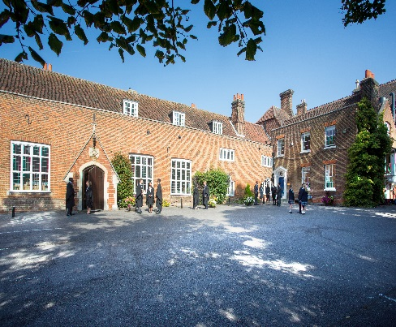

Chigwell School was founded in 1629 by Samuel Harsnett, Archbishop of York and Vice Chancellor of Cambridge University. The School is an independent co-educational establishment with approximately 900 pupils. Located in the village of Chigwell, only 10 miles from central London and close to Epping and Hainault Forests, it is set in its own beautiful grounds of over 100 acres. Our Junior and Senior Schools are able to share a single campus, enabling us to offer an exceptionally stable educational environment. The Junior School caters for children up to the age of 13, the Senior School from 13 onwards.

As well as being an academic school, Chigwell has the reputation for providing a rich and full education, with plenty of opportunities for all pupils who are enthusiastic, co-operative and able. Chigwell is a caring and friendly school, with a close sense of community, not least between colleagues.

Our boarding facilities cater for the 20% of our Sixth Formers who come to study at Chigwell from other countries. Chigwell values very much the contribution of our international students to the diversity of the Sixth Form, as we prepare all our pupils to take their place in today’s global society. Our international students come from a wide variety of different countries, and it is the job of the boarding houses to give them a secure and friendly home-from-home, to support and guide them as they adapt to the British education system and prepare for university.

Our boarders live in a series of small extended-family houses on the school site. Each house is run by a houseparent couple, who live in the house together with a group of seven students.

The Person

The School is looking for a part-time member of staff to help with looking after our male boarders at weekends. The post involves assisting and deputising for the resident Houseparents.

The post would suit a friendly caring person who would enjoy meeting students from all over the world and helping them settle into life at Chigwell. A driver’s licence is essential, as is experience working with young people and/or bringing up a family.

Hours of Work

Each weekend, the Boarding Assistant would be on duty in the boarding house for 13 hours – exact times to be arranged with the Houseparents at their mutual convenience. In addition, up to twice each term the Boarding Assistant would be on duty in the House for 40 hours sleeping overnight in the house, to enable the Houseparents to go away. Two 8-hour days at the start of each new academic year may also be required. Employment is term-time only and there will be two full weekends holiday per term.

In addition, the Boarding Assistant would be expected to participate in some of the social activities organised in the boarding community (e.g. theatre trips, dinners etc.), and to take an interest in the activities of the boys in the house (e.g. come and support if one of them is playing in a concert). These are always very enjoyable occasions, and all expenses would be covered by the School.

Application

Further details of the School may be found on the website at www.chigwell-school.org. Application is by a form which can be completed online or downloaded from our website (select Vacancies) and submitted to HR department: hr@chigwell-school.org

Closing date: 25th February 2018- Early applications welcome

Applications will be considered immediately upon receipt. Candidates will be contacted by telephone or email to attend an interview if required. The School reserves the right to interview and appoint prior to the closing date.

Chigwell is committed to safeguarding and promoting the welfare of children and young people and expects all staff and volunteers to share this commitment. Applicants must be willing to undergo child protection screening including checks with past employers, prohibition orders and enhanced DBS.

