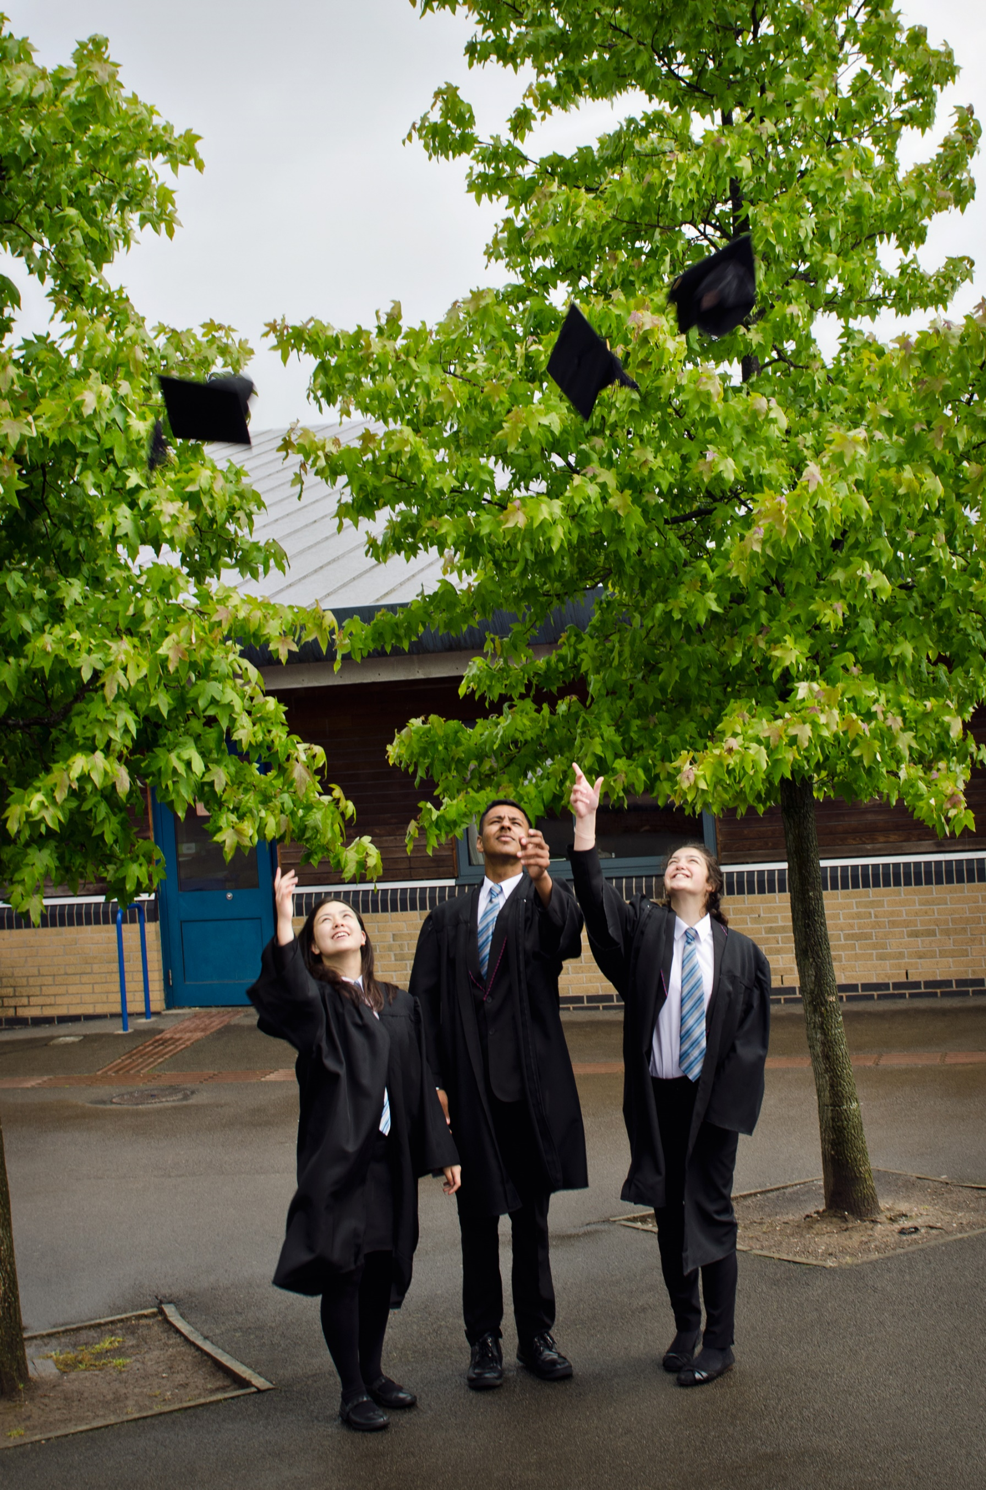
Temporary Teacher of History

Dear Colleague

Thank you for the interest you have shown in the position of Temporary Teacher of History within The White Hills Park Federation Trust. This is an exciting time for our Federation as we build on our successes and plan for the future.

We believe that the Federation will ensure all students can reach their potential, but also as a Federation we will be innovative and forward thinking in our delivery of education; in many respects the Federation itself is an example of innovative practice.

We can offer you a forward-looking and effective Board of Directors, supportive parents, talented and dedicated professional colleagues and positive, well-motivated students. We pride ourselves on the strong relationships that have been established across all members of our Federation, and the contribution this makes to our improving student outcomes.

We are also keen that all colleagues within the Federation have the opportunity to develop and also progress professionally by experiencing new responsibilities and ways of working. As the Executive Principal I am keen to appoint colleagues who will make the most of the opportunities which a Federation brings; the diversity of experience which can be gained and the benefits which can accrue from working closely with colleagues from two other schools.

I hope that after reading the information you are encouraged to apply for the post of Temporary Teacher of History.

We are very happy to arrange visits or to hold an informal conversation – please feel free to contact us.

Yours sincerely

Paul Heery
Executive Principal

The White Hills Park Federation Trust
The White Hills Park Federation Trust is a collective group of schools in Bramcote, Nottinghamshire, and aims at bringing the benefits and economies of scale of a large establishment, while remaining as two individual schools, under one management structure and Governing Body. The Federation was founded in 2006.
Our two schools share one 6th Form facility, called Bramcote College 6th Form. Students from schools and colleges outside of the Federation also attend the College.
We are located in the heart of Nottingham, within close proximity to the M1 and A52, and within easy reach of Nottingham City Centre as well as rural Nottinghamshire and Derbyshire, including the Peak District National Park.

The Aims of the Federation
Every student’s future is important to us; we will ensure that their potential will be reached and their needs will be catered for.
We recognise that we live in a rapidly changing world where those who can adapt, both as individuals and as communities, will be successful. The Federation will be flexible in order that we lead change as well as reap the benefits which the future will bring. We will also ensure that our students face the future with confidence.
We recognise that change brings opportunity and we will seek continual improvement in the work of the Federation and in the expectations that we have for our students.

Alderman White School
Alderman White School is a successful and inclusive school with a record of good progress, excellent student behaviour and a wide range of enrichment activities.
We have retained our distinct identity as a specialist language school, with students benefitting from a range of languages taught both as part of the main stream curriculum and of the extensive community programme including the Saturday family learning classes. We organise exchanges to Germany and visits to France and Spain.
The school is served by five main contributory junior schools, with a significant number of students from several other primaries within a wider geographical area. There is a high level of co-operation and contact within our 'family' and the school engages with many activities within the wider community.

Bramcote College (The Bramcote School)
Bramcote College has a deserved reputation for being a small, inclusive and caring school with strong links with the local community. The school has strong, caring and supportive staff that are committed to raising achievement and the students are keen, loyal and enthusiastic and want to come to school. Young people at Bramcote College are known by their name and their individual potential and needs are supported and encouraged.
We pride ourselves on the breadth and choice of curriculum and of the education and experiences our students have every day. As well as GCSE’s, we can offer school courses and Entry Level qualifications to make the most of our students’ skills, talents and interests. At Bramcote College, we develop the attitudes and skills for every student that support a healthy and fulfilled life together with the confidence for a lifetime of learning.

Bramcote College 6th Form
Bramcote College 6th Form is the Post-16 provider for The White Hills Park Federation. However the College is also open to other students from outside the Federation. The College aims to meet the needs of all students within the Federation; although the majority of courses at the College are traditional A-Levels, the college does provide alternative routes at both GCSE level and A-Level in the form of applied Cambridge Technical qualifications. We also aim to provide a very personalised system both in terms of the curriculum we offer and the guidance we provide. In order to achieve this both teaching and tutor groups are kept small; therefore offering more individual tuition to our students.
We believe that the success of the College rests upon three things: the progress our students make in terms of each individual reaching their potential, the high proportions of students who complete their courses, and also our success in ensuring all students achieve their favoured destination whether this is higher education, training schemes or embarking on their future career.
Of course time in the 6th Form is also about personal development. Our students play an active part in extra-curricular activities such as having the opportunity to learn British Sign Language, Mandarin and take part in a trip to China.

General Information for Applicants
Candidates apply to the Federation and may work at more than one site. However, class teachers will have a ‘home’ school within the Federation.
All offers of appointment are subject to:
- At least two satisfactory references (usually requested prior to interview)
- A satisfactory Enhanced Disclosure and Barring Service (DBS) check
- Proof of the candidate’s identity and their right to live and work in the UK
- Verification of qualifications and professional status

Please note: Applications should comprise the standard application form (attached) and a letter of no more than two sides of A4 explaining why you are a suitable candidate for the position of Temporary Teacher of History at The White Hills Park Federation Trust.
You may choose to include a CV if you feel that it will provide us with important information about you that we will not see from your letter or application form.
Applications should be returned to recruitment@whpfederation.org and reach us by 10:00 am on Monday, 27th November 2017. Shortlisted candidates will be invited to interview by letter or email.
If you have not heard from us in regards to an interview by two weeks after the closing date please assume that you have not been successful on this occasion. We do not normally inform candidates not shortlisted for interview.

Equal Opportunities
The White Hills Park Federation Trust is committed to equal opportunities and fair treatment of its staff and all applicants, on the principle that no one is discriminated against on the basis of his or her actual or perceived race, ethnic or national origin, caste, nationality, religion or belief, gender reassignment, sexual orientation, disability, marital status or civil partnership, pregnancy or maternity or age. All employees and students will be treated and valued equally.

History, Citizenship and Politics at The White Hills Park Federation Trust

The Federation History and Citizenship Department belongs to a faculty encompassing Humanities and Social Sciences. The department is supported by a Head of History and a Head of Citizenship/PSHE.
History and Citizenship are taught in all year groups. There are currently five mixed-ability GCSE History classes in Y10 and four in Y11, as well as A-Level history and A-Level politics classes. The department follows OCR exam courses at A Level and Edexcel at GCSE.
All KS4 students follow a compulsory non-examined core Citizenship course which includes Careers, PSHE, RE and Citizenship elements.
The department is well established and resourced, running a range of extra-curricular activities and trips such as a Year 9 visit to the Imperial War Museum as well as welcoming many outside speakers on Citizenship topics. Staff are experienced and most have worked at the Federation for many years. They collaborate across the two schools which make up The White Hills Park Federation Trust sharing resources, supporting with CPD and running extra-curricular activities.

Job Description
Purpose:
- To teach to a high standard in line with national standards.
- Provide a good role model for pupils and staff.
- Motivate pupils and staff by personal influence and concern for individual needs and development.
- To raise standards of student attainment and achievement within those groups for which the teacher has been assigned.
- To set high standards and expectations for students, to create an effective climate for learning and teaching.
- Links with KS2 to develop opportunities, support progression and recruitment.
- Safeguard the Health and Safety of self and others in accordance with the Federation’s Health and Safety Policy.
Reporting to:
- The Executive Principal
- The Head of Department

Responsible for:
- All pupils on courses for which the Teacher has responsibility.

To co-operate with:

- The Governing Body, making such reports as required.
- All colleagues, both teaching and support staff.
- LA, advisers.
- Unions and other organisations representing teachers and other persons on the staff.

Salary/Grade:

- MPR/UPR
Disclosure:

- Clear DBS check

Main Duties

Teaching:

- Having regard to the curriculum for the Federation, and with a view to promoting the development of the abilities and aptitudes of the students in any class or group assigned.
- To plan and prepare courses and lessons.
- Teaching, according to their educational needs, the students assigned to him, including the setting and marking of work to be carried out by the student in the Federation and elsewhere.
- To assess, record and report on the attendance, progress development and attainment of students, and to keep such records as required.
- To provide, or contribute to oral and written assessments, reports and references, relating to individual students and groups of students.
- To ensure that ICT, Literacy, Numeracy and subject specialisms are reflected in the learning and teaching experience of students.
- To undertake a designated programme of teaching.
- To ensure a high quality learning experience for students which meets internal and external quality standards.
- To prepare and update subject materials.
- To use a variety of delivery methods which will stimulate learning appropriate to student needs and demands of the syllabus.
- To maintain discipline in accordance with the Federation’s policies and procedures, and encourage good practice with regard to punctuality, behaviour for learning, standards of work.
- To set homework in accordance with published timetables and expectations, and to monitor entries in planners and completion.
- To undertake assessment of students as requested by external examination bodies, faculty and procedures.
- To mark, grade and provide written/verbal and diagnostic feedback as required.

Students:

- To promote the general progress and well-being of individual students and of any class or group of students assigned.
- To provide guidance and advice to students on educational and social matters and on their further education and future careers, including information about sources of more expert advice on specific questions.

Staff performance management and continuing professional development:

- Participating in the arrangements made for the appraisal of own performance and that of other staff.
- Participating in the identification of areas for own professional development.

Develop personally and professionally though:

- Reflection on own practice and private study.
- Participation in the Federation’s teacher appraisal programme.
- Participation in appropriate in-service education programmes.

Communication:

- To communicate and consult with the parents of students.
- To communicate and co-operate with persons or bodies outside the School to the benefit of students and Federation provision.
- To participating in meetings arranged for any of the purposes outlined in accordance with the calendar.
- To attend School briefings in support of effectiveness/efficiency and community development.
- To use briefings, weekly bulletin and notice boards to share information.
- To ensure effective communication with designated staff regarding trips, visits and absence.

Person Specification

Attributes | Essential | Desirable | Criteria used for  Assessment
Experience  Knowledge of strategies to  improve the quality of learning  and teaching.  Knowledge of strategies  required to raise  standards.  An appreciation and empathy of the role played by support staff in raising attainment. | *  * | * | A / I  A / I  A / I
Qualifications  Graduate with Qualified  Teacher status.  Degree of equivalent or relevant experience.  Evidence of continued  professional development where applicable. | *  *  * |  | A  A  A
Skills and Knowledge  The National Curriculum and its  Assessment.  The use of performance data in  motivating and supporting  students.  Strategies for promoting good  behaviour based on positive  reinforcement. | *  *  * |  | A / I  A / I  I
Personal Qualities  Good general health.  Good attendance.  Appreciative of the need to present a positive image.  Positive approach to change.  Disciplined time keeper.  Work to tight deadlines and under pressure.  A willingness to contribute to extra curricular activities. | *  *  *  *  *  * | * | A / I / R  R  I  I  R  R  A / I

A—Application I—Interview R—Reference

