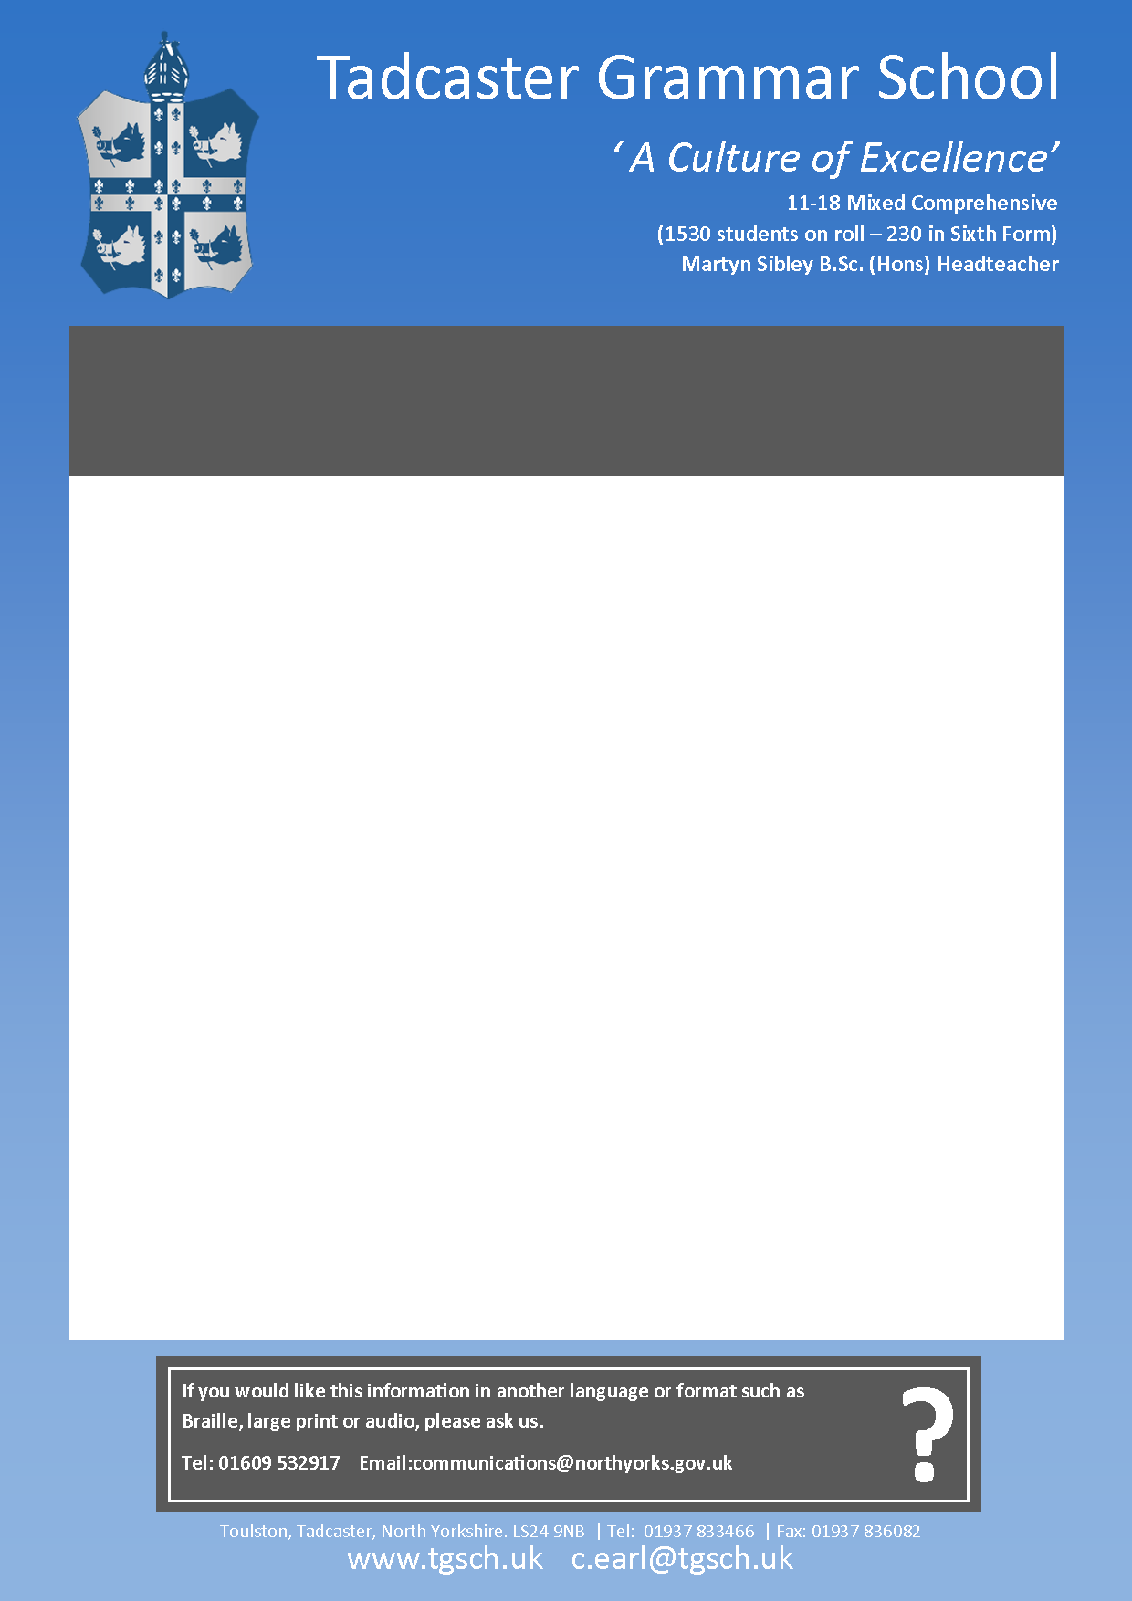

For more information please visit our website: [www.tgs](http://www.tgs)ch.uk

We are seeking to appoint a well-qualified and enthusiastic Teacher of Social Sciences to join a strong Faculty Team in this high achieving and successful school. The Humanities Faculty achieves high academic standards, delivers excellent results, challenges underachievement and is keen to extend the subject beyond the classroom. This is a temporary part-time position required for December 2017 or January 2018.

Candidates for the vacancy should have the ability to teach Psychology to Key Stage 5. The ability to also teach Sociology would be desirable.

Tadcaster Grammar School is a fantastic place to work; we are offering a unique opportunity to be part of an enthusiastic team who are committed to enhancing the teaching and learning experiences for all our students, whatever their role in the organisation. Please access the school’s website which contains full details of the post, together with an application form, which should be returned electronically to [c.earl@tgsch.uk](mailto:c.earl@tadcaster.n-yorks.sch.uk) or by post.

An informal tour of the school prior to application can be arranged through Claire Earl on 01937 833466.

Candidates will be subject to an enhanced DBS check as part of our commitment to safeguarding.

***Applications should be returned by 12 noon on Wednesday 1 November 2017 and interviews***

***will be held w/c 6 November 2017***

**PART TIME TEACHER OF SOCIAL SCIENCES (MATERNITY)**