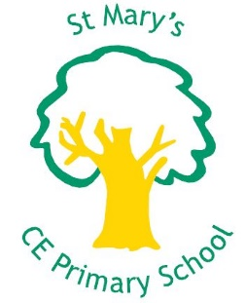
St Mary’s CE Primary School,
Yew Tree Road, Slough, SL1 2AR
‘Building a Bright Future: for myself, my school and my community
Year 4 class teacher for two terms maternity leave
Pay Range: M2 – M6 IN Fringe Area
Following our successful Ofsted report (January 2016), where all aspects of the school were judged to be ‘Good’ and continued improvement has been recognised as a strong feature, we are delighted to welcome applications from teachers who are interested in a maternity leave cover for Year 4 at St Mary’s from January 2018 to the end of summer term 2018.
We are looking for a vibrant teacher who wants to ignite children’s learning and help them become the citizens they aspire to be. We want a teacher who themselves get excited about learning and who are looking to enhance their own knowledge and skills through focused CPD opportunities.
In return we can offer you:
- Brilliant, sparky children who are keen to learn.
- Supportive parents who are keen for their children to succeed.
- A great staff team full of committed team players.
- Fantastic opportunities for professional development.
- Hands-on, supportive, governors.
- A legal and health care support package.
- Well-being days to enjoy a little life-work balance.
- A fabulous new building with relaxing staff space.
- Cuddles with Wilson, our REAL school dog!

Haven’t been to see us yet or want more information? Check out our website at www.st.marys.slough.sch.uk/vacancies and/or please phone 01753 534791 or email recruitment@stmarys.slough.sch.uk for a visit. Ask to speak to Steph, Rachel or Julia.

Applicants will share our commitment to safeguarding, child protection, equal opportunities and health and safety in order to promote the welfare of our children. This position is subject to Enhanced Disclosure from the Disclosure and Barring Service and good references.

Interested? Then please read the Job Description and Person Specification before completing an application form.
Closing date: 27th November 2017 at 12 noon
Interviews will be held on Thursday 30th / Friday 1st December.
We look forward to hearing from you!

