Site Agent
Salary: £16,123 - £17,072 (depending on experience)
Full time, 37 hours per week - Permanent – ASAP start
Are you looking for a new role based in Luton?
Are you self-motivated, hardworking and reliable?
Do you have basic handy-person skills such as simple plumbing/joinery work?
If the answer is yes to these questions, come and join us at The Chalk Hills Academy!

The Chalk Hills Academy are currently recruiting for a Site Agent to join our friendly and good-humored Facilities Department to help keep our Academy safe, clean and in a good state of repair. We are seeking a committed Site Agent who will carry out general repairs and maintenance, liaise with contractors and suppliers and ensure our Academy maintains a high level of health and safety.
The successful candidate will be responsible for:
- The security of the premises
- Heating and lighting
- Maintaining high standards of cleanliness
- Maintaining premises in good state of repair
- Addressing Health and Safety issues

The successful candidate will:
- Have some experience of care-taking duties in a general capacity
- Be able to carry out basic handy-person skills
- Be able to read instructions and maintain work related records
- Be able to contribute positively to the work of the team
- Be able to communicate politely and tactfully with school premise users
- Have some knowledge of Health and Safety, including COSH
Key Requirements:
The job involves a considerable level of physical effort between 10-25% of the total working time. Lifting and carrying is also a feature requiring a high level of effort for 5-10% of working time. In addition, the post holder regularly works outdoors and will sometimes be exposed to the weather in doing so. However, this exposure occurs less than 10% of the working time.

Why work for Chalk Hills Academy?
- £30 million state of the art building
- You’ll be working alongside a collaborative, approachable and supportive team
- Freshly brewed coffee for staff on arrival to the academy every morning
- Employee of the month scheme winning shopping vouchers
- Local subsided gym membership
- Free parcel collection and drop off
- Dry-cleaning collection and drop off
- Free sight test
Here’s what Ofsted have to say: “The purposeful and caring leadership of the Principal and SLT have created a strong academy identity and a positive ethos shared by all members of the community. The strength of leadership is recognised without exception by the academy’s staff. Students’ behaviour is good, the atmosphere in lessons is calm and studious and attitudes to learning are routinely positive as students want to learn. Students are hugely proud of their academy, they wear their blazers and ties smartly, do not drop litter and look after the modern, purpose-built site impeccably. They stand without instruction when any adult enters a classroom.”
If you are interested in this job opportunity, please do apply today – we look forward to hearing from you!
‘We believe in the safeguarding and welfare of children and expect all staff to share this view’.
The Academy is committed to safeguarding and promoting the welfare of children and expects all staff to share this commitment. Applicants must be willing to undergo child protection screening appropriate to the post including checks with past employers and the Disclosure and Barring Service. We are an equal opportunities employer.

HOW TO APPLY

Closing Date: Monday 18th September 2017 Interviews: W/C 18th September 2017

Please read the information in this pack. If you decide to apply please address your application to Hannah Chandler, Recruitment Officer at The Shared Learning Trust and email your application form to academyrecruitment@thesharedlearningtrust.org.uk with the subject line Site Agent.

INFORMATION FOR APPLICANTS:
Site Agent
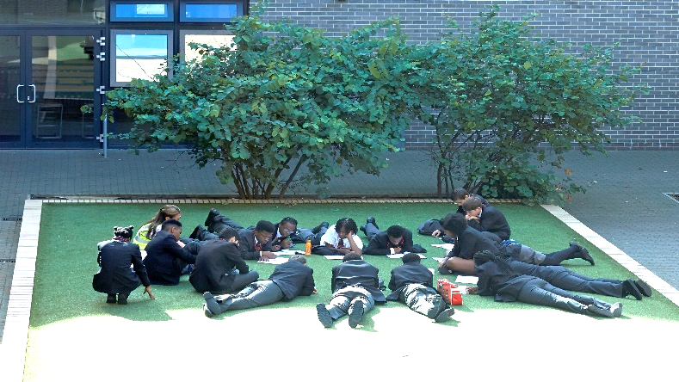
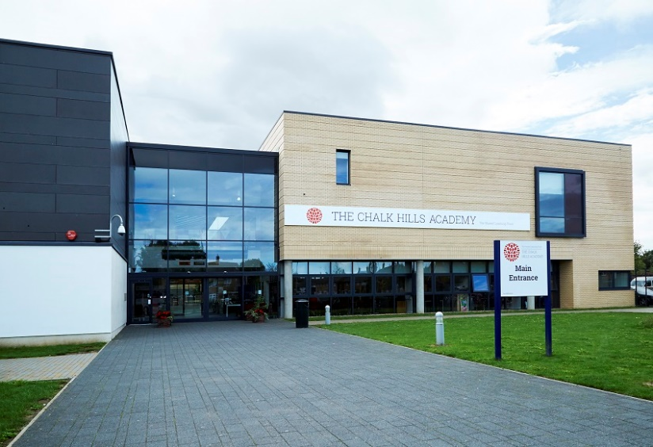

THE TRUST

The Shared Learning Trust is a stand-alone multi academy trust, which runs a family of four schools based in Bedfordshire:

- The Chalk Hills Academy, Luton, age 11-18, judged 'Good' by Ofsted
- The Stockwood Park Academy, Luton, ages 11-18, judged 'Good' by Ofsted
- The Sixth Form, Luton, age 16-19, judged 'Good' by Ofsted (A part of both Chalk Hills and Stockwood)
- The Linden Academy, Luton, age 4-11, judged 'Good' by Ofsted
- The Vale Academy, Dunstable, age 4-13, judged 'Good' by Ofsted

Our Trust is vibrant and friendly, supported by 3 state-of-the-art buildings. It is a learning environment where all students have the opportunity to be high achievers, make good friends, contribute to their community and take part in a wide range of extra-curricular activities.

VISION & VALUES – ‘Strive, Achieve, Believe’

At The Shared Learning Trust, we provide opportunities for all our students and adults to be aspirational and develop a passion and excitement for learning. Working with our communities, we ensure all students are able to achieve beyond their targets to reach the success they deserve. Our students develop a strong self-belief so that they flourish and develop into well-rounded, self-respecting young people.
Our commitment to our vision can be seen through:
- Our academies working together to provide more opportunities for all students and staff
- A focus on the development of our staff with opportunities for clear and dynamic career progression and high quality recruitment and retention.
- Strong Trust approaches to our key issues, for example; teaching, assessment, attendance and curriculum development.
- Partnerships with schools outside of our Trust to maximise opportunities for all.
- Close working and communication with our families and local community.
- Care for our families beyond the school day.
- Excellent lessons and learning incorporating effective use of new technologies.
- An interesting yet challenging curriculum.
- 16-19 provision, which ensures progression, routes for all.
- A Cross-Trust focus on high achievement and high standards.
- Ensuring that every child in our Trust reaches their full potential by providing exciting opportunities both inside and outside of the classroom.
- Exemplary behaviour and conduct at all times.
- A can-do attitude across the Trust that fosters belief and high expectation.
- Ensuring no opportunities are missed.

ABOUT THE CHALK HILLS ACADEMY

Providing the very best education for all our students is the simple goal for The Chalk Hills Academy. Whilst firmly rooted in traditional values, we have made our Academy a vibrant and exciting place with a positive ethos that runs throughout the Academy. We want our children to flourish and develop into decent, disciplined, well-educated and employable adults.

We have an innovative curriculum, which makes the transition from primary to secondary education an enriching and enjoyable experience and enables students to follow a personalised route to success. Our students are achieving the highest standards in the classroom, on the sports field and among the community.

Our state of the art building which we moved into in February 2011 offers cutting edge facilities that are benefiting students even further. Our hardworking and motivated staff are providing outstanding lessons and are given the best possible support. We work closely with parents and carers, encouraging their children to achieve and ensuring that excellent progress is made.

With the rigorous use of data, constant assessment of student progress and quality assurance methods, together, we are achieving more than we ever thought possible. We instantly respond if students experience difficulties. Dialogue with teachers is encouraged as a framework for students to develop ideas, ask questions think about their learning.

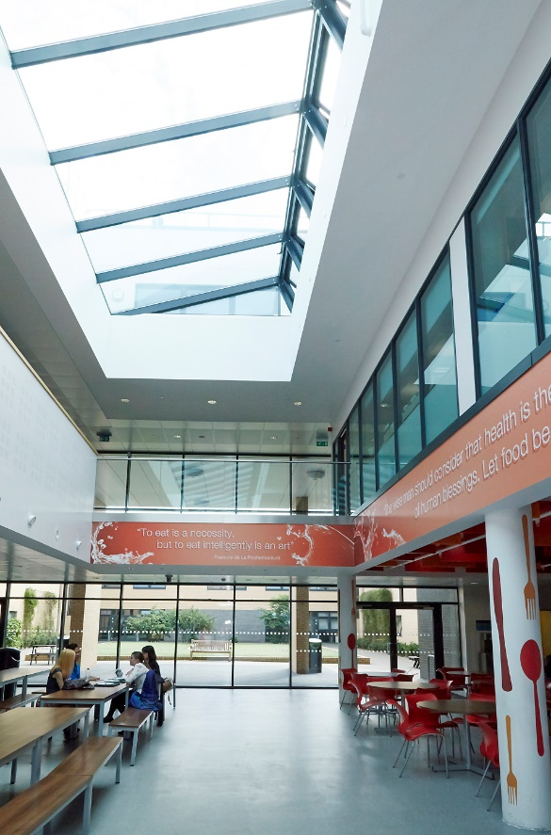
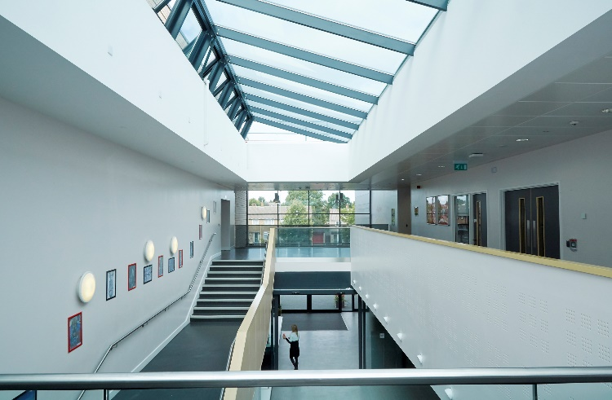

RECRUITMENT TIMETABLE

Thursday 7th September 2017 | Advertisement appears on the Trust Website, Indeed, TES, MyNewTerm and social media sites
Monday 18th September 2017 | Closing date for applications
Week Commencing Monday 18th September 2017 | Interviews commence  *All interviews will be conducted by Friday 22nd September; however, the Trust reserves the right to interview suitable candidates that apply prior to the deadline.

JOB DESCRIPTION

Title: | Site Agent
Salary details: | L2.12 – 15 (£16,123 to £17,072)
Responsible to: | Principal/Facilities Manager/Lead Site Agent

VISION AND PURPOSE
Responsible to the Principal for the attention required to keep the School functioning, particularly in the areas of:
- Security of premises.
- Heating and Lighting.
- Maintaining high standards of cleanliness.
- Maintaining premises in good state of repair.
- Addressing Health and Safety Issues
ORGANISATION CHART:
Principal
|
Facilities Manager
|
Lead Site Agent
|
Site Agent
PRINCIPAL RESPONSIBILITIES:
- Assist in the security of premises:
  - Ensure school is secure out of working hours, following correct procedures for Alarm systems
  - Ensure all doors and windows are secured and all lights and heaters are switched off after use
  - Undertake the responsibility of key holder as required
  - Ensure school is open for pupils each school day and to persons who have hired the premises for public or private use
  - Carry out all necessary checks to ensure fire alarms, extinguishers and related equipment is fully functional at all times.

- Help to ensure that the temperature within the school is maintained at appropriate levels and that all heating and lighting equipment operates efficiently, is regularly maintained with due consideration to energy efficiency. Where appropriate, ensure adequate supplies of fossil fuels are available to enable continuity of heating.

- Assist the Site Agent to Ensure that standards of cleanliness are maintained within the school including monitor work of cleaning employees as required and providing cleaning cover for any accidental spillages, etc. which may constitute a health hazard or as directed by the head teacher. Ensure that cleaning materials are stored and used in accordance with Health and Safety regulations.

- Carry out the prescribed tasks in the letting procedure for the school. This may include maintaining a diary of usage, taking and receipting payment and showing potential users facilities available.

- Undertake other duties as required by the post. This will include; take delivery and store materials, undertake porterage duties, ensure that school site is kept clean and safe, e.g. clearing litter and gritting ice, etc. Ensure all equipment used in cleaning tasks is maintained to required standards. Identify and report to head teacher any repairs and maintenance work required.

- Assist in ensuring all appropriate records and documentation are kept in accordance with regulations and as directed by the principal.

- Building maintenance related duties - carry out handyperson duties in respect of minor temporary repairs (see notes below).

Handyperson Tasks:
- Plumbing:
  - simple tap repairs
  - ball valve replacements
  - clearing blocked sinks, wash basins, baths, urinals, etc.
  - clearing drainage blocks (above ground level) where visible and accessible
  - replacement of toilet seats
  - lavatory (cistern), pull chains and handles, etc.
  - replace plugs on bath, sink, and wash hand basins
  - replace with equal broken pipe brackets, fix or re-fix ditto - toilet roll holders
  - cleaning gutters, rainwater pipes and gullies
  - attention to simple leaks suing compression or plastic fittings as appropriate
  - conduct regular Legionella temperature testing and flushing regime

- Electrical:
  - replacement of all types of tubes and lamps
  - monitoring of Building Management System to include re-booting of the system when required
  - re-fixing of dislodged light fitting diffusers
  - removal of broken light fitting diffusers
  - replacement of missing screws from light switches and socket outlets
  - replacing fuses (on a like-for-like basis)
  - fitting of new and replacement plug tops
  - Regular sound testing of all bell circuits, fire alarms, class change

- Joinery:
  - simple repairs to skirting, door and door frames, windows, furniture and fittings including attention to door handles, catches and locks
  - re-fixing or replacing door stops, restraining catches, hooks, etc
  - easing doors for correct opening and closing, like-for-like hinge replacements
  - fix shelves and pin boarding
  - replace coat hooks, curtain tracks, etc.

- Decoration:
  - simple type redecoration, using proprietary paints and finishes

- Heating:
  - Checking all heating elements, i.e radiators, convectors, fan assisted convectors etc for correct operation and clean annually. Air vent when necessary, re-fix loose and damaged casings.
  - Inspect / replace where necessary filters and belts on Air Handling Units (AHU’s)

- Energy:
  - Regularly, once per month, record gas, electricity and water maters
  - check for correct settings and operations of all thermostats

- Furniture:
  - simple repairs to desks, chairs and other minor repairs to loose equipment

- Emergency Action:
  - Isolate and drain down, where appropriate, water, switch off gas and electrical installations following emergency incidents

- Miscellaneous:
  - simple repair or replacement of window catches, handles, hinges and stops. Easing for easy opening
  - replace isolated damaged wall tiles splash backs with like-for like
  - temporarily block off broken windows
  - repair cleaning equipment for own use (not internal repairs to electrical goods)
  - minor running repairs to fences and gates of all descriptions
  - re-erect dislodged signs and / or fix new ones

- Ventilation:
  - ensure that all rooms are correctly ventilated both in and out of school hours, paying particular attention to toilet areas.
DIMENSIONS:
Financial Resources: Will be responsible for ordering cleaning supplies and fuel (in some locations).
Physical Resources: Responsible for the safety and security of the building, cleaning and handyperson tools and equipment.
Physical Effort: The job involves a considerable level of physical effort for over 10% and up 25% of the total working time. Lifting/carrying is also a feature requiring a high level of effort for over 5% and up to 10% of working time.
Working Environment: The post holder regularly works outdoors and will sometimes be exposed to the weather in doing so. However this exposure occurs for less than 10% of the overall working time, but s/he has regular exposure to very disagreeable, unpleasant or hazardous situations for up to 10% of their working time. Verbal abuse, aggression or other anti-social behavior from members of the public is a feature of this job.

CONTEXT: All support staff are part of a whole school team. They are required to support the values and ethos of the school and school priorities as defined in the School Improvement Plan. This will mean focussing on the needs of colleagues, parents and pupils and being flexible in a busy pressurised environment.

Because of the nature of this job, it will be necessary for the appropriate level of Disclosure and Barring Service to be undertaken. Therefore, it is essential in making your application you disclose whether you have any pending charges, convictions, bind-overs or cautions and, if so, for which offences. This post will be exempt from the provisions of Section 4 (2) of the Rehabilitation of Offenders 1974 (Exemptions) (Amendments) Order 1986. Therefore, applicants are not entitled to withhold information about convictions which for other purposes are ‘spent’ under the provision of the Act, and, in the event of the employment being taken up, any failure to disclose such convictions will result in dismissal or disciplinary action by the Authority. The fact that a pending charge, conviction, bind-over or caution has been recorded against you will not necessarily debar you from consideration for this appointment.

Site Agents will be required to attend the school premises for regular and ad hoc letting, either to attend for the whole period of the booking or at the beginning and completion to ensure the security of the buildings, for which there will be additional payment. In addition some schools will require that weekend boiler and/or security checks are undertaken as part of the normal working week.
The requirement for this role is to work on a late shift.
The working times are:
- Monday to Thursday 11 am – 19:30 (1 hour for Lunch)
- Friday 11am – 19:00 (1 hour for Lunch)
These hours may be subject to variation upon consultation with the post holder.

PERSON SPECIFICATION

This acts as selection criteria and gives an outline of the types of person and the characteristics required to do the job.
Essential | How Measured | Desirable | How Measured
Qualifications and Experience:  - Some experience of care-taking duties in a general capacity | 1,2
Skills / Abilities:  - Basic handy-person skills, able to carry out minor repairs including:  - some simple plumbing and joinery work.  - Literacy skills - able to read instructions, and maintain work related records  - Able to work without supervision  - Contribute positively to the work of the team  - Follow simple instructions and procedures eg security systems and procedures  - Able to communicate politely and tactfully with school premise users | 1,2
Equality Issues:  - Able to identify some types of discrimination that commonly exist. | 2
Specialist Knowledge:  - Some knowledge of Health and Safety, including COSH. | 1,2
Education and Training:  - Willingness to undertake relevant training. | 1,2
Other Requirements:  - Able to adapt to changing operational demands in terms of tasks undertaken | 1,2
1= Application Form 2 = Interview 3 = Reference 4 = Presentation and/or test

We will consider any reasonable adjustments under the terms of the Disability Discrimination Act (1995), to enable an applicant with a disability (as defined under the Act) to meet the requirements of the post.
Vacancy title: |  | Application Form  The Shared Learning Trust is committed to protecting and safeguarding children.  We apply stringent safer recruitment practices.
Closing date:

Academy/
Establishment:

Please ensure that all sections are completed (using black ink or type), otherwise your application will not be considered. All information that you provide will be treated as confidential. The Declaration of Criminal Offences form must be completed. If you require any reasonable adjustments as part of the application or selection process please contact us.

1. About you
Title:
First names:
Previous names:
Surname:
Previous surnames:
National Insurance No.
DFE Number (if applicable)
Address Details
Address:
Town:
Postcode:
Email: |  |  | Daytime telephone number
Mobile: |  |  | Evening telephone number
Do you currently work for the Trust? |  |  | Yes No
Where did you see this vacancy advertised? (publication/website)

Are you applying with a job share partner? | Yes No
If yes, Please specify hour/day arrangement
Do you have a full current driving licence valid in the UK? |  | Yes No

2. Employment history
Please list your current and all previous employers. Any gaps in employment must be explained and a continuation sheet used, if required. If you have been dismissed from any previous employment, please specify below.

Employers’ names, addresses and type of business | Job title, Key responsibilities | Dates of employment |  | Salary/  Grade | Reason for leaving
 |  | From | To

3. Education, qualifications and training – any gaps must be explained and a continuation sheet used if required.

Name of school, college, university etc. | Name of course | Dates |  | Qualification/grade achieved
 |  | From | To

4. Professional association membership

Name of professional association | Year of membership | Grade/level

5. Personal statement

Relevant abilities, skills, knowledge and experience

Tell us how your abilities, skills, knowledge and experience meet the Person Specification, drawing on all aspects of your education and experience, including paid employment and unpaid work.

6. Right to work in the UK
Are you required to have a UK work visa/permit? | Yes No
If yes, do you have a valid visa/permit? |  | Yes No
If yes, when does it expire? |  | dd/mm/yyyy
If yes, Please specify the type of Visa (Example: Tier 2)
7. References
Please give details of two referees from whom confidential enquiries may be made. Your referees should be from your current or most recent employer or your current educational establishment. Please note references will be taken up prior to interview for all shortlisted candidates. Educational referees should only be given where this will be your first employment following qualification. If you are applying for a post which involves working with children or vulnerable adults, you will be required to supply references which go back 5 years. Please attach these on a separate sheet.

Name of referee: |  |  | Name of referee:
Job title: |  |  | Job title:
Organisation: |  |  | Organisation:
Address: |  |  | Address:
Telephone: |  |  | Telephone:
Email: |  |  | Email:
Capacity in which known to you: |  |  | Capacity in which known to you:

8. Declaration
All applicants are required to declare personal relationships with existing employees/ those affiliated with The Shared Learning Trust.

Are you related to, or a close friend of, any member affiliated with The Share Learning Trust?
Yes No

If yes, please provide the following details:

Name:

Relationship:

Address:

Any financial interests that applicants may have in contracts with the Trust or pending tenders must be declared.

Are you or any of your relative’s party to an existing contract or involved in any competitive tendering process?
Yes No

If yes, specify the contract details:

Teaching Disqualifications

Have you ever been disqualified from Teaching? Yes No

If yes, please specify and confirm if the sanction is spent:

9. Declaration of Criminal Offences

The job for which you are applying involves substantial opportunity for access to children. It is therefore exempt from the Rehabilitation of Offenders Act 1974. You are required to declare any convictions or cautions you may have, even if they would otherwise be regarded as "spent" under this Act. The information you give will be treated in confidence and will only be taken into account in relation to an application where the exemption applies. As the occupant of the post will have substantial access to children, a disclosure request will be made to the Disclosure and Barring Service (DBS) to ascertain whether their records reveal any criminal convictions (including spent ones) relating to the successful applicant. All information given will be treated in the strictest confidence and will be used for this job application only. The disclosure of a criminal record will not debar you from appointment unless the selection panel considers that the conviction renders you unsuitable for appointment. In making this decision the panel will consider the nature of the offence, how long ago and what age you were when it was committed and any other factors which may be relevant.

Your application will not be considered without completion of this section.
Nature of offence(s) | Details of offence(s) | Place and date of judgement(s) |  | Sentence(s)
All information given will be treated in the strictest confidence and will be used for this job application only.

I certify that, to the best of my knowledge, the information on this form is true and accurate. I understand that if the information I have supplied is false or misleading in any way, it will automatically disqualify me from appointment or may render me liable to instant dismissal without notice.

Signed - Applicant: |  |  | Date (dd/mm/yyyy):
Name (please print)

Diversity Monitoring Form

The Shared Learning Trust aims to have a workforce that reflects the diversity of talent, experiences and skills of our learners.

We monitor the composition of our workforce to ensure that is representative and that all staff are treated fairly. In addition, we are committed to promoting race equality, under the Race Relations (Amendment) Act 2000, which applies to everything the trust does. The information you give on this form will remain strictly confidential, in accordance with the Data Protection Act 1998, and will not affect any decision to employ you.

Date of Birth:

Age: Under 20 20-29 30-39 40-49 50-59 60 and over

Disability

The Disability Discrimination Act 1995 defines a disability as ‘A physical or mental impairment that has a substantial and long-term adverse effect on his or her ability to carry out normal day-to-day activities’. In this definition, long term is taken to mean more than 12 months.

Do you consider that you have a disability under the Disability Discrimination Act definition?

Yes No

If you have answered ‘Yes’, please select the definition/s from the list below that best describes your disability/disabilities:

Hearing (such as deaf, partially deaf or hard of hearing) | Reduced physical capacity (such as inability to lift, carry or otherwise move everyday objects, debilitating pain and lack of strength, breath, energy or stamina, asthma, angina or diabetes)
Vision (such as blind or fractional/partial sight. Does not include people whose visual problems can be corrected by glasses/contact lenses) | Severe disfigurement
Speech (such as impairments that can cause communication problems) | Learning difficulties (such as dyslexia)
Mobility (such as wheelchair user, artificial lower limb(s), walking aids, rheumatism or arthritis) | Mental illness (substantial and lasting more than a year, such as severe depression or psychoses)
Physical co-ordination (such as manual dexterity, muscular control, cerebral palsy) | Other disability (please specify)

Ethnicity

Asian or Asian British | Black or Black British | Mixed | Other | White
Bangladeshi | African | White and Asian | Chinese | British
Indian | Caribbean | White and Black African | Other | Irish
Pakistani | Black British | White and Black Caribbean |  | Other
Other | Other | Other

If you selected any of the ‘other’ categories, please tell us how you would further describe yourself:

Faith

Agnostic | Atheist | Buddhist | Christian | Muslim
Hindu | Humanist | Jain | Jewish | Sikh
No religion | Prefer not to say | Other faith (please specify)

Gender

Female | Male

Sexuality (Optional information)

Bisexual | Gay | Heterosexual | Lesbian

In addition, if you prefer to define your sexuality in terms other than those used above, please let us know.

I certify that, to the best of my knowledge, the information I have provided on this application form, and on my completed declaration of criminal offences form, is true and accurate. I understand that if the information I have supplied is false or misleading in any way, it will automatically disqualify me from appointment or may render me liable to dismissal without notice. I give explicit consent that the information provided by me on this form may be processed in accordance with the Trusts registration under the 1998 Data Protection Act and authorise the disclosure of personal data when references are taken up.

Signed – Applicant: | Date: dd/mm/yyyy
Please return your completed application form to: The Human Resources Team, The Shared Learning Trust, Dunstable, Bedfordshire LU5 4QP or by email to: academyrecruitment@thesharedlearningtrust.org.uk. If you have not heard from us within four weeks of the closing date you may conclude that you have not been shortlisted.

For office use only
Application withdrawn | Post withdrawn | Shortlisted Yes No
 |  | Appointed Yes No

