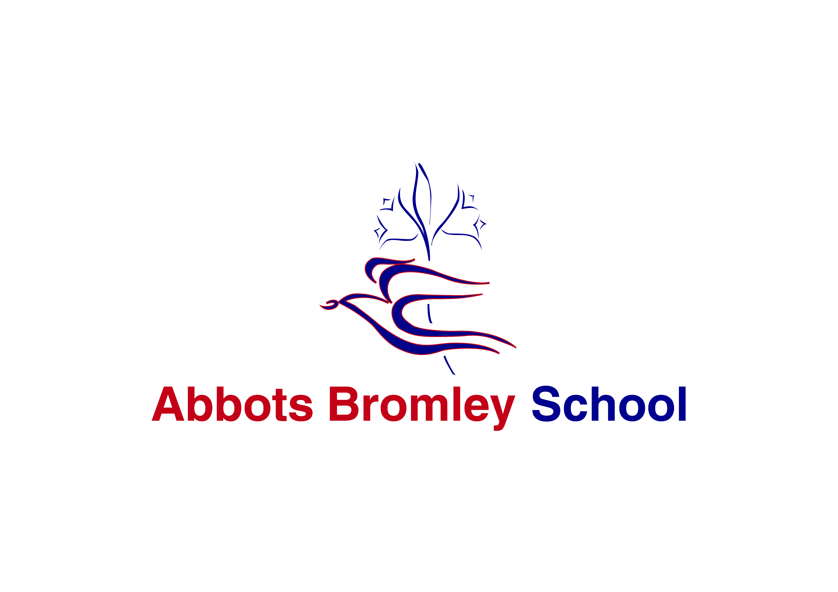
Abbots Bromley School
‘The Creative School in the Creative County’

Application Pack for Graduate in Residence
(one year fixed term contract).

Salary: £10,000 with free accommodation and meals

Start date: 1st September 2018

Abbots Bromley School
High Street
Abbots Bromley
Staffordshire
WS15 3BW

Tel: 01283 840232
e-mail: recruitment@abbotsbromleyschool.com
Website: www.abbotsbromleyschool.com

May 2018

Dear Colleague,

Thank you for your interest in this post. We have three vacancies for Graduates in Residence to work in our boarding houses; two to work in the Girls’ Boarding House and one to work in the Boys’ Boarding House. The role will also involve working with students on each graduate’s specialist subject and would be excellent experience for graduates considering a career in education.

Abbots Bromley School currently has 250 students aged 3-18 on roll, with a community of over 100 boarders from a wide range of nationalities. The School opened for girls only in 1874. In recent years, the school has become co-educational in the Prep School and Sixth Form. As of September 2017, boys joined the Senior School in Year 7 for the first time and this will roll though year on year until the school is fully-co-educational in September 2021.

It is therefore an exceptionally exciting time for the school. In addition, we have received national recognition as one of the best schools in the country for the creative arts. The school is thriving in terms of examination results, enrichment, musical and sporting achievements, fund-raising and community involvement.

The role of a Graduate in Residence is a highly fulfilling one. First and foremost, the successful applicants will have enthusiasm for working with young people, and for nurturing them to live happy and purposeful lives. The strengths of boarding at Abbots Bromley School include the friendly family atmosphere and the extensive programme of activities, trips and social events. Every boarder is encouraged to develop their full potential in all areas of life.

Abbots Bromley School is an extremely rewarding environment in which to work. Our aim is that the students and staff achieve the highest standards of which they are capable. I hope you read the accompanying details and feel that you would like to join us.

Yours sincerely,

Mrs Maggie Shackleton
Principal

.

Abbots Bromley School

Abbots Bromley School is quite remarkable. Set in the beautiful Staffordshire countryside, we offer an extremely high standard of education in an engaging, creative and friendly environment. Our vision for the education of our students is holistic; that by nurturing students inside and outside the classroom, they develop as rounded and grounded individuals.

Students develop their strengths and rise to personal challenges within safe and spacious surroundings. They benefit from outstanding facilities; including our dance studios, equestrian centre, heated indoor swimming pool, all-weather sports pitches, tennis and netball courts, an athletics track and a full sized sports hall, with dedicated areas for trampolining and fitness. Our inspiring chapel is at the heart of our community and our supportive Christian environment enables students to flourish as thoughtful, caring and assured young adults.

Our offer to both day and boarding students is all embracing. Dedicated, dynamic and specialist members of staff ensure academic rigour and a love of learning. As well as offering traditional academic subjects at A-level, we also cater for students who wish to take alternative career routes. They may take a variety of qualifications to a high level in riding, dance and musical theatre alongside their core academic subjects. Indeed, ‘The Alkins School of Dance’ in partnership with the School, has an international reputation for excellence.

Music is an integral part of life at Abbots Bromley School. It is both part of the daily rhythm of the school and the punctuation throughout the academic year, which marks and enhances important events and celebrations. It is the overriding aim of the music department that all students develop a lifelong love of music, and in particular practical music-making. This is achieved in a variety of ways: exceptional curriculum and peripatetic teaching; access to extra-curricular activities of the highest standard; a strong partnership between the liturgical and musical life of the school and a packed calendar of concerts, recitals and trips.

We encourage further personal growth by offering field trips, international exchanges, charitable overseas programmes, clubs, activities and competitions. Such opportunities promote self-confidence and encourage enterprise. The Duke of Edinburgh’s Award is extremely successful, with participants at bronze, silver and gold levels. We are also a ‘Champion School’ for the National Citizen Service. Such leadership opportunities often result in students themselves initiating new ideas for whole school activities and taking on greater positions of responsibility.

Students achieve very highly in examinations. In the 2017 GCSE examinations, 100% of students gained the equivalent of at least 5 A*- C grades, 81% of all examination entries were the equivalent of A*- B grades and 49% of all papers achieved the equivalent of A*- A grades. In addition, over three times the number of the new top grade 9 was achieved, compared with the national average.

At A level there was a pass rate of 100%. 78% of all exam entries were rewarded with A*-C grades and 32% of all grades were A*-A grades. These results enabled students to embark on the next stage of their education following a range of courses including Business Management, Social Work, Dance and Performing Arts, Chemistry, Biomedical Sciences, Physiotherapy, Economics, Music, Sports Science and Pharmacy.

GRADUATE IN RESIDENCE JOB DESCRIPTION

Line Manager: Head of Boarding
Salary: £10,000 with single private accommodation and all meals provided during term time
Post: This is a fixed term post for one year and includes school accommodation and meals. The Graduate in Residence will be on duty five nights each week with either Friday / Saturday or Sunday / Monday off

Boarding is key to Abbots Bromley School and as such this post is fundamental to the success of the School.

The Graduate in Residence works with the House Master / House Mistress and Head of Boarding at all times by:
- ensuring the well-being, safety, discipline and pastoral care of all boarders;
- being fully versed in, and compliant with, all the School’s Child Protection procedures;
- knowing and treating each child in their care as an individual and encouraging self-discipline and a sense of responsibility;
- helping to create a calm, quiet and tidy living and working environment;
- supervising efficiently the day-to-day routines of normal boarding school life, including registration, Sunday chapel, meals, preps. and bedtimes;
- working with students on chosen subject specialism as agreed with the Head of Subject;
- being able in case of emergency and to remain ‘on call’ when not on active boarding duty during the day;
- ensuring that bedrooms and common rooms are kept clean and tidy and liaising with the Head of Boarding, House Master / Mistress and Day Matron over maintenance, laundry, cleaning, furniture and furnishings;
- helping to organise and supervise the extra-curricular life of the students to ensure that they are able to discharge their academic and other obligations efficiently, and find interest and stimulus appropriate to their age and development;
- liaising with the House Master / Mistress and medical staff over general concerns and in emergencies;
- being available at certain times to accompany students on hospital appointments during the day;
- helping to ensure the smooth running of the house;
- attending weekly team meetings as required;
- helping the Head of Boarding, House Master / Mistress to maintain good relations and communications with all parents;
- being in residence two days before the beginning and after the end of terms as required;
- maintaining good communication with the Head of Boarding and House Master / Mistress at all levels. This includes maintaining detailed and confidential written logs;
- implementing the Health and Safety Policy of the School;
- participating in the Staff Performance Management process;
- Promoting the general progress and well-being of all students;
- Assist in the running of the enrichment programme offered to the students.

Duties may be developed through time, as required, for the welfare and happiness of the House.

This is a description of the job as it is constituted at the date shown. It is the practice of the School to regularly examine job descriptions, to periodically update them to ensure that they relate to the job being performed, or to incorporate any proposed changes. In these circumstances, it will be the aim to reach agreement on reasonable changes, but if agreement is not possible, the School reserves the right to make changes to this job description following consultation.

Person Specification for Graduate in Residence
Abbots Bromley School is committed to safeguarding and promoting the welfare of children and young people and expects all staff and volunteers to share this commitment.

 | Essential | Desirable | Method of  assessment
Qualifications | Degree or relevant work experience in a curriculum area taught in the school. | Additional interests which can be shared with students. | Applicant’s certificates
Experience: | Working as part of a team. | Working with children in a school environment;  Working with  international students. | Application form;  Interview;  Professional references.
Skills | Excellent interpersonal skills;  Effective communication skills;  Effective time management and organisational skills;  Ability to use initiative and be proactive to problems as they arise;  Ability to play an active role as part of a team. | Has a high level of skills relevant to their subject. | Application form;  Interview;  Professional references.
Knowledge | Some knowledge and understanding of safeguarding and health and safety issues (to be supplemented by induction training). |  | Application form;  Interview;  Professional references.
Personal competencies and qualities | Demonstrates integrity;  Good sense of humour; Adaptability and sense of perspective;  Approachable and natural authority;  Committed to the ethos of an  independent boarding school (but does not need to have been educated in such a school);  Commitment to the safety, health and well-being of children and young people. |  | Application form;  Interview;  Professional references.

How to apply

In order to apply for this post, please complete the Application Form, Equal Opportunities Monitoring form and a letter supporting your application. In your letter you should:

- State your reasons for applying for this post;
- Outline the experiences that you believe have prepared you for this post;
- Describe the skills and strengths that you will bring to Abbots Bromley School.

Please note that the application form must be completed in full. It is not sufficient to substitute a C.V. for all or any part of the form.

You are welcome to telephone or e-mail the school to ask for clarification on any matters regarding this vacancy. Informal visits to the school can be arranged before the deadline for applications, though applicants will have a tour of the school on the day of interview.

Completed applications should be emailed to recruitment@abbotsbromleyschool.com or posted to:

Mrs Heather Meadows, Personnel Secretary, Abbots Bromley School, High Street, Abbots Bromley, Staffordshire, WS15 3BW

Deadline for Applications: midday on Thursday 7th June 2018

Interviews will be held on Wednesday 13th June 2018. Candidates who have not heard from us by then should assume their application has been unsuccessful on this occasion.

References
Please note that it is our practice to take up references before shortlisting for interview. If you would prefer us not to do so unless you are shortlisted, please indicate this clearly in your application. When an applicant is short-listed, any discrepancies or anomalies in the information provided or issues arising from references will be taken up at interview. Your referees should include your most recent employer and if working in a school, this must include a reference from the current Headteacher. References from relatives or friends are not acceptable.

Safeguarding
Abbots Bromley School is committed to safeguarding and promoting the welfare of children and young people. The successful applicant will be required to undergo Enhanced Disclosure clearance from the Disclosure Barring Service.

Candidates for teaching and support staff posts will be assessed at interview for their suitability to
work with children. Appointment is conditional upon at least two satisfactory references which
include specific comments on working with children and young people. All staff at the school have
a responsibility to promote and safeguard the welfare of students at the school. In addition to the
ability to perform the duties of the post the interview will also explore issues relating to
safeguarding and promoting the welfare of children including:
- motivation to work with children and young people;
- ability to form and maintain appropriate relationships and personal boundaries with children and young people;
- emotional resilience in working with challenging behaviours;
- attitudes to the use of authority and maintaining discipline;
- any relevant issues arising from references;
- any gaps in time not covered by details in the application form.

This school is committed to safeguarding and promoting the welfare of children and young people and expects all staff and volunteers to share this commitment.

