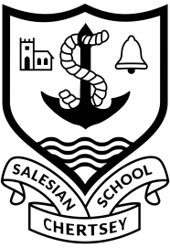

The History Department at Salesian
We are a strong team who pride ourselves on working hard to ensure that every student reaches their full potential and enjoys History. Last year our students achieved 91% A*-C at GCSE and 69% A*-B at A-Level and several went on to study History at university.
The History Department at Salesian is an exciting place to be. Our team is made up of colleagues with a broad range of experience and specialist expertise. We have a great team ethos and our positive energy and enthusiastic approach makes it a great department to work in.
We have a large uptake at GCSE, teaching the following Edexcel syllabus, Weimar and Nazi Germany 1918-39, The American West c.1835-1895, Henry VIII and his ministers 1509-40 and Medicine in Britain c.1250-present.
With the Sixth Form constantly growing at Salesian, there are plenty of opportunities for those who are interested in teaching at Key Stage 5. We have a strong cohort of A-Level Historians and offer the following Edexcel specification, The Rise and Fall of Fascism in Italy 1911-46, Germany and West Germany 1918-89 and Rebellion and Disorder under the Tudors 1485-1603.
The school plays a lead role in the Teach South East SCITT and we therefore have opportunities for colleagues at all stages of their career development from NQTs to those seeking positions of responsibility such as; mentoring, training and developing others.
Would you like to develop your skills further and be part of a forward-thinking department? Please feel free to me for further details. I look forward to meeting you.
Sophie Rider
Head of Department
01932 582549
srider@salesian.surrey.sch.uk

Salesian School is committed to safeguarding and promoting the welfare of children. Enhanced CRB checks will be sought prior to appointment

