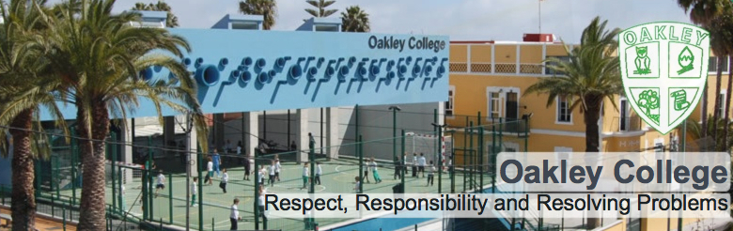

PRIMARY TEACHER
(ICT or PE coordination an advantage)

INFORMATION FOR CANDIDATES

Oakley College is situated on the outskirts of Las Palmas, capital of the beautiful island of Gran Canaria and of the wider Canary Islands. Since its foundation in September 1989, Oakley has grown to a co-educational British International School of 600 students, from 2-18 years of age (Pre-Nursery-Sixth Form). Our Early Years and Primary school (ages 2-11) deliver an adapted Early Years Foundation Stage and English National Curriculum, incorporating strong elements of thematic and enquiry-based learning. Our Secondary students (aged 12-18) study 10 subjects in preparation for IGCSE and A-Level examinations, their learning journeys adapted according to their individual needs. Primary and Secondary pupils study Spanish language and the history and geography of Spain, throughout the duration of their studies at the school. The Oakley College family includes children, parents and staff from more than fifteen countries; therefore while levels of English proficiency are generally high, an awareness of how to adapt lessons for EAL learners, as well as a range of learning styles, is essential.

We pride ourselves on our strong academic programme, our family atmosphere and positive links with the local community and, above all, the committed team of staff who care for and educate our students. The school seeks self-motivated professionals who can achieve excellence by positively adapting to an international setting, whilst maintaining the very highest expectations of their students and themselves. The ideal candidate would be fully qualified (with QTS) and have a minimum of two years’ experience of teaching the National Curriculum.
Oakley provides its teachers with permanent employment contracts after 2 years. Successful applicants will be expected to participate fully in the development of a vibrant, expanding learning community and, through our staff development programme, to further their own skills whilst contributing to our evolving vision for the school’s future success.

OUR LOCATION

The school is on the outskirts of Las Palmas in the residential area of Tafira. It is easily accessible by public transport and staff often live in Las Palmas by the beach district of Las Canteras or nearer the school in the residential area of Tafira Alta, close to the university, national park and gateway to the mountains.

OUR PHILOSOPHY

We believe that a caring and stimulating environment is essential to the development of children. We aim to provide a high quality educational experience to our students, ensuring a passion for learning and life.
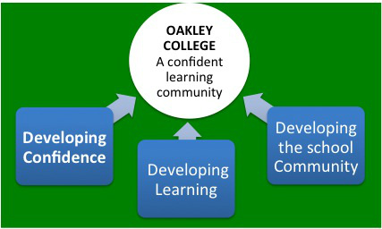

OUR VISION

A confident learning community

OUR MISSION

To provide a high quality British education in a caring family environment

OUR CORE VALUES

Respect, Responsibility and Resolving Problems
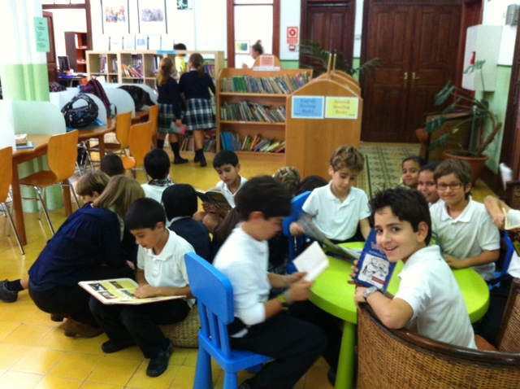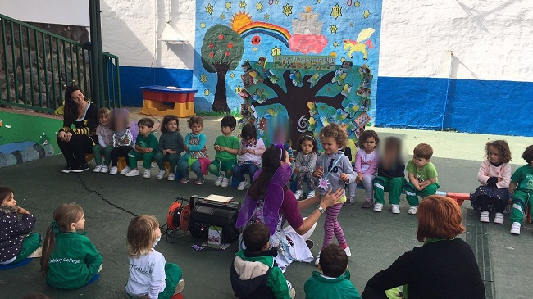

CAMPUS & FACILITIES

The school combines traditional Canarian buildings with 21st century architecture, on two sites a few minutes apart.

The Early Years site is housed in a spacious villa in Tafira Alta, near to the main school building. This accommodates children from 2 to 4 years of age and is equipped with age-appropriate outdoor play areas as well as a kitchen and dining facilities.

The main school building at Zuloaga combines a classical Canarian building, housing the Primary classes with the 21st Century architecture of the Secondary block. Visitors enter a main atrium that houses the school library and independent study areas for Secondary children; this site is equipped with science labs, an ICT suit and is the location for the main administrative offices. All classrooms and offices are linked by an ICT infrastructure including IWB projectors, Internet in every classroom and a file server.

The recently completed modern building extension accommodates the sixth form classes and the new gymnasium. The school is equipped with a number of outdoor play spaces and a neighbouring sports ground.

The Teaching Day
The teaching day starts at 08.35 in secondary and 08.45 for the rest of the school.
EY and KS1 students finish at 15.30 and KS2 and Secondary students finish at 15.45.

Holidays
The school operates 180 teaching days each year, plus 5 in-service days. There are two months holiday in summer (July & most of August), 2/3 weeks at Christmas, 2 weeks at Easter and 2/3 days mid-term break each term plus several Spanish bank holidays.

MEDICAL CARE
Medical care is provided under the Spanish medical system from the start of your contract. Full information in English can be obtained from the Spanish Health Service at http://www.msc.es/en/home.htm
MOVING ABROAD
When moving abroad it is important to be fully informed about all aspects relating to tax, pensions, etc. within the UK. For a detailed reference visit the UK website www.direct.gov.uk/en/index.htm

THE PACKAGE INCLUDES:

- A gross salary paid in Euros, 12 months of the year
- A three course school meal every day, including a vegetarian option
- A CPD annual allowance of 200€
- Free Spanish classes for beginners
- The school does not charge for the education of teacher’s children, over the age of 3 (Nursery).
- Free private medical care in the case of work-related injury or illness

The school also provides administrative support in meeting the legal requirements for foreigners wishing to live and work in Spain, including:

- support in obtaining the legal documentation necessary to work as a foreigner living in Spain
- support in registering with your local doctor
- assistance in opening a bank account and organising Internet and mobile phones.

If you arrive during the summer prior to starting work it is a good idea to bring an EHIC medical cover form with you. You can get this from any post office in the UK.

SALARY

Salary for the post is in line with the teachers in Spain, terms and conditions document (national guidelines). Teaching salaries range between 22.436€ and 26.436€ gross per year depending on experience. Estimated Tax (IRPF): 16% plus Social Security tax: 6.35%
Coordination responsibility plus 1000€ gross.

INTERVIEW PROCEDURES
Short listed candidates will have an interview by skype.

See the following link for cost of living information in Las Palmas:
The Cost of living index for Spain is on average 25% below UK.

Las Palmas - cost of living information
http://www.numbeo.com/cost-of-living/city_result.jsp?country=Spain&city=Las+Palmas

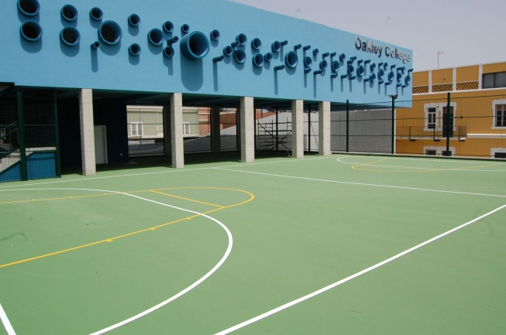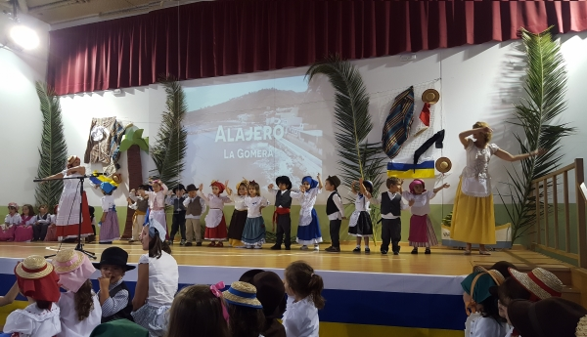

JOB DESCRIPTION FOR TEACHERS
Job Purpose | To teach students, creating an environment where they want to learn and where they can naturally discover their true passions, taking responsibility for their academic progress and pastoral care.
Line Manager | - Head of Primary/Secondary
Learning and teaching | - To plan, prepare and deliver schemes of work in accordance with school policies.  - To maintain a working knowledge of National Curriculum & other DFE documents.  - To maintain records of pupils’ progress including all statutory documents required by the UK DFE or the Spanish Ministry of Education.  - To produce reports and grades for pupils as per the school calendar.  - To conduct termly meetings with parents to discuss and explain their child’s  performance and progress in school.  - To provide and maintain an attractive and stimulating environment in which to foster effective teaching and learning.  - To monitor progress and the effectiveness of class work and to evaluate and modify planning and teaching as necessary
Managing | - To understand and implement:  - Regulations and correct procedures relating to attendance registers  - Emergency and evacuation procedures  - Health and safety policies  - All curriculum polices  - Any other organisational policies or agreed procedures  - To conduct standardised or other tests when required and document pupils’ performance  - To attend and participate in weekly staff meetings and also on other occasions as required  - To attend and participate in all training sessions  - To supervise playtimes and lunchtimes when required  - To supervise pupils in assemblies when required  - To liaise with colleagues enabling satisfactory transfers of children within school between schools and hand over to new staff  - To promote the subject(s) within the school and provide enrichment opportunities  - To provide additional activities and opportunities for pupils outside the classroom
Pastoral | - To be aware of the physical and emotional well-being of pupils and the need to respond to particular situations.  - To carry out duties of care as a form tutor and also during non-class times.  - To understand and implement all welfare and safeguarding policies.  - To liaise with other staff as required e.g. educational psychologist.  - To promote and safeguard the welfare of all pupils at school.
Other information | - Teachers at Oakley College are required to adhere to DFE Teachers’ Standards (published September 21012)

Person Specification

Qualifications

Essential
Degree or equivalent in relevant subject
QTS with at least two years’ teaching experience
Fluent English speaker
Eligible to work in the EU
Desirable
British educational background
International experience

Knowledge and Experience

Essential
A clear philosophy on how and why the
subject should be taught
Sufficient knowledge to challenge more able
pupils
Strategies to deliver differentiated lessons
Up to date knowledge of current educational
developments.
Desirable
Experience or awareness of pastoral and
academic roles and responsibilities as a tutor
EAL experience

Skills and Abilities

Essential
An understanding of how to use assessment for learning strategies to improve learning. Ability to motivate pupils and instil a love of
learning
Good communication skills.
Desirable
Ability to adapt and react positively in any given situation
Willing and able to offer enrichment and/or
extra-curricular activities

Personal Qualities

Essential
Flexible, positive approach when dealing with students
High moral and ethical values
Good interpersonal skills
Ability to work independently and collaboratively
Passion for teaching
Desirable
Willingness to engage in local culture and
learn basic Spanish
Creative when approaching challenges,
offering solutions rather than obstacles.

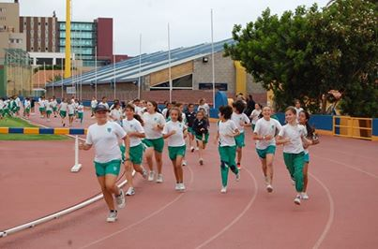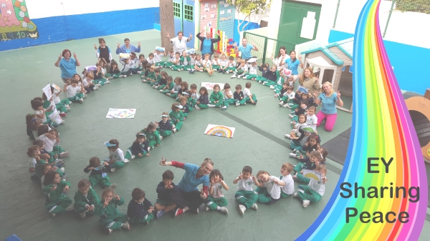

Successful applicants will be required to provide a valid DBS certificate

Top 100 schools in Spain link http://www.elmundo.es/mejores-colegios.html

Oakley College Lipdub www.youtube.com/watch?v=IH-TcrFY1G0

HOW DO I APPLY?

Please send your CV (with two professional referees) and letter of application, along with a recent photograph, to the school Principal, Donat Morgan at jobs@oakleycollege.com
Successful applicants will be required to obtain a DBS check and complete a medical questionnaire to confirm they are medically fit to teach.

Oakley College
Calle Zuloaga 17,
Tafira Alta,
35017
Las Palmas de Gran Canaria
0034928354247
www.oakleycollege.com

FREQUENTLY ASKED QUESTIONS

I don’t speak any Spanish. How easy will it be for me to settle in Gran Canaria and what support does the school provide?

The school provides employees with substantial support in establishing themselves as working residents of Gran Canaria. Dealing with Spanish bureaucracy can be unpredictable and time consuming but is far from insurmountable; moreover, you will be accompanied at each stage of the process by experienced staff whose role is to help navigate these issues.

Basically, the above shouldn’t overly concern new arrivals and it’s important to be aware that the majority of our expatriate staff arrive speaking little or no Spanish; however, following each new staff member’s ‘settling period’ teachers are expected to become increasingly independent in terms of their day-to-day living.

What accommodation help will I receive?

When your employment situation is confirmed we begin a fluid process of communication aimed at speeding up some of the processes. One such process is establishing your preference of accommodation to either a city dwelling near the beach or an out of town country one. The school will have a few places for you to look at based on your preference of area and you are also encouraged to do Internet searches for accommodation.
When you arrive, two weeks prior to the start of work, an administration member will assist you with accommodation. (If you arrive earlier than this school staff are on holiday although we will try and assist where we can).

What is the structure of the working day? How much PPA time does a typical teacher at Oakley have?

Teachers are required to be in school at 08.30. In terms of the overall length of your working day, we rely on professionals’ own ability to assess whether their work has been completed to a sufficiently high standard.

Teachers typically receive four periods of PPA time during the teaching week; one period is fifty minutes in length. PPA time entitlement typically increases with management responsibility.

All departments have a morning, lunch and afternoon break daily. Teachers usually have two duties weekly (in the morning, afternoon or for part of the lunch hour); these will, in so far as is possible, be harmonised with your teaching timetable.

How will my performance be appraised?

New teachers will have professional development targets set for the year during the first half of the autumn term. An appraisal of your performance and progress towards these takes place at least once per term, typically in December, April and June. Analysis of pupil progress and attainment results will form a part of your appraisal criteria, agreed at the beginning of the cycle.

What contribution can I make to the extra-curricular programme and life of the school?

Many of our students travel on school bus routes, and many of them often find it difficult to stay after school. However, we do offer a range of activities, clubs and subject clinics during the school day and after school.
Staff offer a range of clubs which provide enrichment activities at lunchtime, including sign-language, drama and journalism, among many others. Teachers also give generously of their time to provide drop-in clinics during lunch times, to support their subject.
The school offers an extensive range of after-school activities, staffed by external coaches as well as by teachers in the school. Staff are remunerated for offering these activities, which include football, cricket, guitar clubs, choir as well as private subject tutoring.

What professional development and career development opportunities are available to teachers at Oakley College?

At Oakley College we are continuously seeking improvement and development in the education we offer and the systems we have to support this. We have a strong middle-management structure, in addition to a number of positions of responsibility in which staff are given responsibility to support developments or initiatives.
Oakley College is still a relatively young school, and remains an excellent context in which teachers con make a significant contribution in moving the school forwards. We continuously look to reward commitment, interests and skills in our staff by providing opportunities for greater responsibility and professional development whenever it is appropriate.
Oakley College is a member of the National Association of British Schools in Spain, through which access their continuous programme of Professional Development courses. Also, there is considerable internal expertise, which is utilised in supporting professional development through the INSET programme and through Staff Meetings. Staff also access on-line courses provided by both Cambridge and Edexcel.

Teacher Profile

Oakley College is situated in the beautiful Canary islands, with very pleasant weather and a wealth of social opportunities, clubs, activities and sites of cultural interest. Our staff have busy and rich personal lives. At the same time our staff are committed and hard working, in supporting the school, its students and its programme of events and activities. Oakley College is founded on providing a family environment of strong, personal support of students in a private school context. Additionally, the school is relatively young and is full of challenging and exciting opportunities for development. We are looking for staff who who are committed professionally to embracing these development opportunities and to supporting one another as the school continues to grow and develop as the premier international school in the Canaries. If you are looking to commit to a rapidly improving school, work collaboratively, and embrace personal challenge and profesional growth then Oakley College is right for you.

Timetables
EY  Required in school  8.20 on Monday  8.30 every other day | 8:45-10:00 | 10:00-10:15 | 10:15-11:15 | 11:15-11:30 | 11:30-12:45 | 12:45-13:15 | 13:15-13:45 | 13:45-14:45 | 14:45-15:00 | 15-15:20 | 15:20-15:30 | 15:30
 | Lesson Time | Patio | Lesson Time | Patio | Lesson Time | Lunch | Patio | Lesson Time | Patio | Lesson Time | Tidy Up and go to playground | Home time  Teachers remain in school until 3.50pm

KS1 (Years 1 and 2)
Required in school  8.20 on Monday  8.30 every other day | Registration  8.45  (5 min) | 8.50-9.40  Period 1 (50 mins) | 9.40-9.55  (15 mins)  Break | 9.55-10.45  Period 2 (45 mins) | 10.45-11.30  Period 3 (45 mins) | 11.30 – 11.40 /11.45am Phonics | 11.45-12.50  (55 mins)  Lunch | 12.50-1.40  Period 4 (50 mins) | 1.40-2.30  Period 5 (50 mins) | 2.30-2.40  (10 mins)  Break | 2.40-3.30  Period 6  (50 mins)  3.30pm Home time  Teachers remain in school until 3.50pm

KS2 (Years 3 to 6)
Required in school  8.20 on Monday  8.30 every other day | Registration  8.45  (5 mins) | 8.50-9.40  Lesson 1 (50 mins) | 9.40-10.30  Lesson 2 (50 mins) | 10.30-10.50  Break | 10.50-11.40  Lesson 3 (50 mins) | 11.40-12.30  Lesson 4 (50 mins) | 12.30-1.20  Lunch | 1.20-2.00  Lesson 5 (40mins) | 2.00-2.45  Lesson 6 (45 mins) | 2.45 – 3.00  Break | 3.00-3.45  Lesson 7 (45 mins)  3.45pm Home time  Teachers remain in school until 3.50pm

SECONDARY
8.20 on Monday  8.30every other day  Required in school | 8.35 -8.50  Tutor period | 8.50 - 9.40  Lesson 1 | 9.40 – 10.30  Lesson 2 | 10.30 -11.20  Lesson 3 | 11.20-11.35  Break | 11.35- 12.25  Lesson 4 | 12.25- 13.15  Lesson 5 | 13.15- 14.05  Lunch | 14.05-14.55  Lesson 6 | 14.55-15.45  Lesson 7 | 15.45- 15.50  Required in school

