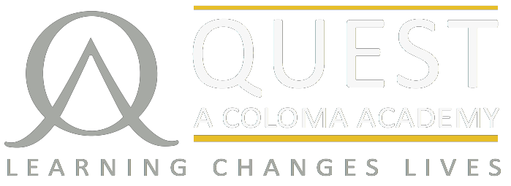
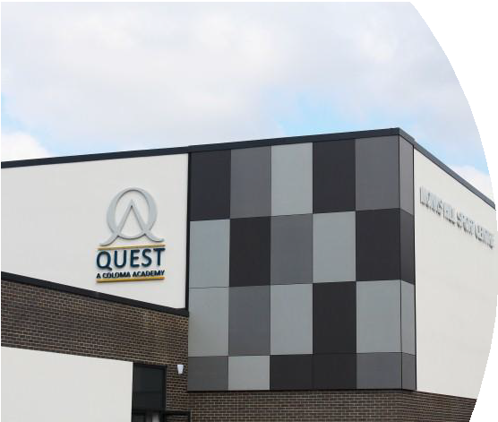
COVER SUPERVISOR

“Our priority is to ensure that students, staff
and parents are proud to belong to The Quest.”
Mr Andy Crofts Principal, The Quest Academy

Location: London Borough of Croydon
Contract type: Term Time Permanent
Date: 1st June, 2018
Salary: £17,500.

The Quest Academy – Coloma Trust was opened in September 2010 and has made rapid progress to become a “good school” (Ofsted June 2015) with above average progress (P8 was +0.46 in 2017) and excellent A level results: A* - E 100%, A* - C 82% in 2017.

Students and staff moved into a £16m new “state of the art” building in September 2014 to add first class facilities to a first class teaching environment.

Quest is an Academy on a journey to excellence. We are quite clear that the purpose of our journey is to provide a high quality, all-round outstanding education for our pupils, present and future, in a calm yet exciting learning environment.

We look forward to applications from those who would like to help us reach our destination.

Applicants should be a confident and capable individuals who can supervise students completing work set by teachers during absence.

We are offering this exciting opportunity for an outstanding candidate who has the relevant experience, commitment and drive and who is passionate about encouraging every child to reach their true potential within a supportive academic environment.

Full details, an application form and job description are attached or available from our website www.thequestacademy.org.uk – or via Georgina Bolter at the contact details below.

Please return forms to: Georgina Bolter, c/o The Quest Academy, Farnborough Avenue, Croydon, CR2 8HD. Telephone: 0208 768 3352 or email: gbolter@thequestacademy.org.uk.

LEARNING CHANGES LIVES

Principal: Mr Andy Crofts
Farnborough Avenue, Selsdon CR2 8HD www.thequestacademy.org.uk

