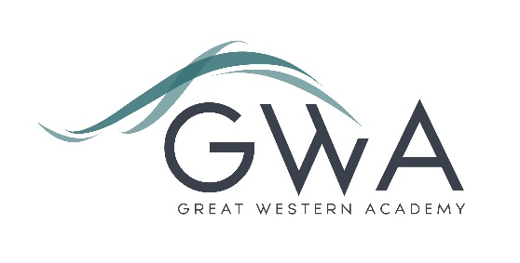

Information for Applicants

Classroom Teachers (Part-time or Full-time)
Great Western Academy will open in September 2018 in North Swindon. The Academy will educate pupils from Years 7 to 13. The first students will be admitted into Year 7 (PAN 150) and Year 12 (PAN 80) in September 2018.
As a small secondary school in our first year our classroom teacher roles can be very flexible. Applications for part-time or full-time roles will be considered, and the ability to teach a second subject would support any application (but is not a requirement); our priority is very much to recruit the very best classroom practitioners. As the school grows in future years there is an excellent opportunity for existing staff to shape and develop their role including potentially moving into leadership positions.
An applicant’s briefing pack with full information about Great Western Academy and the role is available on the GWA website at www.gwacademy.co.uk/school-information/vacancies . If you have any questions prior to application you are very welcome to contact us.
Application process

Please complete the application form supplied and enclose a supporting letter, either in the space provided on the application form or as a separate document. The application form should be completed in full in black ink or type. A CV is not required and should not be submitted as part of the application.

Your supporting letter should be no more than 2 sides of A4 (with a font size no smaller than 11) and should enhance your application by providing further information, matched to the person specification, about your suitability for the post. This should include evidence of the impact on student outcomes you have made in your career to date. You should also make it clear whether you are applying for a part-time or full-time role and whether you can offer an alternative subject.

Electronic applications should be returned via email to gwa.recruitment@newcollege.ac.uk. Postal applications can be returned to:

Graham Davis
Principal, Great Western Academy
c/o New College
New College Drive
Swindon SN3 1AH

Applications will be acknowledged within 3 working days of receipt.

Closing Date: 9am Friday 23rd February 2018
Interviews will take place in the weeks beginning 5th and 12th March. The interview process will include observation of your teaching and a variety of other tasks and activities.
Great Western Academy is committed to safeguarding and promoting the welfare of children, young people and vulnerable adults and we expect all staff to share this commitment and undergo appropriate checks. All posts within the Trust are therefore subject to an Enhanced DBS and barred list check.

References: References will be taken up prior to interview.

