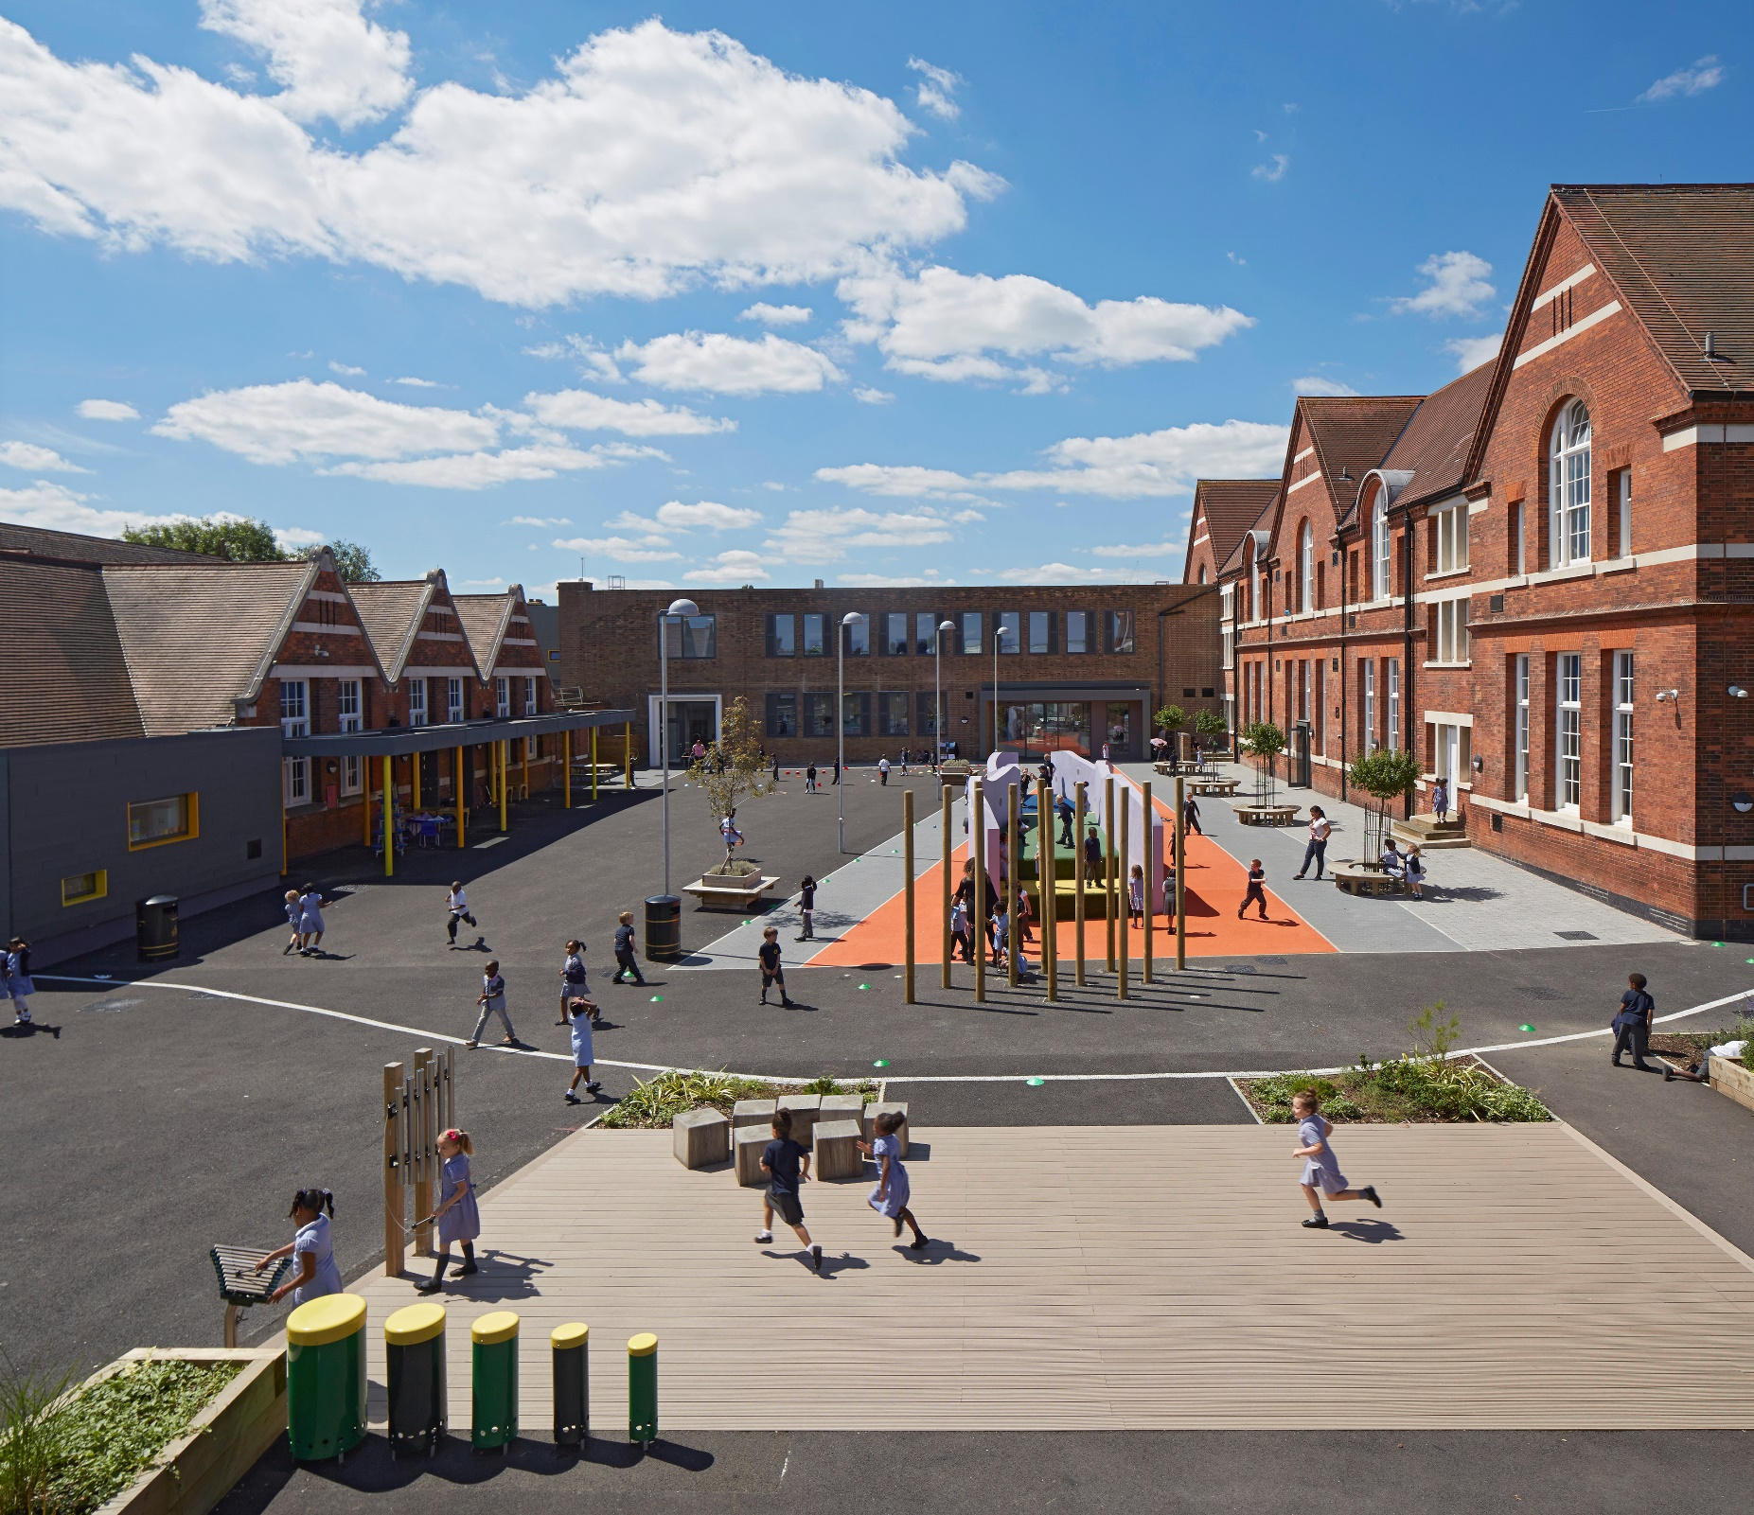
JOIN
TEAM RFA!
Robert Fitzroy Academy,
80 Brampton Road, Croydon, CR0 6JN
Tel. 020 8662 9700 www.robertfitzroyacademy.com

Class Teacher KS1 or KS2
Start date: September 2018
Why apply to RFA?
OUR MISSION
We are a school for human flourishing. Never before have educators been under so much pressure to demonstrate academic achievements and progress through results. At RFA we hold fast to the belief that our pupil’s well-being, confidence and happiness will provide the right foundation for academic rigour. Our aim is to provide a complete education – one that nourishes the mind, body and spirit.
The whole child is the whole point of what we do.

WHAT WE ARE LOOKING FOR
We are looking for a truly excellent teacher- with well-developed pedagogy, a creative mind and an aspiration to join us on an immensely satisfying journey. We wish to appoint a classroom teacher who will:
- Make learning irresistible, effective and inclusive;
- Embrace and develop the reflective pedagogy necessary to implement consistently good or outstanding teaching and learning ensuring all pupils make good progress;
- Be committed to on-going professional development;
- Be confident in using technology in the classroom
- Contribute to the wider life of the school;
- Contribute to a dynamic and inspiring school environment;

WHAT WE OFFER
An ambitious, happy and vibrant place to work and the unique opportunity of being part of a growing school, as well as being part of the wider REAch2 Academy Trust family of primary academies striving to deliver an truly great education for all pupils;
- An active school community with supportive parents
- An award winning learning environment
- Excellent professional development opportunities including a tremendous opportunity to be part of a Visible Learning (John Hattie) project which will be a pioneering piece of research in the UK
- A supportive working culture that focuses on positive learning behaviour and high expectations for all children
- A senior leadership team that believes in distributive leadership and says 'yes' to good ideas.

The Trust aspires to create a family of primary academies that have strong reputations for delivering outstanding education for all pupils. The Trust offers excellent professional opportunities to develop leadership talent through National Professional Qualifications for Middle and Senior Leaders in partnership with Tidemill Academy, a National Teaching School and the Institute of Education.

The Robert Fitzroy Academy is committed to safeguarding and protecting the welfare of children and staff. The successful candidate will be subject to an enhanced disclosure. We are an equal opportunities employer.
KEY DATES

Visits: Can be arranged on an individual basis please call 0208 662 9700 to book.
Closing Date: 12pm 15th March
Shortlisting: 16th March
Interviews: 21st March
We are also holding an open morning at 10am on Saturday 3rd March. If you would like to attend please email admin@robertfitzroyacademy.com

Completed applications should be returned to:

Debbie Tapson – Office Manager
Robert Fitzroy Academy
80 Brampton Road
Croydon
CR0 6JN

Email applications to admin@robertfitzroyacademy.com will be accepted as long as you follow up with a signed copy in the post.
Job Description

Post: Upper Key Stage 2 Classroom Teacher with Leadership Possibilities
Salary: M1-M6/UPR/Lead Practitioner scale (L1-10 for outstanding candidates) negotiable dependent on experience (outer London)
Responsible to: Head of School
Job Purpose

Main Responsibilities

- To carry out all the professional duties of a teacher as set out in the current School Teachers’ Pay and Conditions document
- To continue to meet the required Standards for Qualified Teacher Status
- To teach pupils in the age range 4 – 11 and take responsibility for a FS, KS1 or KS2 class as directed by the Head teacher having due regard to statutory frameworks and school policies
- To provide an effective, stimulating and well organised classroom and be an enthusiastic teacher, whose classroom practice demonstrates ability to help children achieve success
- To take a lead role in the development of one area of the school (for suitable, experienced applicants)

Teaching, learning and assessment

- Be an effective and professional class teacher by demonstrating good practice in:

- planning for effective learning by using clear learning goals and activities appropriate to the subject matter and the children being taught
- providing clear structures for lessons, and for sequences of lessons, which ensure progression, pace and challenge
- assessing and recording children’s progress systematically with reference to the school’s agreed practice and use this to inform planning
- marking and monitoring work, providing effective feedback and setting targets for future progress
- using teaching methods which sustain the momentum of children’s work and keep all children engaged maintaining a purposeful working atmosphere
- setting high expectations for children’s behaviour, establishing and maintaining a good standard of discipline
- establishing a safe environment where respect and positive relationships flourish
- creating a stimulating and interesting classroom where curiosity, questioning and exploration are encouraged
- creating opportunities for co-operative working and for developing independence
- make appropriate educational provision for children with SEND, Gifted and those learning with EAL, with support from the SENDCO

- Implement and keep records of individual progress on learning or behaviour targets for pupils in line with the SEND Code of Practice
- Provide for the spiritual, moral, cultural, emotional and physical welfare of children.
- Select and make use of ICT skills for classroom and management support
- Be sensitive to issues relating to cultural considerations and equal opportunities and to ensure that appropriate action is taken to reduce and remove any inequalities that are identified

- To take responsibility for other adults in the classroom ensuring they are effectively used to support the children’s learning
- Undertake any other reasonable and relevant duties in accordance with the changing needs of the school
- Work closely with colleagues to undertake medium and short term planning and the implementation of agreed Schemes of Work
- Ensure Health and Safety policies and practices including risk assessments, are implemented where appropriate

Knowledge

- Have a secure knowledge of primary subjects and the relevant statutory and non-statutory curricula frameworks across the school
- Promote your subject across the school orbegin to prepare for teaching and learning responsibilities
- Be familiar with and carry out all agreed school policies as an effective team member.
- Be familiar with the SEND Code of Practice and identification, assessment and support of children with special educational needs
- Act at all times in accordance with national, local and school Health and Safety and Child Protection Policies and guidelines
- Support the aims and the ethos of the school by setting high standards

Communication and working with others

- To ensure that each child, regardless of ability, race, sex, religion or background has a positive self-image and is aware of being valued
- To recognise and respect the contributions of parents and carers in their children’s well-being, learning and the life of the school
- Communicate effectively with parents on the progress and welfare of their children as appropriate e.g. informal discussions, Parents’ Evenings, report writing, SEN reviews etc.
- To attend and fully participate in staff meetings and discussions
- Establish and maintain effective working relationships with colleagues
- Demonstrate a commitment to collaboration and co-operative working
- Foster good relationships between the school and the wider community
- To lead and manage CPD in area of responsibility (for those seeking leadership role)

Professional Development

Develop in a professional capacity by:
- Evaluating your performance and show a commitment to improving your practice through professional development
- Participating in the Academy’s appraisal system (not applicable to NQT)
- Acting upon advice and feedback and be open to coaching and mentoring

Other duties and responsibilities

- To carry out any other such duties, which may be, required from time to time in order to meet the changing needs of the school
- Lead when appropriate
- Support the implementation of the School Improvement Plan
- Liaise with the Monitoring Governors as necessary
- Other duties to be agreed following discussion with the Leadership Team

And specifically for a Lead Practitioner role:
With the support of the Senior Leadership Team, take a leading role in improving the standards of teaching and learning, ensuring these are consistently high. This will involve:
- working closely with teaching practitioners across the school (and potentially in other schools in the region) with the aim of raising student achievement at all levels
- Contributing to whole school staff development. This could involve running twilight sessions and contributing to whole school training
- Working with staff throughout the school, putting together coaching/mentoring programmes so that all have the potential to be judged as good or outstanding practitioners

Job Description
Person Specification

The person specification is a picture of the skills; knowledge and experience needed to carry out the job. It has been used to draw up the advert and will also be used in the short listing and interview process for the post. If you are a disabled person and are unable to meet some of the job requirements specifically because of your disability, please say this in your application. If you meet all the other criteria you will be short listed and we will explore jointly with you if there are ways in which the job can be changed to enable you to meet the requirements. Those categories marked ‘S’ will be used especially for the purposes of short listing.

Job related knowledge/aptitude/skills:
(SHORTLISTING CRITERIA Marked ‘S’)
Education & Training
Qualified Teacher Status, DfE number and satisfactory DBS check | S
Recent and relevant attendance on training and/or professional development | S
Knowledge & Understanding
An understanding of current research into teaching and learning | S
Up to date knowledge of the Primary National Curriculum | S
An understanding of the target setting process | S
Understanding of home school liaison links | D
A subject specialism | D
Experience
Proven, recent and relevant experience of teaching primary aged children (within 3-11 years) in a mainstream school setting. | S
Effective and active communication with parents | S
Experience of developing links outside the school community | D
Skills
a) Knowledge of the range of teaching and learning strategies that most effectively contribute towards raising achievement, promoting good behaviour and developing self-esteem in all children in a diverse and inclusive classroom  b) Ability to implement these strategies effectively and consistently | S
Ability to communicate effectively orally and in writing | S
Ability and commitment to implement the school’s ethos, acting as a positive role model for pupils | S
Personal Qualities
Demonstrate a positive attitude to learning and a commitment to in-service training and personal development | S
Reliability and conscientiousness | S
Flexibility and ability to cope with change | S
Creative ideas and support for the development of the school | D
Circumstances
This post is exempt from the Rehabilitation of the Offenders Act. Any criminal convictions will need to be declared if you are appointed
Equal Opportunities
A commitment to implement the schools equal opportunity policy | S
Demonstrate a clear understanding of equal opportunities issues as they affect pupils and their families | S
Staff team and structures

The Robert Fitzroy Academy enjoys generous staff: pupil ratios with full-time teaching assistants or Higher Level Teaching Assistants in all classes, specialist music, PE and art teachers to cover PPA and additional teaching staff providing interventions. KS2 children are taught Spanish by a specialist.

Team working is a noticeable feature of our school culture. Each phase, EYFS, KS1 and KS2 are led by Leaders who shape and develop the curriculum for their phase and organise many aspects of the day-to-day running of the classes. They are also well-positioned to be involved in quality assurance of provision, in the implementation of school policy and contributing to the school vision.

Subject leaders are well supported by the Senior Leadership Team and are instrumental in innovation and ensuring best practice in their areas. The school is well resourced and all areas have a generous budget attached. Subject leaders play a key role in developing the practice of peers and actively contribute to the school’s CPD programme.
Sound like the school for you? Come in and have a chat!
What do our staff think?

Vidhya Yogorajah, Class teacher and EAL Leader
My Robert Fitzroy Academy journey started in 2012 as a newly qualified teacher. In my second year of teaching I was encouraged to take on a subject. Our leadership team helped me consolidate my classroom practice while developing my confidence as a specialised subject leader. I have been on a number of external courses including a project overseas! Now, in my sixth year of teaching, I am training a student teacher, leading an area and continuing my classroom practice. As well as my school responsibilities, I was encouraged by our Head teacher to complete a Masters course. She supported my decision to specialise in Inclusion and I have almost completed a Masters in SEN at Roehampton University. The RFA is a great place to teach as well as learn. With our supportive senior leadership team, inspirational subject leaders, informative CPDs and aspirational pupils, we are given a brilliant platform to grow into outstanding teachers.

Jola Lemin EYFS Leader and Computing Lead
From the moment I arrived at RFA for my interview I knew immediately that this was somewhere I wanted to be and suddenly felt incredibly determined to do well in the process so that I could make my mark on a place that appeared very different but in a very good way. I joined in 2015 as a class teacher in the EYFS and from my first day I was welcomed by an extraordinary group of people who are still inspiring and teaching me new things 3 years on. In 2016 I became EYFS Leader and am having an incredible time creating an environment with my team that nurtures not only the children but our own teaching practice too. To me, RFA is a family of creative, supportive, enthusiastic, innovative and fascinating people of which I am proud to be a member
Kate Scholz, Class teacher
I joined Robert Fitzroy Roy Academy at the beginning of 2017 as a Year 4 class teacher. Coming from Australia and a different educational system, at first I found the change to be overwhelming. But with the support of my amazing team and the senior leaders of the school, they have helped me achieve my personal teaching goals, as well as aspire for further career development. Both pupils and teachers have a positive aura at this school, which truly makes it an enjoyable work place. The opportunities and extra-curricular activities the students are exposed to here are phenomenal and to be a part of their development and growth is extremely rewarding. I can't wait to watch this school flourish as we continue to grow and develop as a school.
Babita Khialani, Class teacher and P4C Lead
I joined RFA 3 years ago as a class teacher and SMSC/P4C lead. I fell in love with the school on my first visit- the environment is so inspiring, the staff all so friendly and the children enthused and happy. The ethos and vision of the school was so evident and I believed instantly that this was a place that genuinely wanted to provide the best possible opportunities, academic and otherwise, for every child. Since working at RFA, I have been trusted and supported in developing my leadership role which has made me far more confident and skilled. As a teacher, we are all constantly striving to better ourselves to be better for our children and all staff work hard to achieve this goal. Our shared values and care for the children make us a strong and united team and I feel very lucky to be part of it.
Melissa Berkeley, Class teacher and History Lead
I began my teaching journey at the Robert Fitzroy Academy in September 2013. The school was only in its second year and was being organically grown from the ground up. Starting my teaching career here has allowed me to grow and develop alongside the school. The Robert Fitzroy Academy is a special school where all members of staff are valued as leaders and children are instilled with the important life skills of resilience, adaptability and enquiry (to name a few) as soon as they begin in Reception. At the Robert Fitzroy Academy you are provided with fantastic professional development opportunities; this has allowed me to progress in my career to Year 1 team leader in a short space of time. The school invest in staff for career development and leadership. Staff are enthusiastic, motivated and have a passion for teaching and learning; with the interests of the children at the heart of everything they do. The children are many of the most inspirational children I have ever met. They are resilient, focused and aspirational but most importantly funny, it’s important that you laugh every day. I feel lucky to be part of such a highly skilled, passionate and motivated team.

