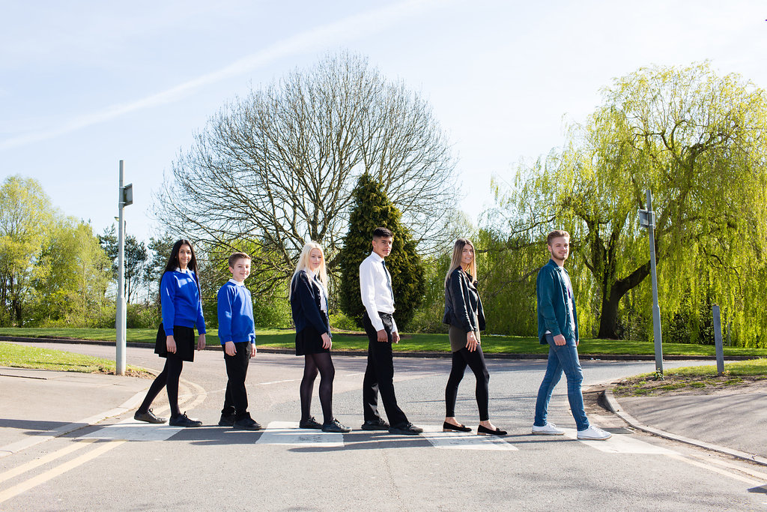

LEARNING SUPPORT ASSISTANTS

Grade 5, £10,751

27.75 hours per week term time
Plus 10 additional hours to be worked on teacher training days and as directed by the Line Manager
8.55am – 3.10pm, Monday - Friday

Content

Vision, Values and Ethos |  | Page 3
Testimonials |  | Page 4
General Information |  | Page 5
The Application Process |  | Page 6
Vacancy Advert |  | Page 7
Letter from the Headteachers |  | Page 8
Job Description |  | Page 9 - 11
Person Specification |  | Page 12-13

Vision, Values and Ethos
The shared vision and values of the Trust underpins all that we do, including the governance arrangements for the Trust.

Our Vision
Valuing Everyone, Achieving Excellence

Our Motto
Work Hard, Be Kind

Our goals
The goals of our trust:
- Outstanding levels of progress and achievement for all
- Outstanding levels of wellbeing for all
- Outstanding preparation for adult and working life
- Outstanding family and community engagement
- Outstanding levels of professional learning for all
Informed by “Schools of Tomorrow”

Testimonials
Extract taken from email correspondence, following a tour of the school by a prospective parent
(April 2016):
‘I would just like to say thank you for the time spent with me today on my tour of the campus, and state how impressed I was with the school. There seems to be a very calm, relaxed and organised approach to how the school operates, and I believe that obviously shows in the way your students behave’.

Written comments from parents following Year 9 Progress Evening (2017):
‘My child always talks positively about school to other children the same age, which I think is a good indicator that he is enjoying school’

‘Welcoming, approachable, friendly and knowledgeable staff’.

Written comments from parents following Year 11 Progress Evening (2017):
‘The teachers have pride in their teaching and in the pupils’ progress. They really care and are prepared to go the extra mile to support the students’.
‘My son seems to have progressed so well in most subjects. I feel this is due to good relationships he has been able to form with teachers and the standard of the lessons’.
Written comment from parent at the end of KS5 (2016):
‘This is my final parents evening after my youngest daughter is coming to the end of her years at GCE. Thank you for very happy years for my three daughters and for their excellent education!’
Thank you from parent of ex-student taking up a place at Cambridge University (2013):
‘To all the staff at Brookvale Groby Learning Campusl.
My son has just started at Cambridge University studying Engineering. It was his ambition to go there and this summer, he achieved the grades he needed. We want to acknowledge the great teaching and support he received during his time with you. He progressed well academically, but also grew so much in maturity and confidence. With thanks to you all for your hard work and dedication.’

Extract of letter from staff member:
‘I have thoroughly enjoyed my time on campus. It has been a real pleasure working with staff who are always friendly, extremely supportive and willing to share ideas and knowledge. I have really appreciated having a senior leadership team which is so warm towards its staff and open to their comments and new ideas.

The children I have taught have made me smile, laugh and cry! I will miss my relationship with them and that buzz you get from seeing them progress. It does, however, give me great satisfaction to think that I have put into place schemes of work for pupils and created learning opportunities for them which should continue even after I have left.

I am sad to leave a post which I still love. Once more, thank you for all of your support and kindness.’

Extract of letter from staff member:
‘I have been very fortunate to have worked with amazing people. I have learnt so much as both a Teacher and as a Head of Department.

I will truly miss everyone here, and it really has been an amazing experience. Thank you for allowing me to be part of such a wonderful group of people.

I wish every success to the campus.’

GENERAL INFORMATION

The Brookvale Groby Learning Campus is a highly successful 11-19 educational organisation created from the integration of two schools on the same site. Brookvale High School is an ‘outstanding’ 11-14 school and Groby Community College is a 14-19 upper school graded ‘good with outstanding features’ in its last Ofsted. Together, the campus meets the educational needs of 1,600 students with nearly 400 at Post 16, and we became a Multi Academy trust together at the beginning of April 2017.

We have a strong ethos of valuing everyone and achieving excellence for all. We set very high standards for our students and ourselves, we work hard, we look after each other, and we are committed to professional learning for all staff. As a consequence the motto we use on a daily basis with our young people is work hard, be kind which we feel symbolises the culture we aim to create on campus.
We have a spacious semi-rural campus location and most of our students live in the surrounding villages with some travelling from Leicester and its western suburbs.
You will be joining a team of enthusiastic Learning Support Assistants, who thrive on helping our students to be the very best that they can be. You will be supported along the way, and if you enjoy a busy and varied schedule, working with young people, then this is the job for you.
We look forward to hearing from you.

The Application Process

Complete application forms should be returned to efreeman@brookvalegroby.com

Or by post to

F.A.O. Elaine Freeman
Brookvale Groby Learning Campus
Ratby Road
Groby
Leicester
LE6 0FP

A letter will be sent to shortlisted candidates with details of the interview process.

Queries

If you have any queries on any aspect of the application or need additional information please contact Elaine Freeman, PA to the Headteacher on 0116 2879921.

Thank you.

The Role

LEARNING SUPPORT ASSISTANTS

Grade 5 - £10,751
27.75 hours per week term time
Plus 10 additional hours to be worked on teacher training days and as directed by the Line Manager
8.55am - 3.10pm Monday to Friday
We are looking for energetic and enthusiastic people, to assist with enabling students with special educational needs in both Key Stage 3 and Key Stage 4 to access the full curriculum within the Brookvale Groby Learning Campus.
We are seeking people with experience of supporting teaching and learning in a formal setting, along with knowledge of child protection and health and safety procedures.
It is essential that applicants hold Level 2 qualifications in Maths/Numeracy and English/Literacy.
Providing toileting support to relevant students may be required, following negotiation with the applicant and after appropriate risk assessment and training have been undertaken.

For further details please email Elaine Freeman - efreeman@brookvalegroby.com

Closing Date: Wednesday 20th June 2018
Interviews will be held within 2 weeks of the closing date

The Brookvale Groby Learning Campus is committed to safeguarding and promoting the welfare of children and young people and expect all staff and volunteers to share this commitment. Applicants must be willing to undergo appropriate child protection screening, including checks with past employers and the Disclosure and Barring Service.

June 2018

Dear Applicant

Learning Support Assistants

Thank you for your interest in the Learning Support Assistant vacancies within the Brookvale Groby Learning Campus.

We hope the documents provided help you to gain a feel for the school and if you would like to visit us as well, we would be delighted to show you round. Please contact Elaine Freeman on 0116 2879921 or efreeman@brookvalegroby.com to make an appointment.

All the documents to support this application process are available on our campus website – www.brookvalegroby.com.

To apply please complete the following:

- Application Form
- A letter of application, no more than two sides of A4, word processed using font size no smaller than 10

Your letter needs to be addressed to ourselves, and if you would like to e-mail your application then please send this to Elaine Freeman on the email address above.

The closing time and date for this post is Wednesday 20th June 2018. The interviews will be held within 2 weeks from that date. If you have not heard from us by then, please assume that your application has not been successful on this occasion. If this is the case, we would like to thank you for your interest and the time spent in applying.

This post will be subject to an enhanced level Criminal Records Bureau check. All Brookvale Groby employees are expected to promote and safeguard the welfare of students at the school. Our Safeguarding Policy is made known to all and is designed to guide staff, students and parents/carers with regard to Safeguarding issues.

In line with best practice guidance re safeguarding we do not require an additional CV and any included with application forms sent to the school will not be taken forward to the short listing panel.

Yours sincerely
Katie Rush Robert Coles
Headteacher, Brookvale High School Headteacher, Groby Community College
Co-Director of BGLC Co-Director of BGLC

Job Profile

Job Title: |  |  | Learning Support Assistant (LSA)
Grade: |  |  | 5
Responsible To: |  |  | SEN Co-ordinator (SENCo)
Key Relationships/  Liaison with: |  |  | Teachers, Other classroom support staff, SENC0
Job Purpose: |  |  | An LSA will work under the direct supervision of a teacher to provide support for teaching and learning and associated activities in accordance with school policies and procedures. This may include providing general support for whole class learning activities, or supporting individuals or small groups of pupils.
Occupational Standards: |  |  | Supporting Teaching and Learning (STL) Level 2
MAIN DUTIES AND RESPONSIBILITIES:
1. | To provide agreed support to the teacher in the delivery of planned whole class learning activities.
2. | To work under the direct supervision of a teacher to carry out planned learning activities with small groups or individual students, providing feedback on their engagement in activities and their achievement of the desired learning objectives.
3. | To help prepare, monitor and maintain a safe and secure learning environment in line with the teacher’s lesson plans.
4. | To observe and feed back to the teacher on student performance and behaviour, taking action as appropriate in line with relevant school policies.
5. | To support the physical, intellectual, emotional and social development of students, including contributing ideas and suggestions to support planning, to meet their development needs.
6. | To interact with and respond positively to children, young people and adults.
7. | To develop positive relationships with colleagues, providing consistent and effective support and working constructively as a member of the school staff team.
8. | To support students to improve their numeracy and literacy skills through focussed learning activities and more generally across the curriculum.
9. | To prepare and utilise ICT resources to support pupils learning.
10. | To prepare and support the use of learning materials and create visual displays, in accordance with the requirements of the teacher, in order to facilitate a relevant physical learning environment.
11. | To provide care and encouragement to children and young people with disabilities or special educational needs, supporting them to participate in activities and liaising, if required, with parents / carers / other professionals as appropriate.
12. | To contribute to the provision of support for bilingual / multilingual pupils if required.
13. | To invigilate internal and external tests and examinations under formal conditions.
14. | To encourage participation in structured and unstructured learning activities, including play (timetabled and during breaks if required). (Primary and Special schools)
Optional extra responsibilities not affecting the grade of the post:
15. |  | To undertake midday supervision duties.
16. |  | To provide catheter duties and toileting support to relevant students as necessary, as well as a willingness to support diabetic students.*
17. |  | To support, as appropriate, in instances where pupils are unwell whilst at the school/college.*
* these duties only to be included by negotiation with individual employees, and after appropriate risk assessment and training have been undertaken.
SPECIAL FACTORS:

Subject to the duration of the need, the special conditions given below apply :
- The nature of the post may involve the carrying out of outside of normal working hours.
- The postholder may be required to attend, from time to time, training courses, conferences, seminars or other meetings as required by his/her own training needs and the needs of the campus.
- Expenses will be paid in accordance with the Local Conditions of Service.
- This post is subject to a check being carried out at an Enhanced level by the Disclosure and Barring Service regarding any previous criminal record.

WHOLE CAMPUS RESPONSIBILITIES:
- Support current policies and recognised good practice within the campus.
- Be aware of the importance of confidentiality and data protection.
- Participate in annual Performance Management review with Line Manager, based on agreed objectives, ideally one of which should be linked to the campus improvement plan where possible.
- To work as part of a team, to act as a contact in providing basic emergency first aid, if training is provided.
- Willingness to be flexible in both approach & use of time.
- All tasks should be undertaken with due regard to Health & Safety Regulations.
- To undertake such other duties which are within the scope of the job purpose, title of the job and it’s grade.

This post is subject to enhanced disclosure from the Disclosure and Barring Service. All Brookvale Groby Learning Campus employees are expected to promote and safeguard the welfare of students at this school.

The Governing Body and the County Council are seeking to promote the employment of people with disabilities and will make any adjustments considered reasonable to the above duties under the terms of the Equality Act 2010 to accommodate a suitable candidate with a disability.

This Job Description sets out the responsibilities of the post at the time it was drawn up. Such responsibilities may vary from time to time without changing the general character and requirements of the post or the level of responsibility entailed. Variations are a common occurrence and do not necessarily constitute additional responsibilities or warrant a higher grade.

Personnel Specification

 | Essential | Desirable | How assessed
Qualifications  - NVQ 2 in Supporting Teaching and Learning, or equivalent  OR  - Able to demonstrate the ability to meet the STL Level 2 National Occupational Standards relevant to this post.  - Level 2 qualifications in Maths/numeracy and English/literacy |  |  | App/Doc  App/Doc
Experience  - Experience of supporting teaching and learning in a formal setting |  |  | App/Int/ Ref
Knowledge  - Knowledge of child protection and health and safety procedures. |  |  | App/Int/ Ref
Skills/Attributes  - Ability and willingness to undertake professional development.  - Good interpersonal skills.  - Empathy with children and young people.  - Ability to work effectively as part of a team.  - Willingness to dress as a professional in line with the ethos of the campus. |  |  | App/Int  Int/Ref  Int/Ref  Int/Ref  Int/Ref
General Circumstances  - An understanding of, and commitment to, Equal Opportunities, and the ability to apply this to strategic work and day-to-day situations. |  |  | App/Int
Factors not already covered  Must be able to perform all duties and tasks with reasonable adjustment, where appropriate, in accordance with the provisions of the Disability Discrimination Act 1995. |  |  | Med

App = Application Form Med = Medical Questionnaire
Test = Test Doc = Documentary Evidence (E.g., Certificates)
Int = Interview

In addition to candidates’ ability to perform the duties of the post, all Brookvale Groby Learning Campus employees are expected to promote and safeguard the welfare of students at the school, therefore the interview will also explore issues relating to safeguarding and promoting the welfare of children including:

- Motivation to work with children and young people
- Ability to form and maintain appropriate relationships and personal boundaries with children and young people
- Emotional resilience in working with challenging behaviours
- Attitudes to use of authority and maintaining discipline

Please be aware that any relevant safeguarding issues that arise on receipt of references may be discussed at interview.

