Cleaner

Candidate
Information Pack

Dear Applicant,
Thank you for your interest in the Cleaner post currently being advertised at St. Joseph’s Catholic College. I thought it might be useful to provide you with a context for our College to help you decide whether or not ours is a community in which you could be happy and contribute to the success of our young people.
The College has made remarkable progress over recent years and has an excellent reputation locally and beyond. This was acknowledged in our Ofsted report published in November 2014.
- “A culture of working together exists to ensure that students receive a highly effective educational experience”
- Our students are “polite … exhibiting good attitudes to learning”
- “Positive working relationships exist between teachers and students ”
We have wonderful students who are proud to be part of our community, a committed, talented staff and excellent facilities. I firmly believe that this is a great time to join the College.
If you are excited by the prospect of playing a role in helping us achieve excellence and have a core belief that all students can achieve regardless of ability or background then we would very much like to hear from you. If you would like to come for an informal visit you are most welcome to do so by contacting our HR department. We do not require staff to be people of any faith for this post but we do ask that applicants respect the Christian ethos of the College.
Yours sincerely,

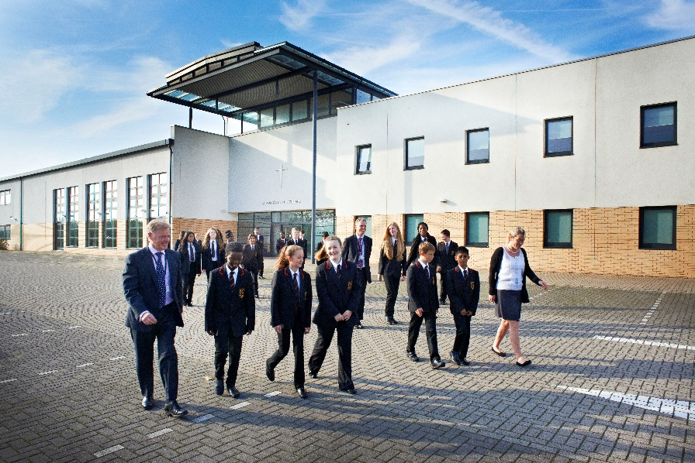
Paul Hughes,
Principal
St Joseph’s Catholic College
Job Description
Post Title Cleaner
Scale 1
Point 8 – 10
Hours per week 10
Working weeks per year 41
Line Manager Cleaning Manager
This College is committed to safeguarding and promoting the welfare of children and young people and expects all staff and volunteers to share this commitment
Job Purpose:
Responsible, under the direction of the Cleaning Manager, or such other Officer as may be designated by the Governing Body, individually or as part of a team to undertake the cleaning of designated areas within educational premises to ensure that they are kept in a clean and hygienic condition.
Duties:
- Cleaning, washing, sweeping, vacuum cleaning, emptying of litter bins, polishing and dusting of the designated areas, (which may include toilets and shower areas), and fixtures and fittings, using where appropriate, powered equipment.
- The movement of items of furniture.
- Whilst every effort has been made to explain the main duties and responsibilities of the post, each individual task undertaken may not be identified.
- Duties may vary between term and closure periods.
General Conditions:
a) All duties must be carried out to comply with:
1. The Health and Safety at Work Act;
2. Acts of parliament, statutory instruments and regulations and other legal requirements;
3. Nationally agreed codes of practice which are relevant;
b) all duties will be carried out in the working conditions normally inherent in the particular job;
Safeguarding children
To promote and safeguard the welfare of all children and young people that you are responsible for, or come into contact with.
Staff must work in accordance with the South West Child Protection procedures and Child Protection/Safeguarding Policy and understand their role within that Policy.

Team Working
To ensure that reasonable care is taken at all times for the health, safety and welfare of yourself and other persons, and to comply with the school policies and procedures relating to health and safety and equality of opportunity.
To work co-operatively with colleagues to achieve the aims and objectives of the post and the College.
To participate positively in the implementation of new working methods and practices as required.
To undertake other duties within his/her competence or otherwise appropriate to the grading of the post as required.
Personal Development
To work positively and constructively with the line manager to identify strengths and agree an action plan in relation to development needs, to set these out in a personal development plan which will be reviewed regularly with the line manager
To be aware of the current national and local issues relating to Education insofar that they affect the post.

It is a requirement, in accord with the guidance of the Catholic Education Council, that staff in Catholic Schools should “have regard to the Roman Catholic character of the school and not do anything in any way detrimental or prejudicial to the interests of the same”
Employees will be expected to comply with any reasonable request from a manager to undertake work of a similar level that is not specified in this job description.
Employees are expected to be courteous to colleagues and provide a welcoming environment to visitors and telephone callers.
The school will endeavour to make any necessary reasonable adjustments to the job and the working environment to enable access to employment opportunities for disabled job applicants or continued employment for any employee who develops a disabling condition.

July 2015

Person Specification
Cleaner Person Specification | Essential | Desirable
Qualifications and professional development
Basic Level of Literacy and Numeracy
Experience
Previous Cleaning Experience
Experience of working in a school or public building environment
Knowledge, Skills and abilities
Knowledge of cleaning substances and their use
A commitment to working within H & S Legislation
Evidence of ability to work effectively within a team
Personal Outlook
Be self-motivated.
Ability to motivate others.
Ability to work under pressure.
Must be proactive.
Have excellent communication skills.
Vision and ethos
Appreciation of, personal comfort with and contribution to the Christian ideals of the College.
Demonstrable commitment to College ethos
Safeguarding Children
Ability to form and maintain appropriate relationships and personal boundaries with children and young people
Sound attitudes to the use of authority and maintaining discipline

St. Joseph’s Catholic College
Our History
In 1958 St. Joseph’s Secondary School was opened for pupils aged 11 to 15. Built close to the centre of Swindon, the school soon made its mark, recognised as one which achieved academically, in sport, and where moral values were unashamedly promoted.

Today St. Joseph’s Catholic College is an 11-18 secondary school with just over 1200 students, of which 90% in Key Stages 3 and 4 are Catholic. The College moved to state of the art buildings in 2006 and has excellent facilities across music, drama, sports, science, art and technology.

Our Purpose
The College believes that every student is unique, with infinite potential to grow and develop. We aim to work in partnership with home, the parish and the wider community to prepare every child for a future in which they are able to make a positive contribution to society. For every student at the College we aim to offer them a secure foundation of learning, promoting aspiration and achievement. We are a fully inclusive, multicultural College committed to the individual, yet still determined to meet the needs and interests of all.

Our Vision
The College offers an education with a solid foundation of Christian values. We expect the very best from each and every student and seek to be a community where all are valued and where the life of the College and the relationships between all in it are defined by Gospel values. Our Gospel values underpin all the relationships in the College, between students and teachers, teachers and staff, and student to student. They are:

• Love of God and love of others
• Tolerance toward others
• Forgiveness of wrong doing
• Justice for the oppressed
• Concern for the causes of suffering
• Compassion for those who suffer
• Service to others

www.stjosephscollege.net

