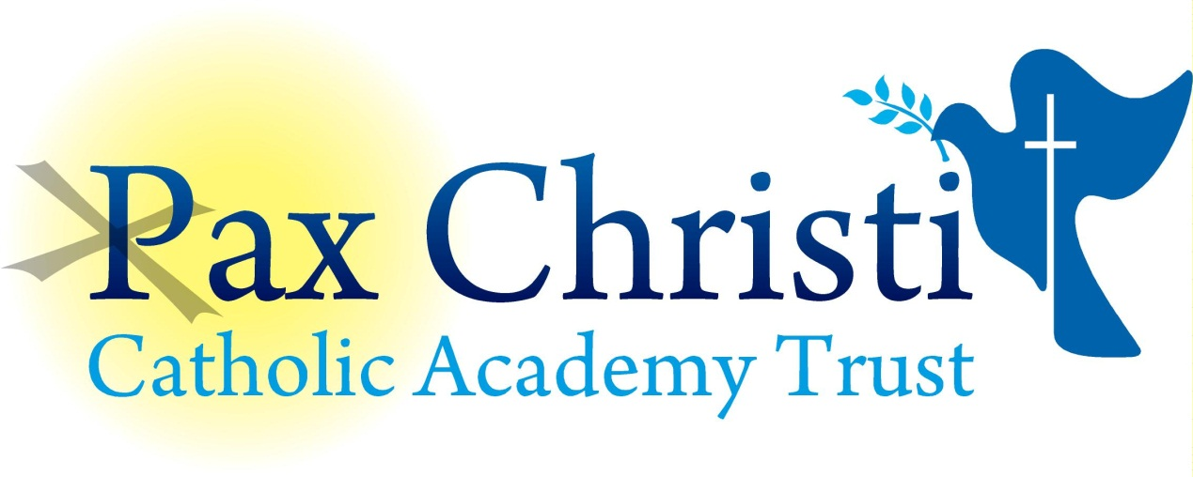

CHRIST THE KING CATHOLIC VOLUNTARY ACADEMY

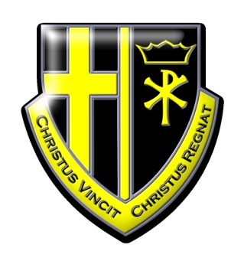

JOB DESCRIPTION

Exams Invigilator
No fixed hours – ad hoc working

Current Post holder: | Vacancy
Job Description Review Date:  Signed…………………………………………………………… | March 2018/  Date………………………………………..
Job Purpose
The post holder will work under the direction of the examinations officer or senior invigilator where one is appointed.

Line Management
Responsible to: Principal, Data & Exams Manager
Responsible for: No staff

Specific Responsibilities
- To work in a team of invigilators supervising pupils undertaking school and external examinations in accordance with the legal and school requirements.
- To ensure that they are familiar with the ‘Guidance for Invigilators’ as provided by the examinations officer and the examination board.
- To ensure appropriate preparation of the exam room as required by the examination board.
- To supervise the candidates in a quiet and unobtrusive manner to ensure that the regulations on conduct, communication etc. are strictly observed.
- To distribute additional paper and/or equipment as necessary.
- To assist in admitting the candidates to the examination room and enabling them to find their allocated seats quietly and efficiently.
- To distribute examination papers and associated materials at the beginning of the examination and to collect them at the end in the required order and format.
- To complete the attendance register for each examination at which they invigilate, together with a seating plan and report absentees as required by the school system,
- To respond to candidates non-curricular queries in accordance with examination regulations.
- To escort and supervise any candidates who may need to leave the examination room in an emergency,
- To assist in the efficient timekeeping of the examination ensuring a clock, visible to all candidates, is in the room they are supervising and that the exam board instructions to candidates are displayed as required.
- To ensure that any minor behaviour issues are dealt with in line with school policy.
- To report any breaches of the examination code of conduct to the supervising teacher/senior invigilator/examinations officer immediately.
- To ensure that any equipment lent out has been accounted for and that examination room is fully prepared for the next session.
- To undertake any other duties which may reasonably be regarded as within the nature of the duties and responsibilities/grade of the post as defined, subject to the proviso that normally any changes of a permanent nature shall be incorporated into the job description in specific terms.

Skills and Abilities
The post holder will be expected to demonstrate the following skills and abilities at all times during the discharge of their duties:

- Work on own initiative and to demonstrate the ability to solve unexpected or new problems in a methodical, efficient manner.
- Learn new skills and expand current skill set and to be able to pass on knowledge and techniques to others.
- Demonstrate good general interpersonal and communication skills.
- Deal with conflicting demands and work flexibly.

Whole Academy Responsibilities
- Be a positive influence on the climate and culture of the Academy and show a positive example at all times.
- Support the catholic ethos of the Academy.
- Be aware of and comply with policies and procedures relating to child protection, health, safety and security, confidentiality and data protection, copyright etc reporting all concerns to line manager.
- Be aware of and support difference and ensure equal opportunities for all.
- Contribute to the overall aims of the Academy.
- Appreciate and support the role of other professionals.
- Attend and participate in relevant meetings as required.
- Participate in training and other learning activities and performance development as required.
- Recognise own strengths and areas of expertise and use these to advise and support others.

General

To work in collaboration with other Pax Christi Academies, sharing good practice and supporting during time of absence and/or heavy workload.
- This job description contains the main accountabilities relating to this post and does not describe in detail all the tasks required to carry them out. All staff are expected to be flexible to ensure the most effective organisation and delivery of services.
- The duties and responsibilities of the post will evolve with the natural development of the Academy and/or Trust. Such changes are, therefore, a normal part of the post and the post holder must be prepared to undertake any other duties commensurate with the general level of responsibility of the post which may be determined from time to time subject to the proviso that any permanent, substantial changes shall be incorporated into the job description and evaluated as such.

