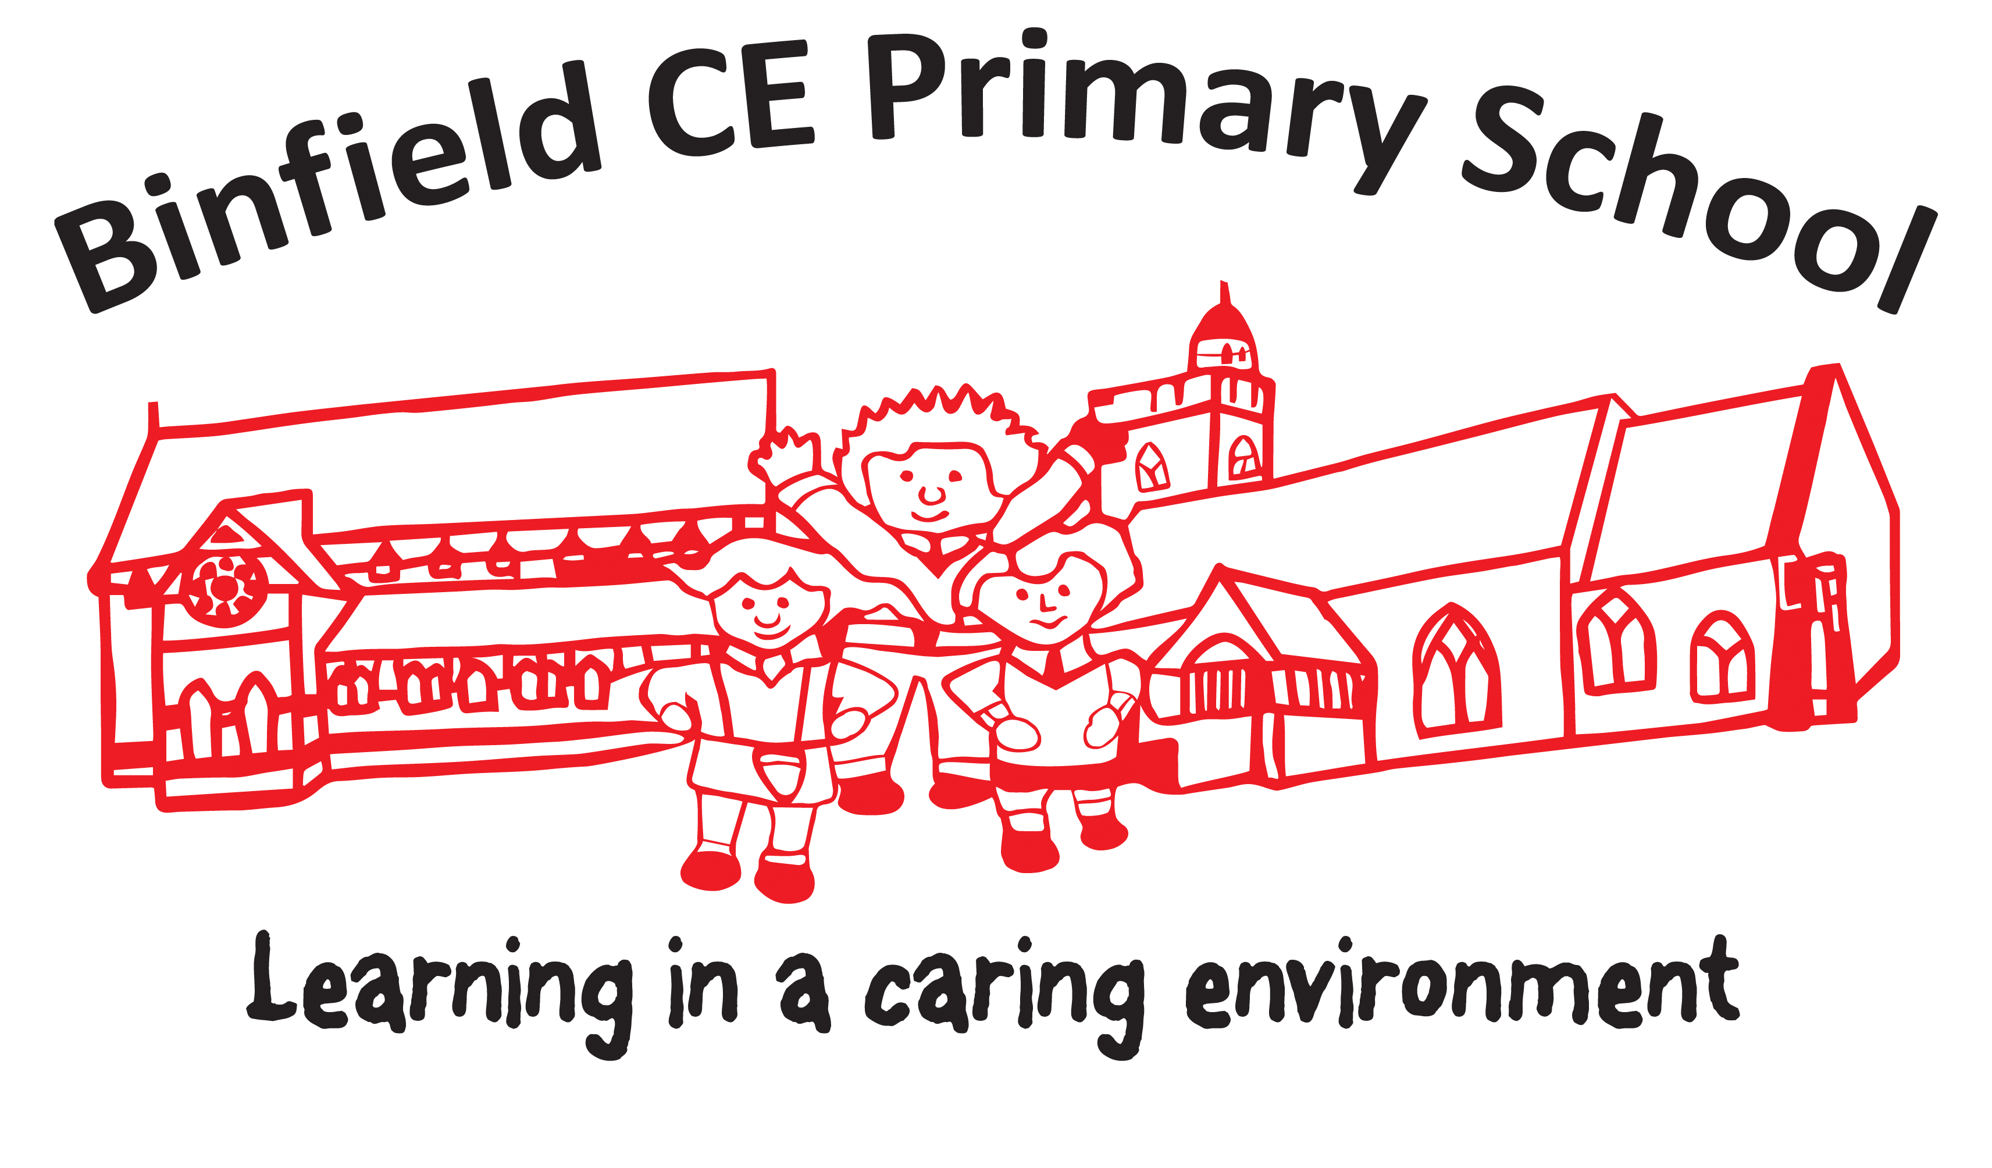
BINFIELD CE PRIMARY SCHOOL (VA)
Classteacher/Subject leader
Person Specification

Selection decisions will be based on the criteria outlined below.

When completing your application form and supporting statement, you should ensure that you address each of the selection criteria and provide supporting evidence of how you meet the criteria through reference to work or other relevant experience.

 | ESSENTIAL | DESIRABLE
SKILLS AND ABILITIES | - Qualified teacher status  - Proven track record of excellent classroom practice  - Ability to positively influence the quality of teaching and learning of others including support staff  - Enthusiastic and able to motivate and inspire pupils and staff  - An effective communicator with excellent interpersonal skills who will liaise closely and work well with their team  - Ability to organise and manage time effectively  - Ability to plan and teach a balanced, challenging and exciting curriculum  - Ability to reflect on your own practice and maximise opportunities to improve  - Be proficient in using ICT | - Any other relevant qualifications  - A positive approach to innovation  - Has a positive outlook and a good  sense of humour  - Recent, relevant curriculum training,  e.g. maths teaching, grammar, etc  - Has a positive outlook and a good  sense of humour
EXPERIENCE | - Experience of working with children with a wide variety of learning needs  - Experience of continuing professional development, including recent participation in the new National Curriculum and assessment | - Experience of leading others within your school  - Experience of leading the implementation of whole school initiatives  - Experience of working in a Church school and supporting a Christian ethos
KNOWLEDGE | - An excellent knowledge of a range of teaching, learning and behaviour management strategies  - Knowledge and understanding of summative and formative assessment  - A thorough knowledge of the KS2 Curriculum and assessment practices  - Knowledge of current Ofsted framework | - Knowledge of current educational issues and development
SUITABILITY TO WORK WITH CHILDREN | - Up-to-date knowledge of relevant legislation and guidance in relation to working with, and the protection of, children and young people.  - Displays commitment to the protection and safeguarding of children and young people. | - Current entry level Safeguarding training

