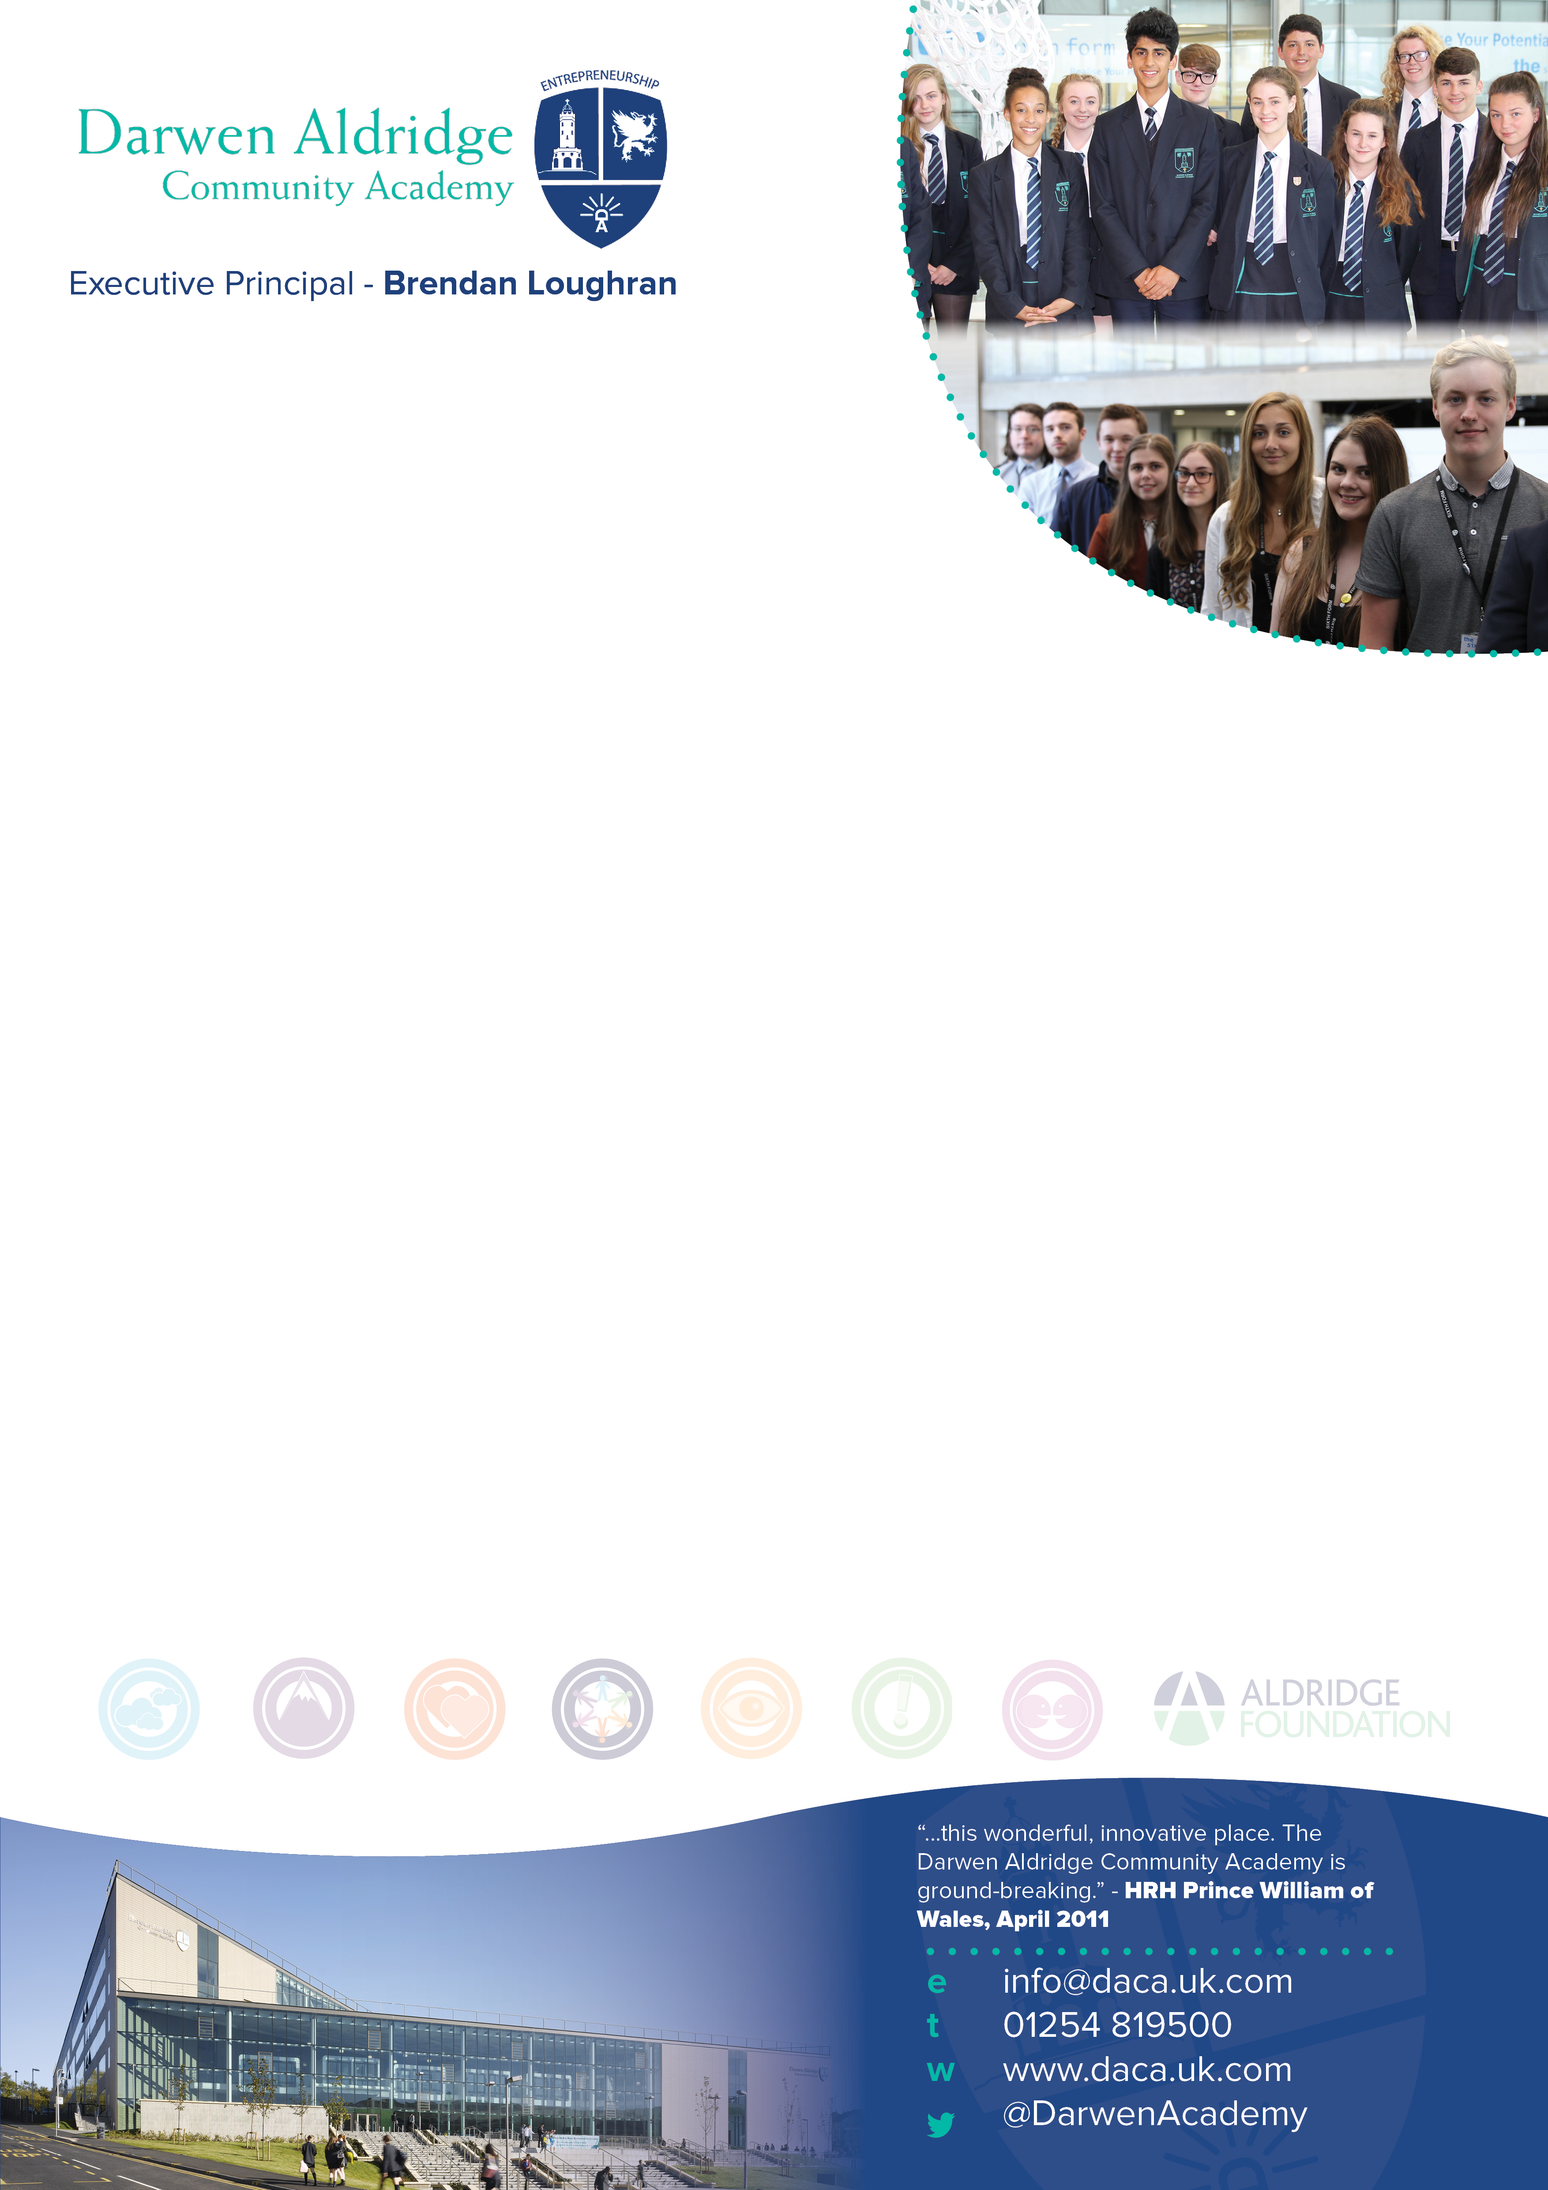

TEACHER OF MUSIC
Salary: MPS

Information for applicants
Required 1st September 2017

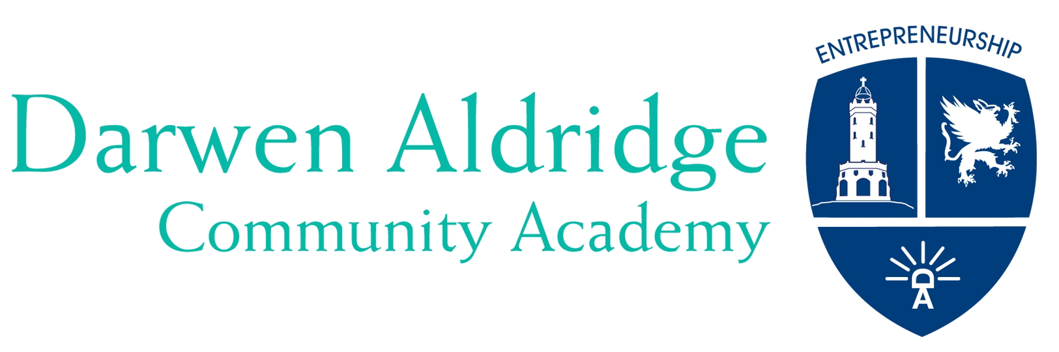

June 2017

Dear Colleague,

Thank you for expressing an interest in the post of Teacher of Music at Darwen Aldridge Community Academy. Darwen Aldridge Community Academy opened in 2008 as an original sponsored Academy. It has been the catalyst to the transformation of educational provision in Darwen, a town of around 40,000 people. In May 2017 the Academy was again judged to be a good school in every respect, and we are determined to see the Academy judged as an outstanding school in due course as we continue to improve outcomes. In September 2015, for the first time, the Academy was oversubscribed with the number of first preferences exceeding the 240 places available in Year 7. In 2016, for the second consecutive year, were again significantly oversubscribed in Year 7 and we are in the same position in September 2017. Upon opening, the Academy Sixth Form was the only post-16 provision in the town of Darwen, and we now work alongside our 14-18 partner, Darwen Aldridge Enterprise Studio School, who provide a complementary Key Stage 5 curriculum. Currently there are 260 students and it is anticipated that the Sixth Form will grow to 400 learners.

Since the Academy opened, GCSE exam results have continued to improve, from 23% (2009) to 60% (2016) gaining 5+A*-C GCSE and equivalent including English and mathematics. In 2013 the Academy was recognised by the SSAT as the 7th most improved school in the country in terms of GCSE results. Year-on-year, around two-thirds of the Year 11 cohort progress into the Sixth Form. To build on our outstanding results and student progress, we are looking for an exceptional practitioner to be part of our growing Creative and Performing Arts Faculty. Music is a popular subject with most students, with many participating in its extra-curricular activities during and after the Academy Day. Results in Music are above national standards, and students often perform above expectation. Applications are sought from both newly qualified and experienced teachers who have the flexibility to offer teaching across the age, ability and subject range. Teaching is likely to include Key Stage 3 and GCSE, and post-16 may be available for a suitably qualified / experienced candidate. The Academy runs a comprehensive induction programme and staff are supported by weekly professional development opportunities throughout the year.
We seek to develop a passion for learning as well as an enterprising spirit, and encourage our students to recognise the potential that they have, and then to fulfil that potential. Potential applicants will find useful details about the Academy and MAT at http://www.daca.uk.com, and our sponsor Sir Rod Aldridge at www.aldridgefoundation.com/site/web/home.html. Our sponsor is a keen supporter of engaging young people in entrepreneurial education and raising their aspirations. In 2015, DACA was named the best UK school in Europe for entrepreneurial education and received the award from JA Europe at the European Parliament in Brussels. We operate as a northwest based cluster which is one part of a single national MAT, Aldridge Education. The cluster and the MAT are growing, creating opportunities for new partnerships and school to school support and learning.

Finally, the Academy is the lead school in a current Teaching School bid, and we will find out whether or not we are successful in June 2017. If we are, this will open up further opportunities to develop our staff training in respect of the sixth form.

Please find enclosed with this letter;
General information about the Academy
A job description for the post
A person specification for the post
An application form
A prospectus

I hope that this information will encourage you to apply for this key post. The closing date for applications is noon on Friday 7th July 2017 with interviews to be held the following week. If you do apply for the above position and have not heard anything within one week of the closing date, you can assume that you have not been short-listed on this occasion.

The Academy is committed to safeguarding and promoting the welfare of children and young people. References will be taken up for all shortlisted applicants, and successful candidates will be subject to satisfactory enhanced disclosure from the Disclosure and Barring Service.

Yours faithfully,
David Cane
Interim Academy Principal

Darwen Aldridge Community Academy Information

The Academy opened in September 2008, and moved into a new state-of-the-art building adjacent to the town centre in September 2010. Its stunning facilities include state of the art classrooms and open learning environments, an entrepreneurship centre, a dedicated Sports Centre with 21st century gym equipment, a MUGA and an all-weather pitch. The building has been designed to meet the needs of our 21st century learners and our local community and businesses.

The Sponsor
The sponsor of the Academy is Sir Rod Aldridge, providing funding through his charitable trust, and on-going support through the Aldridge Foundation. The Aldridge Foundation brings extensive expertise from the public and private sectors to support this project.

The Multi Academy Trust
The MAT is a single national MAT, Aldridge Education. We operate in cluster across the country and we are the lead in the north-west cluster. Our plans are for growth of the MAT and cluster, so this is an exciting time to join us.

Sponsored Academies
Sponsored Academies are secondary schools aiming to break the cycle of under-achievement in areas of social and economic deprivation. Academies bring together innovative approaches to teaching and learning with state-of-the-art technology and surroundings. A defining feature of an Academy is its specialisms. Our first specialism is entrepreneurship which has been a real and dynamic part of Academy life from the moment we opened. The second specialism for the Academy is Sport, which has prominence in our Sixth Form through our sports academies.

Entrepreneurship
Entrepreneurship is the main specialism for the Academy. To us, entrepreneurship means:
Developing a positive attitude and a determination to succeed
Developing the highest standards in the teaching and learning of business and enterprise
Providing opportunities for young people to learn about and become involved in social entrepreneurship
Developing strong partnerships with a range of other education organisations
Developing strong partnerships with adult learning providers and the business community

Through our specialisms, the Academy will instil in young people a determination to succeed, to achieve high expectations and to become more responsible for the world within which they are growing up. An imaginative and innovative curriculum has been developed at the Academy. The timetable combines an offer of academic and vocational courses to ensure that the needs of all students are met. The design of the Academy reflects a curriculum structure where lessons are within extended morning and afternoon learning sessions, with additional extra-curricular sessions beyond the traditional school day. Our most recent Ofsted inspection in May 2017 achieved the grading of ‘Good’ under the new framework.

The Academy is committed to working in partnership with other organisations to support the development of provision, care and achievement for 14-19 year olds. The Academy is part of the Aldridge Multi Academy Trust and in collaboration with the Aldridge Foundation it was successful in its application to sponsor a Studio School based in Darwen. In addition, in the north-west cluster, our partner schools in the MAT are Darwen Vale High School, Sudell Primary School and we co-sponsor the Media City UK UTC at Salford.

We hope that this information motivates you to apply for this position. You will probably recognise that we are in the process of raising standards and embedding the Academy ethos, and this is a great opportunity to make a contribution to an exciting project and to be involved in shaping the future educational provision in the town.

The Creative and Performing Arts Faculty

The Creative and Performing Arts faculty strives to be at the heart of a vibrant curriculum at DACA. Our aim is simple and relevant: we want all students to become outstanding practitioners in their chosen creative discipline. As a faculty we are highly successful team that achieves outstanding results that enables our students to gain places at world class universities .We will equip all students with the creative and visual communication skills that are needed in an ever changing, technologically diverse world. Through a range of exciting and contemporary learning contexts they will be equipped with the foundations for GCSE, A-level and future entrepreneurial success. Our students enjoy academic success and the challenge of learning. They become experts in articulating their developing ideas about a diverse range of issues. AT Key Stage three we teach across creative and performing Arts subjects, providing a holistic approach to the learning for each student. We deliver a contemporary and diverse KS3 curriculum that puts concepts first and attaches skills and processes to the gained knowledge empowering each learner.

The Music Department is currently thriving and an increasing number of students are participating in a range of activities. Student numbers have continued to grow at Key Stages 4 and 5, whilst peripatetic numbers and the Choir have grown considerably in the last 12 months. Students enjoy a diverse curriculum at Key Stage 3, study Eduqas GCSE Music. At Key Stage 5, we have students completing both the BTEC Subsidiary Diploma and started on the Eduqas A-Level Music course for first examination in 2018. Results over the last three years have been consistently above the national standards at Key Stage 4 and are expected to continue to improve. Extra-curricular activities currently include the DACA Voices Choir, Music Technology groups, Senior Rock Band, School of Rock and Keyboard Club. There are further opportunities for the growth of music, music technology and associated courses post-16, as well as increasing the number of students undertaking ABRSM qualifications. Department facilities include two teaching classrooms, two practice rooms, and one ensemble room. The department has Apple Mac computers and a range of software for use in music composition and production, state of the art keyboards, and an array of percussion, including Djembe and Samba kits. There is recording equipment with a studio space, which is an area where further expansion could take place. The school is committed to the success of Music and provides support for students interested in Peripatetic music lessons, with around 60 pupils currently involved in the disciplines of Piano, Voice, Drums and Guitar.

Over the past two years, the Music Department has been able to build a solid base of performers in the school. We have established a regular concert schedule within the Creative Arts Department, including the DACA’s Got Talent show, The Live Lounge night and the DACA Recital evening. This year the department organised the first cross-school performance for our annual Christmas Concert, involving pupils across the Aldridge Foundation in Darwen. The department has provided performers for the Darwen Live Music festival for the past two years and have also been involved in the Bolton Music Service “Voices Together” choral festival. After our successful production of “We Will Rock You”, we are performing “Chicago” for this year’s school musical. The department has a strong ethos of performance, with students heavily involved in the performance of the live music for each show. Finally, the Music department is leading a Concert Tour to Paris this summer for 59 performers across all three Key Stages,

We are looking to appoint an outstanding Music teacher who can inspire students, work as part of our team and contribute to the development of the Faculty as a whole. The department has a solid reputation and foundation with a wonderful group of keen musicians across all Key Stages. The right candidate will be someone who can motivate and inspire our students; someone who is dedicated to developing the ethos of performance that has been cultivated within the department to build on our recent successes.

Louise Klinck
Director of Learning for the Creative and Performing Arts Faculty

Darwen Aldridge Community Academy
Job description – Teacher of Music

You are to carry out the professional duties of a school teacher as set out in the current School Teachers’ Pay and Conditions Document.

All colleagues are expected to demonstrate a wholehearted commitment to the development of the Faculty and a willingness to assist the Faculty Director of Learning in preparing for, and adapting to, the changing needs of the Faculty.

Your primary role is to assist in the delivery of Music and to maintain standards of literacy, oracy, reading, writing and communication.

You will model the entrepreneurial traits of having a determination to succeed and a positive attitude in all aspects of your work. You will endeavour to instil these attitudes in colleagues and students. You will be sincere in the belief that no barrier can prevent a student from achieving.

PURPOSE OF POST:
To teach a timetable including A Level Music (Eduqas specificiation), BTEC in Music, GCSE Music (Eduqas specificiation), and Music at Key Stage 3, across the ability range of the Academy, delivering agreed Schemes of Work, and to carry out the duties of a classroom teacher.
As part of an on-going review of monitoring of student progress, you have three core roles within the faculty:
Making judgements about the standards of students’ achievement.
The teaching and learning of students in your care.
Contributing to sustainable improvement by achieving those targets for improvement set by the Director of Learning for the faculty.

Judging standards
You will work with the Director of Learning for Creative and Performing Arts to make secure judgements about the standards of students’ attainment, rates of progress and personal development within your classes, on the basis of evidence gathered from:
- Analysis and interpretation of data on students’ attainment.
- Reviews with your Director of Learning of your assessments of progress for classes, identified groups and individual students.

Teaching and learning
You are accountable for the quality of teaching and learning within your classroom. You will need to understand what makes effective teaching in your subject area.
As a classroom teacher you are to carry out the day to day duties which include:
- using knowledge of academy policy, plan, deliver, evaluate and assess lessons differentiated to meet the needs of individuals and groups promoting progression, continuity and quality of learning;
- use a variety of suitable teaching and learning styles and clearly communicate learning objectives and expectations;
- take every opportunity in all academy activities to raise standards of literacy, numeracy, ICT and other key skills to give students access to all curriculum areas as well as enabling them to become lifetime learners;
- using relevant classroom management strategies to ensure a purposeful environment for teaching
- using agreed procedures for assessing, recording and reporting on progress and attainment of students;
- preparing students for internal and external tests and examinations informing and using whole-school data to raise expectation and standards of achievement;
- setting and effectively marking homework;
- working as a team member, planning co-operatively, sharing information, ideas and expertise;
- playing an active part in school meetings and working groups.

Sustainable improvement
You will need to ensure that the review, construction and resourcing of your lessons bring about improvements.
- You will agree targets for raising students’ attainment in the classes you teach.
- You will work with other subject and Faculty staff in the development of the new Programmes of Study, Schemes of Work and lesson plans for the Academy lesson delivery structure to embed the new qualifications at Key Stages 4 and 5.

General Duties
- You will work in accordance with current health and safety requirements: Governing Body, DfE, and Government policies.
- You will abide by the Conditions of Employment set out in the relevant paragraphs of the School Teaches’ Pay and Conditions document in operation at the time when you are carrying out your duties.
- You will carry out any other duties relevant to your post designated by Senior Staff and Director of Learning.
- To participate in induction and / or Teacher Appraisal arrangements.
- To take an active part in the pastoral care and discipline of students within your classes and set appropriate sanctions as set out in Academy policies.
- To carry out the role of Form Tutor, according to the Academy policy.
- To carry out a share of supervisory duties in accordance with the duty rota schedules.

Relationships
- You are responsible to the Principal or Vice Principal as delegated.
- You are responsible to the Director of Learning and faculty staff working within the faculty.

Additional Note
The above represents a broad outline of the duties and responsibilities currently attached to the post of Music teacher. Depending on the needs of the Academy, these may be altered from time to time in accordance with the conditions set out in the currently operating School Teachers’ Pay and Conditions Document and the relevant Governors’ Policy Documents.

Darwen Aldridge Community Academy
Person Specification – Teacher of Music
s
 | Essential | Desirable | Evidenced by
Experience | Relevant teaching experience 11-16 | Recent, relevant teaching experience 11-18  Recent experience of delivering consistently good and outstanding lessons  Recent experience as a form tutor | Application form  Interview
Qualifications | Qualified Teacher Status  Suitable qualification for the subject required | Higher degree or advanced qualification  A commitment to pursuing further qualifications | Application form
Professional Development | Evidence of responsibility for own professional development | Recent, relevant in-service training in current educational practice related to developments in English | Application form  Interview
Skills and abilities | Evidence of successful teaching which is consistently good or better  Excellent ICT and pedagogical skills  Excellent classroom management skills  Knowledge and use of a range of appropriate teaching and learning styles including strategies for differentiation  Enthusiastic and creative approaches to teaching and learning which maximise students’ abilities  Able to develop others’ capabilities and help them realise their full potential  Effective organisational skills and the ability to meet deadlines  Ability and willingness to work effectively in a team, planning co-operatively, sharing information, ideas and expertise  Proven ability to transfer enthusiasm and understanding of Music to students | Proven ability to inspire and motivate young people to achieve high standards  The ability to create and maintain a teaching environment which promotes effective learning and strives for achievement and excellence  Ability and willingness to initiate and participate in both cross curricular and extra-curricular activities, as well as demonstrating successful involvement in all aspects of Academy life  Evidence of excellent student achievement  A broad knowledge of relevant curriculum areas and current national initiatives including a sound understanding of assessment and monitoring | Application form  Interview  References  Lesson  observation
Other | Commitment to the safeguarding and welfare of students  Commitment to the aims and values of the Academy  Commitment to academic excellence and high standards  Presentational skills, confidence and fluency to deal with students, parents and others  Awareness, understanding and commitment to inclusion and equal opportunities  An understanding of the needs of young people  Capacity to work hard with all students  Energetic, positive and cheerful attitude  Is a strong role model for staff and students including having  excellent attendance and punctuality | Ability to contribute to the Academy specialism of Entrepreneurship  A good sense of humour, able to work under pressure and the ability to keep things in perspective  Has the potential for further promotion | Interview  Lesson  observation

