
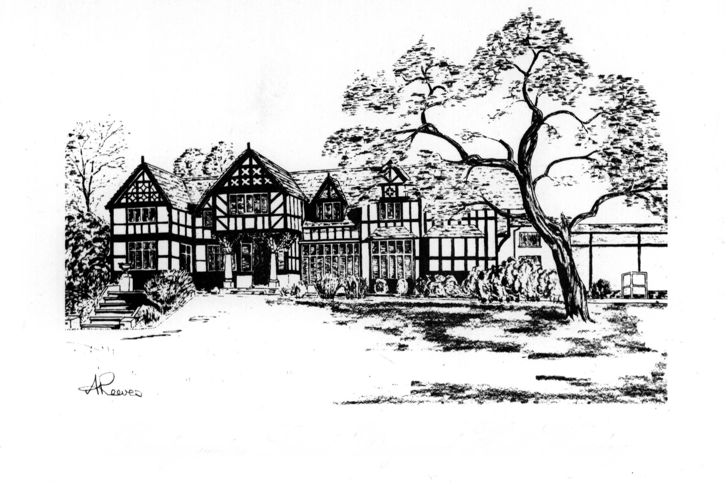
BRIDGEWATER SCHOOL
where individuals count

OUR SCHOOL 2018

Bridgewater School was founded in 1950 by a group of parents and its story over the past 60 years has been one of great success. Our parents are well-represented on our current governing body which is committed to retaining the original family ethos upon which the School was established. We benefit from an outstanding relationship between school and our parents. Bridgewater is an independent school belonging to the ISA (Independent Schools’ Association). Our students – girls and boys – are aged 3 to 18 and come from a wide social, cultural and economic background.

It is the School’s original and unchanging standards of endeavour, personal discipline and excellence which have enabled the School to flourish in such an outstanding way. It is the School’s aim to encourage all pupils to grow and become learners for life. We want our students to be happy and well adjusted, and to attain their full potential in every aspect of school life. This is facilitated in our School community where parents and teachers work together to provide all pupils with the guidance, support and encouragement that they need.

Over the last 20 years the School has invested many millions of pounds in improving its facilities that complement the neo-Elizabethan house which is at the heart of our site. This has included a new Preparatory building opened in 1991; a further classroom block in 1992; a new Senior School building opened in 1996 which included specialist laboratories, classrooms, cloakrooms, library and ICT facilities; then in 2006 a state of the art Sports Complex incorporating a dining hall, a classroom suite together with a combined drama studio and lecture theatre. In 2010 a new Early Years Foundation Stage (EYFS) unit opened which provided a spacious purpose-built area for the Kindergarten and Reception class. This unit was described as “outstanding” by the Independent Schools’ Inspectorate in our February 2015 inspection report. Continued development ensures that new buildings and facilities are suitable for the growing numbers of pupils attending Bridgewater School.

Our curriculum throughout the School is supplemented by numerous clubs, societies, enrichment activities and trips, both abroad and in the United Kingdom. This enables the School to be a happy and industrious community.

Bridgewater recruits outstanding staff and offers a stimulating challenge for a teacher who is well motivated, eager to participate and support the wider aspects of school life and has the desire to work in a school with traditional values – in other words an exciting environment in which to teach.

