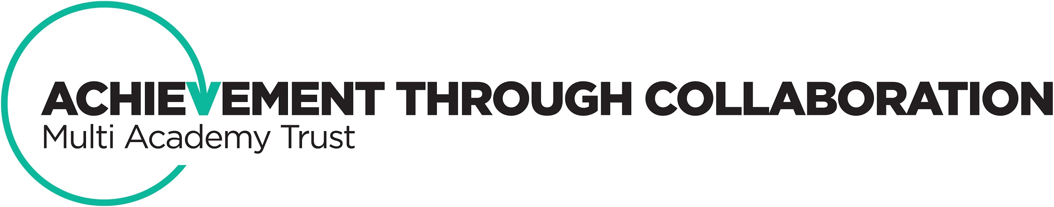

About Witton Park Academy

Witton Park Academy is part of Achievement through Collaboration multi-academy trust, working with Bowland High, and from November Roseacre Primary Academy. The Trust is looking to further grow during the year. Opportunities for professional development in this post exist both within school and across our schools. We would welcome candidates who would be keen to develop their expertise and who are already specialist leaders in education or wish to achieve this designation.

We have a well-developed professional development programme in school that capitalises on the high levels of expertise in our schools. We value training and encourage innovation that will improve the quality of pupils’ education. In addition to training, we offer a well-being package for all staff which includes access to, for example, physiotherapy.

At the heart of our school, and key to our success, is developing positive relationships with pupils and parents. This of course is also important in our working practice. Our leadership in school revolves around a moral purpose.

We have been recognised for our work with many external organisations that include:
- Google for Education
- UCL Holocaust education
- SSAT
- East Lancashire Teaching School Alliance
- UCLAN
- Oasis Human Resource Coaching
- ACE awareness NHS Wales

