Presdales School

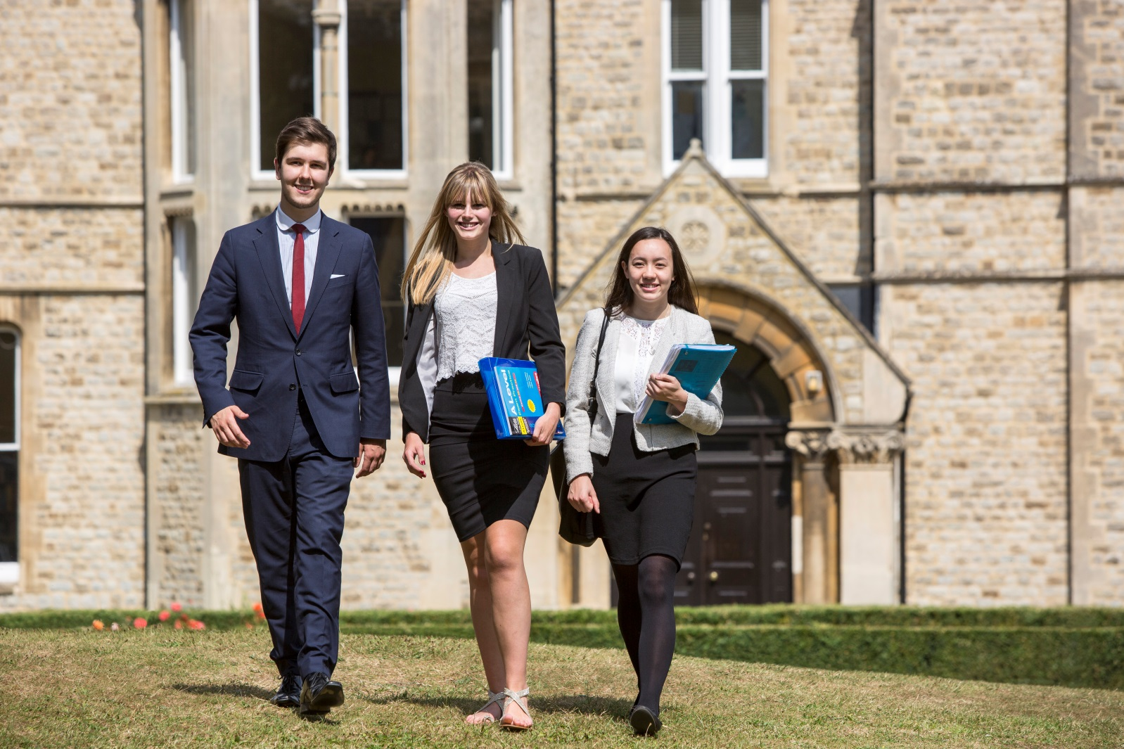

Candidate Information Pack
Teacher of Science (0.6 maternity cover)
Physics and/or Chemistry

Presdales School – Teacher of Science (Physics and/or Chemistry)
Information for candidates
Start date: September 2017
Part-time, 0.6 maternity cover
Thank you for your interest in joining our team of outstanding staff. Please find enclosed in this pack general information about the school and also specific information about the post.
I have been in post as the new Headteacher since September 2016, and took up the position following the retirement of the previous Headteacher after her 28 years as Head of Presdales School. We are a high achieving, all-girl, non-selective 11-18 school (boys are accepted into the sixth form).
Presdales has been graded as ‘Outstanding’ by Ofsted in the last four inspections. Student achievement is high, with 90% of the girls achieving a grade C or higher in both English and Maths, an attainment 8 score of over 61 and a progress 8 score over 0.3. 72% of our students achieved the EBacc measure. We have an intensive extra-curricular programme which offers the girls a chance to develop their leadership and team building skills as well as numerous trips during the year.
Presdales gained specialist college status for Languages, Maths and Computing, and English with Music. The students at Presdales are able to study the traditional languages taught in many schools, along with Russian and Italian. We have very vibrant Music, Art and Drama departments, where students are encouraged to create and perform. A large number of the students take instrumental lessons inside and outside of school.
We are seeking a confident and enthusiastic Teacher of Science who is able to inspire our students and who shares our vision for girls’ education. We have a highly successful Science department. Around 50 girls a year take triple science. We offer all three sciences at A level. You will be expected to teach general science as the timetable dictates.
I do understand and appreciate the time and effort it can take to complete an application for a job such as this; thank you for considering Presdales School.
Matt Warren
Headteacher

Presdales School

Teacher of Science
(Physics and/or Chemistry)
Start date: September 2017
Part-time, 0.6 maternity cover
MPS/UPS

We are looking to appoint an energetic and inspiring Science Teacher.

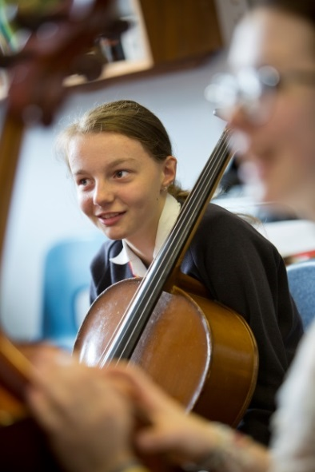
Presdales is an outstanding all-girls 11-18 school, with boys in the sixth form. We are a school which values all students, irrespective of their age and ability and helps them to exceed expectations through high quality teaching and learning and the opportunity to take part in a wide variety of activities which will enrich their educational and personal development beyond the classroom.
We provide a caring environment where all students are supported, as well as challenged, to ensure that there is no limit to their potential. We prepare our students for a world that is constantly changing by encouraging them to be independent learners who are determined, confident and who never give up. Alongside academic excellence there is a strong focus on enjoyment, excellent behaviour and respect for all.
The school is committed to safeguarding and promoting the welfare of young people and expect staff to share this commitment. Applicants must be willing to undergo an Enhanced DBS disclosure and approved references will be required for the post. We are committed to the equality of opportunity for all applicants, and we reserve the right to interview on a rolling basis, therefore an early application is advisable.

Closing date for applications: Friday 28th April (9.00 am)
We expect to interview: w/c 1st May

Please submit:

- A letter of application outlining how you meet the person specification
- A completed application form (available on the school website)

You can post your application to the school, or send by email to recruitment@presdales.herts.sch.uk
Please note that CVs will not be accepted

Person Specification – Teacher of Science

We are looking for a candidate who is able to demonstrate the following essential or desirable requirements

Qualifications
- A good honours degree
- Qualified teacher (QTS)
- A commitment to on-going professional development with evidence of further study or professional training
Knowledge and Experience
- Enthusiasm and passion for teaching
- Excellent classroom practitioner
- Knowledge of current educational developments in subject and implications
- Good understanding of how students learn and how to engage all levels of learner
- Good understanding of how to use assessment to raise standards of achievement
- Good subject knowledge
Skills and Abilities
- Able to communicate well, both in writing and orally
- Excellent organisational skills
- Good ICT skills and be able to use them in own teaching
- Able to manage time effectively and work to deadlines
- Ability to develop good personal relationships with students, staff and parents
Personal Qualities
- Committed to safeguarding and promoting the welfare of young people
- Excellent record of attendance and punctuality
- Ability to work well within a team
- Enthusiastic
- Ability to work under pressure and meet deadlines
- The ability to motivate others
- Positive attitude
- Self-motivated and hardworking
- Creative
- Sense of humour

Job description – Teacher of Science

Vision and purpose

- To teach across the age and ability range and to provide a learning environment that enables all students to make progress regardless of their starting points
- To share the responsibility of all staff to ensure that our students are challenged, encouraged, nurtured and developed as all-round young people

Main responsibilities

- Teach across the full range of age and abilities

- Committed to safeguarding and promoting the welfare of young people

- Monitor and evaluate the progress of students in your classes in line with school policies and lead on actions within your classes to address underachievement

- Plan and deliver lessons that are in line with the department’s curriculum

- To maintain good order and discipline in line with the school’s behaviour policy

- Actively engage in the performance management process

- Communicate effectively both orally and in writing with students, staff, parents and governors

- Have a commitment to your own continued professional development

- Keep up-to-date with your subject knowledge

- Attend all relevant meetings as required in order to fulfil your role and responsibilities

- Be a form tutor as required

- Ensure that all students have equality of opportunity

- Promote the school’s ethos and culture within the department and wider community

- To comply with the school’s Health and Safety policy

Whilst this job description is current, and every effort has been made to explain the main duties and responsibilities of the post, each individual task may not have been identified. Employees will be expected to comply, following consultation, with any reasonable request from the Headteacher to carry out tasks and duties that are of a similar level, but not specified in the job description.

