POSITION: | Lead in Mathematics
REPORTS TO: | Principal
SALARY: | ELSS pay scale equivalent to MPS/UPS + Inner London Allowance + TLR dependent on experience and skills
CONTRACT: | Full-Time, Permanent
PENSION: | Teacher’s Pension

Job Description

KEY PURPOSE OF THE POSITION
Mathematics is fundamental to the teaching vision of East London Science School. Without Mathematics, our pupils are not educated. This outstanding opportunity is for a driven and motivated Mathematics lead to match the desire for knowledge in our pupils with the intellectual vision of the school. We want a lead teacher with genuinely high intellectual and organisational expectations to help develop our curriculum and inspire colleagues to teach Mathematics to the highest level of subject excellence.

MAIN AREAS OF RESPONSIBILITY:
- Exemplifying and modelling the intellectual vision of the subject to pupils and colleagues – and seizing opportunities to do so.
- Ensuring the quantity and quality of Mathematics work done is to a high enough standard for all pupils and is genuinely aspirational.
- Identifying and addressing any gaps in achievement.
- Clarity of communication to colleagues, pupils and parents about the expectations and opportunities in your subject.
- Working with school leadership to ensure subject consistency and expectations are high enough.
- Other professional and statutory roles and conduct as expected or requested.

This post allows substantial access to children; candidates are required to comply with school procedures in relation to criminal records checks processed through the Disclosure and Barring Service (“DBS”), and checks against the Children’s Barred List. If candidates are successful in their application prior to taking up post, they will be required to give written permission to the school to ascertain details from the DBS regarding any convictions against them and, as appropriate the nature of such convictions.

Equal Opportunities
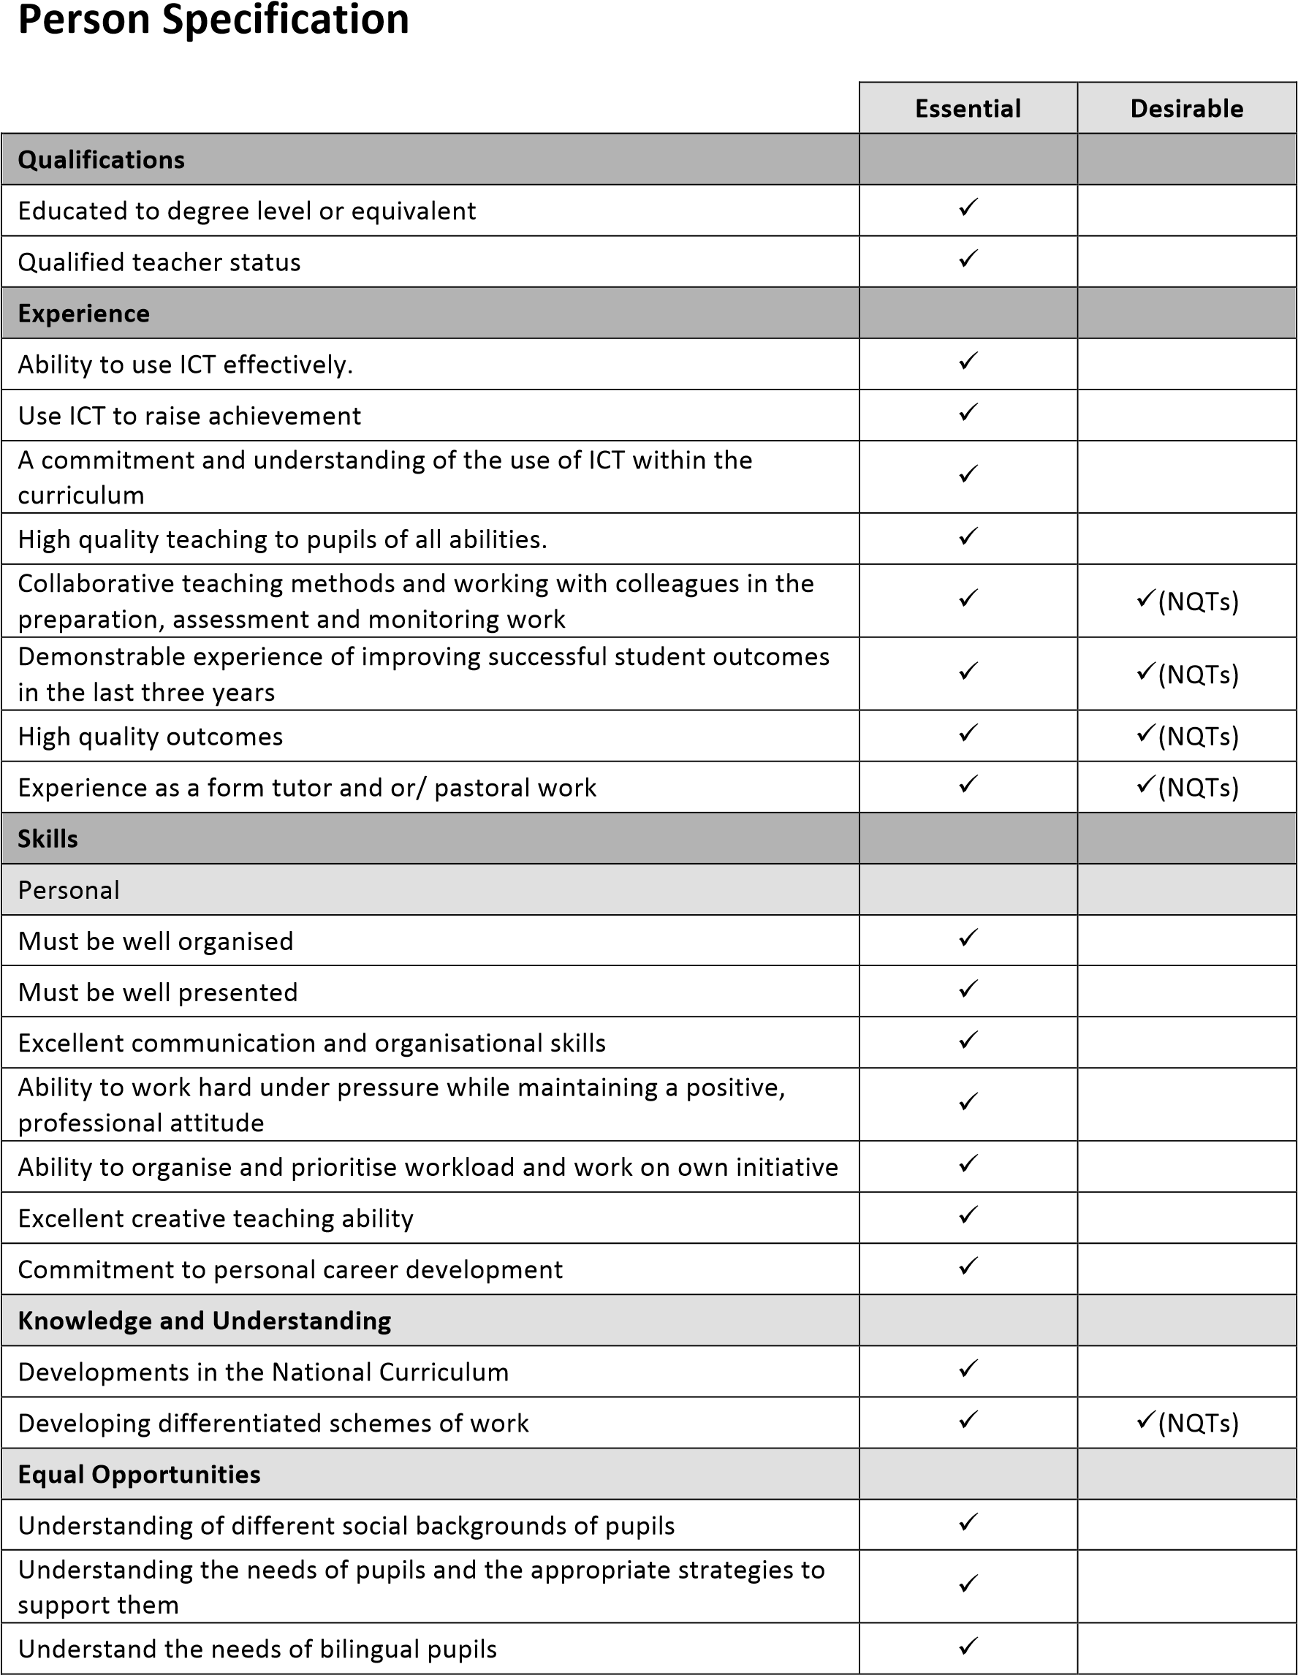
The post holder will be expected to carry out all duties in the context of and in compliance with the school Equalities Policies.

