

Job Description and Personal Specification for Primary Class Teacher

September 2016

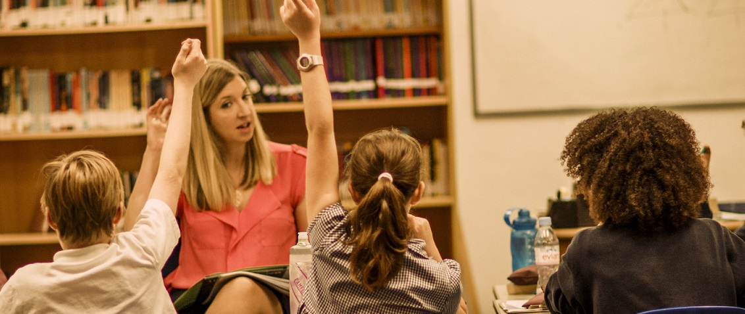
The Lyceum is a small, independent non-selective preparatory school for boys and girls ages 3-11, situated in the City of London and near to Old Street and Shoreditch.
It was founded in September 1997 by two primary school teachers teaching in Hackney who wanted to create a non-selective school which expressed their unique educational philosophy. One that was delivered through a topic-based, holistic approach to teaching and learning, with an emphasis placed on the visual and performing arts at the centre of the curriculum. With access to everything that London has to offer as an educational resource and with an emphasis on courtesy, manners and a compassion for those less fortunate than themselves all of this creates well-rounded children who transfer at 11+ to a range of well- regarded and successful senior schools in London and beyond.
The Lyceum is a happy place where learning is rich, fulfilling and exciting and our pupils do exceptionally well. Our school is an oasis of calm in the heart of London where we nurture our children with time, expertise and care. With just over 100 pupils in the whole school we are able to offer each and every one of our students the individual care and attention they deserve.
“The Lyceum is a wonderful school, full of happiness and joy” Year 6 pupil
While our curriculum is based on the National Curriculum, and delivers all of its subjects, we teach through topics from Early Years onwards, in a carefully structured scheme of work that is as balanced as it is broad. Each class learns about a new topic each term, and through this they explore every aspect of the curriculum, from Maths and English to Dance, IT and Religious Education. There’s never a dull moment in a Lyceum classroom!
“The Lyceum school is a happy place because of the children. As soon as they walk in the door in the morning, they are smiling, they are keen to learn and that’s infectious. That makes the staff smile and that is why we are happy!” – Reception Teacher
The Lyceum has an excellent pupil/teacher ratio with small class sizes. Class teachers are supported by well qualified and trained teaching assistants. The school opens at 8.30am and the formal day begins at 9am. The mornings are devoted to skills-based academic learning. Children bring packed lunches, and after lunch each day the children have a physical activity and an arts/music/sports programme. Formal lessons finish at 3.45pm followed by optional after-school clubs, until 5.45pm.
Our approach, our location and our strong family atmosphere makes The Lyceum a truly unique and special place for children to grow and learn.

Job Description for the position of Primary Class Teacher

Reporting to the Head, the Teacher will uphold the aims and objectives of the school and promote these whenever possible. The Teacher will endeavour to provide his or her pupils with the highest standards of education and care in accordance with the school’s aims, policies and procedures.
Professional Development
- The employee will be given an annual professional development interview.
- The employee will be encouraged to attend professional development courses as appropriate.
- The employee will be expected to attend staff meetings, conferences and other Inset.

Main Duties and Responsibilities
Teaching
- To deliver the curriculum as proscribed by the Head using materials and resources agreed with the Head, presenting lessons which cater for the full range of ability within the class and which motivate learning.
- To take full-time responsibility for the organisation, management and curriculum delivery for a class, and for the children’s progress.
- To produce written schemes of work and weekly plans for each subject taught and to review these from time to time
- To evaluate planning regularly
- To facilitate experiential learning which excites the imagination and unlocks the child’s potential.
- To teach pupils according to their educational needs, including the setting and marking of written work
- To assess, report on and record the development, progress and attainment of pupils
- To write a formal written report on each pupil twice yearly
- To liaise regularly with parents, including three formal consultations per year, to provide feedback on pupil’s progress.
- To promote the general progress and well-being of individual pupils
- To maintain appropriate displays of children’s work, at a high standard.
- To provide guidance and advice to pupils on educational and social matters, making relevant records and reports
- To communicate and consult with pupils’ parents
- To accompany children on trips and outings and complete the required risk assessment forms

Pastoral
- To register the pupils in your class at the beginning of the day and after lunch or to ensure that this is done by another teacher
- To encourage each child to reach his or her individual potential
- To ensure that pupils are well-behaved i.e. that they are both courteous and conduct themselves in a safe manner
- To ensure that pupils are aware of the school rules
- To ensure the safety of pupils both in and outside the school, having regard to the school’s Health and Safety Policy
- To attend to children who become ill or have an accident
- To raise any significant concerns about a child with the Headmaster, Deputy Head and colleagues
- To undertake a share in lunchtime and break supervision and to share general supervision of all children at all times.
- To supervise the collection of pupils at the end of the day

Other
- To communicate, when necessary, with persons or bodies outside the school
- To participate in staff meetings, open days, social evenings etc as required
- To work co-operatively with colleagues, including teaching assistants, offering help and support as required
- To implement decisions made by the Head or senior leadership team
- To participate in the school’s appraisal procedure
- To undergo training and professional development
- To cover for absent staff
- To take part in the development of the school, its policies and its activities
- To be fully aware of all Lyceum’s policies and procedures
- To be proactive in designing, producing and maintaining displays of children’s work
- To be sympathetic to the customs, values and beliefs of the child’s family or carers
- To keep teaching rooms tidy

These duties are neither exhaustive nor exclusive and may be changed from time to time.

