HMC Boarding and Day
1094 Boys; 260 Sixth Form

Head of Marketing and Communications

Bedford School

Situated just 35 minutes on the train from London St Pancras, and half way between Oxford and Cambridge, Bedford School is one of the region’s leading boarding and day schools, educating boys from the ages of 7 to 18. Part of The Harpur Trust, Bedford’s foremost educational and social welfare charity, we’re a vibrant school with a very strong sense of community, set in a beautiful 50-acre estate in the heart of the town.

There are some 694 pupils in the Upper School aged 13 to 18, with approximately 260 in the Sixth Form. 35% of the boys are boarders in our six boarding houses, each of which is “twinned” with a day house. Our Prep School with 400 boys caters for the 7-13 age range on the same campus, and has its own junior Boarding House.

Academic excellence is central to life at Bedford School, and we encourage boys to aspire to the highest possible standards and to exceed their expectations. Our success is demonstrated by a long history of impressive exam results at GCSE, A level, and in the International Baccalaureate Diploma. IB and A Level combined results saw 84% of grades at the equivalent of A* to B in 2017. 61% of GCSE results were at A/A* 2017. The vast majority of our leavers go on to Higher Education, and 78% of our Upper Sixth boys accepted places at Russell Group universities this summer; 10 boys went to Oxbridge in 2017.

The school was inspected in November 2016, and we are particularly proud of the fact that ISI (Independent Schools Inspectorate) gave us the top ratings possible. Full details, including a copy of the inspection report can be found here:
http://www.bedfordschool.org.uk/Inspection-Report

The school adopts a selective entry policy without being ruthless and seeks to provide an environment where all boys will thrive academically. It emphasises continuity of education at 13+ and 16+ so that, although there are academic entry requirements at each point, they are geared to whether boys are suitable to move to the next stage rather than over-formulaic targets. We believe in an all-round education that exposes all boys to a wide range of experiences and opportunities.

We place great emphasis on the value of Sport, Music and the Arts for the camaraderie, teamwork and self-motivation they instil, and encourage boys to explore their individual talents. Our extensive programme of extracurricular activities is wide-ranging and offers boys the opportunity to learn new skills and discover new interests outside the classroom. Boarding is at the heart of the school and all full-time members of the teaching staff are expected to contribute to the wider life of the school through involvement in the tutoring system and in activities outside the classroom.

The school’s ongoing development programme has included the construction of a new Library (2003), Observatory & Planetarium (2003), a new Music School (2006) and a wonderful new theatre in St Luke’s Church, on the edge of the estate (2015). Other developments have included renovation of the school dining halls and kitchens (2009), fitness suite (2010), staff common room (2011), sports pavilion (2012) and science department (2015).

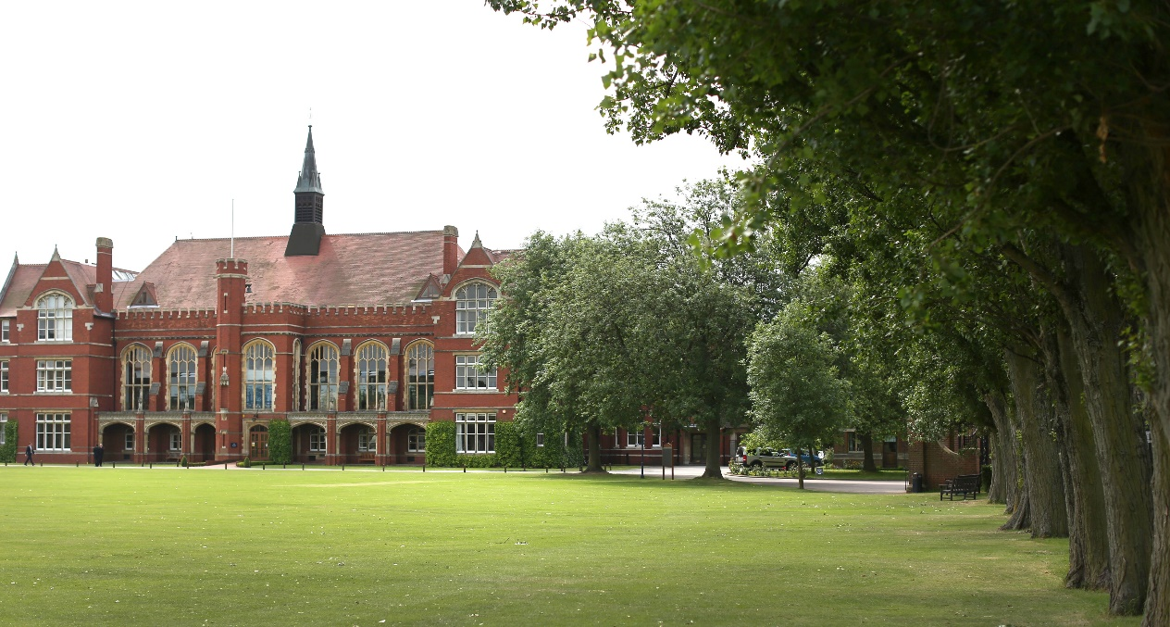

The Role

The Head Master is looking to appoint a Head of Marketing and Communications as a new role for Bedford School. This is an exciting opportunity for a proven marketing and communications professional to join this vibrant community, on a beautiful 50 acre campus in a riverside town only 40 minutes on the train from London.

This role would suit an individual who is a marketing specialist with a demonstrable track record of managing multi-channel marketing campaigns, an ability to systematically analyse markets, to efficiently build and execute marketing strategy and to influence others effectively. Strong team working and persuasive communication skills, both written and verbal, are essential to the role. The successful candidate will show drive and have an instinctive feel for the School’s customers and their needs.

Currently, the marketing of the school sits under the leadership of the Assistant Head (External Affairs). The Assistant Head (External Affairs) is simultaneously in charge of 3 key teams: admissions (a team of 3 FTE), events and holiday lets (a team of 2.5 FTE), and marketing, communications and PR (a team of 2.5 FTE). The teams reside in the heart of the school’s main building and work together in open plan and adjoining offices.

From September 2018, the Assistant Head (External Affairs) will take up a post as a Boarding Housemaster; he will keep his role in admissions, but the rest of the department will be restructured, with the marketing/communication/PR team reporting into a new “Head of Marketing and Communications” – i.e. this new role.

The new Head of Marketing and Communications will therefore arrive to lead an existing team, which administers the website, all social media, publications (digital and print) and advertising of the school. He/she will provide strategic leadership for this team by working closely with the Head Master to achieve the school’s goals. Beyond the immediate team, he/she will need to influence all involved in the school to embrace their responsibilities in this area.

Admissions at the school are as strong as they have been in recent years; and numbers this September are likely to be our second highest since 1990. We are now looking to build on this success with the recruitment of an outstanding specialist to take our public image forward.

Benefits of Service

Bedford School has high expectations of its staff and therefore looks to reward them with a competitive salary and beneficial conditions of service.

Bedford is set in beautiful grounds and staff are welcome to make use of the extensive leisure and sporting facilities (which includes gym, swimming pool, tennis courts, squash courts etc.) for themselves and their immediate family.

A generous pension scheme and private health care scheme with cash back benefits are available and all staff enjoy free on-site parking. Lunch (of outstanding quality) and free refreshments are available throughout the day.

Bedford is a dynamic and incredibly rewarding place to work with a strong sense of community.

General Information

Bedford School is committed to safeguarding and promoting the welfare of children and young people and expects all staff to share this commitment. Offers of appointment are subject to satisfactory references and DBS clearance.

Application Process

Applicants are asked to complete the School Application Form; CVs in place of an Application Form cannot be accepted.

Short-listed candidates will be invited to the school for interview on the advertised date.

For further information about the role please contact Anna Smith, HR Adviser on 01234 362218 or by email hr@bedfordschool.org.uk

Bedford School is part of The Harpur Trust

