Rhyddings Business and Enterprise School
Haworth Street, Oswaldtwistle, Lancashire, BB5 3EA
Telephone: 01254 231051
Headteacher: Mr P Trickett

Headteacher’s Position
Application Pack

Information for candidates

November 2017
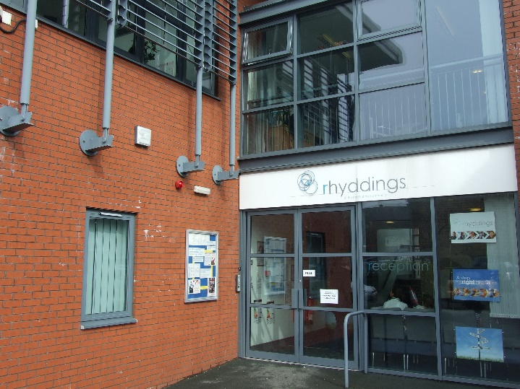
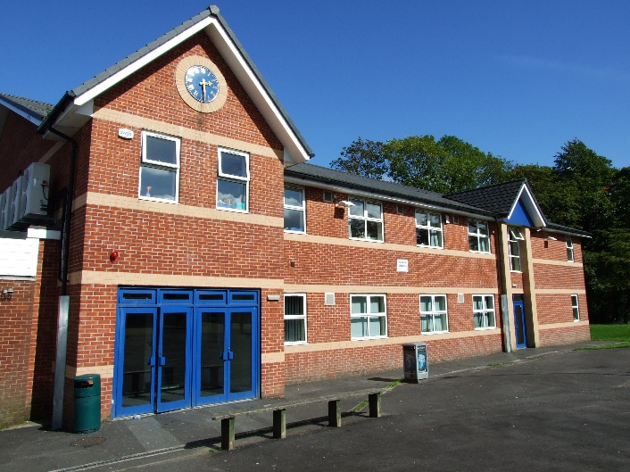
Application details

RHYDDINGS BUSINESS AND ENTERPRISE SCHOOL HEADTEACHER
GROUP 5 L22 – L29 (£66,017.00 - £78,359.00)
 | Group 5 Pay Range
 | L31 | £82 293
 | L30
ISR for a similar Group 5 School L22-L29 | L29 | £78 359
 | L28
 | L27
 | L26
 | L25
 | L24
 | L23
 | L22 | £66 017
 | L21
 | L20
 | L19
 | L18 | £59 857

The range for this post is L22 – L29 with the starting point to be negotiated.

Applicants are asked to provide a completed application form and a supporting statement (no longer than 3 sides of A4 in length in Arial point 12) that:

- clearly sets out how your experience to date prepares you for the advertised post (with reference to the enclosed person specification);
- Includes your personal philosophy for a successful 11-16 secondary school.

Governors would prefer applications to be returned by email to Mrs Shorrock, the Headteacher’s PA: school@rhyddings.co.uk

Opportunity for informal pre-application visit to the school:
Wednesday 15, Thursday 16, or Friday 17 November. Please telephone Mrs Shorrock at the school to arrange a convenient time. (Tel 01254 231051 Ext 232).

Closing date for the receipt of completed applications:
12noon, Thursday 23 November 2017

Shortlisting date:
Tuesday 28 November 2017

Interviews:
Thursday 7 December 2017 (in school)
Friday 8 December 2017 (at the Oswaldtwistle Mills Business and Conference Centre)

Please note: Receipt of an application will be acknowledged by email. Subsequently if you have not been contacted within one week of the shortlisting date, you should assume that your application has been unsuccessful.

It is our policy to take up references for shortlisted applications from their present Local Authority or Academy Trustees. It would greatly assist this process if you were able to supply e-mail addresses for all referees on your application form.

Rhyddings Business and Enterprise School
A message from the Headteacher
Dear Applicant,

First of all I would like to say how very proud I am to have been the Headteacher at Rhyddings since January 2009 and deputy headteacher up to then from September 1993. Needless to say there have been many many changes in that time, as the general landscape of education developed.

What hasn’t changed is the strong commitment to the local community that Rhyddings has shown and that helped form and develop what I have always referred to as the ‘Rhyddings Family’. Visitors will, more often than not, describe the tangible relationship between staff and students here that replicate/perpetuate the supportive, sympathetic and challenging attributes of a family.

During my 25 years here, the school has changed demographically in many ways. We have now approximately 560 students with current average intake of 105-110. This has shrunk from its largest of approximately 1050. The change has meant that the school has had to respond by actively reducing the number of staff through 2 major redundancy processes plus one re-structuring project. Whilst traumatic at the time, this has now lead to a smaller but stable staffing situation which allows us to still deliver a broad and balanced curriculum across all year groups.

At leadership level we have myself plus a leadership team of four assistant headteachers making up the SLT. Each member has their own specific set of skills and responsibility areas, but our strength is in the way we work collaboratively. In addition there is an extended leadership team of six who also have a specific whole school responsibility in addition to their collaborative contributions.

In terms of school published outcomes the school has always performed well, whatever the change in criteria and in particular showing very good value added for our students. In 2015 and 2016 there was a downward blip which saw us dip below floor target and hit criteria for a ‘coasting school’.

Deep analysis of the possible reasons for this resulted in a very focussed set of interventions leading up to the 2017 examination series. Consequently the outcomes improved to well above floor targets and criteria for ‘coasting schools’. We were the most improved school in Hyndburn and second most improved in Lancashire. We are extremely pleased about this and it illustrates how leadership and management have strategically reacted to a situation with a very positive impact.

Currently we are building on the strategies used and putting a re-emphasis on ‘Teaching and Learning’ through focussed action-research groups and whole school CPD.

In a ‘nut-shell’ then the school is in a stable staffing and economic situation with an improving outcome profile – who wouldn’t want to respond to this exciting opportunity?

My very best wishes to all who enquires and good luck to all who apply.

Yours faithfully,
Mr P Trickett
Headteacher

Rhyddings Business and Enterprise School
A message from the Chair of Governors

Dear Applicant,
Thank you for showing an interest in the position of Headteacher at Rhyddings Business and Enterprise School. Rhyddings is located in Oswaldtwistle, a township within the Borough of Hyndburn.

The school caters for students from Oswaldtwistle and Accrington, with some from further afield. Rhyddings is a true community school that attracts students from a wide variety of backgrounds.

Our school has a strong commitment to creating an environment in which the achievements of our students are maximised through tailored programmes of personalised learning. This commitment presents many challenges to leadership, staff and students. The ability of the school community to surmount these challenges is reflected in a consistent attainment of a “good” rating from Ofsted.

Governors are looking to appoint a Headteacher with the experience and expertise to build on the existing and good achievements and relationships within the school. The new Headteacher must be able to promote high expectations and have a clear strategic vision and core values to sustain continuous progress and improvement.

We are seeking to appoint a Headteacher who can build on existing good practice to ensure all our pupils achieve at a level that reflects their true ability.

You are most welcome to visit the school prior to your application on Wednesday 15, Thursday 16 or Friday 17 November. Please contact Mrs Shorrock on 01254 231051 to arrange a convenient time.

Yours faithfully,
R G Allonby
Chair of Governors

Rhyddings Business and Enterprise School
A message from our Junior Leadership Team (JLT)

Dear Applicants,
Thank you for taking an interest in the role of Headteacher at Rhyddings Business and Enterprise School. As a school which lives by its motto of being ‘at the heart of the community’, you will find us warm and welcoming and recognise our Rhyddings’ family environment as soon as your enter our building.
Students feel appreciated, valued and cared for and leave Rhyddings with big dreams and grades to be proud of. We are taught skills which set us up for the future such as: resilience, team work, self-management and reflection. Furthermore, as members of the JLT we have a voice which is listened to, and this is also reflected throughout the school with student voice groups, prefect roles and form and house captains. Once again this highlights our caring family environment. As a candidate for the Headteacher post you should be willing to build on the good rapports and get to know every student. With our school being small in size this means that the links between staff and students is stronger than most and is something which is very important to us.
Our school offers lots of exciting opportunities, such as an extra-curricular programme which is always evolving and an array of school trips. These include visits to Amsterdam, Pendle Hill, Wales, Belgium, France and Auschwitz, as well as many other cultural experiences. Rhyddings also offers every year 9 student the opportunity to partake in the Duke of Edinburgh Award.
Students here are more than just a number on a spreadsheet - we are individuals all from a range of backgrounds. We truly believe that the role of Headteacher at Rhyddings will be both challenging and extremely rewarding, and a great opportunity for anyone ready to take on the position.
We look forward to hearing from you if you feel Rhyddings is the school for you.

Rhyddings Junior Leadership Team

Rhyddings Business and Enterprise School
Person Specification

The applicant will be required to safeguard and promote the welfare of children and young people

Selection decisions will be based on the criteria below. At each stage of the process an assessment will be made by the appointment panel to determine the extent to which the criteria have been met and the ability to fulfil the job description for the post.
Candidates failing to meet any of the essential criteria will automatically be excluded at any stage of the process.
The appointing panel will use a combination of assessment tools to determine each candidate's suitability and the extent to which the criteria have been met. These assessment tools include (but are not limited to) the application form, supporting statement, information gathered during the interview process and references.

*A= Application Form & Letter (supporting statement), I= Interview, R= Reference

[A] Qualifications
Qualification requirements | Essential/Desirable | Evidenced By*
Qualified teacher status | E | A
Degree | D | A

[B] Professional Development
 | Essential/Desirable | Evidenced By
Evidence of recent and appropriate professional development for the role of headteacher. | E | A
Evidence of recent leadership and management professional development | E | A
Up to date safeguarding training and knowledge of legislation for the protection of young people. | E | A

[C] School leadership and management knowledge and experience
 | Essential/Desirable | Evidenced By
Successful leadership as a headteacher | D | A/L
Successful leadership as a deputy headteacher or assistant headteacher | D | A/L
Evidence of successfully leading school improvement | E | A/L/I/R
Evidence of the application of strategies to review, evaluate and improve teaching and learning. | E | L/I
Experience of curriculum leadership and development | E | L/I
Experience of working constructively with parents | E | L/I
Experience of monitoring staff performance | E | L/I
Experience of effective budget management and financial analysis | E | L/I
The ability to provide support and advice to the Governing Body to enable it to meets its responsibilities. | E | L/I
An understanding of strategic financial planning in relation to its contribution to school improvement and pupil achievement. | E | L/I
To have had experience of guiding, coaching, mentoring or training individuals or teams. | E | L/I
Maintains good awareness of current national education policy and strategy. | E | L/I

[D] Experience and knowledge of teaching
 | Essential/Desirable | Evidenced By
Successful teaching of pupils in the secondary phase | E | R
Experience of teaching in more than one school | D | A/R
To have a working and current knowledge and understanding of Key Stage 3 and Key Stage 4. | E | A/L/I
Can effectively analyse school data and identify appropriate actions which then form part of the school improvement plan. | E | I
Commitment to ensuring inclusion and addressing diversity positively. | E | L/I
A sound understanding of how children learn, how teachers can best teach and how to raise achievement for all pupils. | E | L/I

[E] Professional Attributes
 | Essential/Desirable | Evidenced By
Strong behavioural management skills | E | R
An ability to communicate effectively, both orally and in writing, with a range of audiences | E | L/I
To be a leader of learning; demonstrating, promoting and encouraging excellent classroom practice. | E | L/I/R
A commitment to the professional development for all staff, and self. | E | I
Have a good commitment to sustained attendance at work | E | R
To have good judgement; able to assess and balance risks and opportunities | E | I
A desire to engage and work collaboratively with parents and carers. | E | L/I
The ability to plan and prioritise and organise self and others | E | I/R

[F] Personal Qualities
 | Essential/Desirable | Evidenced By
A passion for achieving the very best outcomes for all children | E | I/R
A clear vision for an innovative, progressive and forward thinking school. | E | L/I
The ability to communicate the clear vision for the school to all people | E | I
The capacity to provide inspirational, enthusiastic and innovative educational leadership | E | I/R
A caring and considerate attitude towards children, which values each child's potential and recognises each child as an individual. | E | I/R
Flexibility, initiative and drive to maintain a positive attitude in the face of a challenging and demanding job | E | I/R
An ability to establish effective working relationships with a wide and diverse range of people including pupils, parents, governors, colleagues, other professionals and wider community | E | I/R
The ability to inspire confidence | E | I/R
Excellent interpersonal skills. | E | I/R
The ability to perform effectively under pressure | E | I/R
The ability to build, create and then communicate a clear vision for the school | E | I/R
Think analytically and creatively and demonstrate initiative in solving problems | E | I/R
Be aware of their own strengths and areas for development and listen to, and reflect constructively and act upon as appropriate, feedback from others | E | I/R

[G] Safeguarding
 | Essential/Desirable | Evidenced By
Displays commitment to the protection and safeguarding of children and young people | E | I
The ability to form and maintain appropriate relationships and personal boundaries with young people. | E | R
Has up to date knowledge and understanding of relevant legislation and guidance in relation to working with and protection of children and young people | E | A/I/R
Will co-operate and work with relevant agencies to protect young people | E | I

[H] Professional Skills

Each candidate will be expected to demonstrate knowledge and understanding of the National Standards of Excellence for Headteachers 2015 which also form the basis of the Job Description. Candidates will be expected to show evidence of having applied this knowledge and understanding in their current setting as well as an awareness of how this will be applied in Rhyddings Business and Enterprise School.

[I] Confidential References and Reports
Positive recommendation from all referees, including current employer | E

[J] Application Form and Supporting Statement

The form must be fully completed and legible. The supporting statement should be clear, concise and related to the specific post.

Rhyddings Business and Enterprise School
Headteacher Job Description

This job description reflects the National Standards of Excellence for Headteachers
(2015) these standards are built upon The Teaching Standards (2011) which apply to all teachers, including headteachers.

The appointment is subject to the current conditions of employment of headteachers, contained in the School Teachers’ Pay and Conditions document and other current
educational and employment legislation, including that of the Department for Education In carrying out his/her duties, the headteacher shall consult, where appropriate, with the Local Authority, the governing body, the staff of the school, its pupils and the parents of its pupils.

A. The Core Purpose of the Headteacher
The core purpose of the headteacher is to provide professional leadership and management for the school. This will promote a secure foundation from which to achieve high standards in all areas of the school’s work. To gain this success the headteacher must establish high quality education by effectively managing teaching and learning and using personalised learning to realise the potential of all pupils. The headteacher should establish a culture that promotes excellence, equality and high expectations of all pupils.
The headteacher is the leading professional in the school. Accountable to the governing body, the headteacher provides vision, leadership and direction for the school and ensures that it is managed and organised to meet its aims and targets. The headteacher, working with others, is responsible for evaluating the school’s performance to identify the priorities for continuous improvement and raising standards; ensuring equality of opportunity for all; developing policies and practices; ensuring that resources are efficiently and effectively used to achieve the school’s aims and objectives and for the day-to-day management, organisation and administration of the school.
The headteacher, working with and through others, secures the commitment of the wider community to the school by developing and maintaining effective partnerships with, for example, schools, other services and agencies for children, the Local Authority, higher education institutions and employers. Through such partnerships and other activities, headteachers play a key role in contributing to the development of the education system as a whole and collaborate with others to raise standards locally.
Drawing on the support provided by members of the school community, the Headteacher is responsible for creating a productive learning environment which is engaging and fulfilling for all pupils.

B. The Four Domains of Headship
Domain One: Qualities and knowledge.

- Hold and articulate clear values and moral purpose focused on providing a world-class education for the pupils they serve.
- Demonstrate optimistic personal behaviour, positive relationships and attitudes towards their pupils and staff, and towards parents, governors and members of the local community.
- Lead by example – with integrity, creativity, resilience, and clarity – drawing on their own scholarship, expertise and skills, and that of those around them.
- Sustain wide, current knowledge and understanding of education and school systems locally, nationally and globally, and pursue continuous professional development.
- Work with political and financial astuteness, within a clear set of principles centred on the school's vision, ably translating local and national policy into the school's context.
- Communicate compellingly the school's vision and drive the strategic leadership, empowering all pupils and staff to excel.

Domain Two: Pupils and staff.

- Demand ambitious standards of achievement and attendance for all pupils, overcoming disadvantage and advancing equality, instilling a strong sense of accountability in staff for the impact of their work on pupils' outcomes.
- Secure excellent teaching through an analytical understanding of how pupils learn and of the core features of successful classroom practice and curriculum design, leading to rich curriculum opportunities and pupils' wellbeing.
- Establish an educational culture of "open classrooms" as a basis for sharing best practice within and between schools, drawing on and conducting relevant research and robust data analysis.
- Create an ethos within which all staff are motivated and supported to develop their own skills and subject knowledge, and to support each other.
- Identify emerging talents, coaching current and aspiring leaders in a climate where excellence is the standard, leading to clear succession planning. Hold all staff to account for their professional conduct and practice.

Domain Three: Systems and process.

- Ensure that the school's systems, organisation and processes are well considered, efficient and fit for purpose, upholding the principles of transparency, integrity and probity.
- Provide a safe, calm and well-ordered environment for all pupils and staff, focused on safeguarding pupils and developing their exemplary behaviour in school and in the wider society.
- Establish rigorous, fair and transparent systems and measures for managing the performance of all staff, addressing any under-performance, supporting staff to improve and valuing excellent practice.
- Welcome strong governance and actively support the governing body to understand its role and deliver its functions effectively – in particular its functions to set school strategy and hold the headteacher to account for pupil, staff and financial performance.
- Exercise strategic, curriculum-led financial planning to ensure the equitable deployment of budgets and resources, in the best interests of pupils' achievement and the school's sustainability.
- Distribute leadership throughout the organisation, forging teams of colleagues who have distinct roles and responsibilities and hold each other to account for their decision making.

Domain Four: The self-improving school system

- Create outward-facing schools which work with other schools, organisations and the local community– in a climate of mutual challenge – to champion best practice and secure excellent achievements for all pupils.
- Develop effective relationships with fellow professionals, colleagues in other public services, parents/carers to improve academic and social outcomes for all pupils.
- Challenge educational orthodoxies in the best interests of achieving excellence, harnessing the findings of well evidenced research to frame self-regulating and self-improving schools.
- Shape the current and future quality of the teaching profession through high quality training and sustained professional development of all staff.
- Model entrepreneurial and innovative approaches to school improvement, leadership and governance, confident of the vital contribution of internal and external accountability.
- Inspire and influence others- within and beyond schools- to believe in the fundamental importance of education in young people's lives and to promote the value of education.

The applicant will be required to safeguard and promote the welfare of children and young people. The Headteacher is expected to demonstrate this commitment to safeguarding and promoting the welfare of children and young people and is expected to hold all staff and volunteers accountable for their contribution to the safeguarding regulations.

This job description forms part of the contract of employment of the person appointed to the post. It reflects the position at the present time only and may be reviewed in negotiation with the employee in the future. The appointment is subject to the current conditions of employment in the School Teachers’ Pay and Conditions Document as they relate to headteachers.

Rhyddings Business and Enterprise School
At a glance

STUDENT ACHIEVEMENT
 | 2013 | 2014 | 2015 | 2016 | 2017
Year 11 KS2 APS on entry | 25.7 | 26.6 | 26.3 | 26.7 | 27.1
Attainment 8 |  |  | 37.7  (opted out) | 41.2 (35.1 shadow data) | 40.8
Progress 8 |  |  | -0.72  (opted out) | -0.66 | -0.16
Proportion gaining 5A*C | 76% | 50% | 46%
Proportion gaining 5A*CEM | 52% | 43% | 38%
Proportion gaining EM C/4+ |  |  |  | 36% | 45.4%
Proportion making EP (English) | 66% | 59% | 63%
Proportion gaining C/4+ (English best entry) | 60.5% | 55.9% | 58.7% | 55.3% | 61.9%
Proportion making EP (Maths) | 58% | 51% | 39%
Proportion gaining C/4+ (Maths) | 62.8% | 50.7% | 45.7% | 42.7% | 53.6%
Disadvantaged pupils:  Progress 8 Gap |  |  | -0.09  (opted out) | -0.38 (in-house)  -1.02 (against national other) | -0.32
Disadvantaged pupils:  Progress 8 Gap (English) |  |  |  | -0.3 (in-house)  -0.92 (against national other) | -0.3
Disadvantaged pupils:  Progress 8 Gap (Maths) |  |  |  | -0.2 (in-house)  -0.93 (against national other) | -0.2

STUDENT CHARACTERISTICS
Figures taken from the October 2017 school census.
Number on roll | 574
Eligible for free school meals | 121
Attendance October 2016 | 92.9%
Attendance October 2017 | 94.2%
Percentage of students with SEN | 14%

Rhyddings Business and Enterprise School
Senior Leadership Team Structure and Responsibilities

Headteacher
Strategic direction  Overall standards/ Outcomes  Safeguarding  Oversight of SLT & ELT  - Lead Learner – Student Impact | - Business Studies  - Computing  - English  - PE
Assistant Headteacher – Professional and Social Capital
Pastoral/student support  Appraisal  CPD  SMSC + Citizenship  - Lead Learner – Coaching  - Lead Learner – SEND | - Evolve (performing arts)  - Geography  - RE + H&Sc  - Travel and Tourism
Assistant Headteacher
School Business Manager
Financial Planning
Non-teaching + Ancillary staff
CEIAG and Transition (2º3º)
Partnerships – business + community
Duke of Edinburgh Coordinator
Primary Liaison
Property Management
Health and Safety
Assistant Headteacher - Principled Curriculum Design
Teaching for Learning  Curriculum  Options  Pupil Premium  - Lead learner – Interventions  - Lead learner – Learning | - Art  - History  - Science  - Student mobility
Assistant Headteacher – Intelligent Accountability
Data manager  Reporting  Timetabling  Able Gifted Talented  - Lead Learner – Assessment  - Lead Learner – Technology for learning | - Maths  - Media  - Technology  - MFL

Rhyddings Business and Enterprise School
Leadership and staffing structure

Headteacher
School Design & Strategic Direction
 | Assistant Headteacher  Principled Curriculum  Cycle 2 DHT |  |  | Assistant Headteacher  Professional & Social Capital  Cycle 3 DHT |  | Assistant Headteacher  Intelligent Accountability  Cycle 1 DHT |  | Assistant Headteacher  School Business Manager  & Outward facing school  Cycle 4 DHT

 | Lead Learners
 |  | Induction and Coaching for improvement | Student impact | Learning | Interventions | Assessment frameworks |  | 1b

 |  |  |  | Technology for learning | SENCo |  |  | 2c

 | Lead Subject Teachers
 |  | Maths |  |  | Science |  |  |  | PE |  |  |  | RE/H&SC |  |  |  | 2c
 | Geography |  | History |  |  |  | EVOLVE |  |  |  | Design & Technology |  |  |  | MFL |  | 2b
 |  | Travel & Tourism |  |  |  | Business Studies |  |  |  |  |  | Media |  |  |  |  | 2a

TLR 3 may be used for time limited extra responsibilities

General teaching staff

