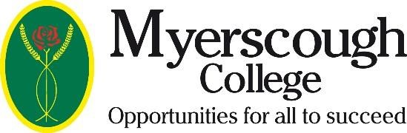

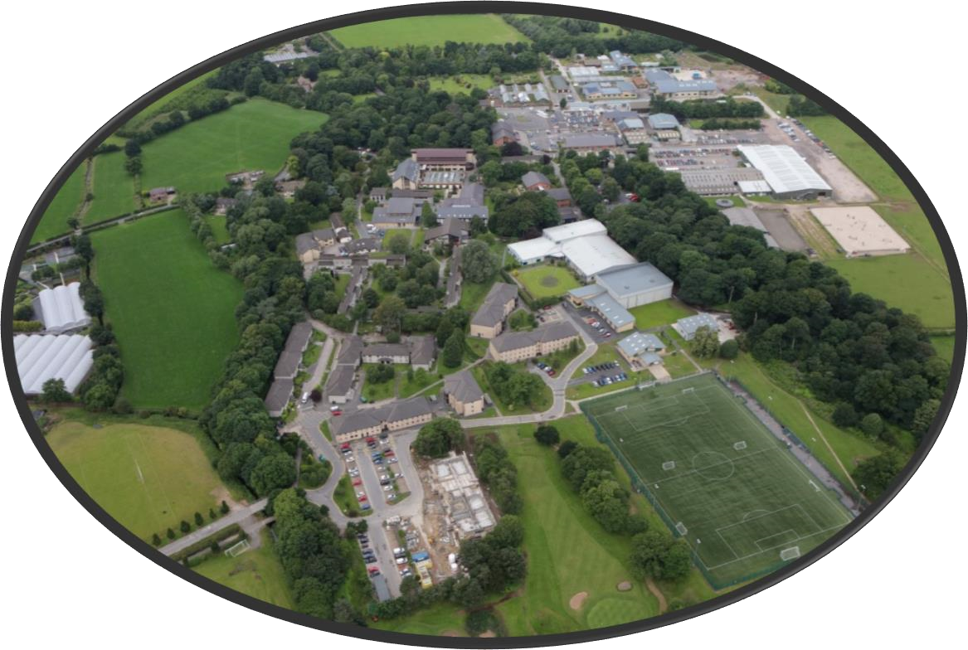

Chief Executive & Principal
June 2017

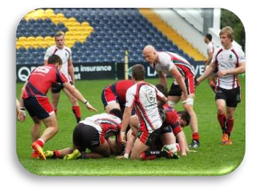

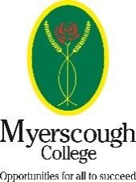

Table of Contents:

Letter from the Chairman 2
A little about Myerscough 3
College mission & values 4
Job description 5
Person specification 9
College management structure 11
College Corporation Structure 12
How to Apply 13

LETTER FROM THE CHAIRMAN OF MYERSCOUGH COLLEGE CORPORATION

Dear Candidate
Chief Executive & Principal
Thank you for your interest in the role of Chief Executive & Principal at Myerscough College in Lancashire and a very warm welcome to one of the leading land based and sports colleges in the country. This role will provide a strong, ambitious and passionate leader with the opportunity to make a significant contribution to the educational, economic and social landscape of Lancashire and play a leading role in the land based sector nationally.
Working with our committed, knowledgeable and enthusiastic Myerscough team in industry standard facilities alongside a wide range of regional and national partners, our mission is to provide opportunities for all to succeed. We provide students with not only a first class academic qualification but also the practical skills to meet the needs of industry and ensure their future employability. Delivering courses from entry to postgraduate level, alongside apprenticeships, Myerscough provides the opportunities for academic progression, whilst strong industry links with over 1400 employers ensure that the courses are not only industry relevant but also provide the best opportunities to progress into employment.
The College is an inclusive, caring community, putting the needs of the students at the heart of all decision making and ensuring their safety and wellbeing is paramount. Judged by Ofsted as outstanding for social care (March 2014) and meticulous for safeguarding (March 2017) the dedicated, cross college approach to student support and welfare ensures that each student is valued and able to gain confidence, progress and achieve their full potential.
The College approach to widening participation has seen the establishment of centres in Croxteth, Liverpool and Blackburn, areas of high levels of deprivation where the College provides the opportunity to study a land based qualification within a smaller, inclusive, caring community. A specialist centre, exclusively for cricket studies, is based at Old Trafford in Manchester utilising the first class resources available at the home of Lancashire County Cricket Club.
We believe that Myerscough is a special place to live, work and study and we are truly passionate about the future for Myerscough and the difference it can make to so many individuals. We are now seeking an inspirational, outstanding Chief Executive & Principal who is fully committed to building further on the current success, deliver on our aspirations to be recognised by Ofsted as outstanding, further grow our higher education, and ensure the long-term financial sustainability of the College.

If you want to join the Myerscough team and pursue your interest in this unique opportunity to lead the College to its next level, then I look forward to receiving your application.
Stuart Heys
Chairman of Myerscough Corporation

June 2017

ABOUT MYERSCOUGH COLLEGE

Myerscough College is a specialist land based and sports college based near Preston in Lancashire with centres in Liverpool, Blackburn and Manchester. It delivers courses from entry level to postgraduate within these specialist areas, supporting not only the local but also the regional, national and increasing international skills need. It was originally established as Lancashire County agricultural training centre in 1894, making it not only one of the largest but also one of the oldest specialist colleges in the country.
Myerscough was recognised as a Leader in Diversity in 2017 and has a culture that celebrates diversity and values every individual. A recent Ofsted inspection (March 2017) re-confirmed the position of the College as Good and recognised many significant strengths of the organisation where the student came first and teaching, learning and assessment was central to all decision making within a truly inclusive culture.
The QAA Higher Education Review in May 2014 gave Myerscough 2 commendations and identified 10 areas of best practice (the best report for any university or college in the country) with the Higher Education Teaching Excellence Framework (June 2017) awarding Myerscough with the silver standard, again reflecting the high quality of provision in a student centred organisation.
The recent area based review of post 16 provision in England confirmed that Myerscough would standalone post the review and recognised it as a large, specialist, financially strong college that contributes to the national as well as local skills needs of the sector.
The College is an Associate School of the University of Central Lancashire, whilst remaining independent, Myerscough works closely with UCLan on strategic developments to enhance the opportunities for students and meet the strategic priorities for the Lancashire Local Enterprise Partnership. Myerscough is a member of Landex, land based colleges aspiring to excellence and fully engaged in the peer review process and national activities. As a core member of the National Land Based College, Myerscough is playing a key role in developing new qualifications alongside the employers to ensure qualifications meet the needs of industry and with the formation of a new virtual college to enable the nationwide development of CPD and higher-level programmes to meet the significant skills shortages of the sector.
The College is financially strong and recognised by ESFA and the College auditors for the strength of financial management and control. The financial health is currently very good, in a planned dip from outstanding to allow for investment into the campuses. This investment has amounted to over £30m in the last 5 years including capital support from both the Lancashire and Liverpool City region LEPs.
Myerscough works closely with industry to ensure that the curriculum is fit for purpose, meets the needs for today, mindful of the demands of tomorrow and ensures students have not only the academic knowledge but also the practical skills to prepare them for employment or academic progression
.

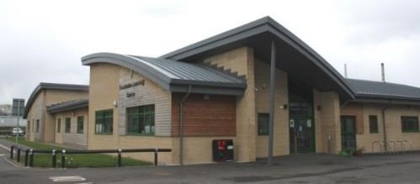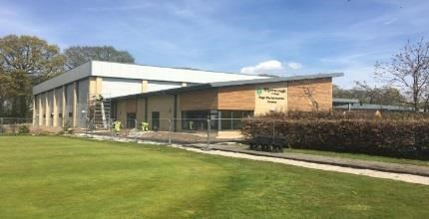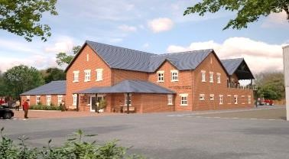
COLLEGE MISSION & VALUES

Vision:
To continue to be a leading provider in the land based and sports sectors and the natural choice for research, industrial partners and students who aspire to success.

Mission:
Myerscough will be the College of choice providing opportunities for all to succeed

Values:
- Respect for yourself, each other and the environment
- Welcoming, honest and inclusive
- Happy, safe and supportive culture
- Inspiring learners and staff to be the best they can be
- Positive and innovative

Strategic objectives:
- We will continue to build and enhance our brand and reputation for excellence within the land based & sports sectors.
- We will provide an outstanding teaching and learning experience
- We will create opportunities for all to succeed
- We will deliver great value for money

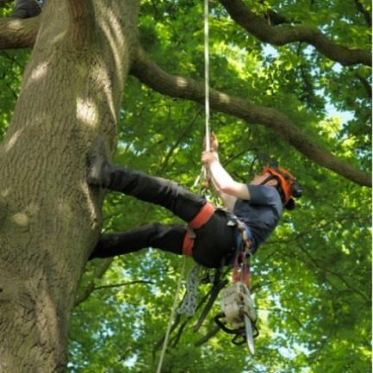

JOB DESCRIPTION

POSITION: |  | Chief Executive & Principal
LOCATION: |  | The College operates at its main campus near Preston, Lancashire and
 |  | from other centres in Liverpool, Blackburn and Manchester.
TERM OF APPOINTMENT: |  | Permanent
REMUNERATION: |  | Circa £120k p.a. plus negotiable benefits package
PENSION SCHEME: |  | Final salary pension scheme (Teachers’ Pension Scheme or Local
 |  | Government Superannuation Scheme)
REPORTING TO: |  | The Board of Myerscough College Corporation
LINE MANAGEMENT: |  | The Executive team:  Vice Principal & Deputy Chief Executive,  Deputy Principal Resources,  Deputy Principal Finance & Corporate Services,  Personal Assistant.

JOB PURPOSE:
The Chief Executive & Principal is responsible for the overall strategic leadership of the College, formulating and implementing strategic plans for the ongoing improvement and effectiveness of the organisation whilst providing highly effective leadership to ensure the achievement of the College’s mission.
Providing first class leadership to staff and students the Chief Executive & Principal will set high expectations and deliver excellent outcomes.
As Chief Accounting Officer, the Chief Executive & Principal will ensure the effective and efficient operation of the College, delivering the performance targets, budget, objectives and strategic plan as set by the Corporation.
In carrying out the role the Chief Executive & Principal will always act in the best interests of students with a strong focus on quality, standards and outcomes and the College mission of ‘Opportunities for All to Succeed’.
The post holder will be the Chief Ambassador for the organisation, articulating the College’s voice and values with all relevant stakeholders whilst building strong partnerships that benefit the College, its students, staff, employers and the wider community.
Context:
The Board of Governors have identified the following key opportunities and challenges for the new Chief Executive & Principal:
- Driving a successful college into the next phase of its development, delivering high quality education within a truly inclusive college.
- Maintaining strong financial viability and management
- Delivering the Government policies on education.
- Maintaining and developing Myerscough as a premier land based and sport college, at the leading edge of education, training and research
- Building and strengthening external partnerships with other providers, employers and professional bodies within the specialist sectors supported by the College
- Strengthening the College’s role as a major focus for skills development and industry innovation within the region and nationally
- Growing provision, notably in higher education
- Recognition by all external inspection agencies, including Ofsted, as Outstanding.
- Supporting and developing the College culture of inclusivity with ‘Opportunities for All to succeed’.

KEY RESPONSIBILITIES:
The Chief Executive & Principal will have the following responsibilities:
- Strategic Leadership and Development:

  - Provide first class leadership to staff and students, setting high expectations and delivering excellent outcomes.

  - To assist the Corporation in its determination of the character (including educational character) and mission of the College and be responsible for implementing the policies and decisions of the Corporation.

  - Work with, and to, the Corporation on the development of strategic plans for the ongoing improvement and development of Myerscough College, to ensure they meet the needs of students and respond appropriately to the local, regional and national educational and economic priorities.

  - To identify and exploit opportunities that will improve the College’s educational and business performance.

  - To determine the academic activities of the College to meet the needs of industry and students.

  - To foster an innovative, flexible and responsible attitude towards changes in the external environments to maintain Myerscough at the forefront of education, training and research within the specialist areas served by the College.

  - Ensure that local, regional and national educational and economic priorities are appropriately responded to through the provision of responsive and relevant education and training.

  - Ensure that there are effective arrangements in place for the monitoring, assessment and evaluation of performance against plans.

  - Ensure a high quality and responsive student experience is delivered in a student focussed, supportive, inclusive manner in which the student voice is effectively heard to enable effective decision-making.

- Culture and People:

  - Provide effective leadership across the College. Inspiring and motivating colleagues to deliver excellent outcomes.

  - Ensure the safeguarding and welfare of all students, staff, volunteers and visitors, notably in relation to Safeguarding and the Prevent legislation.

  - Ensure ‘loco parentis’ responsibilities for those students under 18 resident on campus.

  - Ensure the effective performance of staff, being a visible and approachable leader who inspires people to deliver high quality learning experiences and services.

  - To be an effective, supportive line manager, leading the Executive team to ensure a shared vision of an inclusive, high performing, values driven college.

  - Embrace the culture of inclusivity, celebrating diversity and constantly striving to provide opportunities for all to succeed.

- Relationship Management and Community Leadership:

  - Reputational management with the best possible promotion of the College externally.

  - Ensure that Myerscough is the College of choice for students, staff, employers, industry representative bodies and research.

  - To maintain and develop effective links with the local community, local and regional Government, external academic institutions, employers, professional bodies, representative groups and appropriate Government departments through both civil servants and elected representatives.

  - To represent the College on those external committees or other bodies which are considered to be relevant and influential to the present and future needs of the College.

  - Position the College as a proactive and open partner, constantly building the reputation of the organisation whilst exploiting opportunities to further the ambitions of the College.

- Business Effectiveness:

  - To ensure that the College’s operational objectives, plans and procedures are congruent with the strategic plan.

  - To obtain the highest efficiency from, and utilisation of, the human, physical and financial resources of the College.

  - Ensure robust financial planning to achieve future sustainability.

  - Ensure business and curriculum plans are capable of achieving financial, funding and contract targets in the most efficient manner.

  - Ensure the formulation of financial strategies and business plans to sustain the financial health and commercial resilience of the College.

  - On an annual basis, deliver the College budget and annual statement of income and expenditure, which are approved by the Corporation.

  - Ensure accurate, timely financial information is provided to the Corporation and its committees to allow effective decision-making.

- Effective Governance & Compliance:

  - Ensure the Corporation and its committees receive timely and accurate information to enable the effective oversight of College activities and to properly discharge its responsibilities.

  - Serve as Chief Accounting Officer, ensuring that the College maintains a sound financial position, whilst delivering a first class student experience.

  - Ensure that the College complies with all its statutory and regulatory responsibilities, enabling effective implementation of all policies and procedures having due regard for legislative requirements.

  - Work closely with the Chair and Vice Chair of the Corporation to ensure the effective oversight and performance of the College.

To undertake such other duties as the Corporation may, from time to time, determine in consultation with the post holder to ensure the continued existence, viability and progress of the College.
A Performance Enhancement Review will be carried out annually in accordance with College policy. This is undertaken by the Chair and Vice Chair of the Corporation.

PERSON SPECIFICATION

Experience
Essential | Desirable
Strong and inspirational leadership delivering strong outcomes in a setting of relevant size, scale and complexity. | Within an educational or training environment
A record of improving the quality of service and outcomes. | Improvements in student outcomes
Budget management and improving financial performance.
Strategic and business planning that delivers tangible improvements in performance.
The development and implementation of strategies, policies & approaches that result in improved performance.
Delivering successful outcomes in regulatory inspections. | Ofsted, QAA
A strong track record of establishing and developing positive external relationships and partnerships that brings tangible benefits to the organisation.
Ambassadorial role, representing an organisation.
Experience of, and interest in the land based industries and rural sector | Qualification in a land based subject &/or employment within the sector
Working with the Governing body to develop strategic aims, objectives and business plans.
Driving up performance and motivating staff from across the organisation to excel.
Strong team building skills and experience of operating a strong performance management system.
Experience of managing change programmes.

Ability, skills, style and behaviour
Essential | Desirable
Already working at a high level in a complex organisation. | Currently Principal or Vice Principal level
An accomplished team builder with the proven ability to motivate and inspire others to improve and succeed.
An expert people manager with the ability to lead others at all levels of an organisation with energy, enthusiasm, commanding respect and to provide an environment where others will feel motivated to achieve outstanding results.
A reflective and responsive leader who is a role model internally and able to translate strategy into operational success.
The ability to lead others with clarity, enthusiasm, passion, energy and gaining respect throughout the organisation.
A commitment and passion for an inclusive, diverse culture that values the individual.
A commitment to and focus on quality.
A collaborative, respected partner who facilitates positive relationships.
The ability to assess opportunities and seize them when appropriate for the benefit of the organisation.

A strong communicator (verbal and in writing) who enjoys a visible presence across the organisation and the respect of external stakeholders.
Commitment to the highest professional and personal standards of work, behaviour and conduct.

Qualifications
Educated to at least degree level, ideally with a higher level post graduate or equivalent professional qualification.

MYERSCOUGH COLLEGE MANAGEMENT STRUCTURE

Corporation
Chief Executive &
Principal
Deputy Principal
Resources
Human resources
Capital projects
Campus developments
Maintenance & estates
College farm
IT & MIS
Library & central resources
Vice Principal &
Deputy Chief Executive
FE curriculum
HE curriculum
Apprenticeships & skills

Student support
Equality, diversity & inclusion
Marketing & schools
R
Deputy Principal Finance &
Corporate Services
Financial management & control
Strategic financial planning
Funding
Data protection
Central administration services
Commercial services

Personal Assistant

MYERSCOUGH COLLEGE CORPORATION STRUCTURE

HOW TO APPLY

What to include:
- A completed application form
- Your detailed CV
- A covering letter explaining your motivation for applying and the knowledge and experience you can bring to the role and in particular your ability to meet the criteria laid out in the person specification. (no more than 3 sides of A4)
- A completed equality, diversity and inclusion form

Key dates:
Closing date for applications | Wednesday 30 August 2017 at noon
Short listing (if required) & opportunity to visit the College, tour the facilities and meet the current Chief Executive & Principal | Tuesday 12 September 2017
Final interviews | Monday & Tuesday 25/26 September 2017

Submitting your application:
Please submit your completed application form, CV, covering letter and equality, diversity & inclusion form, marked private and confidential to Mrs Jean Bird, Director of Human Resources, Myerscough College, St Michaels Road, Bilsborrow, Preston PR3 0RY ahead of the closing time and date.

