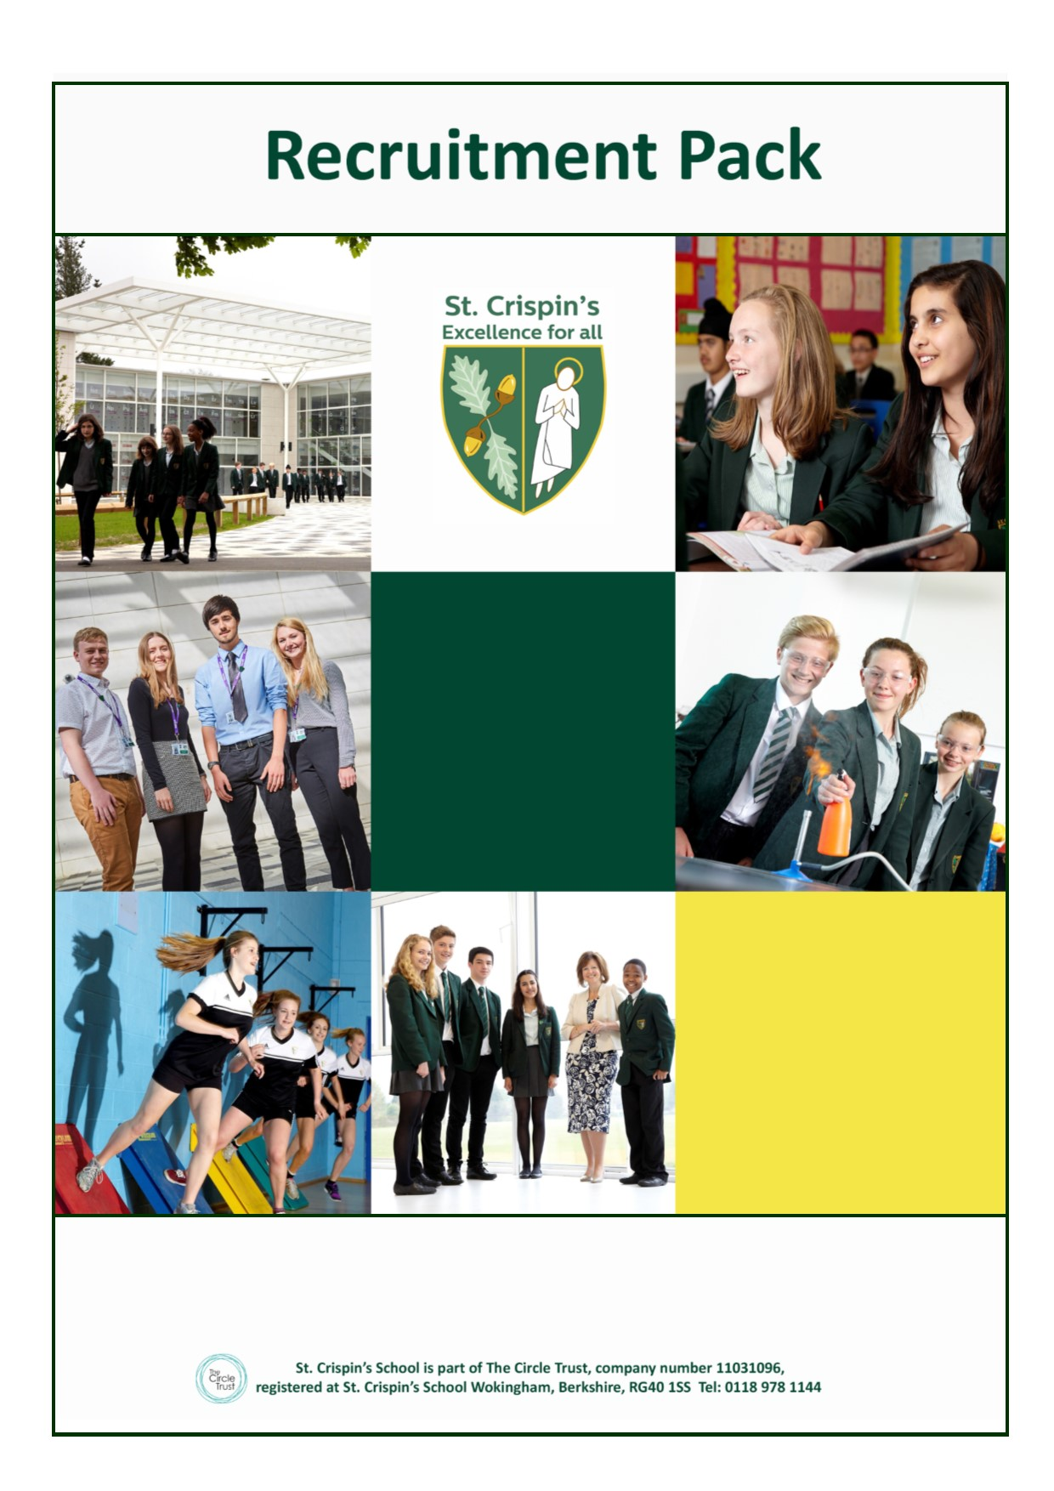
Deputy SENCO
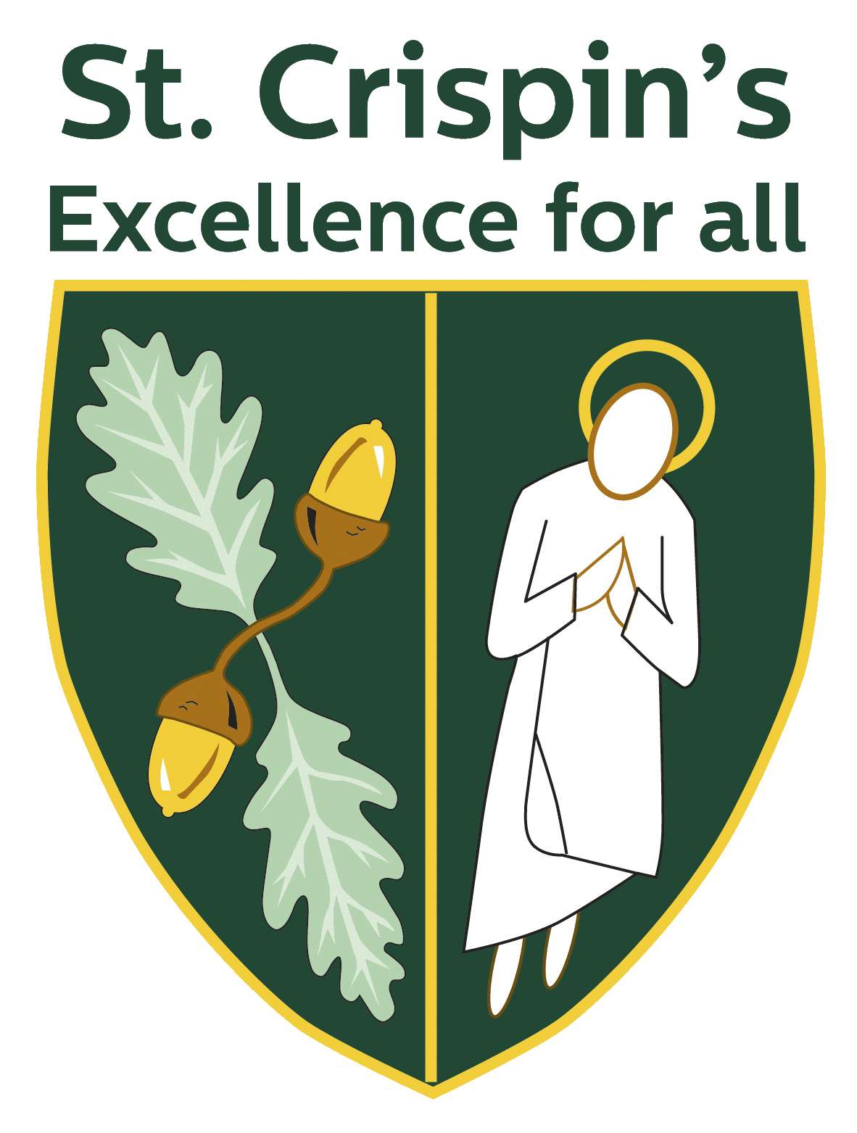
Deputy SENCO

St Crispin’s School
Headteacher:
Ginny Rhodes
NOR 1130, 11-18
Mixed Comprehensive, London Road, Wokingham, Berkshire RG40 1SS
Tel: 0118 978 1144
www.crispins.co.uk
Deputy SENCO - Full time TLR 2.2 for September 2018
Great opportunity for professional development and seekers of a long-term SENCO post

We are seeking to recruit a new Deputy SENCO to support the leadership of the Learning Support Department.

St. Crispin’s School is a very happy and oversubscribed 11-18 mixed comprehensive school. Our school motto is “Excellence for All” and this encapsulates our commitment to do the very best for both our students and staff. Standards within the school are high and St. Crispin’s is a lovely and positive place to work. Our school has a great many strengths, is far from complacent and has the potential to do even better.

To apply, click on the APPLY button or visit: www.crispins.co.uk/vacancies

For more information, contact: Mel Knight on 0118 978 1144 or email: knightm@crispins.co.uk

Visits to the school are warmly welcomed!

Closing date: 9am, 22nd May – Application form and letter of application to the Headteacher
Interview date: 24th May

This school is committed to safeguarding and promoting the welfare of children and young people and expects all staff and volunteers to share this commitment. Appointments are subject to enhanced CRB clearance and satisfactory employment references.

Job Description

Aim and main purpose of the job

To support the SENCO in leading and managing the Learning Support Department.

General Accountabilities

- Deputise for the SENCO in their absence.

- Support to identify, assess, monitor, review and evaluate pupils with SEN.

- Support to provide up to date and relevant information to all teachers regarding pupils with SEN providing them with information and strategies to support learning.

- Support the development of the curriculum to ensure the delivery of an appropriate, comprehensive, high quality and cost effective Bridge curriculum programme.

- Provide regular feedback for Teachers and LSAs in a way that recognises good, practice and supports their progress against performance management objectives resulting in a tangible impact on student learning.

- Support a continuous and systematic review of the standards of leadership, teaching and learning in Learning Support, consistent with the procedures in the school self-review policy.

- Ensure all Learning Support Department staff understand and are actively implementing, the key aspects of the school’s behaviour and inclusion policies.

- Act as a role model in leading staff in own high quality teaching, continuous professional development and professional presence in the department.
- Follow statutory guidance and school policies including child protection and safeguarding.

- Teach mainstream specialist 0.5 load.

- Carry out tasks as reasonably required by the Headteacher.

Specific Accountabilities

- Ensure the efficient deployment, organisation and upkeep of departmental resources. Including the responsibility that rooms and areas used by the department provide a safe, high quality environment for learning.

- Present and promote curriculum area for evening events such as Options, Open Eve. Sixth Form Open Eve.

Details of Line Management

This post is line managed by the SENCO; this post line manages, in the absence of the SENCO, members of department in Learning Support

Notes:

Whilst every effort has been made to explain the accountabilities of this post, each individual task undertaken may not be identified.

This job description is current, but following consultation with you, may be changed by the Headteacher to reflect or anticipate changes in the job, which are commensurate with the salary and job title.

Learning Support Department Information

Thank you for your interest in joining the Learning Support Department at St. Crispin’s.

St Crispin’s School is committed to inclusion. We work closely with our primary feeder schools so that we have a clear understanding of the individual barriers to learning that the young people joining us have. This enables us to offer the best possible support for students transitioning to us. We recognise the importance of early intervention and the Learning Support team works closely with every department to ensure the needs of all students are met. The work that we do, therefore, impacts on every department in the school and across all key stages.

The Learning Support Department is an enthusiastic, forward-thinking and flexible team who are committed to raising standards and supporting a wide range of pupil needs. The Deputy SENCO plays a key role in leading and managing the department. I encourage staff to develop their skills in areas of particular interest and allow them to grow in their roles.

The range of special educational needs and disabilities (SEND) that we support at St. Crispin’s is vast and comes from all four areas of need outlined in the Code of Practice for SEND. There are currently over 50 pupils with a diagnosis of ASD, our largest area of SEND within the school. Forty students have an Education, Health and Care Plan/Statement of Special Educational Need and a further 80 are on our SEN register.

It is not essential that you know about all of these SEND as we can provide training as needed, however, there are certain characteristics that will make you a successful member of our department. These include empathy, patience, a good sense of humour, flexibility, proactivity and teamwork skills.

In addition to our work in the mainstream, we have a number of students that join us in Year 7 with achievement and attainment significantly below that of their peers. We support them with a curriculum pathway called The Bridge. These young people study English, Maths and Humanities in a literacy and numeracy rich environment, at an appropriate pace and differentiation to meet their needs and enable them to make progress. They also receive additional support for literacy and cohort based needs such as social skills.

Our specialist resource for young people with autistic syndrome disorder (ASD) opened in September 2017. This has added another important element to our work with young people with SEND. The Oaks currently has five students in Year 7 and they have the resource area as their base. We welcome a further five students in September and hope that, with our support, they will have a successful time at St. Crispin’s.

You are very welcome to visit the school should you like to see the department first hand before you make an application, which I hope that you will go on to do.

Rebekah Brumby
SENCO & Head of Department
Recruitment Privacy Notice

Policy Statement

We are St Crispin’s School. As part of your application to join us, we will gather and use information relating to you. Information that we hold in relation to individuals is known as their “personal data”. This will include data that we obtain from you directly and data about you that we obtain from other people and organisations. We might also need to continue to hold an individual’s personal data for a period of time after the recruitment process, even if you are unsuccessful. Anything that we do with an individual’s personal data is known as “processing”.

This document sets out what personal data we will gather and hold about individuals who apply for a position with us, why we process that data, who we share this information with, and your rights in relation to your personal data processed by us.

What information do we process during your application process?

We may collect, hold, share and otherwise use the following information about you during your application process.

Up to and including shortlisting stage:

- your name and contact details (i.e. address, home and mobile phone numbers, email address);

- details of your qualifications, training, experience, duties, employment history (including job titles, salary, relevant dates and working hours), details of driving licence (if relevant for role), membership of professional bodies and interests;

- your racial or ethnic origin, sex and sexual orientation, religious or similar beliefs;

- information regarding your criminal record;

- details of your referees;

- whether you are related to any member of our workforce; and

- details of any support or assistance you may need to assist you at the interview because of a disability.

Following shortlisting stage, and prior to making a final decision

- information about your previous academic and/or employment history, including details of any conduct, grievance or performance issues, appraisals, time and attendance, from references obtained about you from previous employers and/or education providers;*

  - confirmation of your academic and professional qualifications (including seeing a copy of certificates);*

  - information via the DBS process, regarding your criminal record, in criminal records certificates (CRCs) and enhanced criminal records certificates (ECRCs), whether you are barred from working in regulated activity;*

  - your nationality and immigration status and information from related documents, such as your passport or other identification and immigration information;*

  - medical check to indicate fitness to work;*

  - a copy of your driving licence (or other appropriate documentation as listed on the Home Office list);*

  - if you are a teacher, we will check the National College of Teaching and Leadership (“NCTL”) Teachers Services about your teacher status, whether you are subject to a prohibition from teaching order and any other relevant checks (for example Section 128 direction for management posts and EEA teacher sanctions);* and

  - equal opportunities’ monitoring data.

You are required (by law or in order to enter into your contract of employment) to provide the categories of information marked (*) above to us to enable us to verify your right to work and suitability for the position. Without providing us with this information, or if the information is not satisfactory, then we will not be able to proceed with any offer of employment.

If you are employed by us, the information we collect may be included on our Single Central Record. In this scenario, a further privacy notice in relation to data we collect, process, hold and share about you during your time with us, will be issued to you.

Where do we get information from about during your application process?

Depending on the position that you have applied for, we may collect this information from you, your referees (details of whom you will have provided), your education provider, any relevant professional body, the Disclosure and Barring Service (DBS), NCTL and the Home Office, during the recruitment process.

Why do we use this information?

We will process your personal data during your application process for the purpose of complying with legal obligations, carrying out tasks which are in the public interest, and taking steps with a view to entering into an employment contract with you. This includes:

- to assess your suitability for the role you are applying for;
- to take steps to enter into a contract with you;
- to check that you are eligible to work in the United Kingdom or that you are not prohibited from teaching; and
- so that we are able to monitor applications for posts at St Crispin’s School to ensure that we are fulfilling our obligations under the public sector equality duty under the Equality Act 2010.

How long will we hold information in relation to your application?

We will hold information relating to your application only for as long as necessary. If you are successful then how long we need to hold on to any information will depend on type of information. For further detail please see our Retention and Destruction Policy.

If you are unsuccessful we will hold your personal data only for six months, after which time it is securely deleted.

Who will we share information with about your application?

Academy
We will not share information gathered during your application process with third parties, other than professional advisors such as legal as HR advisors.

Rights in relation to your personal data

All individuals have the right to request access to personal data that we hold about them. To make a request for access to their personal data, individuals should contact:

The Data and Admissions Manager, Katrina Devereux at

Please also refer to our Data Protection Policy for further details on making requests for access to personal data.

Individuals also have the right, in certain circumstances, to:

- Object to the processing of their personal data
- Have inaccurate or incomplete personal data about them rectified
- Restrict processing of their personal data
- Object to the making of decisions about them taken by automated means
- Have your data transferred to another organisation
- Claim compensation for damage caused by a breach of their data protection rights

If an individual wants to exercise any of these rights then they should contact the Data and Admissions Manager, Katrina Devereux at katrina@thecircletrust.co.uk. The law does not oblige the school to comply with all requests. If the school does not intend to comply with the request then the individual will be notified of the reasons why in writing.

Concerns

If an individual has any concerns about how we are using their personal data then we ask that they contact our Data Protection Officer in the first instance. However an individual can contact the Information Commissioner’s Office should they consider this to be necessary, at https://ico.org.uk/concerns/.

Contact

If you would like to discuss anything in this privacy notice, please contact:

The Data Protection Officer, Andy Hinchliff at andy@thecircletrust.co.uk

