May 2018

Dear Candidate,

Many thanks for your interest in a position as a class teacher here at Chisenhale School. We have enclosed for you:
- Job pack, which includes job description and person specification
- Application form
- Information Booklet for Parents and Carers

Chisenhale is a friendly and successful local primary school, with great partnerships and links. The children are from a mix of backgrounds, with a supportive and active parent body as well.
Our motto is ‘Learning Together for a Better Future’. The school aims to expand this vision by developing children:
- as successful learners
- as confident individuals
- as responsible citizens
Please see our website chisenhale.towerhamlets.sch.uk for more information.

We would love you to come and look round our school, meeting the children and staff, in order to get a better feel of the school and your place in it. Please phone to book an appointment. I look forward to meeting you.

Start Date: 3 Sept 2018
Closing date for applications: 21 May 2018
Interviews: 23 May 2018
How to apply: by email to kglynn.211@lgflmail.org

Yours sincerely,
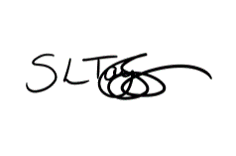
Sharon Taylor-Sezgin
Headteacher

