

**‘Let us be united by knowledge’**

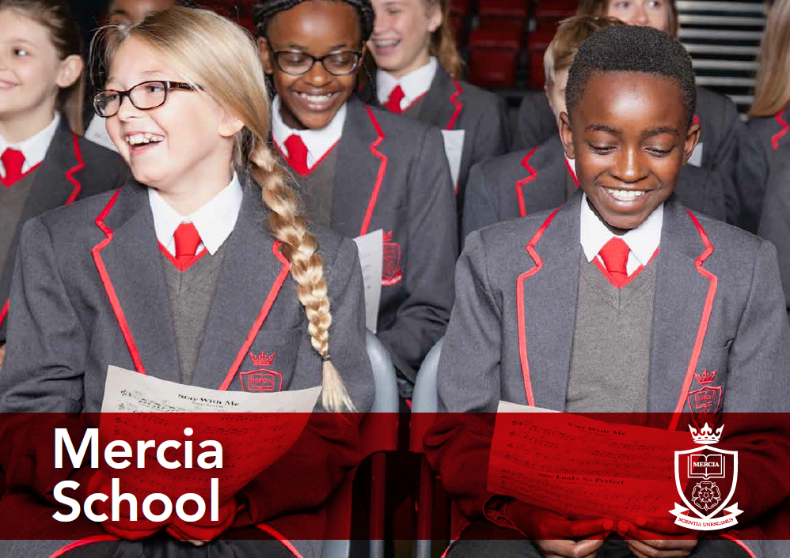

**Head of Science**

**Information Pack**

**School Information**

**Job Description**

**Person Specification**

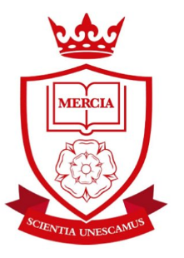

Contents:

* Information about the Mercia Learning Trust
* Letter from the Headteacher
* Advert
* Job Description
* Person Specification
* The Application Process



**‘Let us be united by knowledge’**

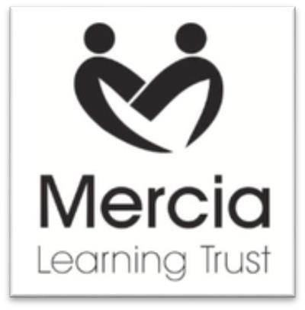

**THE MERCIA LEARNING TRUST**

The Mercia Learning Trust, established in January 2014, currently comprises: Mercia School, King Ecgbert School, Newfield School, Totley Primary School, Valley Park Community Primary School and The Nether Edge Primary School.

The mission of the Trust is to provide an outstanding education for pupils from 0-19. We are passionate that all our pupils should see their time at school as happy and fulfilling, with their potential developed to the utmost. Our approach is founded on partnership working — binding together our schools, parents and their communities.

At all Mercia Learning Trust schools our pupils will benefit from:

* A fully inclusive approach, maximising the attainment and achievement of every pupil
* A broad and balanced curriculum, with high quality teaching that responds to individual needs
* Promotion of resilience and self-reliance in our learners, thus enabling them to meet the challenges and opportunities of the changing world
* Support to develop and maintain positive well-being in all aspects of life
* High standards of orderly behaviour rooted in strong moral values
* Continual investment in the professional development of all our staff, as the foundation of our offer to pupils

For more information, please visit our website: http//www.ecgbert.sheffield.sch.uk/Mercia-Learning-Trust



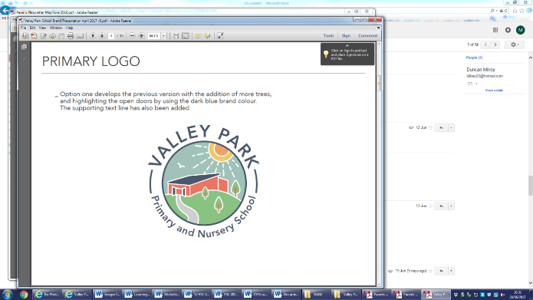   





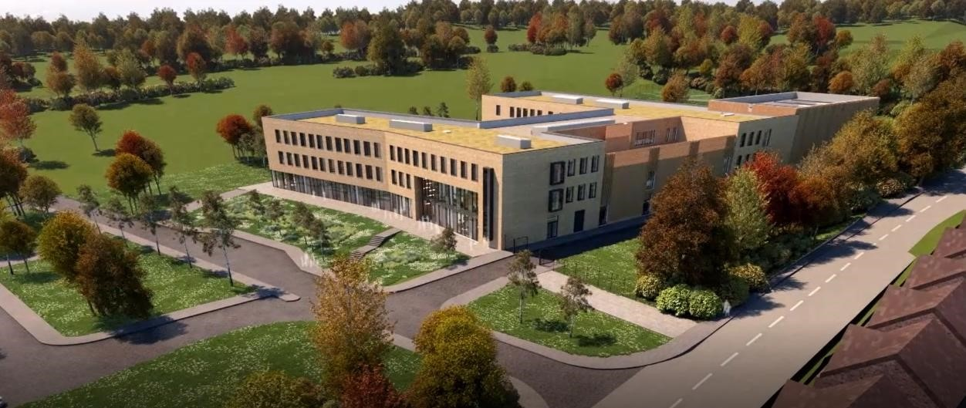

Dear Applicant

Mercia School is a brand new 11-18 school that will serve the south-west of Sheffield. The school will open in September 2018 with 120 Year 7 pupils and grow incrementally for 7 years. Mercia School is part of the Mercia Learning Trust, a local and ambitious Trust that is dedicated to improving the life chances and careers of its pupils and professionals.

Mercia School will provide all pupils, no matter their background or starting point, a rich and demanding education that will inspire. Mercia School will be different. The curriculum will be purely academic with a focus on acquisition of knowledge at its heart. Children and young people will receive high levels of challenge in their studies and be supported to achieve accelerated progress. We will set the highest aspirations for our children so they can achieve their individual potential and personal ambition.

Mercia School will be a traditional school, following the practices of the very best schools in the land. In essence, Mercia School will share the traits of elite schools, however, we will be a non-selective comprehensive school. We will drive social mobility and achievement for all.

Mercia School will expect that teachers teach from the front with excellent subject knowledge. Our classrooms will be arranged in rows with children learning things by heart. We will cherish our teachers’ passion for developing their craft and specialism by ensuring they have time and energy to be reflective. CPD and a transparent team approach to improving practice will ensure we achieve our ambitions together.

Underpinning the ambitious curriculum and teaching will be a consistent discipline approach. The behavioural standards at the school will be of the highest standard. We will employ a firm approach to behaviour, systematically supported by the senior staff. This will enable our teachers to prioritise the planning and teaching of subject knowledge. We will also have a rich culture of celebration, supported through a traditional house system model, that will highlight and celebrate exceptional performance and excellence in all its forms.

As Headteacher, I am excited about the prospect of leading my team into the new school. It is imperative that I have a team of teaching staff and senior leaders that are truly excellent in the classroom and fully committed to building a world-class school for its community.

I am seeking a highly skilled and talented individual, with a thirst to learn, to serve as the school’s Head of Science. You will have a chance to build something incredibly special in the science department and beyond – this is a once in a career opportunity. You will be required to work harder than you have ever done before with unrivalled passion, as we shape our world class school. You will be ambitious and have a hunger to be the best you can be.

You will love teaching and be excited at the prospect of a high teaching commitment, as we deliver truly excellent and challenging lessons for our children. As Head of Science, you must absolutely believe that every child is entitled to a first-class education, no matter their background or ability, achieved through the acquisition of core knowledge through the study of traditional subjects.

If this letter has filled you with excitement and you believe you are the person I am looking for to lead the science department, I would welcome your application.

Mercia Learning Trust is committed to providing high quality support, training and opportunities for your professional development.  The opportunity for learning and development for both teaching and support staff are such that there has never been a more exciting time to join our fantastic schools.

Mercia School is committed to safeguarding and promoting the welfare of children and young people and expects all staff and volunteers to share this commitment. Successful candidates will need to undertake an Enhanced Disclosure via the DBS and/or provide police checks from other countries, where appropriate. Mercia School is an equal opportunities employer.



**Dean F Webster**

**Headteacher Mercia School**



**‘Let us be united by knowledge’**

**Mercia School**



**Head of Science**

**MPS and TLR 1B**

**Commencement Date: 1 September 2018**

We are seeking to appoint an outstanding leader and teacher of science

**At Mercia School, science will be:**

- Exceptionally challenging for all pupils, no matter their ability or need

- Taught in a traditional way that gives pupils time to practise and master content

- A subject that raises aspiration so all pupils have a successful career and a happy life

- Aware of the challenges at GCSE and A-level, pupils will be prepared from day one

Your role will be to lead and develop a team that establishes excellence amongst the pupils, promotes a love of science and enhances progress from day one.

We welcome applications from talented, ambitious individuals who can dedicate themselves to the implementation of the school’s vision.

If you are interested in the above post, further information may be obtained from the school website: [www.merciaschool.com](http://www.merciaschool.com)

**Closing date for applications: Midday on Thursday 30 November 2017**

**Interviews to be held week commencing 11 December 2017**

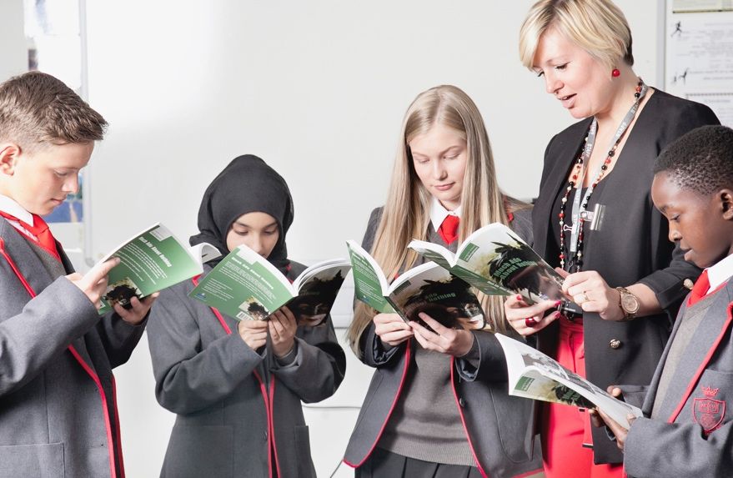

**‘Let us be united by knowledge’**

**Job Description**



|  |  |
| --- | --- |
| Post title: | Head of Science |
| Responsible to: | Headteacher |
| Purpose of the role: | * To deliver the vision of Mercia School without fear or favour, particularly through exemplary leadership of the science department. This will relate predominantly to the successful delivery of a knowledge rich curriculum taught through traditional, didactic pedagogical approaches. * To drive the standards agenda in science so that every pupil aspires to be the best they can be. * To implement excellent teaching and learning strategies to ensure every student achieves at the highest possible level in science. * To ensure teaching and learning in science is first-class and in line with the Mercia School Teaching and Learning policy, namely a knowledge-based approach with a focus on mastery in science. * To implement the school’s rigorous QA systems and contribute to CPD as directed by the senior team. * To line manage colleagues so that outcomes are excellent across the department. * To work with the Leadership Team in designing a curriculum that is challenging and inspiring. * To consistently drive high standards and expectations throughout the science team and in the school generally. * To build effective networks and partnerships that are pertinent to science, so that Mercia School is innovative whilst staying true to its core values. |
| CORE DUTIES | |
| Strategic Planning: | * To work courageously with the Leadership Team to deliver the vision for the school with particular focus on the science department’s performance and quality. * To ensure units of work in science are challenging and have an abundance of knowledge at their heart which children learn off by heart. * To develop, produce, and maintain, departmental documentation including appropriate schemes of work detailing content, method, and assessment strategies. * To plan and deliver timely science CPD that inspires teachers to plan and implement world-class lessons. * To monitor the work of the department to ensure that all departmental members are consistently applying the policies and procedures of the department. * To ensure the efficient administration of the department through regular departmental meetings. Such meetings are to ensure effective communication of ideas and information among staff in the department and to enable staff to co-operate as a team in planning Professional Development and solving problems. * To create excellent partnerships and networks that aide the design of the science curriculum. * To have attention to detail and strategically plan so that all pupils and groups of pupils achieve equally well in science. * To monitor and react to developments in terms of scientific pedagogy and research. * To work with the Headteacher on ensuring full staffing throughout the year. |
| Quality Assurance: | * To monitor and evaluate all procedures and processes put in place for managing Teaching and Learning and student achievement in science. * To establish effective standards of practice concerning developments within scientific Teaching and Learning and student achievement. * To assist the Leadership Team in maintaining the climate for learning using consistent policies, with particular focus on science. |
| Staffing: | * To promote teamwork and to motivate staff so that we maintain an effective science curriculum, delivered by excellent teachers. * To share and promote departmental student outcomes so that all staff know the children in their classes and therefore plan accordingly. * To drive student outcomes in science, exerting necessary challenge to staff who are not meeting the required standard. * To participate in the interview process for vacancies in science. |
| Communication: | * To ensure that staff in the science department are clear on all Mercia School policy. Clarity of instruction must be excellent and departmental heads must reinforce messages without fail. * To ensure that all communication/consultation relating to the science department is appropriate. This includes letters home, social media and contact with any stakeholder. |
| Publicity and Liaison | * To actively promote the school within Sheffield and nationally. This will include participation in national scientific competitions and events. * To contribute to the school liaison and publicity activities. * To network within the Trust, city and nationally so that we create an unrivalled talent list, with particular focus on science. |
| Management of Resources: | * To requisition stock needed by the department, to keep stock lists up to date, and to forward to the Leadership Team as required. * To induct new members of staff as required, where appropriate act as a mentor to NQTs/Teach First in line with school policy under the direction of a member of the leadership team. * To advise the Leadership Team on the allocation of classes and other timetable requirements for the subject. |
| Additional Duties: | * Assist the Leadership Team in improving the quality of teaching and learning in the school, ensuring the effectiveness of lesson plans and schemes of work including the development of targets for the teaching and learning of basic skills/knowledge within the department. * Assist the Leadership Team in raising academic standards and raising attainment in the curriculum area across the school and with a cross-curricular dimension. * Assist the Leadership Team to ensure that all pupils receive their entitlement to the full departmental curriculum within a framework of equal opportunities and ensuring regular monitoring and reporting of their progress. * Liaise with Leadership Team on departmental timetable and curriculum matters. * Liaise with Leadership Team with regard to work, behaviour, attendance or other issues involving individual pupils. * Be aware of and respond to practice affecting the subject in primary feeder schools and liaise with the Leadership Team regarding primary liaison policy and departmental involvement in that policy. |
| Teaching | * To teach excellent lessons that are in line with the Mercia School Teaching and Learning policy. * To teach science with passion and a reflective attitude. * To inspire other teachers to deliver excellent lessons in the science department. * Be abreast of assessments/examinations at GCSE and A-level so that the curriculum is relevant in science from Year 7 and beyond. |
| OTHER SPECIFIC DUTIES | |
|  | * To take part in personal professional development. * To observe, without fail, dedicated duties as determined by the Leadership Team. * To participate in staff observations as a part of day-to-day practice. This will include regularly being observed by colleagues and vice versa. * To proudly contribute to an open, honest and candid school climate. We expect candour from all, no exceptions. * To participate in *Family Lunch* every day, relishing the opportunity to spend quality time with all of our pupils. * To be a commited and excellent form tutor, delivering rich reading, PHSE and fulfilling pastoral duties in line with school policy. * To have an unrelenting commitment to the cause, as shown by exemplary attendance and completion of our longer school day. * To take part in our House system, as directed by the Headteacher. * Any other delegated roles, as directed by the Headteacher. |
| The specific responsibilities of the post will be further determined according to the expertise and experience of the successful candidate. | |
| The school will endeavour to make any necessary reasonable adjustments to the job and working environment to enable access to employment opportunities for disabled job applications or continued employment for an employee who develops a disabling condition.  This job description is current at the date as shown, but in conjunction with the post holder, may be changed by the Headteacher to reflect or anticipate changes in the role which are commensurate with the grade and job title.  November 2017 | |

**Person Specification**



|  |  |  |
| --- | --- | --- |
| Post title: | Head of Science | |
| **Qualifications and Training** | * Degree in biology, physics, chemistry or an equivalent secondary subject. * Qualified teacher status essential – not suitable for NQTs. * Recent and relevant professional development relating to knowledge based curricula is desirable. | * Application Form * Application Form * Application Form and interview |
| **Skills and**  **Knowledge** | * Must have highly effective communication skills which engage pupils, parents, staff, Governors and the wider community. * Must be able to use traditional pedagogical approaches appropriate to the teaching of science to the highest level. * The ability to teach in a didactic way is essential, giving pupils exceptional knowledge across all three sciences is vital. A desire and will to change practice as requested is essential. | * Interview * Application Form and References * Application Form |
| **Experience** | * Teaching science to a full range of age and ability within a secondary school. * Experience/knowledge of current initiatives relating to achievement and inclusion in science is desirable. * Track record as a successful classroom practitioner (Ofsted criteria) across the secondary school age and ability range. * Track record of exceptional results at GCSE and A-level is essential. * We welcome existing subject examiners, however this is not essential. Please be aware that all teachers at Mercia School will become examiners in their subject area. | * Application Form * Application Form, Interview and References * Application form, Interview and References * Application Form and References |
| **Personal**  **Qualities** | * Must be able to demonstrate the ability to take initiative, lead, motivate, inspire and support the full range of stakeholders to achieve excellence. * Must be ambitious for self and others, showing a powerful commitment to continuous improvement and raising standards within a knowledge-based curriculum. * Must be resilient and optimistic, having a relentless focus on achieving the best for young people and being prepared to develop creative strategies to achieve this. * Must have a clear strategic vision for achievement and inclusion including providing opportunities for learning outside the school day. * Must be able to show evidence of an alignment with the values of Mercia School both in words and behaviours. Knowledge will be at the heart of everything we do * Must have the capacity to demonstrate leadership of science. Prior subject leadership is not essential. | * Application Form, References and Interview * Application Form, References and Interview * Application Form, References and Interview * Application Form, References and Interview * Interview * Application Form and References |



**‘Let us be united by knowledge’**

**The Application Process**

All details, including the Application Form, Job Description and Person Specification can be found

within this pack or on our school website www.merciaschool.com

We hope that our recruitment pack and website provides you with plenty of information about us.

However, should you require any additional information, or would like an informal discussion, please contact Sharon Hodkinson, PA to CEO and Finance Director, on 0114 349 4230 or email

shodkinson@ecgbert.sheffield.sch.uk

To apply, please email your completed application to shodkinson@ecgbert.sheffield.sch.uk or send it

in the post to:

Sharon Hodkinson

PA to CEO and Finance Director

Mercia Learning Trust

79 Glen Road

Sheffield

S7 1RB

All applications submitted electronically will receive an email confirming receipt.

**Please note that we do not accept CVs - applicants must submit an application form.**

Please also note that in all cases written references will be taken up BEFORE the final selection stage.

An email and/or letter will be sent to shortlisted candidates with details of the interview process.

If you have not heard from us within two weeks of the closing date please assume that, on this

occasion, your application has been unsuccessful.

Mercia School is committed to safeguarding and promoting the welfare and safety of children and

young people and expects all staff to share this commitment. The successful candidate will therefore be required to complete a DBS check in line with the Rehabilitation of Offenders Act

(ROA) 1974 (Exceptions) Order 1975 and the Police Act Regulations.

We are an Equal Opportunities employer.

If you have any further queries on any aspect of the application process, please contact

Sharon Hodkinson, PA to CEO and Finance Director, on 0114 349 4230 or by emailing

shodkinson@ecgbert.sheffield.sch.uk