APPOINTMENT OF BIOLOGY AND PE TEACHER

COMMENCEMENT: SEPTEMBER 2018

An exciting opportunity has arisen to join Elutec UTC as a Biology and PE teacher. Successful applicants will be enthusiastic team players. There will be opportunities for rapid career development to Head of Department for the right candidate.

Elutec UTC
Elutec – the 14-19 University Technical College for East London - opened in September 2014 and aims to be a leading STEM UTC in the UK. Elutec is housed in an impressive new building in Barking and Dagenham, surrounded by a Business and Science Park which is soon to be joined by an exciting new film studio complex. The school has excellent transport links, with Dagenham East tube station a short walk away.

The school’s exceptional sponsors include Ford Motor Company, one of the world's foremost design, engineering and manufacturing enterprises and the Faculty of Engineering at University College London (UCL), ranked as one of the top 20 “super-elite” universities in the world (especially in Elutec's specialist areas of manufacturing and engineering). Elutec is also sponsored by The Centre for Engineering and Manufacturing Excellence (CEME) in Havering, where Elutec was originally located and by Prospects College of Advanced Technology, one of the country's leading education providers of work-force development needs.

Elutec aims to offer learners and employers an outstanding solution to current skills shortages. Our vision is that our pupils will stand out from the crowd and will be educated and coached to win the technical jobs that local employers desperately need to fill. In those jobs they will stand out as competent young engineering and manufacturing technicians. When they pursue further qualifications, they will stand out as those precious few who "know how to make things" as well as design, test, simulate and research them. Our student destination include Apprenticeship as well as STEM subject degrees at University.

THE POST
Teacher of PE and GCSE /A’ Level Science (Biology). Potential for rapid career development with whole school responsibilities.

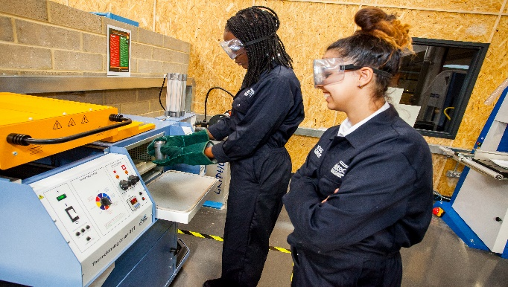

How to apply
Please return your completed application form by email to: g.howard@elutec.co.uk
Closing date: Noon, Tuesday 22nd May 2018
Interview date: Thursday 24th May 2018
CVs will not be accepted

Pre-employment checks
Confirmation of appointment is conditional upon a satisfactory enhanced DBS check and occupational health check.

References
Confirmation of appointment is also subject to the receipt of two satisfactory references.

Salary
Inner London Main Scale (depending on skills and experience)
For a candidate with the potential for further leadership, the salary will reflect the additional responsibility.

Commencement
September 2018

Visits and informal discussions

If you would like to arrange a visit and/or have an informal discussion about the post, in the first instance please contact Gillian Howard: g.howard@elutec.co.uk

Key Role Descriptors for this Post
- To ensure that the vision and values of Elutec as a UTC are evident in all aspects of the post
- To have overall accountability for the standards attained by all students within assigned classes
- To monitor standards of attainment, progress and attendance across classes - targeting key groups to develop strategies and intervention that supports rapid progress.
- To ensure the development of effective Teaching and Learning that maximizes individual progress, with particular emphasis on Assessment for Learning, Literacy, Personal Development
- To be accountable for the monitoring, quality assurance, assessing and reporting of progress across classes
- To have a Teaching load commensurate with this level of responsibility

Teachers Standards

Teachers make the education of their pupils their first concern, and are accountable for achieving the highest possible standards in work and conduct. Teachers act with honesty and integrity; have strong subject knowledge, keep their knowledge and skills as teachers up-to-date and are self-critical; forge positive professional relationships; and work with parents in the best interests of their pupils. All teachers must adhere to the Teacher Standards

Experience

- A proven track record of success delivering GCSE and A’ Level Science (Chemistry and or Physics) is desirable.
- Successful experience of achieving high standards and raising standards with pupils of all abilities

Other Requirements

- A passion to help young people become happy, productive, self-confident adults.
- A sense of fun, humanity and collegiality
- Resilience and the ability to work well under pressure.
- The ability to prioritise and to manage one’s own work and that of others.

