

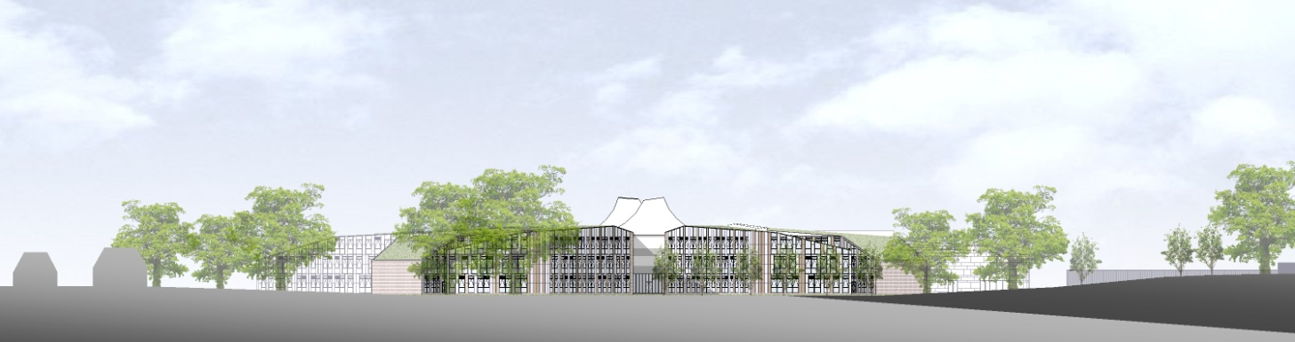

# ST. BARTHOLOMEW'S SCHOOL

TECHNICIAN: DESIGN & TECHNOLOGY - FOOD

Part-time, permanent

# Required as soon as possible



**Andover Road**

**Newbury RG14 6JP**

**Tel: 01635 – 521255**

**Fax: 01635 576320**

**Email:** [**recruitment@stbarts.co.uk**](mailto:recruitment@stbarts.co.uk)

[**www.stbarts.co.uk**](http://www.stbarts.co.uk)

**THE FACULTY**

The Design and Technology faculty at St. Bartholomew’s School is cohesive, supportive and successful.

Students in years 7&8 spend 2 hours (a double lesson) per week for a term, in each of the Product Design, Food and Textiles departments. They opt to spend year 9 in one of these subjects.

Students can then opt to study GCSE Art Textiles, Food Preparation & Nutrition, or Product Design; or Jamie Oliver BTEC Levels 1 & 2.

In the sixth form we offer Food Science and Nutrition; Art Textiles, and Product Design.

The faculty team is comprised of 8 Teachers, 4 Technicians and a faculty Teaching Assistant. We share a faculty staff room. We have a Head of Faculty/Head of Food Technology, a Head of Department for each of Textiles and Product Design.

**THE POST**

* We are seeking to appoint a Technician: Food and Textiles to join the department as soon as possible on a permanent basis.
* The position is part-time, term-time only plus 5 training days pro rata.
* The days and hours of work will be:

16 hours and 30 minutes (16.5) per week (including 2 hours per week in Textiles) as follows:

Wednesday 11.30am to 4.00pm

Thursday 9.30am to 4.00pm

Friday 9.15am to 3.45pm

When you work 5 hours or more in a day you are entitled to a 30minute break which is unpaid.

###### THE SALARY

* The successful candidate will be paid in accordance with the national APT&C scale, point 11-13 (currently £17,007 to £17,391 per annum full-time equivalent). This equates to a starting salary of £6,472.52 gross per annum or £8.82 per hour. Staff will be appointed to the start point of the advertised scale unless there is a specific experience reason for the Headteacher to agree an alternative point within the range.
* All leave must be taken during school holidays. Your annual salary will be calculated to include payment for your leave entitlement. Your annual salary will therefore be 44.5 weeks’ pay, to be paid in 12 equal monthly amounts.

**HOW TO APPLY**

Full post details, an application form and instructions on how to upload your completed application are available via the Contact & Apply / Job Opportunities section on the School’s website:

[**www.stbarts.co.uk**](http://www.stbarts.co.uk)

(Please note that curriculum vitae and covering letters cannot be accepted)

Successful candidates will be subject to a DBS enhanced check along with other relevant employment checks.

## Closing date: Sunday 3 June 2018

Thank you for considering St Bartholomew’s School.

Julia Mortimore

Headteacher