
Languages Facility

The Languages Faculty is highly regarded amongst teaching colleagues, students, parents and governors/trustees. We are based in five classrooms within a designated area in the centre of the school. All classrooms are well resourced, being equipped with networked IT facilities. As a faculty we value displays as a learning tool and as a means of recognition of excellence. There are ample display areas for both students’ work as well as well as relevant language specific posters.
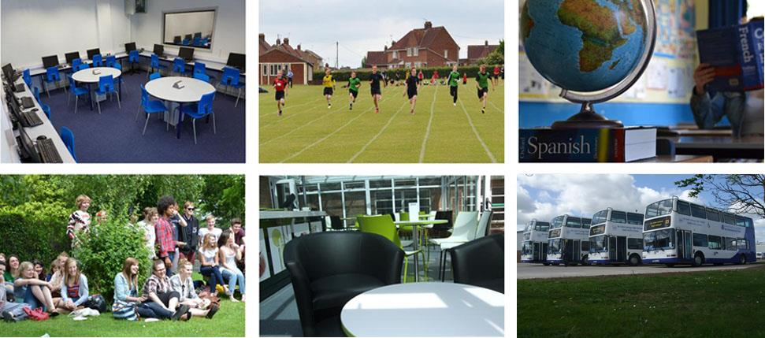

Staffing

The Modern Foreign Languages Faculty is staffed by six full time specialists who, between them, have knowledge of French, Spanish, Italian and German. We regard the promotion of European culture as an important responsibility. In September the faculty is very keen to celebrate the “European Day of Languages”; offering taster lessons in different languages as well as inviting the whole school to become involved through the availability of cross-curricular lesson ideas.
The faculty has made the most of close links with some of our partner schools and work is being done to work towards a more common approach to language learning to ensure a smooth transition.
All our language teachers are encouraged to share resources and learning ideas.

Facilities

There are well resourced ICT facilities available within the school. Our faculty team room and two of the classrooms are also our resource bases for both French and Spanish at all Key Stages. For GCSE and A level oral exams, there is access to a discrete area suitable for the recording of candidates’ assessments. There is modern recording hardware available for this purpose.

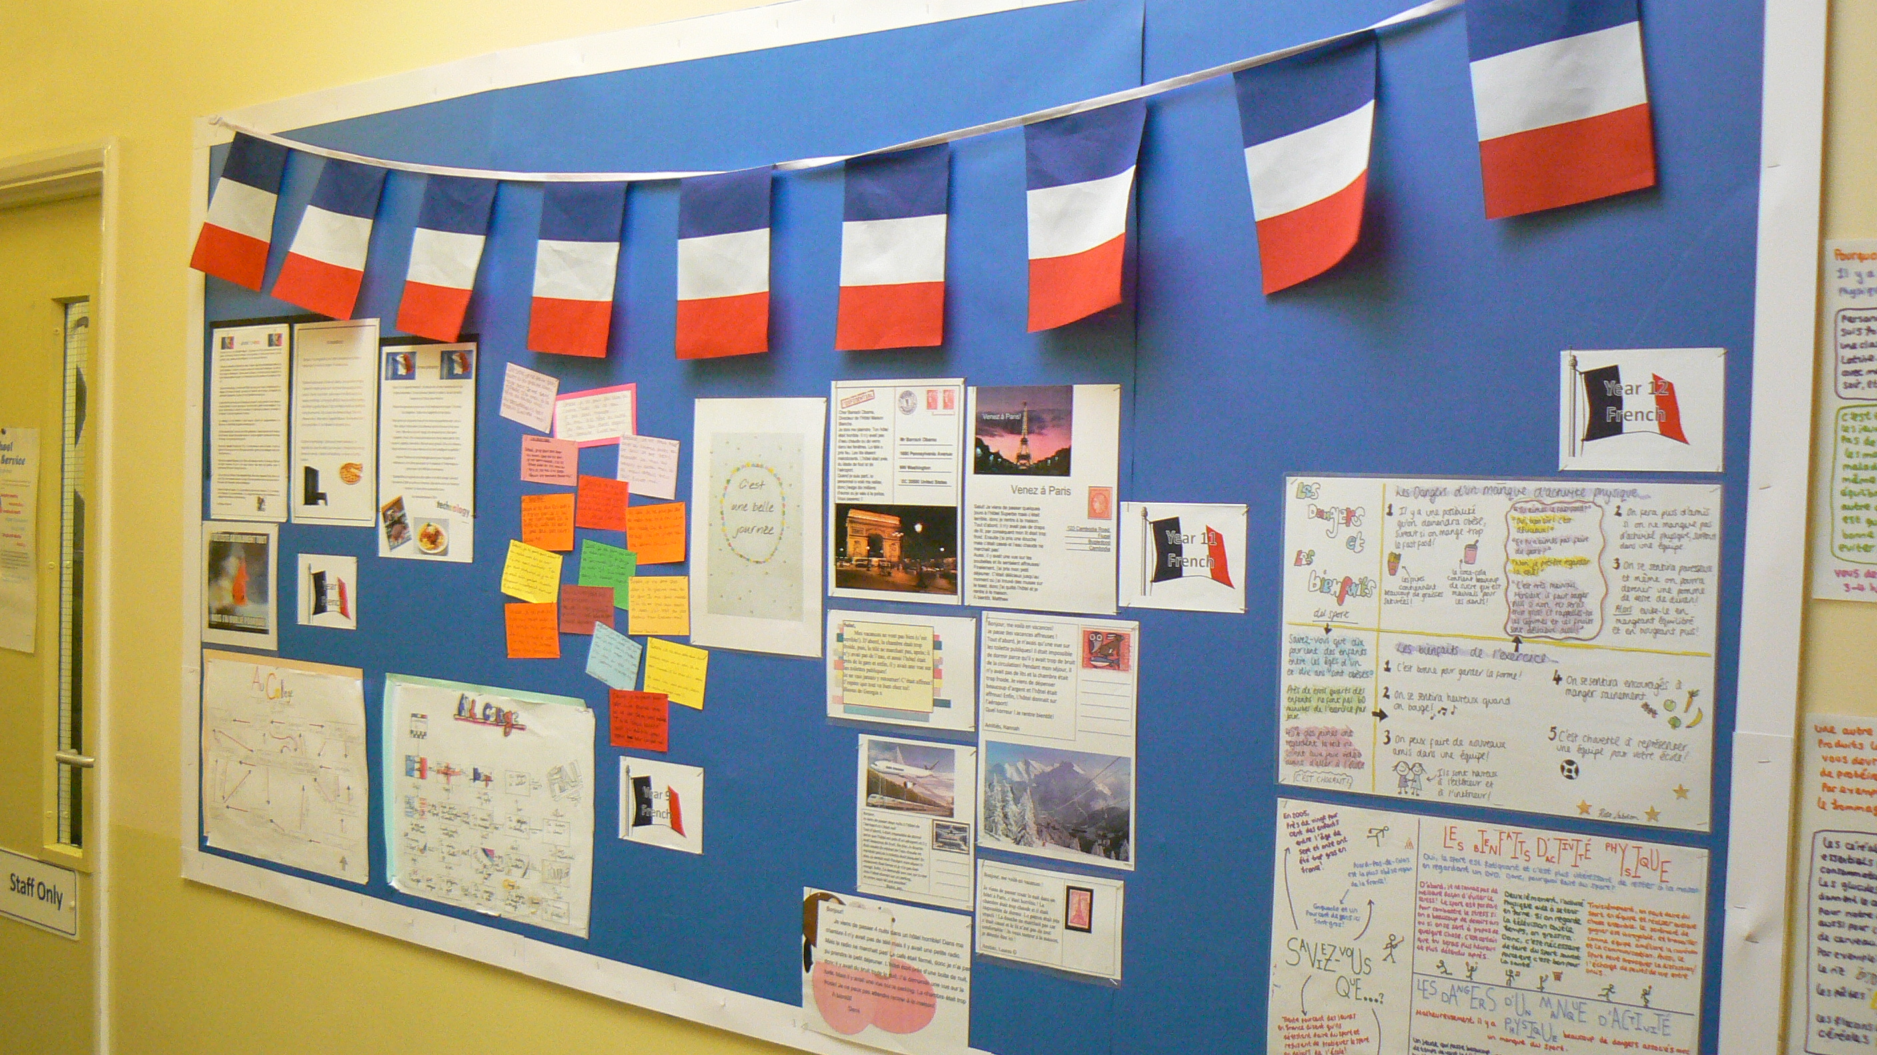

Enrichment, Support and extra-curricular activities

Every year the faculty offers a range of enrichment activities for students across all key stages. We have strong links with the outreach department at the University of East Anglia and our students regularly take part in their Language events such as Discover Japan, Discover French and Language in Business. We also run day trips and residential trips to France and Spain each year so that our students have the opportunity to immerse themselves in the culture and language outside of the classroom. The faculty would welcome an applicant who would add to our enrichment provision.
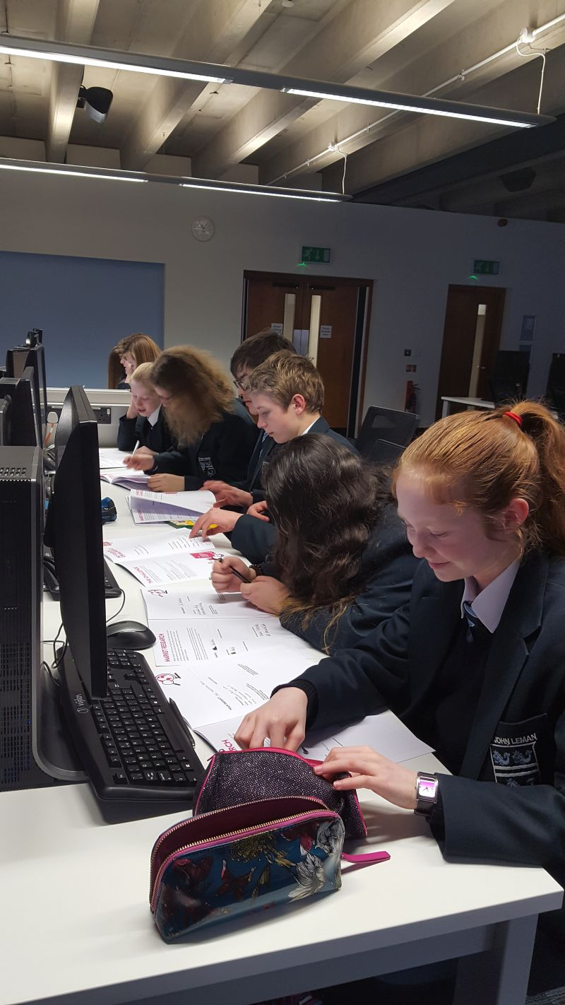

Teaching and Learning

The quality of teaching and learning within the faculty is of the very highest priority. We place great emphasis on effective assessment and extended learning (homework) to ensure progress.

Key Stage 3
French is studied by all students in Years 7, 8 and 9 and Spanish by all students from Year 8. We use Accès Studio then Studio 1 and 2 for the delivery of French during KS3 for use across the full ability range together with extended learning tasks (homework) and end of module assessments plus supplementary resources as appropriate. We use Mira 1 – 2 for Spanish. The course material is successfully providing ample opportunities for the development of the four skill areas and covers all the Year 9 teaching objectives in both languages.
The Languages Faculty is in a strong position to fulfil its obligation to students following government proposals regarding the English Baccalaureate offer.

Key Stage 4
The uptake of French and Spanish at Key Stage 4 is a major and continuing strength of the faculty and the school. We currently have one GCSE French and four Spanish groups in Year 10. Great care is given to ensure potential language students are offered the very best advice and guidance. Students may take French and Spanish at GCSE. We use the AQA Studio GCSE course book for new specifications French and the AQA Viva GCSE course for new specifications Spanish. Extended learning tasks (homework) together with end of module assessments and practice exam papers for regular assessment are used in both languages. The balance between French and Spanish is anticipated to be more equal for September.

Key Stage 5
The faculty enjoys a healthy uptake of students wishing to continue the study of French and Spanish in our Sixth Form and students regularly join us from neighbouring schools to do so too. We are using the Hodder A level publications as the core resource for delivering the new specifications to Year 12 and 13 French and Spanish.
The majority of our KS5 students go on to study languages at university, often combined with other subjects. Two students have recently completed their university degrees in Paris and a number of our sixth formers have embarked on careers in language teaching.

