Ravenscourt Park Preparatory School, London W6 0SL
The School
Ravenscourt Park Preparatory School is one of London’s leading independent preparatory schools. It is co-educational and non-selective, has a distinct ethos and provides a curriculum of the highest quality, extensive in both breadth and depth. The Headmaster is a member of IAPS.
The catchment area for RPPS is one of the most exciting in London. It is within easy travelling distance of Hammersmith, Chiswick, Notting Hill, Kensington, Kew and Richmond. The location of RPPS, next to Ravenscourt Park, and the fact that the majority of parents are local to the area means that the school feels part of the community and our parents take an active role in school life.

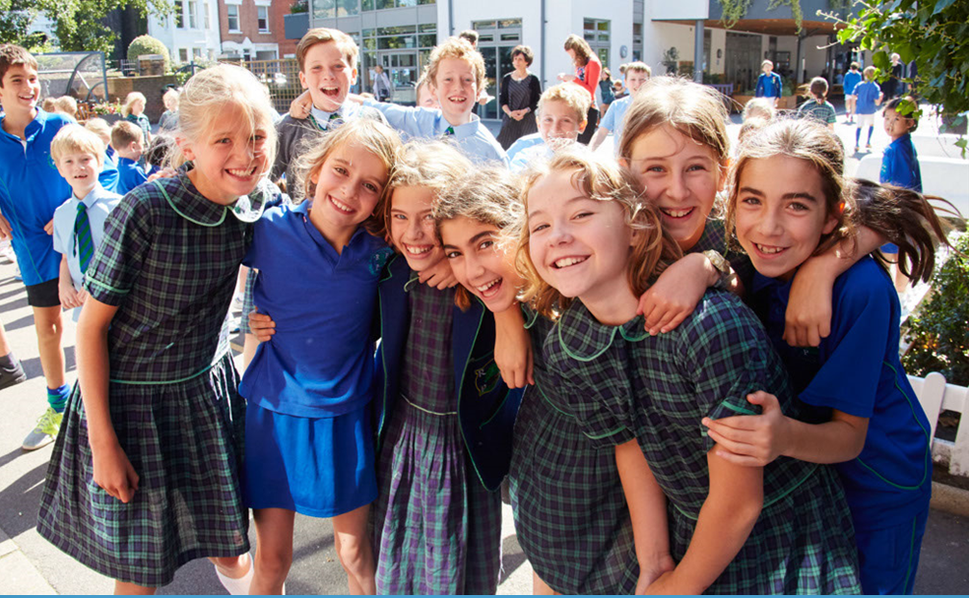

RPPS caters for 420 boys and girls aged 4 to 11, with three classes of 20 children in each year group. The number of registrations for Reception places each year far exceeds the 60 places available and priority is given to siblings of existing children at the school, followed by a ballot of those who registered when their child was 1 year old. A waiting list is in operation for any further places that may arise, including for occasional places higher up the school.

Philosophy and Values
These are the main principles of our educational philosophy:
- We believe that each child should be nurtured, inspired and motivated to allow them to fulfil their full potential.
- Our approach is holistic with a balanced focus on a child’s intellectual, moral, spiritual, physical and emotional development.
- We engender confidence and self-esteem, leading to intellectual risk taking and a love of learning.
- We cultivate values of respect, compassion, tolerance and community responsibility in each child.
- We are non-selective in our approach to admissions.

Our values reflect our philosophy and permeate all aspects of school life and apply to all members of our community:
- Excellence in teaching and learning – we are committed to the provision of the highest standard of education for each child and we always celebrate achievement, however small.
- Communication – we operate a true “Open Door Policy” where we make ourselves available to those who need to speak to us and communicate face to face whenever possible. The school is a welcoming place for parents and their involvement in school life is regarded as essential.
- Innovation and flexibility – we continuously reflect on our practice, constantly seeking to improve. We encourage initiative and embrace change.
- Our place in the world – we promote the understanding of what it means to grow up in a Britain of the 21st century, preparing our children to make positive contributions in school, work and life.
- We value education as a journey and not simply as a method for passing exams.
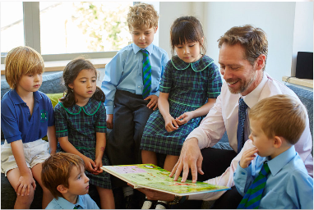

RPPS staff pride themselves on pupils achieving their very best. The school promotes self-esteem, creativity and individuality. This leads to both excellent academic results and rounded, confident individuals leaving at the end of Year 6.

RPPS currently sends pupils to all of the leading senior schools in London including St Paul’s, Latymer, City Of London, Hampton, Westminster, Ibstock Place, Lady Eleanor Holles, Francis Holland, Godolphin and Latymer, Notting Hill and Ealing, Kew House School, King’s Wimbledon and many others.

Pastoral care is a real strength and children feel safe and valued at RPPS. The school has a tangible sense of community and parents are encouraged to get involved with supporting the education provided through helping on school trips, hearing readers and giving talks about areas of interest in assembly. There is a thriving parents group, known as the Friends of RPPS.

In September 2011, the school opened The Gardener Building, providing a new theatre, library, science laboratory, art room, music suites and extra teaching rooms. This building has led to the provision of extra space in the other pre-existing buildings on site which, as well as teaching rooms, include a gymnasium and dining hall.

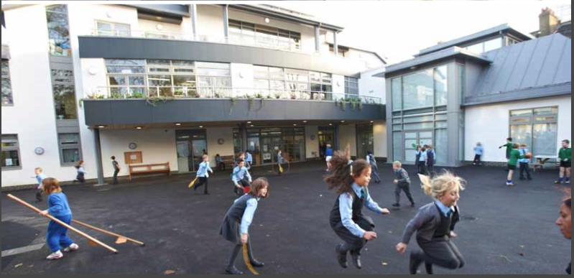

Ravenscourt Park Preparatory School is committed to safeguarding and promoting the welfare of children and young people. The post is subject to enhanced DBS check and receipt of two professional references. Please make sure to bring along proof of identity (such as a passport or driving licence) and original academic qualification certificates when you come to interview.

Our safeguarding and safer recruitment policies can be found on our website: http://www.rpps.co.uk/policies.html

