## left_facing

## CHADWELL HEATH ACADEMY

**APPOINTMENT OF TEACHER OF**

**SCIENCE**

**DETAILS FOR APPLICANTS**

Chadwell Heath Academy a company limited by guarantee, registered in England with number 7346826

***Chadwell Heath Academy***

Christie Gardens, Chadwell Heath, Romford, Essex RM6 4RS

Tel: (020) 8252 5151 Fax: (020) 8252 5152

Email: [office@chadwellacademy.org.uk](mailto:office@chadwellacademy.org.uk)

Headteacher: Mr S.N.Bull

Dear Colleague,

We are pleased to receive your enquiry about the post of **Teacher of Science**.

The following pages give more details about our School and the type of person we are seeking for this post. It is difficult to judge what information to give to help people decide whether they wish to submit a formal application. If you would like further information please telephone the School. Further information about the school is also available on our website [www.chadwellacademy.org.uk](http://www.chadwellacademy.org.uk)

**The closing date for applications is as advertised.** We reserve the right to bring forward the closing date where we find suitable applications and so we advise that applications should be submitted as soon as possible as we may choose to interview shortly after receipt

If you would like your application acknowledged, please enclose a stamped addressed envelope.

Thank you for your interest in the post.

Yours sincerely

Mr S. N. Bull

Headteacher.

**THE DEPARTMENT**

The Science Department is a large, lively department made up of a mixture of young and experienced teachers and technicians. Twelve teachers and four technicians work together to deliver the best possible science education. It is the priority of the Department that all pupils should achieve the highest academic results they can. The successful candidate will be entering a collegiate, hard-working and supportive environment with ample opportunity for self-development.

There are eleven laboratories, allowing each teacher to be based in one laboratory for the majority of their timetable. Each Laboratory is equipped with a computer, internet access, projector and interactive whiteboard. The Department is also well resourced in terms of equipment, books and science software.

Years 7 - 9 Key Stage 3 - All pupils follow the QCA Exploring Science Scheme of Work and resources. The six forms in each Year Group are divided into eight teaching groups.

At GCSE students follow the AQA Combined science: Trilogy (Double Award). GCSE class size across the whole department is around 15 to 20 students.

Years 12 & 13 – At AS and A2 Biology, Chemistry and Physics are taught as separate sciences and are very popular and successful. The Chemistry course follows the Edexcel syllabus, whilst Physics follows the AQA syllabus and Biology the OCR syllabus.

The GCSE pass rate is routinely in excess of 80%. At AS level in 2017 the pass rate was 83%. At A-level the pass rate was 98%, with 69% of grades A\* to C.

**THE POST**

The post will require the successful candidate to teach across the department at KS3, with the opportunity for a suitably qualified candidate to teach their specialism at KS4 and 5.

You will be passionate about your subject, dedicated to providing exceptional learning experiences in the classroom, and keen to contribute to wider aspects of school life.

The Department is very supportive of teachers wising to learn new skills; there is an opportunity to develop teaching and leadership skills through bespoke CPD provision and opportunities for in house career progression. There is a comprehensive induction program for all new staff.

You will be responsible for setting appropriate homework ensuring that it is marked and returned to pupils/students within a suitable time frame.

You will be responsible for all necessary syllabus and examination requirements for the pupils you teach.

You will contribute to Department discussion on the development of styles of teaching and syllabus development.

You will contribute to the Department programme for the recruitment of students onto suitable AS and A2 courses.

**THE SCHOOL**

We are an 11-18 all ability, mixed comprehensive with a roll of over 1200 pupils. In 2010 we became one of the first Ofsted outstanding schools to convert to standalone Academy status.

Our aim is to provide, within a framework of good discipline and encouragement, the opportunity for all our pupils to achieve their very best. Our examination results place us amongst the top comprehensive schools in the Country and our intention is to ensure that we remain so.

The School has undergone extensive refurbishment and we are well equipped with general teaching rooms, subject specialist areas, a Sports complex consisting of Sports Hall, Dance Studio, Fitness Room and Gymnasium, hard play areas and a sports field.

Session Times are: 8.45 a.m. - 1.10 p.m. and 1.55 p.m. - 3.20 p.m.

On joining the School, pupils are placed in forms, which are arranged to contain an even spread of abilities. These social groupings remain together until the end of Year 11. Extra teaching groups are formed in a number of subjects to bring class sizes down to the low 20s. There is progressive setting in Mathematics and Science in order that teaching may be carried out at levels most suited to the pupils’ developing needs. Pupils with learning difficulties receive help from a Learning Support Assistant working alongside the class teacher during lessons.

Years 7 - 9: Allpupils follow a common core of subjects which include all the National Curriculum subjects to Key Stage 3: - Art, Design and Technology, Drama, English, French, German, Geography, History, Mathematics, Music, Physical Education, Religious Education, Science and Personal and Social Education. From Year 8, all Pupils follow an Information Technology course. All courses in the Lower School are arranged in 8 week modules which end with an assessment.

Years 10 - 11: All pupils study English, English Literature, Mathematics, Science and ICT. They also follow a programme of Personal and Social Education and Physical Education. Pupils then have a choice of a range of subjects to complete their timetable. These additional subjects are selected after consultation between pupils, parents and teachers. Most pupils are expected to gain 9 high grades at GCSE.

The range of option subjects available for Years 10 and 11 include: Art and Design, Business Studies, Dance, Drama, French, Food Preparation and Nutrition, Geography, German, History, Media Studies, Music, Physical Education, Product Design and Religious Studies.

Sixth Form - We have a large and flourishing Sixth Form of around 300 students and offer a range of qualifications at both A-Level and BTEC. All students who have not achieved a Grade C in Mathematics or English follow a resit course in those subjects.

Courses currently available in the Sixth Form at AS and A-Level are: Accounts, Art and Design, Applied Information and Communication Technology, Biology, Business Studies, Chemistry, Dance, Product Design, Drama and Theatre Studies, Economics, English Literature, French, Further Mathematics, Geography, German, Government and Politics, History, Law, Mathematics, Media Studies, Music Technology, Physical Education, Psychology, Physics, Religious Studies and Sociology. At BTEC we offer Business, Media Communication and Production, Physical Education and Science.

**Homework**

Homework is set regularly and parents are asked to assist the School in ensuring that sufficient time is spent on it. A Pupil Organiser or Planner, in which homework is recorded, is used as a regular means of communication between school and home.

**Pastoral Care**

Pupils within the School are proud to be part of a thriving mixed gender, multicultural community**.** Each pupil has a Form Teacher, who takes a close interest in the development of pupils within their care and who is responsible to a Head of Year. The whole system is carefully monitored by two Deputy Headteachers. Information about progress is regularly available through Effort and Attainment Grade reports. There is also an End of Year report on each pupil and a formal Parents’ Evening for each Year Group. In addition, parents are welcome to see staff by appointment.

Careers Guidance is available at all stages in a pupil's schooling, but concentrated advice is given from Year 9 onwards. All Year 10 pupils have two weeks of Work Experience in the Summer Term.

**Parents**

The full support of parents is required in matters such as the wearing of School Uniform, the completion of homework and the implementation of the Home School Agreement, a copy of which is supplied to parents of all pupils who enter the School.

**Discipline**

We strive to encourage the development of self-discipline, as a high standard of behaviour is expected both inside and outside the School. Parents are kept fully informed if a pupil's behaviour or effort does give cause for concern. There are clear rules, and those who transgress are punished.

**Uniform**

A smart uniform imparts a sense of belonging and helps to maintain the high tone of the School. For these reasons a full school uniform is worn by all pupils below the Sixth Form. For Sixth Form there is a separate Dress Code. Pupils who arrive at school improperly dressed are liable to be sent home.

**Extra Curricular Activities**

These are encouraged and available to all members of the School. The Physical Education Department offers a wide range of sporting activities. There is also Orchestra, Choir and instrumental groups, Science Club, Computer Club, Drama Club and many more. There are several drama and musical presentations throughout the year. Pupils undertake fieldwork in Geography and Science, while trips to France, Germany and Spain serve to improve their awareness of life in other countries, enhance their understanding of foreign languages, or simply give them an opportunity to ski.

Applications should be addressed to the Headteacher and arrive no later than as advertised**.**

**DIRECTIONS TO THE ACADEMY**

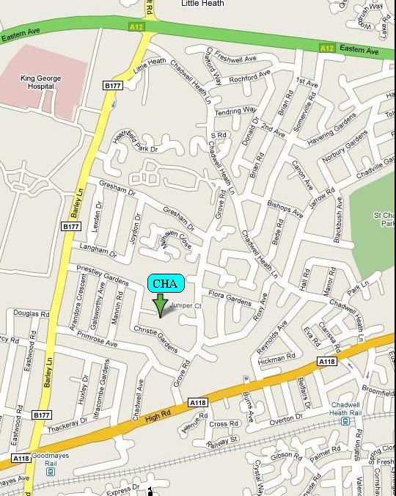

**By Car**

From the M 25 exit Junction 28 - signposted A12 Romford.

Follow the A12 - signposted London.

Turn Left off the A12 - signposted Chadwell Heath/King George Hospital.

The 4th turning on the left is Priestley Gardens and the School is at the end of the road.

**By Train**

From Liverpool Street Station to Goodmayes Station via the

NationalRail Great Eastern Line.

Turn right out of the station.

Proceed across the traffic lights along Barley Lane.

The 4th turning on the right is Priestley Gardens and the School is at the end of the road.