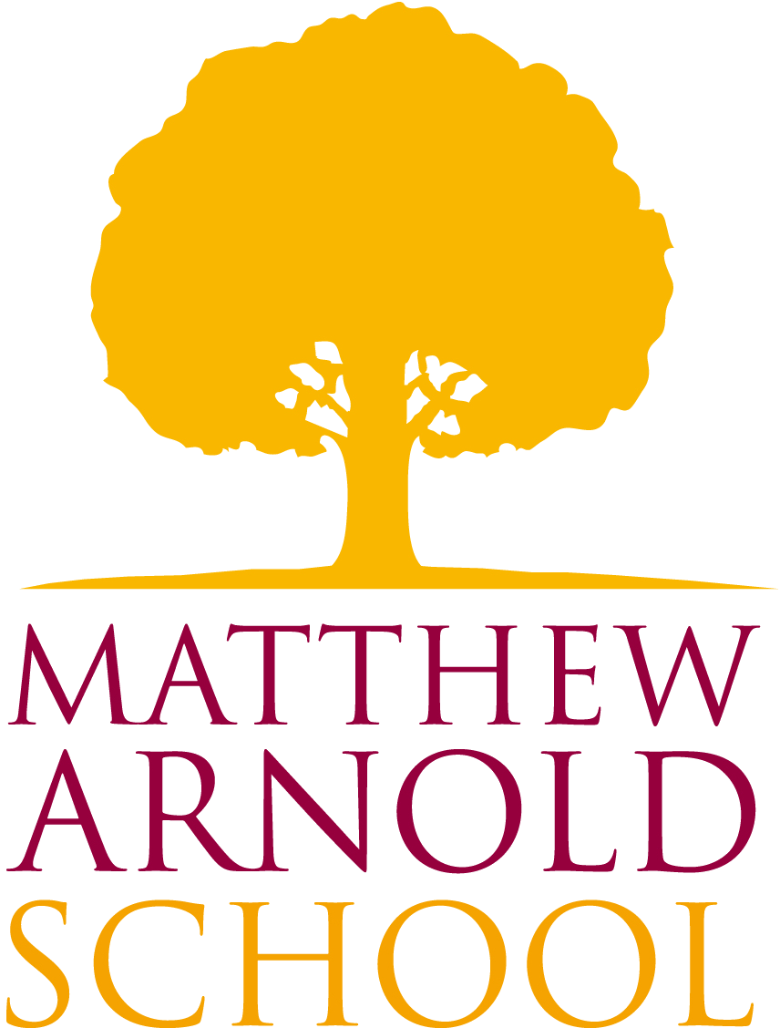
English Department

This vacancy has become available at a crucial time for the subject. English has always been taught as an exciting and dynamic subject at our school, providing fundamental literacy skills which underpin most other subjects, and offering access through developing written and language competence to a wider understanding of world and society.

The English Department is a very successful, experienced and committed team comprising ten teachers, seven of whom teach full-time and three who teach part-time.

Currently, the Department offers GCSE English Language and English Literature (AQA) to all students. Our GCSE English and Literature results are among the best in the school, and this is reflected in the popularity of A Level English Literature. We offer the AQA A Level, which includes a coursework component and some open text examination. There are English A level classes in years 12 and 13, and we also offer Film Studies (WJEC) at A Level taught solely by English department members.

The school operates a 50 period per fortnight timetable, with pupils in Years 7, 8 and 9 receiving six lessons of English a fortnight, Years 10 and 11 receiving seven lessons, and Years 12 and 13 students receiving eight lessons a fortnight. We have an integrated approach to Inclusion and we receive classroom support from the Learning Support Department. Half of each year group at KS4 has additional pathway English lessons in lieu of additional optional subjects.

The English Department is based in 6 spacious teaching rooms with the Newman Library between. Most full time staff have their own teaching base, and make good use of the ICT facilities for teaching and learning.

Extra-curricular activities play a vital role in the running of the English Department. As well as trips to the theatre we invite companies into school to work with whole year groups. We have a range of Book Groups and writing groups across the Key Stages that are very well attended as well as a Scrabble Club. We offer workshop sessions and encourage students to take part in competitions and events such as ‘Youth Speaks’ and a variety of writing competitions.

The English Department values the contributions from all department members. The annual rotation of responsibilities allows teachers to develop areas of interest and enhances career progression. All members of the department have a real enthusiasm for the subject and are committed to working as a team to ensure all students have a positive, enjoyable and successful experience of English across the school.

Natalie Kemmitt
Curriculum Leader

