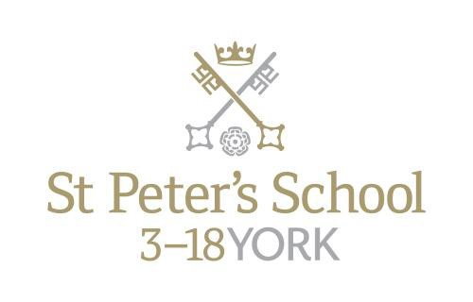

Teacher of Classics

Maternity Cover from October 2018

The Post

The post would equally suit a new entrant to the profession or a teacher wishing to broaden his or her experience. The successful applicant should be able to teach Latin and Classical Civilisation at all levels from the Year 9 to GCSE.

The Department

The department currently comprises three full time and two part time specialist teachers.

For the first year at St Peter’s (Year 9, approximately 105 pupils), all pupils study a classical subject, and this divides into 3 sets for Latin and 2 sets for Classical Civilisation. At the end of Year 9, pupils choose their GCSE subjects. Those studying classical subjects at St Peter’s have increased in number in recent years and approximately 70% of the year group opts to study a classical subject to GCSE.

There are two sets for Latin and three for Classical Civilisation in both Years 10 and 11. In the Sixth Form there are currently five pupils studying the new linear Latin course in the L6th and six studying for A2 in the U6th; for Classical Civilisation there are seventeen at AS and twelve at A2. We anticipate a positive uptake for the forthcoming year as we complete the move to linear A levels throughout the department. In the last five years, pupils have been awarded places at Oxford, Cambridge, London, Bristol, Manchester, Edinburgh and other universities to study a variety of classical degrees.

Recently, the department has also been involved in the York Independent and State School Partnership programme with some excellent feedback from all concerned. The local Classical community is very supportive and we aim to meet regularly to discuss current issues, share strategies and to consider ways of promoting the subject locally.

For Latin, we follow the Cambridge Latin Course, which is supplemented from departmental resources by more traditional methods for teaching grammar: extension tasks for the most able often include English-Latin translation. The OCR syllabus is followed at GCSE and A-Level. For Classical Civilisation, the department has extensive resources built up over many years, and all members of the department are happy to share ideas and resources. The OCR syllabus is followed at GCSE and A-Level.

Greek has recently been re-introduced into the mainstream timetable in combination with Latin (‘Gratin’) at GCSE level. Our first cohort was examined in summer 2014 and nearly all pupils achieved A* in both Latin and Greek; subsequent groups have achieved similar success. This is an exciting project that we are sure will grow and prosper; we now have Greek candidates at every level of the school and hope to continue this tradition.

The department is well resourced, and with good accommodation. There are three dedicated classrooms, all of which have been recently refurbished. Each classroom also has a computer and printer as well as its own digital projector.

Sixth Formers regularly attend a variety of conferences, talks and plays. Previously, the department has visited Hadrian, Persia and Pompeii exhibitions at the British Museum, as well as a staging of Aristophanes’ Frogs at the Bloomsbury Theatre in London. This year will also attend lectures at a variety of venues and have already enjoyed the National theatre Live broadcast of Medea and Antigone. We also work on projects within our local Classics community, and this year we will be reviving a Classics Reading competition and staging a regional Classics quiz. We are also hosting the author Ben Kane for a day of lectures and Peter Jones came to speak as part of our Lecture Series (which is open to the public).

Meanwhile a party of Year 10 pupils regularly visits Hadrian’s Wall in what has become an increasingly popular overnight trip. Overseas trips are also an important aspect of departmental life. There was a trip to Greece in 2011 and a trip to Pompeii took place in October 2013. In October 2015 47 pupils visited Pompeii and Rome and we now have 71 pupils signed up to join this trip in October 2017.

The School is committed to safeguarding and promoting the welfare of children and young people and expects all staff and volunteers to share this commitment. The successful applicant will be required to undergo checks with the Disclosure and Barring Service.

All staff at St Peter’s School are required to observe all relevant Health and Safety, Equality and Data Protection legislation and procedures.

Salary

The starting salary will be at a point on the St Peter’s salary scale, related to the old National Scale.

Other Opportunities

The school works a busy six day week and the person appointed will be expected to play an active part in the school’s tutorial system and in its extra-curricular life. The guideline teaching load is 28 forty minute lessons in a 40 period week. This post will be in the region of 0.5 to 0.7. The School’s co-curricular programme is broad and is well-supported by the teaching staff. An overview of the current range of activities is attached. While the standards of both girls’ and boys’ sport at the School are high, all sports have a number of competitive teams and so an ability to coach sports would be an added recommendation. Opportunities exist to choose to become involved with the School’s active Music Department, the Community Action programme and the various dramatic productions staged annually. Because of the breadth of activity on offer, there is scope for the interests and expertise of the successful candidate within the framework of extra-curricular activity provision. There is also a broad range of School trips each year, from expeditions to Ecuador and India, major sports tours, Choir tours to Europe, numerous cultural visits as well as Ski trips. The School runs an active and well-supported CCF and a large number of children complete Duke of Edinburgh awards each year.

Applications

Please return a completed application form and accompanying letter to: Mr Leo Winkley, Head Master, St Peter’s School, York, YO30 6AB
Tel: 01904 527408
Fax: 01904 527302

Or by email to j.warner@stpetersyork.org.uk

The closing date for applications is 9.00am on Monday 25 June 2018. Interviews will be held at the end of the same week.

June 2018

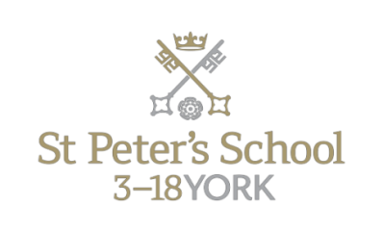

About St Peter’s

Background

St Peter’s School, York comprises three schools: St Peter’s School (pupils aged 13 – 18), St Olave’s School (pupils aged 8 – 13) and Clifton School and Nursery (pupils aged 3 – 8 years). The school is fully co-educational with 1,100 pupils, of whom 158 are full time boarders and 231 are in the Sixth Form. There are over 300 teaching and support staff. It is one of very few schools in the North of England to offer three distinct phases of education, each sharply identified and focused towards the needs of its pupils at each age group and set within an overall context of trust, confidence-building, inspiration and opportunity.

St Peter’s is one of Europe’s oldest schools, founded in 627AD, and is ranked in the top 100 schools in the country for its academic results. The school is located within a short walk of York city centre, with its thriving cultural, educational and commercial life. Many of St Peter’s facilities are modern and spacious, with playing fields adjacent to the main building that stretch down to the River Ouse.
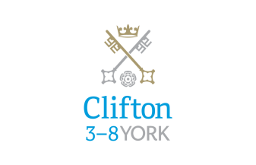

Clifton School and Nursery

Clifton School and Nursery, for day girls and boys aged rising 3 to 8 years, has its own building with use of extensive play areas, sports hall and swimming pool. Under the leadership of the Head, teachers use the attractive buildings and play areas to maximum advantage, teaching a broad and balanced curriculum which gives a wide variety of experiences, and emphasises the importance of basic skills. The curriculum is based on the National Curriculum and Primary Strategy, but goes far beyond this, both within the school day and during the wide range of co-curricular activities and visits outside of School.

Clifton enjoys separateness, a clear identity and its own House system. It allows smooth academic progression and provides tailor-made approaches and facilities for each age group.
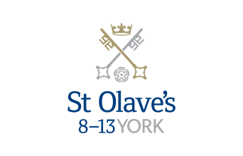

St Olave’s School

St Olave’s School (pronounced ‘olives’), for girls and boys aged 8 to 13 years, is adjacent to the main campus of St Peter’s and introduces boarding as an element of the School. Under the leadership of the Master, the teaching staff provide expertise in the 8 to 13 range, guaranteeing subject specialism to challenge and support every pupil.

The curriculum is wide and challenging with expert teaching from the earliest age. There are many opportunities for recreational and competitive sport with girls’ and boys’ teams enjoying success both regionally and nationally. There are numerous co-curricular activities to choose from on a weekly basis. Music plays a central role in school life, involving the full range of orchestral instruments.

Boarding is an integral element of the School and is accommodated in Wentworth, a boarding house on the main school campus.

St Olave’s has retained its own identity – a school within a school – giving all pupils a sense of pride and identity. It is recognised as a school in its own right, playing a vital role in the success of Clifton and St Peter’s.

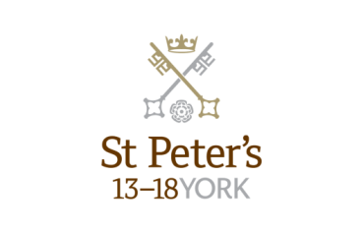

St Peter’s School

St Peter’s School, for children aged 13 to 18 years, is underpinned by academic rigour and challenge. Through outstanding teaching, first rate facilities, high expectations and sheer determination on the part of its pupils, St Peter’s achieves considerable success across a broad curriculum.

The four vibrant and successful boarding houses for boys and girls lend vitality to the pastoral life of the School. Inspiration from living in close proximity to a cultured and historic city adds further richness to the pupils’ lives. The Ofsted inspection of Boarding in December 2010 found the School’s provision to be Outstanding.

The School Chapel stands at the centre of the campus and regular services (three mornings a week) give pupils and staff the opportunity to reflect together on the spiritual values of the community and on the meaning and significance of what is happening locally, nationally and globally.

Music, Art and Drama are central to the cultural and academic depth of the School. The Sports programme is extensive, providing a wide range of choice for both girls and boys. Results are excellent, and St Peter’s pupils’ co-curricular achievements are considerable. The excellence of the teaching and facilities allows pupils to thrive.

The school’s website can be visited at www.stpetersyork.org.uk. The most recent inspection report is available on the ISI website.

About York

St Peter’s School is situated five minutes’ walk away from York’s compact city centre. York is one of the oldest and most beautiful cities in Europe, famous for its gothic Minster and winding medieval streets. York has won a number of tourist awards and further details are available on the Visit York website. York is regularly voted as one of the best places to live in the UK. Such is the size and layout of York, walking and cycling are ideal ways to get around, including taking in the famous sights of this historic city; an ancient Roman and Viking capital.

York is a central rail hub between Edinburgh, London and Manchester. The main railway station is only a 15 minute walk from the School. In addition it has a large variety of restaurants, pubs, theatres, cinemas, parks, museums and galleries, and life in York is always interesting, by day or by night.

Finding somewhere to live is also comparatively easy. York’s rental sector is in good health, though demand remains high. If you are trying to buy you will find York prices are around the national average.

York is a family friendly city. Attractions such as the Jorvik Viking Centre, the Barley Hall, the York Dungeons, the National Railway Museum and the York Chocolate Story are immensely popular with people of all ages.
The city lies in the Vale of York, a valley that runs north to south between the heathery North Yorkshire Moors to the east and the famous Yorkshire Dales to the west. Both areas offer an excellent escape for walkers, cyclists, climbers – indeed anyone with a love of fresh air and rolling countryside.

How to find us

You can find St Peter’s School, York, at YO30 6AB. The School is less than fifteen minutes on foot from York Railway Station.

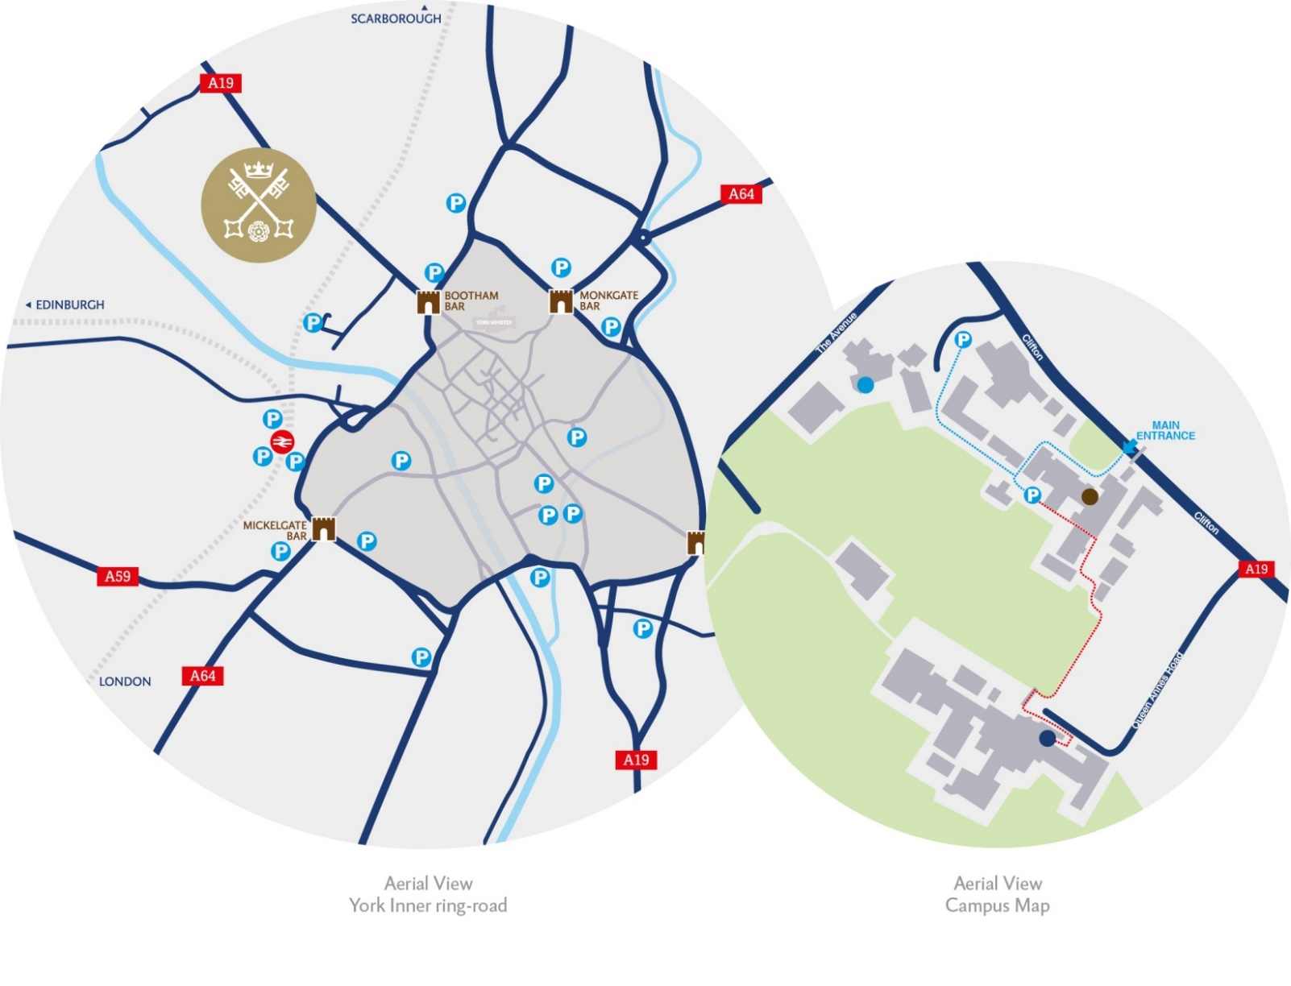
By car:

From York City Centre: Take the Thirsk Road (A19) at the Bootham Bar traffic lights. The school is 700m on the left, immediately after the footbridge.

From the A64: Take the Northern Ring Road (A1237). At the A19 roundabout turn towards the city centre. The school is two miles on the right, 300m after Clifton Green. Turn right into the school immediately before the footbridge that crosses the road.

Parking is available on site.

