KENT COLLEGE

______________________________________________________
INDEPENDENT DAY AND BOARDING SCHOOL FOR GIRLS 3-18

KENT COLLEGE PEMBURY
Maternity Leave
Early Years Teacher (Reception)
Full time
September 2018 – August 2019

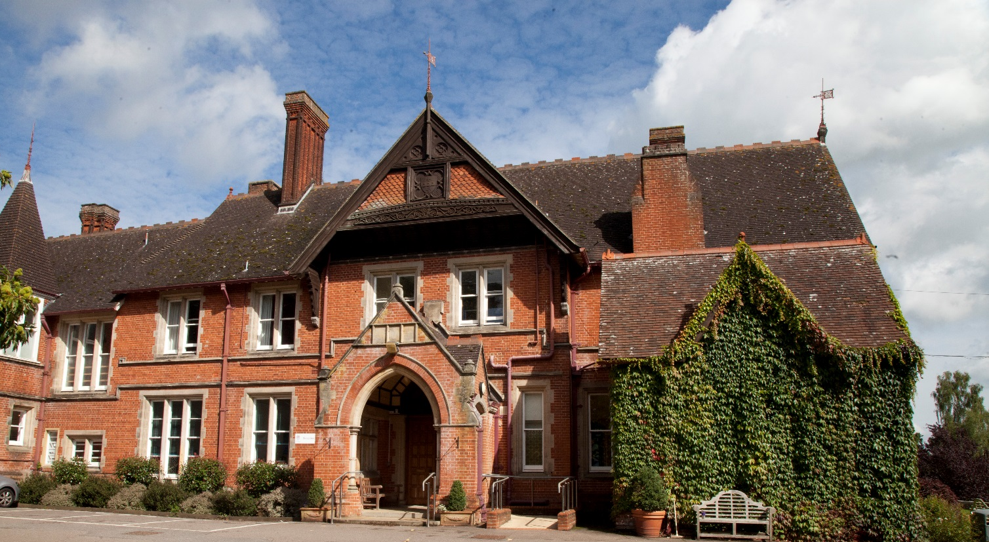

Background
Founded in Folkestone in 1886, Kent College is an independent day and boarding school for girls, with a Senior School (ages 11-18) and Preparatory School (ages 3-11) sharing the same site, facilities and some specialist staff. The school is one of a group of ten schools under the control of the Methodist Independent Schools Trust. The school has a resident Chaplain who leads the Christian worship in the school.

Since 1939, Kent College has been located on 75 acres of beautiful countryside in Pembury, near Tunbridge Wells. The school campus comprises an elegant Victorian manor house and purpose-built modern facilities, including boarding houses, a music centre, science building, sports hall, A level study centre, and an indoor, heated swimming pool. The school is committed to a continuous programme of development and the resources are excellent. IT provision is first-rate, including the number of interactive white boards, laptops and data projectors. In 2008 a new science wing was opened, providing inspirational science laboratories, and recent boarding refurbishment includes an extension of ICT facilities to individual study areas. The Countess of Wessex Theatre reopened in 2012 following extensive refurbishment and an iconic Library and Arts Centre opened in spring 2013. Our additional Sports Hall is now complete and was opened in October 2015.

The Prep School
In 1939 the School moved to its current site in Pembury, near Tunbridge Wells. In 1945 a Prep School was opened in the centre of Tunbridge Wells and in 1989 it was moved to the Senior School site in Pembury into architect-designed purpose built accommodation. The move also enabled the Prep School to benefit from a range of excellent facilities which now include an indoor heated swimming pool, sports hall, theatre and dining hall.

The Prep School is a friendly, caring and happy school with a current roll of 180 girls aged 3 to 11 (Nursery – Year 6). The majority are day pupils with a small number of boarders. In addition to the core subjects of English, Maths and Science, all of the girls in Key Stage 2 study Geography, History, Art, DT and RE. Specialist teachers in ICT, Music, French, Drama, PE and Swimming work with girls throughout the school, and Mandarin is now also taught in Year 6. Class sizes in KS1 and KS2 range from 12 to 18. Each year, a number of girls apply for and are awarded scholarships to the Senior School.

Extra-curricular Activities (ECAs)
Kent College places a strong emphasis on extra-curricular activities and has a flexible and innovative lunchtime and evening programme of prep and activity sessions. Boarders can choose when they do their prep and day girls choose whether to do homework at home or at school. All girls participate in extra-curricular activities and are encouraged to plan the use of their time so that they follow a balanced programme of academic work and extra-curricular activities. The pastoral care in the school is very strong and all staff are highly involved in PSHCE and general pastoral matters. All teaching staff are required to be involved in at least one ECA and most do more than this, as both subject and general ECA are available.

Inspection
The school underwent a full integrated inspection by the Independent Schools Inspectorate in December 2015 and was found to be excellent in all areas. The report together with other information about Kent College can be found on our website at www.kent-college.co.uk

Benefits
Kent College Pembury employs over 200 people in both academic and support staff positions. Highly skilled, dedicated and passionate staff are the driving force behind our ‘Excellent’ school.

We are delighted to welcome applications from candidates who share our core values and who are able to contribute to our continued future success. We recruit staff of the highest calibre who will inspire, support and challenge the girls, and fellow colleagues, to achieve their full potential. Whatever your role, you will benefit from a being part of a large staff community with opportunities for professional development.

We believe in rewarding our staff and offer a complete range of employee benefits including:

Reduced school fees
Childcare voucher scheme
Free meals during working hours
Free eye tests
Subsidised Flu Vaccinations
Free onsite parking
On-going training and development
Use swimming pool and fitness suite (at allocated times)

The Department
The Early Years Department consists of Nursery class and the Reception class with three teachers and two teaching assistants, the staff work closely as a team. The pupils are also taught by specialist staff for a number of subjects including French, music, drama and PE. The Early Years Department is an important part of the whole school.

Job Description
We are seeking a dynamic and energetic teacher to join our committed and passionate Early Years Department as Reception teacher for Maternity Cover initially for one year. The successful candidate needs to be flexible, organised, efficient, enthusiastic and experienced teaching in an Early Years setting.

Key Responsibilities

• To maintain high standards of preparation, monitoring, teaching and assessment of pupils’ work in line with school policy.
• To assist with the provision of care, guidance and support of the girls in the Prep School.
• To encourage girls to contribute fully to the life of the school and take up opportunities that will enrich their school experience.
• To work alongside the Early Years and KS1 Teachers effectively as a member of the Key Stage 1 team.
• To encourage pupils to achieve the highest standards of which they are capable and to provide constructive feedback on pupils’ progress.
• To contribute to the arrangement of attractive displays of pupils’ work in the school
• To provide the relevant information so that accurate reports for parents are written in line with Kent College guidelines and to provide feedback for parents’ consultations.
• To continue with personal professional development through appropriate in service opportunities.
• To encourage pupils to make use of a variety of learning styles and strategies.

Salary
Kent College’s salary structure is based on the national Teachers’ Pay Scale according to experience, albeit with enhancement, together with the school’s own management and responsibility points. Kent College also offers the staff the opportunity of moving to the upper pay range of teachers’ pay, including progression from U1 to U2, on KC criteria; existing threshold achievement to U2 will be honoured. The post holder will be eligible to join the Teachers’ Pension Scheme operated by the Teachers' Pensions Agency.

Application process
The completed application form, including the names and addresses of two referees, cv and a letter of application should be sent to Headmistress, Ms Julie Lodrick, Kent College, Old Church Road, Pembury, Tunbridge Wells, Kent TN2 4AX by letter, fax (01892 820232) or email (hr@kentcollege.kent.sch.uk)

Closing date: Friday 20 April 2018 by Midday

References will be taken up prior to interview. One of the referees should normally be the applicant’s current or most recent employer. The post requires the highest level of clearance through the Disclosure and Barring Service (DBS).

Kent College is committed to safeguarding and promoting the welfare of children. Appointees must be prepared to undergo child protection screening Child Protection and welfare are taken very seriously at Kent College, with guidelines on confidentiality and staff-pupil relationship procedures well-publicised to staff.

All gaps of employment are to be accounted for and rigorously investigated. Referees are contacted to ensure the validity of the reference. Testimonials are not acceptable in place of confidential references.

