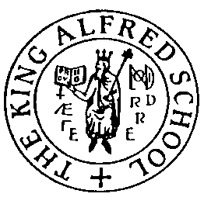

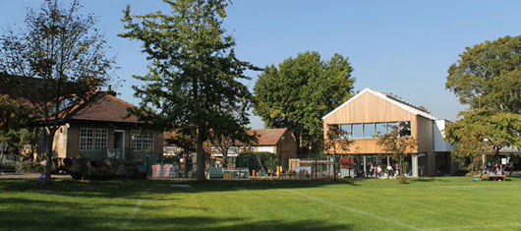

THE KING ALFRED SCHOOL
Appointment of LSA
with immediate effect

Information for Candidates
May 2018

For further information about The King Alfred School, please visit our website at www.kingalfred.org.uk
1. THE KING ALFRED SCHOOL
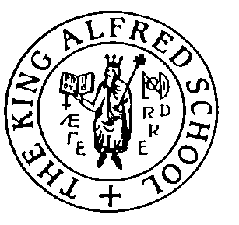
For over 100 years, The King Alfred School [KAS] has stood for a rational, nurturing and enlightened educational experience. Founded in 1898 by a group of parents in opposition to Victorian educational practices – authoritarian discipline, regimentation, religious instruction, collective worship – KAS was created as a demonstration school committed to encouraging learning for its own sake and to the effective application of research into the educational process. It sought to provide a well-rounded education that focused on what was best for the whole child and on the development of character and individuality.

KAS still stands out from the prevailing educational environment as a school that achieves academic success without unnecessary pressures, and social success through the development of relationships and responsibility rather than external discipline. It is a school that is genuinely loved by students, parents and staff alike.

KAS has often been referred to as a “progressive” school. Certainly, it subscribes to many of the concepts of the progressive movement. We emphasise child-centred education, which aims to draw out the best in the individual child. We believe that the principles of mutual respect, of relationships based on trust rather than authority and punishment, and of allowing each child to develop at his or her pace in an atmosphere that is free from fear, provide the best learning environment. The school places a strong emphasis on creative and active learning and on the value of play. Co-education, mixed ability, all ages and non-denomination are its essential and enduring characteristics. Informality is typified by the use of first names, the absence of uniform and as few rules as can be managed within a community.

The village green setting of the main site, next to Hampstead Heath, contributes to the community feeling of KAS. The school has about 645 students, from age 4 to 18. Most children will join at Reception and continue on to the end of their school lives. Transition from Lower to Upper School is a natural one and for KAS pupils does not depend on assessments, tests or examinations. Even though KAS is divided into two sections [Lower School, from Reception to Year 6; Upper School, from Year 7 to Year 13], it perceives itself as one school in which all parts belong to a whole. Age groups are encouraged to mix. We aim to provide a happy, compassionate environment in which the emotional, physical and social developments of the child are held in equal regard to academic progress.

A high teacher/pupil ratio enables the committed and professional staff to provide a rich variety of activities. Within the confines of a structured curriculum leading to successful preparation for GCSE and A levels, teachers strive to provide a broader and more generous education. KAS measures the success of its philosophy by the acknowledged maturity of the students when they leave, by their successful university careers and by the fact that students invariably end up doing something worthwhile, interesting or unusual.

KAS is committed to professional development and training for all its staff. New ideas from teachers and children are encouraged and there is active staff involvement in all aspects of the school.

The school is owned by and operated through the King Alfred School Society, members of which are mainly parents, ex-parents, ex-students and members of staff. The majority of the governing body – Council – is currently composed of parents and ex-parents [some of them ex-pupils]. Like any board of governors, Council is legally responsible for educational policy, financial management and the development of the school. In practical terms, Council appoints the Head and the Bursar and is then consulted and informed by the Head and the rest of the Leadership Team about general aspects of school life. Maintaining the school ethos remains an important part of Council’s responsibilities, and to this end, the KASS Framework has recently been produced.

Annual election of Members of Council ensures that parents maintain an active interest and input in how education is carried out at KAS. On the principle that family life is a vital overall aspect of education, parental involvement in the general life of the school is encouraged.

The King Alfred School is situated on two beautiful sites. On the main site at Manor Wood, school buildings are spread around an open field; a number of mature trees from the original Manor Wood provide play and camp-building areas for the younger children and protection for a small amphitheatre. The facilities have been expanded considerably over the years: most recently with major re-development of the Lower School, the development of new Art, Music, Science and Drama suites, the refurbishment of a 1.75 acre site [Ivy Wood] across the road and the building of our Design & Technology facility.
The Forge
What Motivates Children Conference – Stephen de Brett
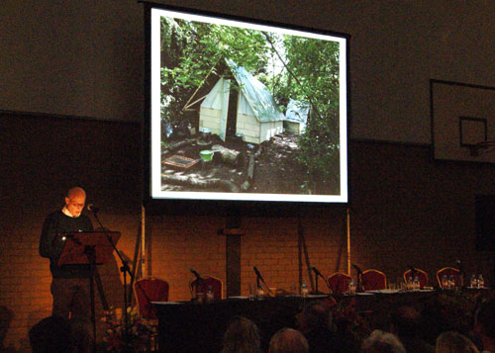

The Village
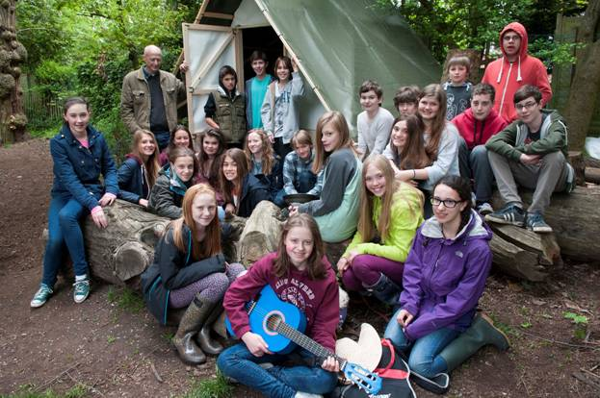
Girl’s Hockey team
3. Job Description
Date | May 2017
Salary | Between £12 to £14 per hour (depending upon experience)
Line Manager | Lower School SENCO
Hours | Part time  9.00am to 1.30pm daily  Term time only  Available to accompany the student on residential school events, such as camps*

* this may include, on an exceptional basis, an event which falls on the weekend or in school holidays

Job Specification:
This is initially a Key Stage 2 appointment, to provide support for a Y6 student to achieve academic and social success.
Have empathy for and understanding of a specific child whilst maintaining a sensitive, friendly and positive attitude to all children. Work with the teachers and other staff towards the inclusion and independence objectives detailed in the education plan.
All those working at this school support the KAS environment and foster the relationships which are fundamental to the ethos of KAS

Main Responsibilities:
- Attend classes with the student. Provide sensitive support when necessary
- Pro-actively help to build and then monitor the student’s emotional security and liaise with the class teacher
- Help to foster student’s positive attitude and emotional resilience
- Attend briefings to keep well informed on relevant aspects of life in school.
- Observe professional confidentiality about all children, students and their families, and any other sensitive matters relating to life in school.
- Ensure the safety of the child during break times and on trips.
- Follow the school’s Safeguarding, and Health and Safety Policies.
- Carry out all reasonable requests made by management.

- Person Specification
Attributes |  | How identified
Qualific-ations / training | - Good standard of written and spoken English  - Degree (desirable) | Application
Experience | - Evidence of working with SEND students  - Evidence of working well in a team | Application, reference &  Interview process
Skills and abilities | - Interpersonal : Ability to establish successful relationships with the particular student, students more broadly, the parents and colleagues  - Emotional Intelligence : Ability to work sensitively with the student on a 1-2-1 basis and in larger groups  - Advocacy : Ability to articulate the student’s needs to others as appropriate  - Planning : Ability to think pro-actively about the student’s needs and opportunities  - Organisation : Ability to organise, prioritise, plan ahead and coordinate a variety of tasks and procedures, in tandem with colleagues | Application, reference, &  Interview process
Personal attributes | - Empathy, sensitivity and a good sense of humour  - Enthusiasm, determination, flexibility  - Positivity and resilience  - Tact and diplomacy  - Welcomes feedback and accountability  - Sets and maintains high standards in professional relationships with students and colleagues | Application, reference, &  Interview process
Commit-ment to | - The KAS ethos, and child –centred progressive education  - Working in a ‘can‐do’ culture with a commitment to continuous improvement  - The happiness, well‐being, and progress of all at the school  - Safeguarding and welfare of all children and young people | Application, reference, &  Interview process

