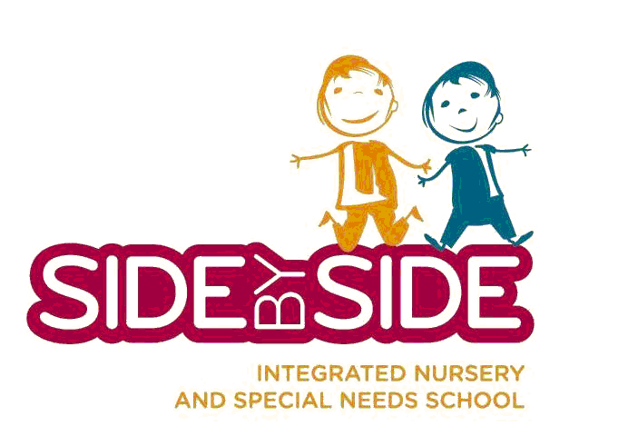

Job Description

Job Title: Speech and Language Therapist

Responsible to: Head Teacher

Hours : To be agreed

Salary : Competitive - based on experience and qualification

Location: 9 Big Hill, London E5 9HH

Side by Side Children Ltd. is committed to safeguarding and promoting the welfare of children and young persons. Staff must ensure that they follow school policies, guidance and regulation to safeguard children and young people. The successful candidate will be required to undergo an Enhanced Disclosure form the Disclosure and Barring Service (DBS).
It is essential to maintain complete confidentially on all school matters.

Side by Side is committed to providing an outstanding education for all its pupils. The Charedi ethos of the school will meet the needs of the Charedi Community through providing a broad Kodesh and secular education with therapeutic and life skills programmes as an integral part of the school day
Main Responsibilities
Clinical
- To provide speech and language therapy assessment, intervention and advice in accordance with the children’s needs.
- Ensure relevant therapeutic intervention in line with the requirements of their Statement of Special Educational Needs.
- Develop intervention plans based on student needs and regularly evaluate.
- Monitor and reassess the effects of speech and language therapy intervention and the need to continue, modify, or discontinue intervention.
- Participate in multidisciplinary meetings to review evaluation results, integrate findings with other disciplines, offer recommendations and develop individual education plans and intervention plans to achieve IEP goals.
- To be an active member of Side by Side’s MDT team and contribute to the strategic planning, monitoring and evaluation.
- Collaborate with other disciplines to ensure teams understanding of the students’ speech and language strengths and needs, through evaluation, educational programme planning and service delivery.
Management
- Prioritises and schedules work tasks independently.
- Maintain clinical and administrative records in accordance with professional standards and school guidelines.
- Write reports reflecting specialist knowledge as required. E.g. Annual Reviews, statementing process etc.
- Maintain together with your colleagues all SLT and general resources.
- Advise and monitor the key workers/teaching assistants with respect to the pupils’ programmes.
- Liaise with Side by Side staff, community agencies, parents and students to increase understanding of the student’s speech and language performance.
Communication
- Communicate effectively with all stakeholders
- Advise school manager of any incident of any student whose care/health is causing concern
- Participate in MDT meetings and training sessions as required
- Maintain complete confidentiality on all maters
- Notify school manager of any absences

Other Responsibilities
The duties and responsibilities in this job description are not restrictive and the post holder may be required to undertake any other duties which may be required from time to time.
The post holder must carry out his/her duties with full regards to the setting’s Health and Safety Procedures.
It is the post holder’s responsibility to maintain their HCPC registration, CPD records and any other relevant regulatory requirements.

Person Specification
 | Essential | Desirable
Experience | - 2+ years post SLT qualification working in pediatrics  - Experience in working across a multi-professional team  - Working with parents and volunteers  - Managing and evaluating resources within a setting | - Experience in delivering training.  - Delivered SLT in a school setting
Qualifications | - Speech and Language Therapy Qualification  - Registered with the HCPC | - Attended relevant post- qualification training.
Knowledge and Skills | - Ability to develop and deliver effective programs for the pupils.  - Monitor the effectiveness of programs and adapt as required.  - Ability to advise and support other professionals.  - Ability to identify own training needs, attend required training and continued professional development.  - Able to communicate confidently with a wide range of people both written and verbal.  - Worked with children with additional and special educational needs.  - Able to work independently as well as being part of a team. | - Knowledge in the area of AAC.  - Knowledge of Makton
Personal Attributes | - Warm and caring personality – friendly and approachable to families, staff and children.  - Highly motivated and commitment to high standards.  - Flexible

