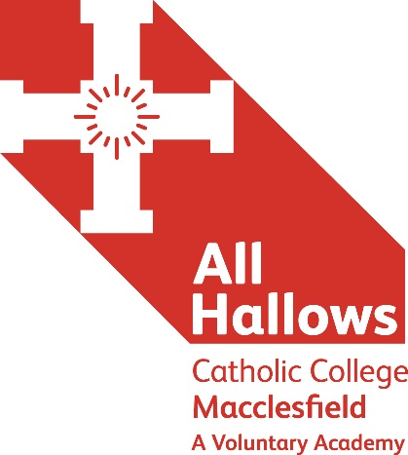

TEACHER OF SCIENCE
Main Pay Scale Range
This post is to commence as of September 2018

We are seeking to appoint an inspirational, enthusiastic and committed individual to teach Science within a highly successful department in an Outstanding 11-18 Catholic Academy, whilst also making a contribution to the Catholic life and ethos of the College.

This post is open to all science specialisms, however the ability to offer a specialism in one area to A level would be an advantage.
It’s about us and it’s about you…

All Hallows has built sustainable school improvement with a passionate focus on teaching and learning together with highly effective leadership and a high value placed on the young people’s personal development and spiritual well-being. These are the ingredients for the successive outstanding Ofsted judgements in 2011 and 2104 that recognise the superb achievements of our students.

As a National Teaching School and SSAT National TEEP Champion School, we offer excellent professional development opportunities for all our staff in structured programmes of high value. As a Lead Practitioner Accreditation Centre we actively encourage professional reflection and research so that our teachers constantly deepen their knowledge and fine-tune their practice. Leadership development is actively encouraged through NAML, NPQML and NPQSL programmes that are delivered on site by our own accredited trainers.

Working at All Hallows Catholic College and within our Multi Academy Trust is an opportunity to join a progressive teacher-learning community, inspired by Christian values, which focuses on the art, craft and science of teaching, as a noble vocation, in a place where students enjoy learning.

Application documents can be found on the Catholic Education Service website: http://www.catholiceducation.org.uk/employment-documents/application-forms

Please go to: Employment Documents / Application Forms
You are required to complete the following documents:
Teacher Application Form / Recruitment Monitoring Form / Rehabilitation of Offenders Disclosure Form
All posts are offered subject to agreement to sign the CES contract of employment with the Holy Family of Nazareth Catholic Academy Trust and enhanced DBS clearance suitable for working with children and young adults.

Applications to the Director of HR and Operations at:
All Hallows Catholic College, Brooklands Avenue, Macclesfield, Cheshire SK11 8LB
hr@allhallows.org.uk

CLOSING DATE: Monday 26th February
INTERVIEW DATE: To be confirmed
‘Aspire not to have more, but to be more’
Blessed Oscar Romero
☩ Honourable purpose ☩ Respect ☩ Compassion ☩ Cooperation ☩ Stewardship ☩

A Member of The Holy Family of Nazareth Catholic Academy Trust

