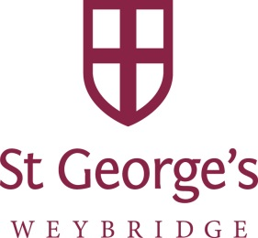

St George’s Weybridge is committed to equal opportunities and wishes to be representative of the community it serves by ensuring we attract and recruit a diverse group of people.

The completion of this monitoring form is voluntary and the information you choose to provide will stay confidential and be held separately to the rest of your application.

Equal opportunities monitoring
Nationality
Cultural/Ethnic background
Gender
Sexual orientation
Religion/belief
Do you consider yourself to be disabled according to the definition below? YES ☐ NO ☐
The Equality Act 2010 defines a person as having a disability if she/he has a physical or mental impairment that has a ‘substantial’ and ‘long-term’ negative effect on his/her ability to do normal daily activities.
Please state the nature of your disability:
If you are selected for interview are there any special arrangements we should consider for you?
Please state where you heard about this vacancy:

