St Luke’s Church of England School

secure foundations excellent practice faith, hope and love

Headteacher
(L12-18 Group 1 School £59,087 - £67,305)

Ours is a happy, well-organised and effective school. Open since 2011, we have had a successful start and there are strong systems in place. This is an interesting opportunity to lead and further develop a school which is well placed for the future.
About the post
- The vacancy has arisen because our headteacher has decided not to return at the end of her maternity leave
- This is a full-time appointment however governors are open to exploring the possibility of a part-time role for the right candidate
- Mentoring or support from an experienced headteacher is available
- This is an interesting and exciting opportunity to further develop a school which has laid strong foundations and is well placed for the future
About you
- You might be an ambitious deputy head looking for a first headship in a small, innovative setting which is well supported by the Local Authority and LDBS
- You might be an experienced head looking for a new challenge and something different
- You will be an inspiring and dynamic practitioner who appreciates what has been achieved and who can lead us through our next exciting stage
For an informal discussion about the role or to arrange a visit contact the Chair of Governors, Penny Roberts, penny.roberts@london.anglican.org.
Closing date Noon Wednesday 18 October 2017
Shortlisting Thursday 19 October 2017
Visit to candidate schools for shortlisted candidates Friday 20 October 2017
Interviews Monday 30 October 2017

We consider the safety of our children to be of paramount importance and this recruitment process is in line with safer recruitment practices. St Luke’s School expects all staff and volunteers to share our commitment to safeguarding and promoting the welfare of children. The successful applicant will be expected to undertake an enhanced criminal records check via the Disclosure and Barring Service.

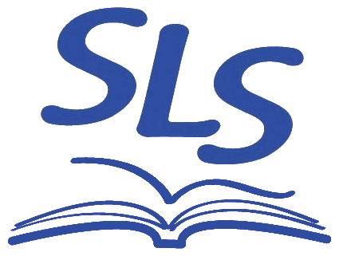
St Luke’s School, Kidderpore Avenue, London, NW3 7SU
www.stlukesschool.org.uk
office@stlukesschool.org.uk
020 7435 5604

St Luke’s Church of England School is a company limited by guarantee No 7451568
Registered in England. Registered address: Kidderpore Avenue, London, NW3 7SU
Member of the LDBS family of schools

