Pastoral Manager
Candidate Information Pack

INTRODUCTION
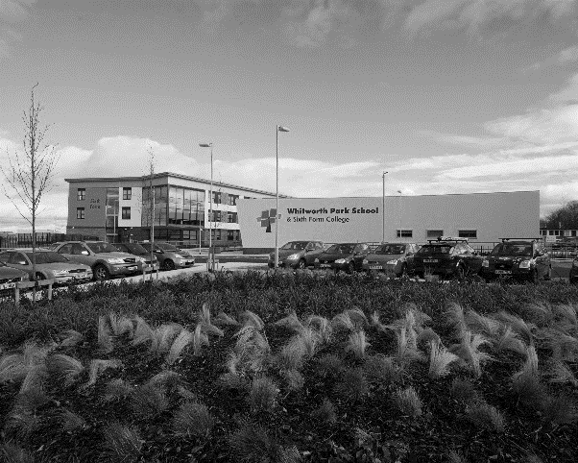
Whitworth Park School & Sixth Form College is a successful, welcoming and caring school.
Whitworth Park School & Sixth Form College was opened in September 2012 following the amalgamation of Spennymoor School and Sixth Form Centre and Tudhoe Grange School. Both schools were highly successful serving the community of Spennymoor and the surrounding villages. The school is situated in a semi-rural location within easy reach of the cities of Durham and Newcastle-Upon-Tyne. Spennymoor is also ideally located for access to the A1M which is close by, whilst house prices are moderate when compared to the national average.
The school offers a broad and balanced curriculum and is committed to offering the highest quality learning experience to all of its students.

JOB DESCRIPTION

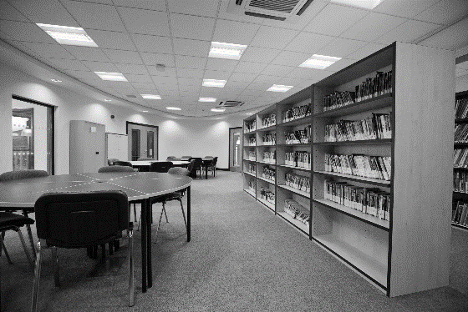
JOB TITLE:
Pastoral Manager
ACCOUNTABLE TO:
House Leader
GRADE:
Grade 7, point 24-28 (£21,962 - £24,964 pro rata)
Term time only + 12 days

THE POST:
The Pastoral Manager will be responsible for the day to day management of an agreed School House on all pastoral matters in order to:
- raise standards of student safety, care and guidance
- raise standards of student attendance, punctuality and behaviour
- monitor, raise and celebrate student achievement

KEY RESPONSIBILITIES

Staff are expected to support and contribute to the school ethos:
Success through Partnership - an inclusive education for all learners in the community of Spennymoor providing “Excellence for Everyone.”

The school aim is to create an environment which is inspirational and aspirational, in which every learner has the opportunity to develop the skills to lead a positive and fulfilling life. We work in collaboration with parents, carers, the community, and all other educational and service providers to nurture all of our young people. Our educational programme provides a climate which inspires learning, creates trust, respect and tolerance and promotes sustainability and collaboration - “Excellence for Everyone”.

Duties and responsibilities specific to the post:

- to develop a climate within their year group where students feel safe and secure and free from all forms of intimidation and bullying;
- to develop relevant student skills to be useful members of the school and local community;
- to act as the point of contact for the parents/carers within their area of responsibility;
- to be on call and available for students throughout the day;
- to manage and supervise students on moderated timetables;
- to initiate, sustain and develop the use of 1:1 mentors to address issues of behaviour and general standards in school;
- to develop a positive culture of rewards and celebrations across their House, with respect to achievement, behaviour and safety;
- to organise House assemblies and celebrate success whenever possible;
- to coordinate and deliver innovative student interventions to correct issues with student behaviour and attendance;
- to assist in the organisation of parental/carer events such as:
  - Open days
  - Parent evenings
  - Progress days
  - Achievement presentations etc;
- to ensure students, parents and carers receive appropriate support and guidance with respect to all aspects of pastoral care, including the signposting to:
  - School Counsellor
  - Mentors
  - Parent Support Advisors
  - School Nurses
  - Education Welfare Officer
  - Parent Partnership;
- to attend external meetings with respect to behaviour and attendance for students at risk of FTE and PE, including:
  - Team Around the Family/Child
  - Team around the school
  - Other outside agencies as required;
- to assist House Leaders in producing monthly reports to the Senior Leadership Team on key aspects, including:
  - Students at Risk of regular FTE
  - Students at Risk of PE
  - Attendance
  - Lateness
  - Achievement;
- to lead on Student Council with respect to their relevant area of responsibility.

To carry out additional responsibilities relevant to the role of a Pastoral Manager as required by the AHT Behaviour and Welfare and House Leaders.

General expectations of all support staff:

Staff will:

- contribute effectively to the work of the school and to the achievement of the ‘School
Improvement Priorities’;
- play a full part in the life of the school community, to support our distinctive aims and ethos, and to
encourage staff and students to follow this example;
- follow school policy regarding care, support and supervision of students;
- attend training and development activities and courses, ensuring continuing personal and
professional development;
- contribute to a welcoming school culture by promoting mutual respect for all, working with students and parents in a courteous, caring and responsible manner at all times;
- comply with any reasonable request from a leader to undertake work of a similar level that is not
specified in this job description;
- work effectively as a team member;
- act as a role model to students in speech, dress, behaviour and attitude.

Duties and responsibilities of all support staff:

All support staff will:

- promote and safeguard the welfare of the students s/he is responsible for, or comes into contact with;
- support and encourage colleagues at all levels within the school;
- promote the school’s stated ethos and support the school’s policies;
- contribute to and implement the annual School Improvement Plan and agreed policies;
- support and assist the progress of student learning;
- take responsibility for their own professional development;
- contribute to the development of work policies as appropriate;
- attend and contribute to appropriate meetings and professional development activities;
- take an active part in the school’s self-evaluation process;
- promote good behaviour and positive attitudes at all times;
- support subject, tutor group, year and school activities as appropriate;
- to accompany and supervise students on trips and visits as appropriate;
- carry out general administrative/clerical duties as necessary;
- undertake whatever other duties might reasonably be requested by the Headteacher or Line Manager;
- have common duties in the areas of: Quality Assurance, Communication, Professional Practice,
Health and Safety, General Management (where applicable), Financial Management (where
applicable), Appraisal, Equality & Diversity, Confidentiality and Induction.

This job description will be reviewed annually and may be subject to amendment or modification at any time after consultation with the post-holder. It is not a comprehensive statement of procedure and tasks but sets the main expectations of the school in relation to the post holder’s professional responsibilities and duties.

PERSON SPECIFICATION

 |  | Essential | Desirable
Application | A well-structured letter of application indicating interests and strengths in the subject | *
Qualifications and Professional Development | Educated to G.C.S.E Grade C or higher in English and Maths | *
 | Recent and relevant in-service/professional development in Pastoral Needs of students |  | *
 | Ability to use ICT as a learning tool |  | *
 | Commitment to further study including any in-service training | *
Experience | Ability to demonstrate high standards with respect to the Pastoral support of students | *
 | Knowledge of a wide range behavioral, attendance and safety issues and their impact on learning | *
 | Knowledge of the use of data to inform planning, measuring progress and to aid target setting and improving performance against identified outcomes with respect to behaviour, attendance and Safety. | *
 | Experience of multi-agency working and liaison with external agencies |  | *
 | Ability to assess and review young people and family circumstances and plan appropriate responses, drawing on in-school and external advice and expertise where necessary | *
 | Ability to work effectively and network, with a wide range of support services, from both the public and private sectors, and an ability to draw upon a wide range of support, information, opportunities and guidance | *
 | Ability to identify potential barriers to learning and jointly engage in strategies to overcome these barriers | *
 | Ability to engage in joint goal setting with an individual student as part of the learning action planning process | *
 | Ability to work effectively and network, with a wide range of support services, from both the public and private sectors, and an ability to draw upon a wide range of support, information, opportunities and guidance | *
Qualities & Values | A drive to make the student experience in school fun, engaging and exciting | *
 | The ability to inspire others and share good practice | *
 | Good communication skills with the ability to relate effectively to all ages and abilities | *
 | A commitment to promoting inclusion | *
 | Ability to provide and present evidence for reports | *
 | Ability to provide advice to school staff and liaise with parents/carers. | *
 | Ability to contribute to the monitoring of, and intervention in, cases of unauthorised absence and poor punctuality | *
 | Ability to maintain a non-confrontational approach | *
 | Planning and prioritising own workload and managing conflicting demands | *
 | A commitment to Equal Opportunities | *
 | Knowledge and understanding of safeguarding | *
Personal Attributes | Ability to work under pressure and retain a sense of humour | *
 | Ability to work as team member to achieve common goals | *
 | Initiative, energy and perseverance | *
 | Enthusiasm and self-confidence | *
 | Personal presence and impact | *

Assessment against the criteria outlined above will be through the Application Form, Letter of Application, Interview Process and References. In addition to candidates’ ability to perform the duties of the post, the interview will also explore issues relating to safeguarding.

Any relevant issues from references will be taken up at interview.
APPLICATION

Please return a completed application form including the names, addresses and relevant contact details of two referees together with your letter of application.
The letter of application should be no more than two sides of A4 and should set out the particular strengths that you would bring to the post and how you feel you meet the criteria outlined in the job description and person specification.
Completed applications must be received by the school by noon on Wednesday 17th January 2018 addressed to:
Mr D Stone
Interim Headteacher
Whitworth Park School and Sixth Form College
Whitworth Lane
Spennymoor
County Durham
DL16 7LN

or by e-mail to the Headteacher’s PA, Mrs J Woodward at: j.woodward@whitworthpark.org.uk

Interviews are scheduled to be held week commencing 22nd January 2018.

If you have not heard from us within 4 weeks of the closing date please assume that you have been unsuccessful on this occasion.

Whitworth Park School and Sixth Form College:

- is committed to the protection and safety of its students. Appointment will be subject to an enhanced DBS check, satisfactory medical report and satisfactory references
- operates a strict no-smoking policy
- is an equal opportunity employer. As a disability confident employer, we are committed to employing disabled people and people with health conditions making reasonable adjustments to support disabled applicants when required.
Where our roles are customer facing and you are required to speak to members of the public, the ability to converse at ease with customers and provide advice in accurate spoken English is essential for the post.

Unfortunately we are unable to acknowledge receipt of your application.

