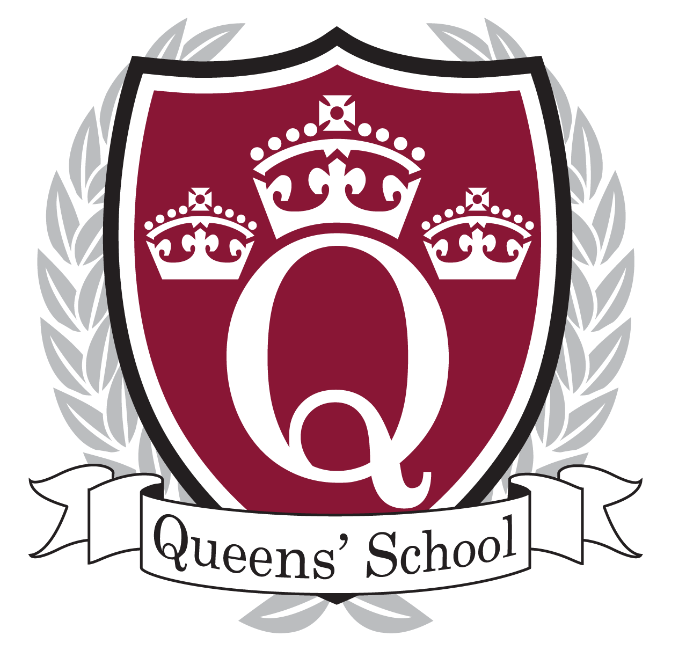

Queens’ School

Candidate Pack

Queens’ School
Aldenham Road
Bushey
Hertfordshire
WD23 2TY
01923224465
office@queens.herts.sch.uk

QUEENS’ SCHOOL

I am delighted to welcome you to Queens’ School. This is a thriving and highly successful oversubscribed school, the largest in Hertfordshire. GCSE results in 2015 placed us in the top 100 non-selective state-funded schools nationally. Our Ofsted Inspection in December 2015 confirmed that Queens’ continues to provide a high quality educational experience.

This is an exciting opportunity and one which should be a key stepping stone in your career. The successful candidate will be an excellent classroom practitioner who is able to lead by example, is ambitious, focused and driven but also someone who is innovative and thinks creatively to ensure the best possible outcomes for all our students.

Informal visits are welcome before the closing date by contacting Jo Walker, 01923 224465, to organise a mutually convenient appointment.

If you wish to apply for the post, you are invited to complete and return the Application Form along with a letter of application demonstrating how you feel you meet the Personal Specification. Your letter should be no longer than two sides of A4 (word processed and using size 12 font). All details, including the Application Form, Job Description and Personal Specification can be found on our school website: www.queens.herts.sch.uk.

All applications should be submitted electronically to: applications@queens.herts.sch.uk. An email will confirm receipt. A letter will be sent to the shortlisted candidates with details of the interview process. If you have not heard from us within 2 weeks of the closing date, please assume your application has been unsuccessful.

We are committed to safeguarding and promoting the welfare of children and young people and expects all staff and volunteers to share this commitment. All posts are exempted under the Rehabilitation of Offenders Act 1974. Appointments will be conditional upon the receipt of a satisfactory response to a check of police records via the Disclosure and Barring Service and references from previous employers. We are an Equal Opportunities employer.

I am very aware that applications take a considerable amount of time, so thank you in advance for your submission.

Jonathan Morrell
Headteacher
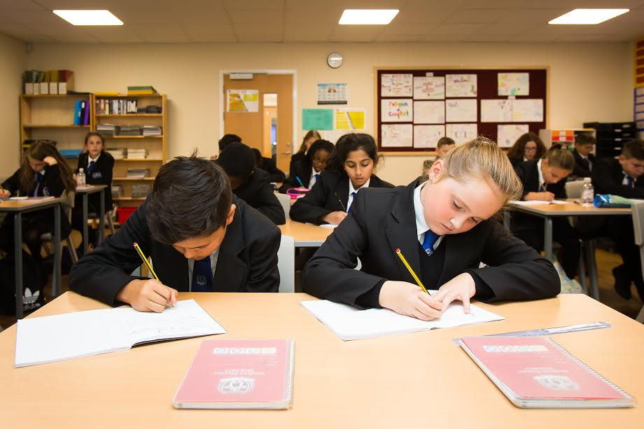

QUEENS’ SCHOOL

Why work for us?

- Top 100 non-selective state funded schools 2015 (GCSE)
- Outstanding progress at A-level Progress (ALPS 2) 2016
- Outstanding reputation and Good Ofsted 2015
- Teachers’ pay enhanced through the Fringe Allowance
- Pupils eager for success
- Supportive parents who value education
- Caring colleagues
- Excellent professional development and guidance
- Highly regarded senior team driving forward improvement
- Teaching and learning at the top of the agenda
- Happy friendly school community
- A holistic approach to student development
- Pupils are proud and enjoy learning
- Large range of extra-curricular opportunities: Sports; Arts; CCF; DoE; Debating

The Vision
A Great School
- Outstanding achievement and progress for all students
- The highest quality teaching
- The highest standards of personal behaviour and individual responsibility
- A culture of high expectations, aspiration and scholastic excellence

Ethos
Queens’ provides a safe, caring and challenging environment for learning, committed to the development of:

‘active, aspirational, creative, independent and resilient learners who embrace risk, learn from mistakes and make outstanding progress.’

Partnerships
- Herts and Bucks Teaching School Alliance (TSA) a network of secondary schools committed to developing the best for our students through sharing best practice, knowledge and expertise.
- Established partnerships with School Direct and Universities supporting professional development
- Watford and Hertsmere School Sport Partnership
- CCF partner with Aldenham Independent School.
- UK Career Ready
- Partner schools in Zambia and Taiwan.

A Desirable Location

- Large site set in 52 acres of playing fields
- Attractive area on the outskirts of Watford
- Easy access via excellent road links including the M1 and M25.
- Bushey Station is 20 minutes by train from London Euston

Excellent facilities
- Commitment to renovation and rejuvenation of current buildings
- Modern and purpose built science labs
- Large purpose build sports centre
- Well resources fitness suite
- 12 all-weather sports pitches
- Outdoor classroom
- Google School
- Catering by Cucina

Staff Wellbeing
- Staff wellbeing committee
- Access to our fitness suite
- Salary Sacrifice schemes:
- Ride to work
- Childcare
- Apple ICT
- Free eye tests
- Annual flu jabs
- Termly HR surgery with our solicitor
- Staff social gatherings ranging from weekly Friday night sports to our annual end of year party
- Coaching and mentoring culture
- Generous planning and preparation time
- Well-equipped staff room
- Complimentary refreshments throughout the day (Tea and Coffee)
- Service Awards
- Staff laptop

Developing Your Career
- Strategic partner in the hugely successful Herts and Bucks Teaching School Alliance
- Challenge Partner School
- Strong collaborative teaching culture
- Coaching and mentoring culture
- Highly regarded school CPD Programme with a focus on Teaching and Learning Communities (TLC’s) to improve pedagogy and practice
- Departmental Professional Learning (DPL) with a subject focus
- Range of personalised professional learning and development programmes to match aspirations:
  - Teacher Led Development Work (TLDW)
  - Postgraduate studies (Masters and Doctorate)
  - National Professional Qualification for Middle Leaders (NPQML)
  - National Professional Qualification for Senior Leaders (NPQSL)
  - Lead Practitioner accreditation
  - Specialist Leaders of Education accreditation
  - National Professional Qualification for Headship (NPQH)

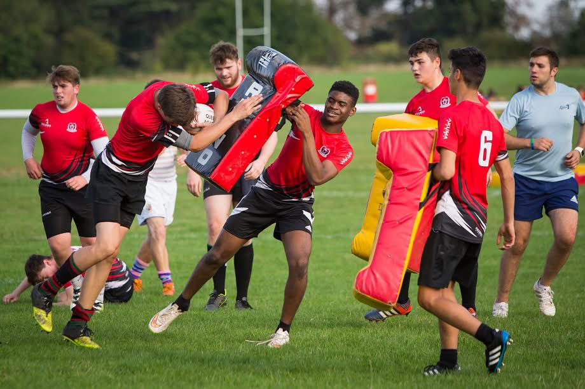
Alumni
- Anne Coffey MP
- Kenny Jackett Football
- Terry Johnson Playwright
- Jordan Littleboy Football
- Sean Murray Football
- Mark Oaten MP
- Callum Shinkwin Golf

Find Out More
For further information about career opportunities or to find out about our current vacancies:

Website: www.queens.herts.sch.uk
Email: office@queens.herts.sch.uk
Twitter: @queenssch
Tel: 01923 224465

Application forms are available to download on our website.

You are welcome to send a copy of your CV however it must be accompanied by a fully completed and signed application form.

Completed application forms will be acknowledged. Applicants who are not called for interview will not be informed that they have been unsuccessful.

If you are selected for interview, you will also be invited to visit the school. This will normally take place on the same day as the interview, however if you have queries regarding details of the role prior to your application please contact the school.

Queens’ School is committed to safeguarding and promoting the welfare of children and young people and expects all staff and volunteers to share this commitment. All posts are exempted under the Rehabilitation of Offenders Act 1974. Appointments will be conditional upon the receipt of a satisfactory response to a check of police records via the Disclosure and Barring Service and references from previous employers. We are an Equal Opportunities employer.

