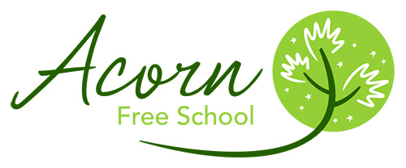

Thank you for your interest in the Acorn Free School. The Acorn Free School opened on 16th September 2013. We are an Alternative Provision Free School providing support to students aged 11 – 16 who are at risk of exclusion and who are experiencing emotional and behavioural difficulties. We also deliver a high quality outreach service for pupils throughout primary and secondary school who have been identified as needing support in managing their behaviour or improving their attendance in school.
During our first year we had 24 full-time equivalent pupil places, rising to 44 for the current academic year. We have reached our pupil numbers for the current year and are currently oversubscribed. Many of the pupils only attend for 2 or 3 days per week which means that in reality our model will allow access for some 150 students over the year. We have a small number of pupils in KS4 who will complete their education at the Acorn Free School, returning to their mainstream setting for exams. We have a newly refurbished school building in Calder Road, Lincoln which offers renovated accommodation for pupils to access learning and re-engagement in smaller pupil groupings with a focus upon their own personalised learning. Pupil groupings are currently between classes of 6 and 12 depending on the changing needs of schools and students.
Our behaviour support provision is an outreach service to primary and secondary schools throughout Lincolnshire. We work directly with students delivering interventions for those experiencing emotional and behavioural difficulties. In addition we also offer strategic advice and training to school staff to enable them to improve their behaviour management techniques. The service also provides Education Welfare to schools for pupils with low attendance. This can take the form of support for parents and students or a more formal approach for schools through the legal process.

