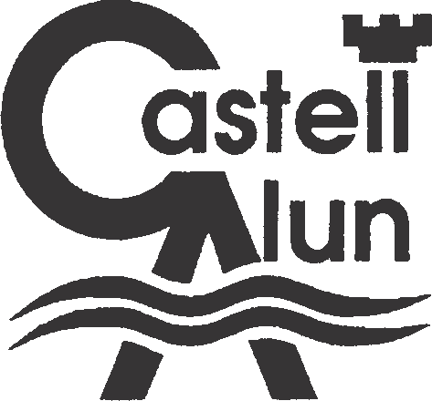
CASTELL ALUN HIGH SCHOOL
ROLE PROFILE

Name :
Job Title : Science Technician Reporting to : Learning Manager : Science
Profile : 3.4 Tech 3 Level 3 Contract : Term time only
JOB PURPOSE

Under the guidance of senior staff : provide a specialist support in a specific curricular / resources area, including preparation and maintenance of resources and support to staff and students.

KEY RESPONSIBILITIES

Support for the Students :
- Use specialist skills / training / experience to support students
- Provide feedback to students in relation to progress and achievement
Support for the Teacher :
- Create and maintain a purposeful, orderly and productive working environment
- Ensure timely and accurate design, preparation and use of specialist equipment / resources / materials
- Assist in the development of lesson / work plans, administration of coursework, worksheets etc.
- Contribute to planning, development and organisation of systems / procedures / policies
- Be responsible for maintaining records, information and data, producing analysis and reports as required
- Promote and ensure the health and safety and good behaviour of students at all times
- Undertake marking of students’ work with specialist area and accurately record achievement / progress
- Administer and assess routine tests and invigilate exams / tests
Support for the Curriculum :
- Monitor and manage stock within an agreed budget, cataloguing resources and undertaking audits as required
- Maintenance / cleaning of specialist equipment, check for quality / safety, undertake specialist repairs / modifications to be carried out by others
- Demonstrate and assist in the safe and effective use of specialist equipment / materials
- Provide specialist advice, guidance and technical support as required
- Implement agreed work programmes / practical lessons under the guidance of the teacher
Support for the School:
- Be aware of and comply with policies and procedures relating to child protection, health, safety and security and confidentiality, reporting all concerns to an appropriate person
- Be aware of and support difference and ensure students have equal access to opportunities to learn and develop
- Contribute to the overall ethos/work/aims of the school
- Establish constructive relationships and communicate with other agencies/professionals, in liaison with the teacher, to support achievement and progress of students
- Attend and participate in regular meetings
- Participate in training and other learning activities and performance development as required
- Recognise own strengths and areas of expertise and use these to advise and support others
- Supervision of support staff as appropriate within guidelines developed by the school
- Implement planned supervision of students out of lessons times e.g. clubs/extra curricular activities
This profile is intended to reflect the roles and competencies of expected of a Science Technician. It is intended to be enabling not exhaustive, and therefore the post-holder will also undertake other reasonable activities commensurate with this level of responsibility.

