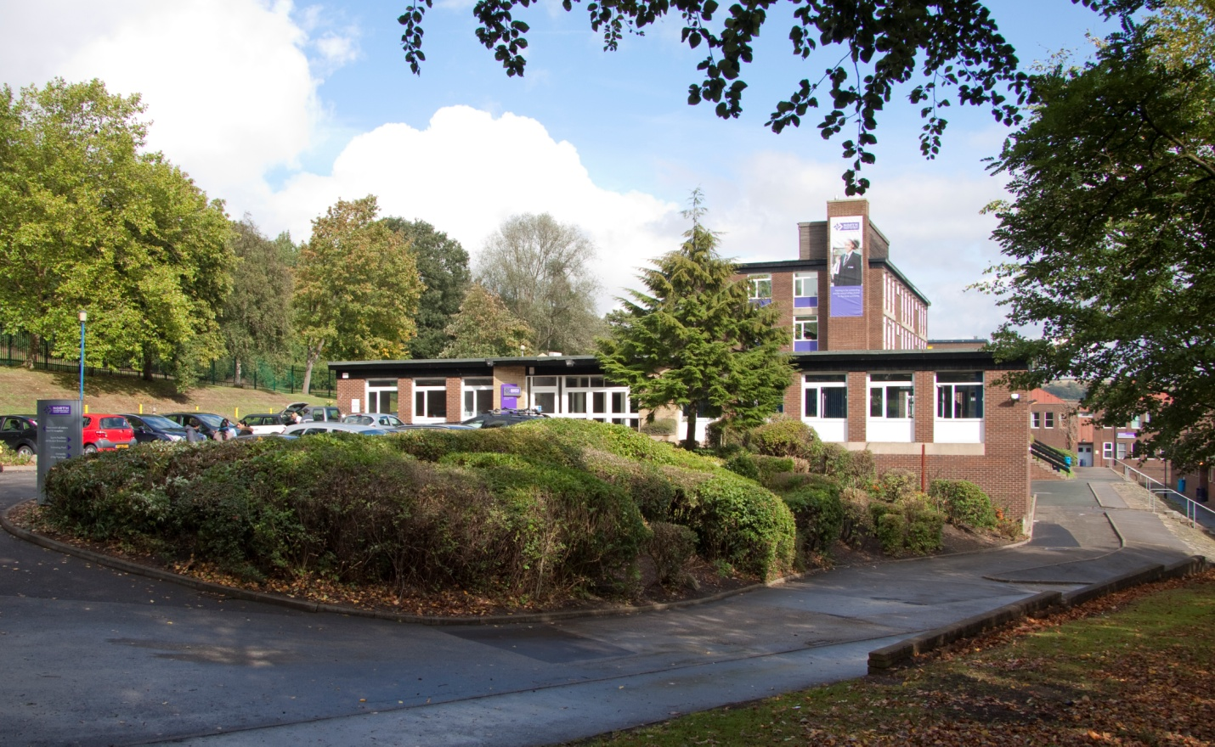

Vacancy: Assistant Head Teacher
Applicant Information Pack

Welcome

Thank you for your interest in this vacancy at North Huddersfield Trust School. We hope that you find the information within this pack useful and that it helps you to build a good picture of the exciting opportunities at the school.

North Huddersfield Trust School is now 6 years old and as we continue to move from strength to strength, our growing student numbers reflect that families are recognising the hard work of staff and students in creating a school of which the local community can be justifiably proud.
Ofsted has recognised us as a “Good” school which is outstanding in its work in keeping students safe and secure and for students’ personal development and well-being. We will continue to drive forward standards and ensure that we provide the best education for our students. Above all, our main priority is that we have a happy school where students feel safe, well-supported and able to thrive to achieve their full potential, so that when they leave us at 16 they are well-rounded, confident young people who will willingly contribute to their local community and far beyond.
Whilst we are aware of the fantastic progress we have made we will not rest on our laurels and have a clear plan for further improvement. There are a whole range of challenges ahead, but with these challenges come opportunities and excitement.

Thank you again for taking in interest in North Huddersfield Trust School and we look forward to hearing from you.

Loz Wilson
Head Teacher

Vacancy Details

Assistant Head Teacher

L14 – L18 £54,250 - £59,857

Closing date: Friday 27th April (Midday)

Start Date: 1st September 2018

"Pupils wear their uniform immaculately. They are proud of their school and the opportunities it provides for them. Pupils and their families value the support of their teachers and staff."

Ofsted 2017

North Huddersfield Trust School is recognised by Ofsted as a 'Good' school which is outstanding in its work around students' personal development, well-being, safety and security. We continually drive forward standards and are passionate about maximising the potential in all. Our caring and nurturing approach to education within and beyond the classroom contribute to what makes our school a special place both to work and to learn.

We place great value on the fulfilment and well-being of our colleagues; our successes to date are in no small part down to their hard work, commitment and determination and as a relatively new school, our growing student roll enables us to provide opportunities for both personal and career development.

The successful candidate will assist the Head Teacher in maintaining and improving standards, achievement, student progress and development by contributing fully to strategic leadership, direction, quality assurance and staff management as a senior leader. They will also be accountable for pre-defined areas encompassing whole school improvement.

If you would like further information please contact the Head Teacher, Mr Loz Wilson

If you wish to apply for this post please apply through the TES Website www.tes.com or North Huddersfield Trust School website www.nhtschool.co.uk. Applications should be returned to Mrs Nora Brown, Operations Manager, by email to nbrown@nhtschool.co.uk by 12 midday on Friday 27th April. Invitations to interview will be sent no later than close of business on Friday 4th May.

We are committed to safeguarding and promoting the welfare of children and young people. An enhanced DBS is required for successful candidates.
Woodhouse Hall Road, Huddersfield, West Yorkshire, HD2 1DJ 01484 452100
www.nhtschool.co.uk

JOB DESCRIPTION
Role | Assistant Head Teacher
Grade (SCP) | L14 – L18
Weekly hours | Full Time

Job Summary
To maintain and improve standards, achievement and student progress and development by contributing fully to strategic leadership, direction, quality assurance and staff management as a senior leader. Accountable for pre-defined areas, encompassing whole school improvement.
Key Responsibilities:
- Whole School Leadership
- Line Management
- Teaching and Learning
- Personal Development
- General

Duties
Key accountabilities | Key tasks
Whole School Leadership | - As a member of the senior leadership team, lead the monitoring, evaluation and review of all aspects of school life  - Support the Head teacher in managing the school effectively and ensuring the successful implementation of change  - Take responsibility for key strategic areas of the school as directed and agreed with the line manager  - Motivate and empower others to deliver the school’s vision  - Set an excellent example to staff and students  - Represent the school with stakeholders and external bodies  - Contribute, shape and deliver the school development plan, taking ownership of specific aspects linked to the role’s responsibilities  - Share general aspects of school management, including recruitment, staff development, organising and supporting events and communication  - Provide a significant presence around school every day, including the carrying out duties and detentions  - Ensure the school’s policies are up to date and reviewed regularly  - Responsible and accountable for the management and reporting of key aspects of school life as agreed with the Head teacher, ensuring that stakeholders, including Trust partners and governors are kept up to date regarding the school’s progress  - Deputise for the Deputy Head from time to time as required
Line Management | - Manage staff within departments as agreed with the Head teacher  - Play a key role in ensuring the school develops and supports colleagues  - Follow the school’s performance appraisal procedures  - Assess and report on the impact of own and others’ work regarding student progress and whole school improvement
Teaching and Learning | - Fulfil the professional responsibilities of teacher standards  - Work within the boundaries of school policy, including appropriate consideration of school budget and resources  - Contribute to the design and delivery of departmental and whole school development plans  - Responsible for the learning and achievement of all students in allocated classes, ensuring an inclusive and differentiated approach  - Responsible and accountable for achieving at least good outcomes for all students  - Create and maintain a vibrant and positive learning environment where students can thrive  - Responsible for continually driving standards to ensure that all students have the opportunity to maximise their potential  - Adhere to deadlines for all assessment, reporting and other aspects of school life as agreed or directed  - Set an excellent example to students of good behaviour, professionalism and respect  - Consistently uphold the school’s behaviour policy  - Build and maintain positive working relationships with stakeholders, including colleagues, students and parents, ensuring that communication is timely and accurate and in line with the school’s ethos
Personal Development | - Develop self and others through the participation in the school’s continual professional development programme  - Continual development of teaching skills, seeking and embracing new and creative techniques and technologies  - Contribute to the school’s extra-curricular and / or transition programmes  - Seek opportunities to develop leadership skills  - Assist in the recruitment of new staff
General | - Always uphold the school’s PRIDE agenda  - Adhere to strict standards of confidentiality  - Ensure compliance with data protection, equal opportunities, health and safety and safeguarding regulations, policies and guidance

This job description is not necessarily a comprehensive definition of the post and may be subject to modification or amendment at any time after consultation with the post holder. Additional duties may be requested from time to time which are commensurate with the post.
We are committed to safeguarding and promoting the welfare of children and young people and all post-holders are expected to share this commitment.
Reports to: | Head Teacher/ Deputy Head
Responsible for: | Multiple as agreed

PERSON SPECIFICATION
 | ESSENTIAL | DESIRABLE
Education / training | - Qualified teacher | - Recent leadership CPD  - Previous experience of a senior leadership role
Experience | - Evidence of successful leadership of a whole school initiative  - Evidence of significant positive impact on the outcomes of students, including those who fall into vulnerable and high need categories  - Experience of working in a high school setting
Specialist knowledge / skills | - Evidence of strategic planning and delivery  - Team leadership skills and a proven ability to get the best from others  - Capacity to manage significant workloads to agreed deadlines  - Ability to analyse and evaluate data  - Previous line management experience | - Experience of whole school responsibility
Personal skills | - Willingness to take ownership of whole school aspects  - Excellent attention to detail  - Well organised and team spirited  - Outstanding communication skills  - Professional resilience  - Enthusiastic and an outstanding role model for students | - Commitment to lifelong learning
General | - Excellent understanding of safeguarding guidance | - A good understanding of school policies

