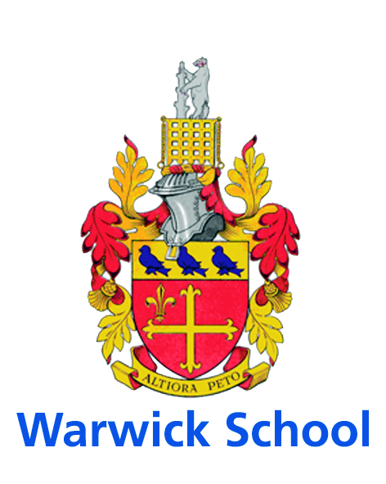
Academic Application

www.warwickschool.org
TEACHER of Chemistry

The Post
A gifted and inspirational teacher is required to join the Chemistry department from September 2018. This is an exceptional opportunity to be part of a popular and dynamic department. The successful applicant will be able to teach at all levels, up to and including U6th.

The Science Department

In 2007 the Science department moved to a new dedicated building. Chemistry occupies an entire floor and has five 110m² laboratories which comprise both theory and practical areas. Each laboratory is equipped with modern ICT equipment. In addition, the science building houses a lecture room seating 130 students, 4 Physics laboratories, 4 Biology laboratories, Psychology teaching and a research facility which allows students to carry out research at undergraduate level in Friday afternoon “Science in Action” activities.

Chemistry
The department is focused on the delivery of outstanding performance and enabling all pupils to deliver to their capability. It comprises five full-time chemistry teachers, one part-time teacher and technical support is provided by two laboratory technicians. All full-time teachers are able to teach Chemistry at every level, from Lower Fourth (Year 7) to Upper Sixth (Year 13). Each year follows a dedicated chemistry course.

The AQA 9-1 specification is taught at GCSE and Edexcel for A-level. All courses contain as much relevant student practical work as possible and innovative thinking into continued improvement in pupil learning is an important focus, as is the development of ICT and VLE resources. There are 140 GCSE candidates per year with the majority sitting Separate Award Chemistry and the remaining boys entered for Science and Additional Science. Chemistry is a consistently popular A-level choice, with over 75 Sixth Form boys studying the subject. External examination results at all levels are consistently strong with some 69% A* & A grades at A-level over the last 2 years and 87% at A* & A grades in Chemistry IGCSE Triple and Double Award combined.

Directly Responsible to: The Head of Chemistry

Primary Function
Perform ‘the duties of a school teacher’ as outlined in the teaching staff contract.

Specific Duties and Responsibilities
A. Teaching

- Plan work in accordance with the department’s scheme of work
- Liaise with relevant colleagues on the planning of work for collaborative delivery
- Take account of boys’ current & prior levels of attainment and use them to set targets for future improvement
- Maintain good discipline by adherence to the advice given to staff in the staff memoranda and elsewhere
- Set high expectations for boys’ behaviour by establishing a purposeful working atmosphere in accordance with the school’s behaviour code
- Set appropriate and demanding expectations for boys’ learning, motivation and presentation of work
- Make significant and positive contributions to the development of departmental teaching resources and schemes, with particular emphasis on ICT-based learning and AFL.
- Ownership for the development and execution of year-group based schemes of work, examinations and tests.
- Lead chemistry extension and extra-curricular activities and trips e.g. Chemistry Olympiad, C3L6, Top of the Bench, University Lecture Trips etc.

B. Assessment, Recording and Reporting

- Maintain plans of lessons undertaken and records of pupils’ work
- Mark, monitor and return work (in line with Chemistry Department policy) within a reasonable and agreed time span providing constructive oral and written feedback, and clear targets for future learning as appropriate
- Report on pupil progress in line with school policy and as specified in the published calendar
- Keep parents informed of pupil progress by attendance at parents’ evenings, and by other measures as appropriate
- Be familiar with the code of practice for identification, referral, assessment and monitoring of special educational needs

C. Pastoral Care

- Undertake responsibility for a form group as required, including tutor/tutee interviews
- Be the first point of contact for parents of pupils in the form
- Set targets for and monitor the social and academic progress of pupils in the form
- Undertake responsibility for the delivery of the PSCHE programme to the form
- Promote good attendance and monitor in accordance with school policy

D. Professional Standards

- Support the aims of the school
- Treat all members of the school community with respect and consideration
- Treat all pupils fairly, consistently and without prejudice
- Set a good example to pupils in terms of appropriate dress, standards of punctuality and attendance
- Attendance at, and participation in, events such as open days, chemistry extension activities, options evenings, and those in which form members are involved, e.g. concerts & plays
- Participate in the school’s extracurricular programme, which includes activities, trip leadership & planning, clubs and societies, sport, drama and music
- Take responsibility for professional development, participating in staff training and the school’s Review and Development Policy
- Participate in the management of the school by attending departmental, section and staff meetings
- Ensure that all deadlines are met as published in the school calendar
- Undertake duties that may be reasonably assigned by the Headmaster (directly or indirectly)
- Take responsibility for matters relating to health and safety

Responsibilities may be direct, joint or through devolved structures, but always in accordance with whole school policies. These details may be amended at any time by agreement, but in any case will be reviewed during the appraisal process.

The candidate will visibly maintain the highest professional standards, have excellent interpersonal, communication, presentational and ICT skills, and have the ability to work flexibly within the school structure.

The closing date for applications is Monday 29th January at 4p.m. It is planned that interviews will be held on Friday 9th February.

A.R. Lock
Head Master

