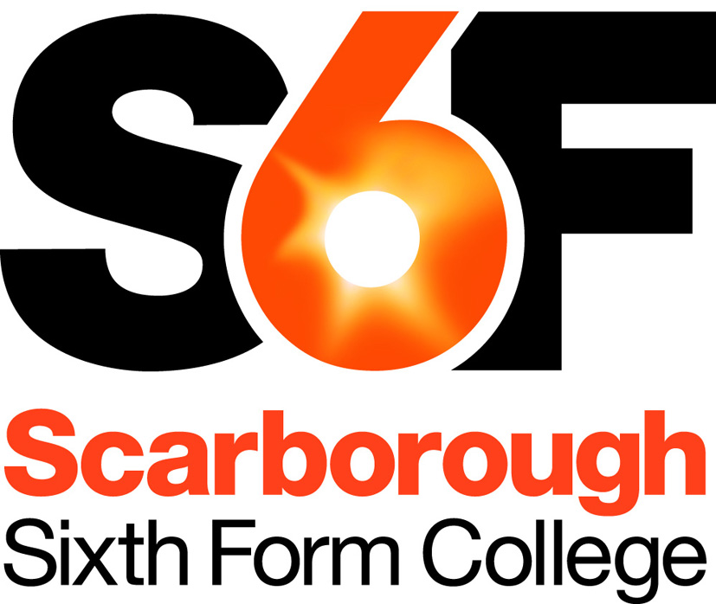
College Overview

Scarborough Sixth Form College is an open-access College, which provides general education primarily for 16-19 year olds in the area. We provide courses for over 1000 students drawn largely from five local schools. Students also join us from independent schools, from 11-18 schools and we also recruit some mature students onto daytime and evening provision.
The majority of our students are full-time, and follow Advanced (level 3) courses from which most progress onto Higher Education. We currently offer 28 different subjects at AS and A level. The College has developed a very successful vocationally-related provision in a range of BTEC Nationals and some 40% of our students now follow a study programme on which a BTEC is the main component. There is also a one-year Level 2 programme (our “Progression Year”) consisting of GCSEs in Maths, English and Science plus a range of BTEC Firsts. Achievement at the College is high, and above national benchmarks, with outstanding positive value-added overall. The College recently had a Short Inspection in September 2016 and was confirmed as a Good provider: the report is available here. In truth, the College is close to Outstanding, and it is a realistic ambition for this to be achieved soon. Overall, the College deserves its strong reputation in the local community.
Enrichment activities form an important part of a student’s education and we have high uptake of the Extended Project, the Duke of Edinburgh Gold Award and various sport teams and activities. In addition, our work placement programme is growing, and many students benefit from curriculum trips, visits, speakers, or input from local employers.
Like all sixth form colleges we are financed directly by central government primarily through the Education Funding Agency and we take responsibility for our own expenditure and budgets. The governing body is responsible for the strategic direction of the College and for overseeing its activities. Governors have a wide range of skills and experience which enables them to provide good support and challenge.
The College is a member of the NorVIC Sixth Form Colleges Federation, which is a grouping of the fifteen colleges in the north east. This provides the opportunity for extensive networking and staff development at all levels with colleagues from other sixth form colleges. Overall we have a comprehensive in-service education and training programme and are committed to helping members of staff develop their personal and professional knowledge and expertise.
We also work closely with other partners in education and skills. Out of the Area Review we are entering a framework agreement for collaborative planning with our local Further Education College. We have very strong supportive relationships with 11-16 partner schools and our local University and we are increasingly engaged with local employers, and helping to meet the needs of the local economy, as well as serving the ambitions of the many students for whom the College acts as a gateway to Higher Education.
The College enjoys good teaching facilities enhanced by up to date IT resources. It is set in attractive grounds on the outskirts of the town. The buildings have been developed and refurbished to meet the needs of a modern Sixth Form College with about £5 million being invested in the last few years.
Scarborough is a friendly seaside town with good beaches and a most attractive coastline of cliffs and headlands. The town is beautifully situated on the edge of the North Yorkshire Moors National Park, giving easy access to the moors. The area provides wonderful opportunities for walking, mountain biking and water sports. The City of York is just 40 miles away, although Scarborough has its own cultural highlights such as the Stephen Joseph Theatre, home venue of the internationally famed playwright Sir Alan Ayckbourn. The whole environment makes the area a highly desirable place to live.

For further information on the College, please visit our website www.s6f.org.uk and download our on-line prospectus.

