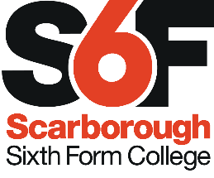
Job Description
Sign Language Tutors

Responsible to: Business Support Officer

Job purpose: To deliver high quality learner-centred Sign Language workshops

Key Duties

Tutoring Responsibilities:
Enable effective and enjoyable learning, through:
- Effective planning of workshops and use of resources
- Delivering high quality Sign Language workshops
- Providing effective and positive feedback to workshop participants
- Communicating and co-operating with persons or bodies outside of the College, if necessary
- Keeping up-to-date with teaching practices
- Providing support for individual workshop participants.

Departmental Responsibilities:
Contribute to the success of the department, through
- Constructive participation in departmental meetings
- Supporting colleagues and sharing resources/ideas.
Quality:
- Participate in professional development reviews and staff development activities.
- Contribute to college and departmental self-assessment / planning.
Responsibilities of all staff:
- Promote high expectations of students in and outside the classroom; and promote and safeguard their welfare
- Carry out administrative duties relevant to the post, including maintaining records and providing information/data
- Work within college guidelines and promote college values
- Give due consideration to Health & Safety and Equality & Diversity issues within all activities
- Maintain confidentiality regarding sensitive or personal information
- Carry out other duties as reasonably required by the Principal.

This job description is provided to assist the post-holder in knowing what his/her main duties are. From time to time these duties may be changed as the requirements of the job change. Updated: Nov 2018

