Head of Art & Textiles
H

Science

MPS +TLR 2C £6,450

Application Information Pack
June 2017

GCSE success for our 'Class of 2016'
In summary, this year our 'Class of 2016' have achieved:
• English and Maths combined score up by 10% from last year to 61%
• English 73.9% A-C grades
• Maths 65.4% A-C grades
• A-C grades including English and Maths 59.2%
• Increased results for - Drama, Business Studies, Further Maths, Geography, Maths, Product Design, Resistant Materials, RS,
Core Sciences, Statistics, Art and Textiles.

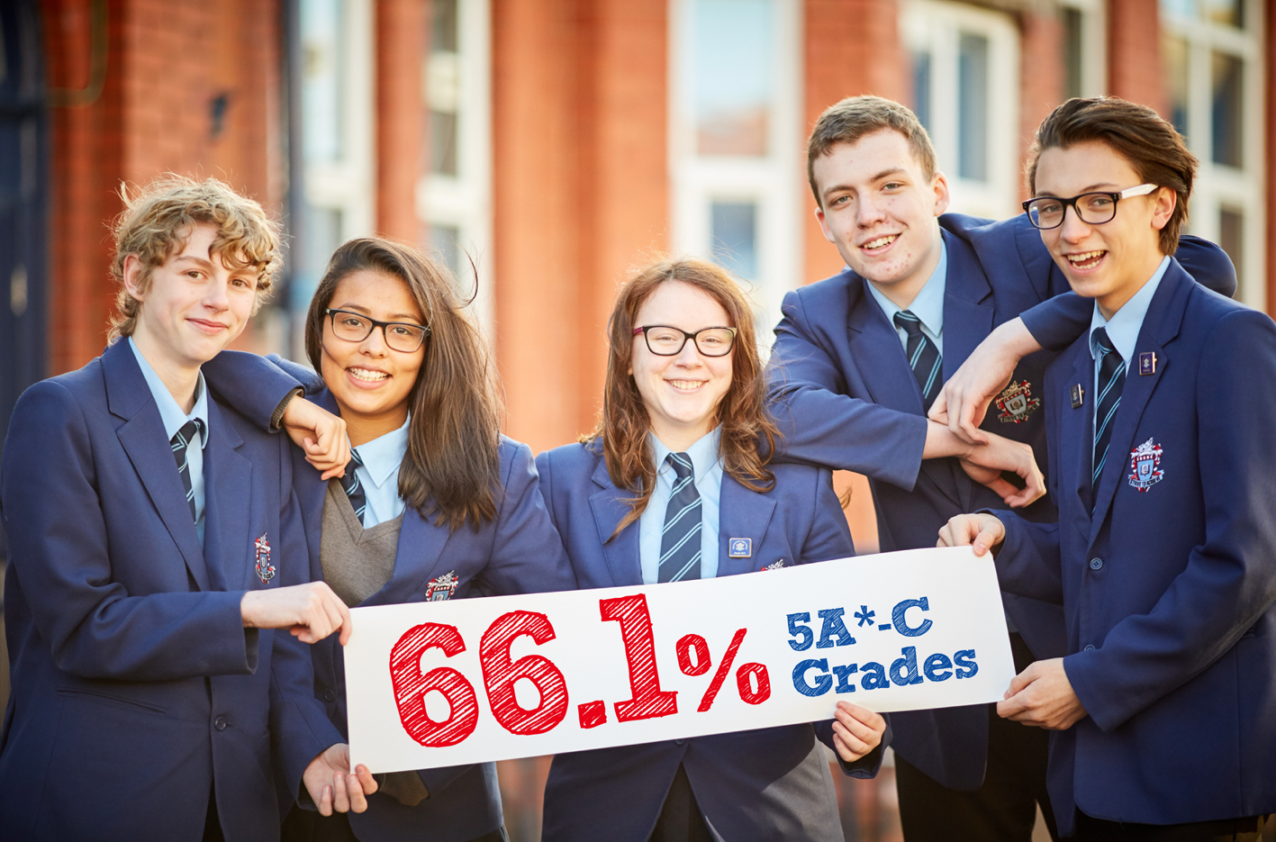

Contents…
Page 4 | Welcome from our Headteacher
Page 5 | Job Advert
Page 6 | SECTION 1 : The Swinton High School  Current  The Future  School Location
Page 15 | SECTION 2  The Post  Person Specification  Job Description
Page 18 | SECTION 3  Arrangements for the application  Enhanced Disclosure

Welcome from our Headteacher…

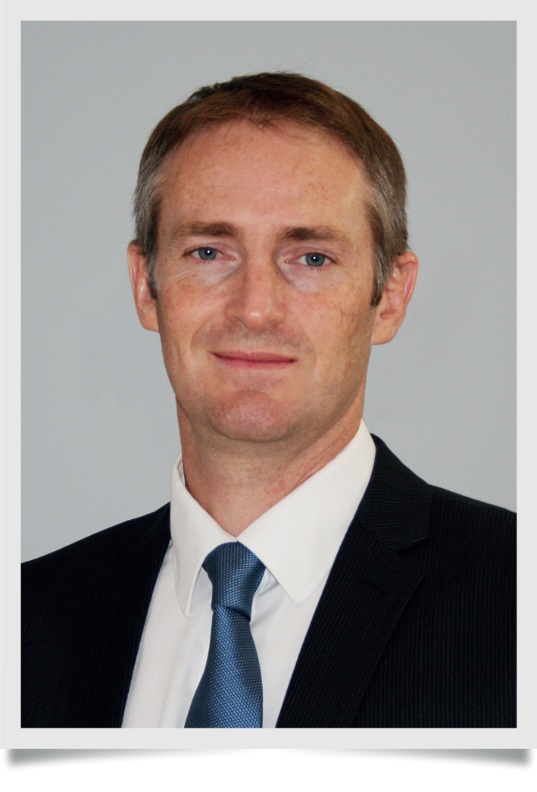
Thank you for considering this vacant post at
The Swinton High School. We hope you will find
all you need to help you consider our school for your next career move.

On arriving at The Swinton High School, you immediately notice the excellent relationships evident between students and staff and the purposeful environment evident in lessons. With this foundation, our students' journey to being confident, happy and able to achieve their aspiration has already started.

The Swinton High School provides an outstanding setting for our childrens’ education. Having seen year on year improvements in our students’ results placing us in the top three schools in Salford. In addition we are ambitious to give our children every advantage, and following our previous full refurbishment and extension of our facilities, we are now completing work on our new catering classrooms and community cafe.

This development is an example of our constant drive to provide our students with the best possible opportunities. It is a great privilege to be the Headteacher of such a thriving school. We believe all children can be successful and it is our mission to teach them that effort and determination will help them achieve this. Our students are taught to be independent and versatile so that they can be successful in an ever-changing competitive world.

The statement ‘Strive to Achieve’ underpins all our work and reflects the beliefs of the students, staff and Governors here at The Swinton High School. Collectively we must build our students’ aspirations, give them the skills and opportunities to achieve them and create leaders in the community.

If you share our vision for The Swinton High School and are determined to help our students strive to achieve their best then I look forward to reading your application.

Mr M. Harrison

Headteacher, The Swinton High School
The Swinton High School : A Converter Academy
Headteacher: Mr M. Harrison BSc (Hons) PGCE
Sefton Road, Pendlebury, Manchester, M27 6JU
Tel : 0161 794 6215 Email: enquiries@tshs.co.uk
NOR 732 11 – 16 years

Head of Art & Textiles MPS + TLR 2C

We require an enthusiastic and inspirational head of department to join our Art & Textiles department for the 1st September or 1st January (for the right candidate). The successful candidate will need to demonstrate strong classroom management skills and must also be able to: establish good relationships with students to inspire learning; promote interest in the subjects and ensure high achievement; be able to work well with colleagues in the department and across the school; have commitment and initiative and a ‘can do’ approach, willing to make a contribution to the life of the school and to ensuring that all our students achieve the best possible outcomes. Applicants must be outstanding and motivated teachers with a proven track record of delivering results at KS4.

We offer:
- A friendly, supportive and inclusive ethos
- Students who are enthusiastic to learn
- Good facilities
- A strong departmental team
- An excellent team of support staff
- Opportunities for professional development
- The opportunity to develop a successful career
- A great chance to help make a difference to young people’s lives.

The Swinton High School is popular and one of the most improved schools in the country. We are a converter academy, the first in Salford. Inspected under the new Ofsted inspection framework, we are delighted to have achieved a good judgement in every category and an overall judgement of good. We are well on the way to becoming the Outstanding school that the community deserves. As a Converter Academy, we continue our drive for excellence, in everything we do, to better our students’ life chances.

Application forms are available from our school website www.theswintonhigh.co.uk and returned via email to Gemma Davies at The Swinton High School gdavies@tshs.co.uk

The Swinton High School is committed to safeguarding and promoting the welfare of children and young people and expects all staff and volunteers to share this commitment. Any offer of employment is subject to a satisfactory enhanced DBS check.

Closing date: 29th June at 3pm

Interview date: To be arranged

SECTION 1
The Swinton High School : A Converter Academy

Context
Swinton is situated on the outskirts of Salford, bordering Bolton, Bury and Trafford. It is well served by the motorway networks, M6, M60 and M62 giving access to the surrounding countryside of Cheshire, Lancashire, The Lake District and Derbyshire national parks. The school is within easy reach of the rail network into Manchester City Centre. Swinton rail station is two minutes’ walk from the school and serves the Southport, Wigan, Bolton, Manchester lines. The regeneration of Manchester city centre, Salford Quays and the Trafford Centre gives a wide diversity of theatres, clubs, cinemas, restaurant and shopping opportunities within a few miles of our school. LS Lowry, the famous artist, lived within a few hundred yards of our school where he painted some of his most famous works.

The Swinton High School, an 11-16 comprehensive is one of 14 high schools and academies in the Salford Local Authority. On the 1st August 2011 our school converted to an Academy and you will be interested to know that our governing body is committed to maintaining staff and teachers’ terms and conditions.

Accommodation
Our school originally came into existence in September 1988 when Wardley High School and Pendlebury High School merged to form a single 11-16 comprehensive school on one site, located half a mile from the Swinton town centre. Whilst the buildings vary considerably in age and appearance, internal refurbishment of existing facilities has provided a pleasant working environment. A new maths suite, totally refurbished science laboratories, an ICT resource area comprising five computer rooms, a technology block and refurbished art and library facilities have improved the teaching environment. Improvements to the school environment have been substantial over the last few years and are continuing. We regard the environment as an important factor in encouraging students to learn and every effort is made to maintain high standards. Despite all of these developments we acknowledge the need for continued refurbishment for our school so we may continue to serve our community in the best possible environment.

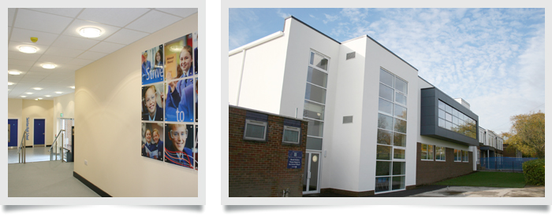
Major Building Refurbishment

Now completed, the funding from the Academies Capital Maintenance Fund means our school has created; seven refurbished science laboratories, a new purpose-built maths block, new PE changing facilities, a remodeled ground floor corridor, two new additional classrooms on the ground and first floors and a complete new build to house our new reception and entrance area. This development will continue this year with our new catering block, including our community café. We have already seen what a huge difference this much-welcome funding from the Academies Capital Maintenance Fund has made to our school.

ICT
In September 2015 we launched the innovative E2BN Ici Solution, being the first school in England to do so. This will put us at the cutting edge of cloud based learning. We have almost one laptop or tablet PC per student in the school. Every teacher currently has their own laptop computer and all staff who wish to have an interactive whiteboard and visualiser in their classrooms do so. Lesson observations show that ICT for learning is a strength across all areas of the curriculum.

School Finance
Our governing body annually monitors comparative data on school expenditure on ICT for students as well as books, equipment and materials. This is to ensure that our expenditure on these items is always the highest in our immediate area.

Students
We attract students across the full ability range, and have at present 671 students between the ages of 11 and 16 years on roll. Our students are drawn mainly from the Swinton, Clifton, Pendlebury and Wardley areas of Salford. However, it is worth noting that 1:5 of our students are from out of the immediate catchment area. This is a phenomenon which reflects our increasing popularity and is directed related to our growing reputation and improving exam results. 127 of our students are eligible for Free School Meals and there are 7 students with statements of special educational need and 9 Looked After Children.

There is a substantial upsurge in student numbers currently in our local feeder primary schools and the expectation is that by 2018 The Swinton High School, along with many local secondary schools, will be full to capacity.
Care, Guidance and Support (CGS)
We believe that the success of our students is founded on high expectations, on good teaching and a solid partnership between school and home. ‘Respect’ and ‘Strive to Achieve’ underpin everything we do and drive our school to challenge ourselves and each other. The system of care, guidance and support underpins the ethos of the school. It is based on the Year Group principle led by a Pupil Progress Coordinator (a qualified teacher) with a full time Year Manager in assistance. The Pupil Progress Coordinator reports to the line manager Assistant or Deputy Headteacher. Three Year Managers and two social inclusion officers support learning for children by providing a complementary service to existing staff, external agencies working with the school and links with parents, with an aim to assist in improving attendance and academic attainment of targeted children. Our Year Managers also provide post-school study support. All our staff are committed to this system, both as form tutors and in their working relationship with the students. All staff are expected to support the maintenance of high standards of behaviour, discipline, appearance and uniform, upon which the school places a high priority. There is a Student Council with representatives from each year group, including the Head Boy, Head Girl and Senior Prefects. They meet to discuss issues raised by students at form and year level. There is a planned form tutor programme every morning, organised by the Pupil Progress Coordinator.

1. Able, Gifted and Talented students : to provide curricular enrichment activities for all years and specific mentoring programme in Years 10 and 11. An evaluation of its impact on school achievement forms part of the examination review. Such students are given priority access to the banks of laptops situated in maths (90 laptops), English (60 laptops) and science (60 laptops).

2. Retreat : a unit which withdraws students who may need a withdrawal from mainstream lessons during the school day.

3. Retreat + : an effective alternative to fixed term exclusion where students have an on site personalised learning programme. This has kept fixed term exclusions exceptionally low in number.

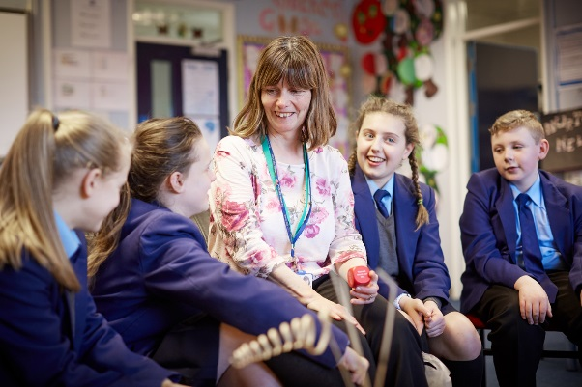
4. Nurture Group : A supportive facility for those vulnerable students particularly in Years 7 and 8.
We have been awarded Kitemark status by the
Nurture Group Network. This offers a supportive coherent programme, which develops social skills
for those whose needs are identified by the Boxall Profile. We are regularly visited from schools across the country to see this excellent practice.

Academic Organisation
We have a staffing complement of some 68 full and part-time members, including teachers, support assistants, site, administrative/reprographic staff, technicians, cleaners and kitchen staff. Since September 2012 we now manage our own catering and cleaning, and those staff are directly employed by the school.
The academic structure of the school is based on a system of four Faculty Leaders: Communications (English, French and Spanish), Mathematics, Science and Humanities are each led by a Director of Learning. There are six head of departments: Technology, Computer Science, Business Studies & ICT, Arts & Textiles, PE, Music & Drama and Special Educational Needs. All reporting to their respective Deputy Head or Assistant Head Line Manager. The extended leadership team consists of core senior leaders and four directors of learning.

There is a fully calendared programme of weekly directed time meetings including: regular Curriculum, ICT for learning, Care, guidance and support, and Senior Leadership Team Meetings. We place high emphasis on staff development both for school improvement and personal professional development. There is a successful Induction programme for new staff, which has been praised by Ofsted.

Extra-Curricular Activities
As an example of our ‘Respect’ and ‘Strive to Achieve’ agenda we provide a wide range of extra-curricular activities, which are well supported by students and all staff. These provide opportunities for students to follow their interests and talents in drama, sport, music and dance. Our school’s musical activities have an excellent reputation and the Steel Pans have performed in a wide variety of locations.

All staff are actively involved in a comprehensive range of extra-curricular activities including an extensive programme of after-school lessons, clubs and activities.

Community Links
Recognised in our Ofsted inspections of 2007, 2012 and 2015 The Swinton High School has developed outstanding links with the local community through community placements including local nurseries and old people’s homes and the local Salford Business Education Partnership. We are one of only 9 Manchester United Foundation Schools in the country and work closely with Salford Red Devils and Swinton Lions Rugby teams.
Termly concerts are a regular feature of the school calendar, which are well supported by staff, parents, governors and students.

Primary School Links
All faculties have developed links with feeder Primary Schools. We have a Deputy Headteacher responsible for transition between Key Stage 2 and Key Stage 3 and all staff participate in primary liaison activities at some point during the year, usually but not exclusively, in June and July. This is an extremely successful programme, recognised as such in our 2007 and 2012 Ofsted inspection reports. At Key Stage 4 we provide careers advice and guidance to all students and currently hold the gold CEIAG award. In addition to this, local and national charities are well supported by our school community.

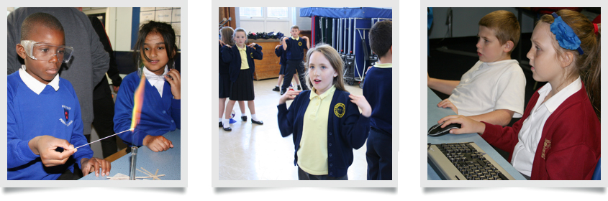
Pictured Above: Children from our many feeder primary schools enjoying taster lessons during our Open Mornings

Attendance
We take attendance very seriously and see good staff and student attendance as a key factor in sustaining school improvement. For the last five years our student attendance has risen annually and for the last four years it has been significantly above the national average for all secondary schools. Raiseonline consistently shows this element of our work to be outstanding.

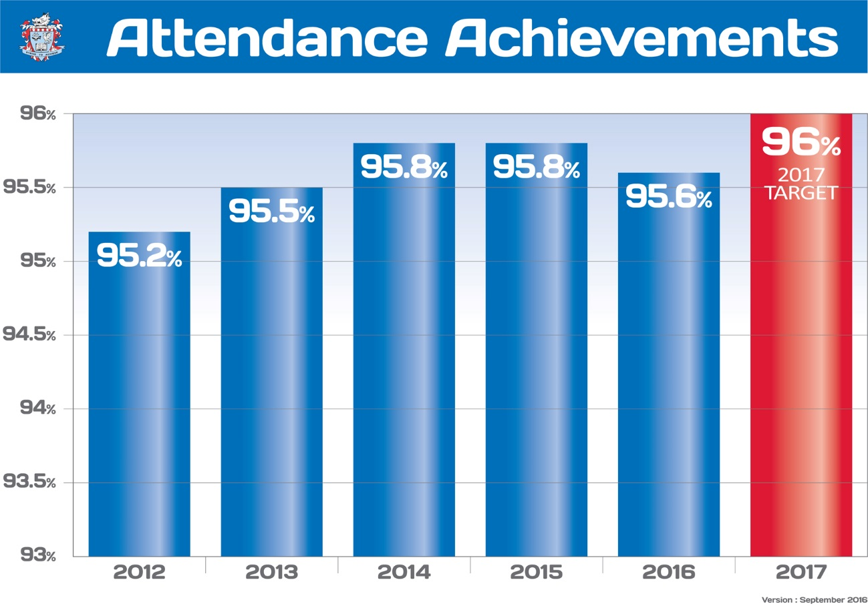

Results

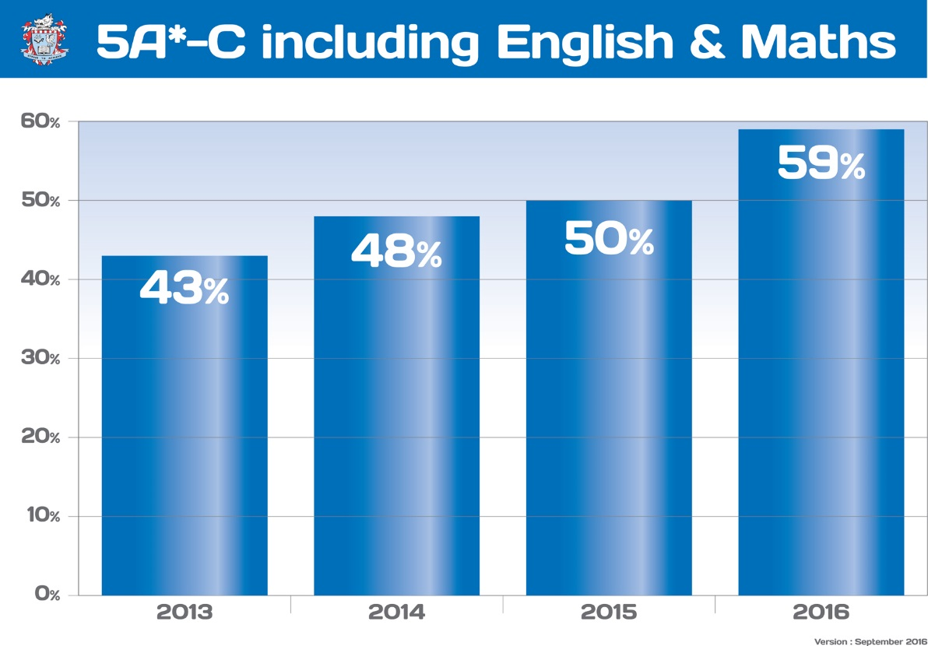

Monitoring and Evaluation
We have a detailed development planning cycle aimed at fostering a shared determination to develop an already good school into an outstanding one. Monitoring and evaluation of teaching is incorporated into the school calendar and Performance Management is thriving. We operate a range of monitoring and evaluation processes such as formal lesson observations, learning walks, work samples and our Directors of Learning regularly monitor staff planners.

Homework
There is a homework timetable which we expect all staff and students to adhere to. This is monitored for the frequency and quality of homework and appropriate action taken to acknowledge good practice or address underperformance.

Teaching and Learning
We are committed to giving our students the best possible learning opportunities. In addition to our substantial investment to support ICT for learning we are continuously developing collaborative staff approaches to learning for example by thriving coaching sets, Kagan Structures, use of lesson objectives and assessment for learning techniques. The importance of teaching and learning permeates through all of our work. It is a first agenda item on almost all of our meetings.

Curriculum Plan
We believe that the breadth and quality of the Curriculum is central to the ongoing achievement, progress and motivation of our students. We adopt a rigorous programme of literacy intervention to support our academy pledge that every child has a reading age of 10.5 or more by the end of Year 7. This ensures that our students can all access the opportunities that our modern curriculum presents to them. Our school operates a two year Key Stage 3 in Years 7 and 8 followed by a three year Key Stage 4 in Years 9, 10 and 11. Guided option choices are made in Year 8. Students will be given every support and encouragement to pursue subjects aligned to their abilities and interests.

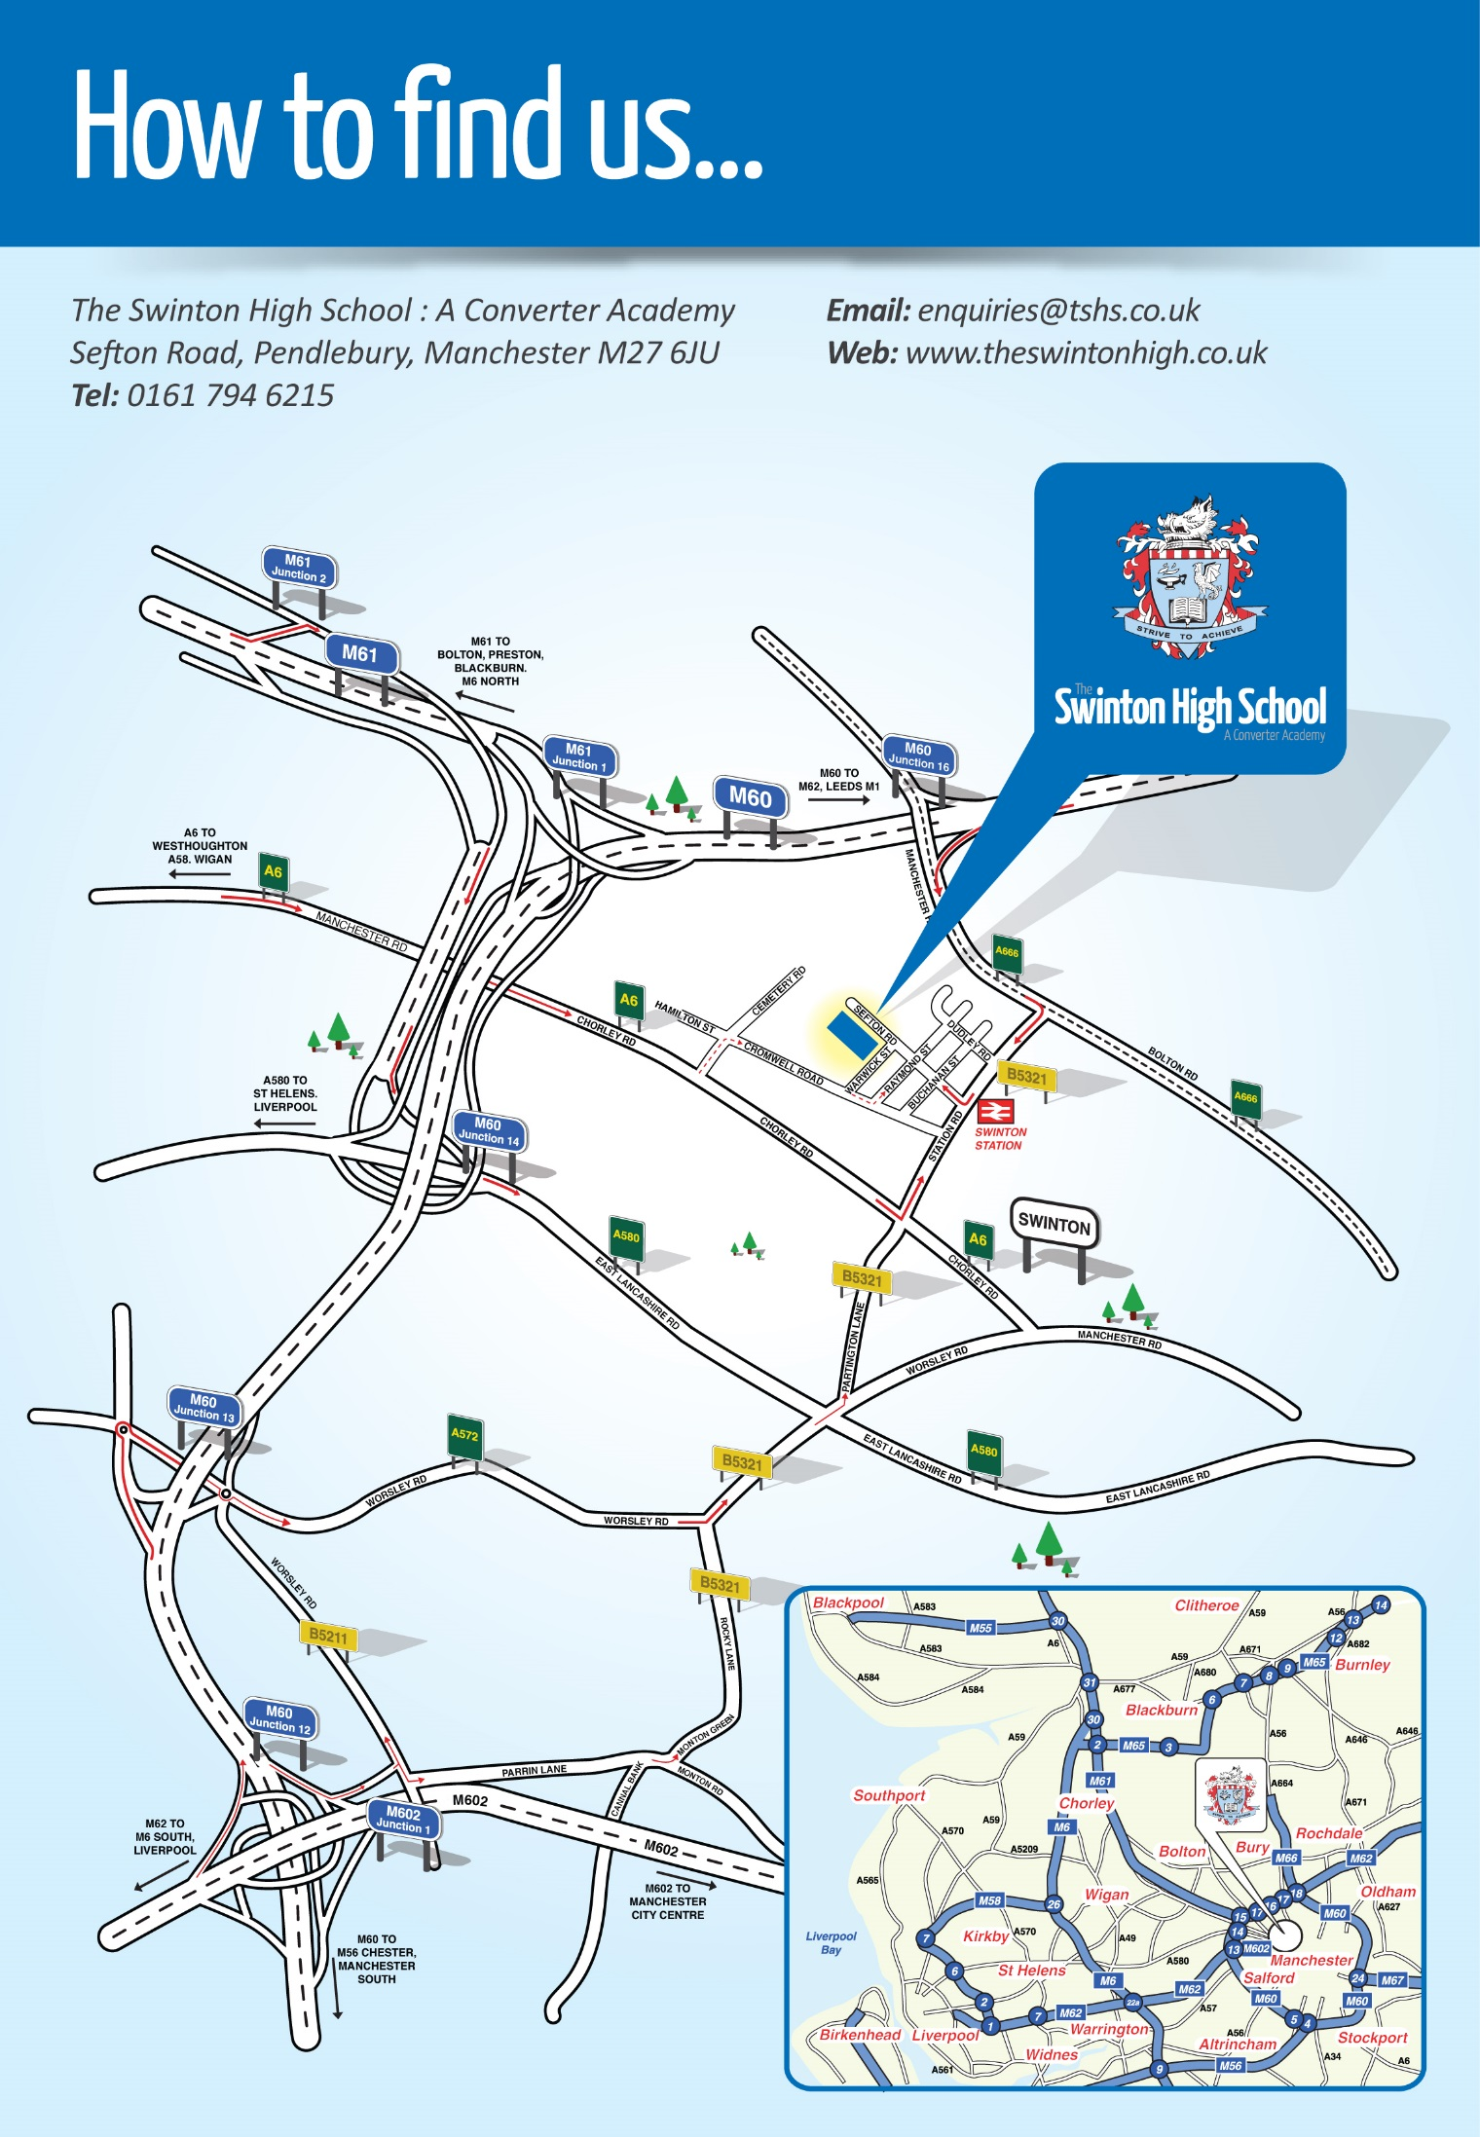
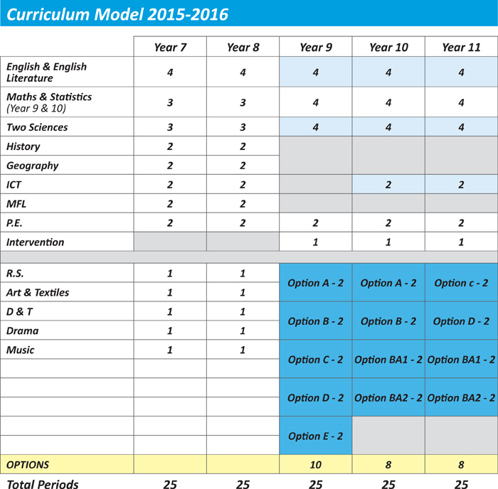
SECTION 2

The Post, Person Specification and Job Description

The Post
Job Title: | Head of Art & Textiles
Salary: | MPS + TLR 2C
Start Date: | 1st September 2017 0r 1st January 2018
Tenure of Post: | Permanent

Person Specification
Experience: | - Experience of successfully teaching Art/Textiles/Photography in one or more UK secondary schools at both Key Stage 3 and 4.  - Good record of attendance and punctuality.
Qualifications: | - Qualified teacher of Art  - Degree in Art or equivalent qualification.
Knowledge/Skills: | - Previous experience as a teacher of Art across the full age and ability range.  - Evidence of personal professional development relevant to this post.
This is a real opportunity to develop your career alongside like-minded, skilled professionals, in a dynamic and supportive team.

The Art & Textiles Department
Within the faculty in the 2017-2018 academic year will be two Art teachers and a Technician. Teachers are actively involved in the school’s teaching and learning community, sharing good practice with a variety of other subjects. As a result the standards of teaching within the department are very high.

At Key Stage 3 all Art subjects are taught to Years 7 and 8. Key Stage 4 extends across Years 9, 10 and 11. GCSE options are available in Art/Textiles, uptake in Art/Textiles at GCSE is good, with many pupils opting for these subjects at GCSE level.

All Art/Textile classrooms are situated in very close proximity to each other, which makes for a supportive team structure. The department has the use of a suite of Ipads and Laptops, along with interactive whiteboards and visualisers in each classroom.

This is a real opportunity to develop your career alongside like-minded, skilled professionals, in a dynamic and supportive team.
Job description

POST TITLE: Head of Department Art & Textiles

Responsible to: Assistant Director

Salary Scale: MPS + TLR 2c

Responsible for: Standards in Art/Textiles & Photography and all staff teaching those subjects.

Main purpose: To provide leadership of teaching and learning in Art/Textiles & Photography and play a key role in raising teaching and learning standards through the quality of the post-holders’ own teaching and by leading and supporting the professional development of colleagues.

Contract: Permanent

Hours of duty: In accordance with school teachers’ pay & conditions

Main Duties and Responsibilities/Accountabilities:

Teaching and Learning:
To lead on all aspects of Art/Textiles & Photography and ensure that schemes of learning are effectively implemented and that members of the department are clear about use of levelled learning outcomes and communicate these to students.
To ensure that there are clear structures for lessons which maintain pace, motivation and challenge for students.
Monitoring: This is an important aspect of ensuring that the department works with cohesion and in harmony. Informal and formal monitoring contribute to these tasks which involve looking at lesson planners, lesson observations, scrutiny of students’ work and teachers’ files, before producing reports to inform Core SLT.
To assess, record and report on the development, progress and attainments of students.
To organise the provision of support/revision/booster classes for all students taking external examinations, mock exams, module tests and course work
To ensure the effective and efficient management and organisation of learning resources, including information and technology.

To ensure coverage, continuity and progression within the department for all students, including those of high ability and those with specific or additional learning needs.
To analyse student progress and attainment using school and national data.
Track progress of students and implement strategies to tackle underachievement.
To measure the impact of intervention strategies.

Transition Year 6/7, be an active leader and participant in primary liaison activities. Ensure a smooth and effective transition occurs on such matters as target setting, transition visits etc.

The liaison with pre-11 and post-16 agencies/institutions re the continuity of the department’s contribution to our students’ education.

To support and ensure that members of the department follow the school behaviour policy and procedures and take responsibility for the standards of behaviour in the department.

To manage classroom and teaching equipment to create a positive, stimulating and safe learning environment, which makes full use of available resources.

To set aims and objectives for the department, monitoring and evaluating the achievement of these in line with the aims of the school and the requirements of the National Curriculum.

To allocate students in Years 7-11 to teaching sets and review placements on a termly basis in consultation with colleagues of the department, other associated faculties and members of the pastoral staff. The preparation of set/group lists and organising the methods for promotion/demotion between the sets, as necessary.

The development and implementation of schemes of assessment and reporting to parents in line with the overall school policy and the secure maintenance of examples of students’ work required to justify any internal assessments.

The submission and checking of all entries to external examinations and to supervise the administration necessary for operating examinations where necessary.

To ensure quality learning experiences for all students in the department.

To attend and participate in meetings and training sessions and contribute to school decision making and consultation procedures as required as a middle leader.

Undertake the role of the Form Tutor to a group of students and undertake appropriate responsibilities associated with that role. Contribute to the delivery of PSHCE, citizenship and enterprise.

To carry out the standard duties and responsibilities of any teacher in The Swinton High School.

The Leadership of a Team:
To lead by example and provide motivation for the department.
To establish short, medium and long term plans for the development of the department.
Keeping the department up-to-date of recent educational developments within the subject area and provide a role model of best classroom practice.
Supervising and monitoring the work of colleagues in the department, ensuring that lesson content, teaching methods, monitoring and assessment procedures are in keeping with the departmental policy.
To establish and implement clear practices for assessing, recording and reporting on student achievement in line with school policy and to effectively use data to recognise achievement and to challenge staff in providing appropriate intervention to meet the emerging needs of the department.
To establish clear expectations and constructive working relationships within the department, devolving responsibilities and delegating tasks, as appropriate; evaluating progress and developing an acceptance of accountability.
The preparation, updating and distributing of schemes of work for the department staff with copies being given to the Senior Team. To ensure that work is set for classes of absent colleagues and the provision of support when needed by ‘cover’ teachers (including supply teachers).
To be the representative for the department members.
To be a key participant in the Performance Management system for Art & Textiles staff.
To support and ensure that members of the department follow the school behaviour policy and procedures and take responsibility for the standards of behaviour in the department.
Staff Development:
To support and advise the Headteacher on the appointment of staff to the department and to play an appropriate part in the interview procedure.
The provision of support, when needed, to trainee teachers, newly qualified teachers and other colleagues.
To ensure adequate provision is in place within the department to support colleagues that are new to the school.
To assist with the school’s performance management policy within the department, working collaboratively with the schools CPD manager. Identifying training needs and opportunities for the department that meet both the personal development needs of colleagues and the improvement priorities of the school.
To submit minutes of all department meetings to the Senior Team, within one week of a department meeting and to maintain accurate records of all department activities.
Resource Management:
To advise on levels of capitation required, allocate resources given within the department and monitor their use. Organise the efficient use of teaching space. Organise effective methods of stock control and to submit annually on request from the Headteacher details of all items with a value of £100 plus. The day-to-day monitoring of the teaching areas allocated to the department. To monitor the health and safety situation within the department and make referrals when appropriate. To produce an annual report on request from the Headteacher.

General
Adhere to Teachers’ Standards at all times.
Be aware of and comply with policies and procedures relating to Child Protection, health, safety and security, confidentiality and data protection, reporting all concerns to an appropriate person.
Contribute to the overall ethos/work/aims of the school.
Establish constructive relationships and communicate with other staff to support achievement and progress of students.
Set a good example to pupils and other staff in their presentation and personal conduct.
Carry out duties with full regard to The Swinton High School’s policies and procedures.
Be aware of and support difference and ensure equal opportunities for all.
To safeguard and promote the welfare all students.

This job description is not a definitive list of responsibilities but identifies the key components of the role. The post holder will, therefore, be required to undertake any other reasonable duties commensurate with the level of responsibility/salary of this post.

……………………………………………… ……………………………
Signed Dated

SECTION 3

Arrangements for the Application

Application Details:
Please apply by submitting to the school:
- A completed application form.
- A letter in which you state how your personal qualities and experience to date would enhance the role of head of Art & Textiles at The Swinton High School.
- The names, addresses, email addresses and telephone numbers of two referees.

Closing date: 29th June at 3pm
Interview Date: To be arranged

* Candidates called for interview may be contacted by telephone or in writing.

ENHANCED DISCLOSURE

Thank you for your interest in this position at The Swinton High School.

The post you are applying for involves working with young people. It is therefore exempt from the Rehabilitation of Offenders Act and any offer of employment will be subject to an Enhanced Disclosure.

As this post is exempt from the Rehabilitation of Offenders Act, you must declare any convictions, including pending convictions, cautions, reprimands and warnings which would otherwise be regarded as ‘spent’ under this Act.

Further details will be sought prior to appointment.

An enhanced disclosure is carried out by Disclosure and Barring Service and will check criminal records for information on any convictions, cautions, reprimands and warnings held on the Police National Computer and on Local Police Records.

All information on criminal records provided by both you and within the Enhanced Disclosure will be used, stored and disposed of in confidence and in line with the Disclosure and Barring Service Code of Practice of Disclosure Information.

If your application is successful you will receive further information on how to complete the Enhanced Disclosure.

Please note, it is school policy that all newly appointed staff must have full enhanced DBS clearance and two satisfactory references before they begin work at The Swinton High School.

