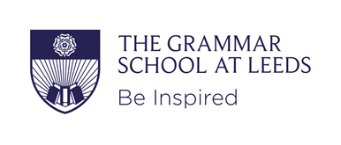
Person Specification
Job Title: Teacher of Religious Studies, Senior School
Location: The Grammar School at Leeds, Alwoodley Gates
Summary of Duties and Responsibilities: To contribute to the teaching of Religious Studies in Senior School, alongside pastoral responsibilities and co-curricular activities.

• Strong and relevant qualifications: typically this would be strong A Levels, a good degree in Religious Studies plus PGCE or other suitable teaching qualification.
• Relevant experience, skills and knowledge
• Inspirational teaching and evidence of excellent progress/outcomes
• Good quality of communication
• Strong teamwork within and beyond the department

